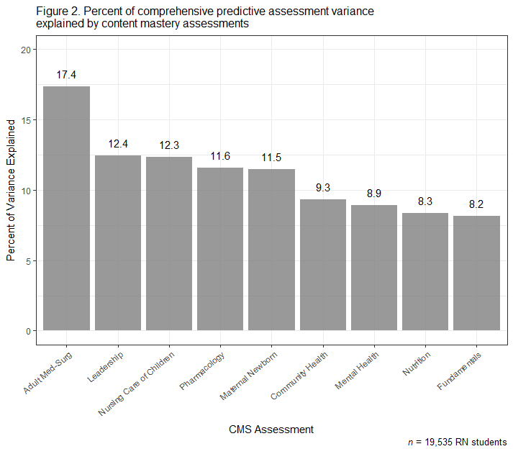
Supplemental Digital Content, Figure. Relative Importance Analysis (average R-squared contribution). Percent of comprehensive predictive assessment variance explained by content mastery assessments

