This sample wikicountry has been converted from the blackboard wikitool to a word document for the purposes of sharing the content. The original wikicountry was housed in the wiki format.

Welcome to Nigeria
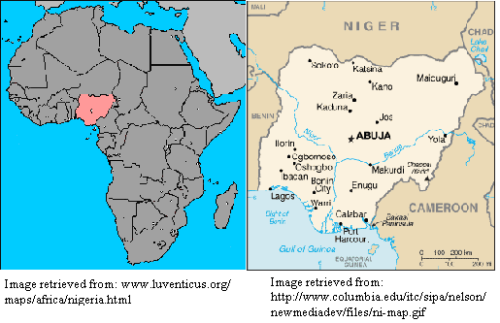

Introduction The People Health and Education

Health and Economic Status and Poverty

Health Indicators Current Health System

Access to Healthcare Services

Culture and Health Gender Norms Cultural Practices

Specific Cultural Facts and Taboos

Factors affecting Health (Occupational Environmental Nutritional)

Health Promotion Common Communicable Diseases

Common Non-Communicable Diseases Challenges to Prevention and Control

Current/Potential Measures of Control and Prevention References
Welcome to Nigeria! This country sits on the Gulf of Guinea encompasses 356,700 square miles, or approximately the size of California, Nevada and Arizona combined (“Background Note: Nigeria,” 2010). Nigeria is a land of much diversity in both its landscape and its people. The terrain of the region ranges from southern costal swaps and tropical forests along the southern borders, to woodlands, grasslands, and desert in the northern regions. Nigeria is home to the Jos Plateau mountain range, with the highest point at 2,400 meters above sea level (“Background Note: Nigeria,” 2010). The climate is also very different in these regions, as rainfall along the costal regions averages 381cm and less than 64cm in the northern regions (“Background Note: Nigeria,” 2010).
The natural resources of Nigeria include oil and natural gas, which account for 36 percent of the gross domestic product, tin, iron ore, coal, limestone, lead, and zinc. The agricultural resources of the country include palm oil, yams, cassava, sorghum, millet, corn, rice, livestock, groundnuts, and cotton (“Background Note: Nigeria,” 2010).

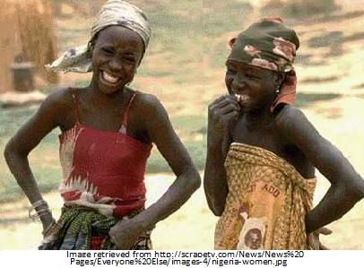
The People
Nigeria has an approximate population of 118 million people and is just as diverse as its landscape(“Nigeria”, 2010). Nigeria’s population includes 250 separate ethnic groups, and accounts for over half of the entire population of West Africa. The predominant ethnic group is located in the northern two-thirds of the country, and is called the Hausa-Fulani, which is a predominantly Muslim ethnicity. The northern regions are also inhabited by several other major ethnic groups including the Nupe, Tiv, and Kanuri. The southwest region of the country is mainly inhabited by the Yoruba (“Background Note: Nigeria,” 2010).

Health Indicators
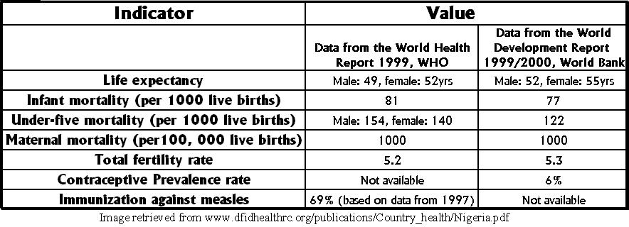
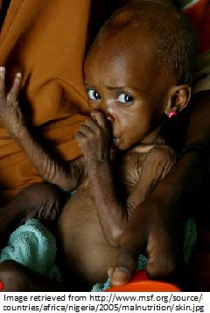Nigeria has several health indicators that demonstrate the health status of the country. For the adult population, malaria, HIV/AIDS, water-borne illnesses, non-communicable diseases, and maternal mortality are major concerns for the country. In Nigeria, along with the entire Sub-Saharan regions of Africa, cases of malaria have been on the rise. Although actual number deaths from the disease are unknown, it is estimated that almost a million people suffer from the disease each year (Johnson, 2000).
HIV/AIDS transmission rates have risen over the years. In 1990, the prevalence of the disease in the population was only 1.8 percent. In 2007, the prevalence rate was 3.1 percent. In a country of roughly 120 million people, 2.6 million are living with the virus. The virus accounted for 170,000 deaths in the year 2007 alone (CIA, 2007). Less than fifty percent of the population has access to drinking water that is safe, so the spread of water-borne illness such as bacterial and protozoal diarrhea, hepatitis A and E, and typhoid fever, are frequent and widespread (CIA, 2007). Non-communicable diseases, such as hypertension are present in eight to twelve percent of the population.
Maternal mortality and female practices are also a key public health concern (Johnson, 2000). Maternal death rates vary from 339 deaths per 100,000 deliveries in the south-west of the country to 1,716 deaths per 100,000 deliveries in the north-east. Also, only ten percent of women in the country practice any type of contraception, and many still participate in female genital mutilation (Johnson, 2000). 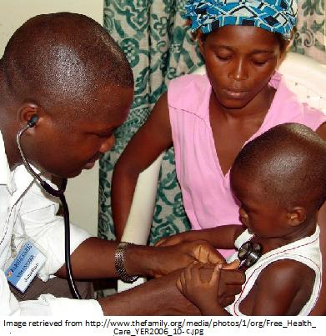
For children, almost fifteen percent do not live to their fifth birthday. The three leading causes of child mortality are malnutrition, which accounts for 52 percent of all child mortality, malaria, which accounts for 30 percent of all child mortality, and diarrhea, which accounts for twenty percent of all child mortality (Johnson, 2000). These major health problems are related to inadequate and decaying health facilities, and inadequate funding due to the needs of other departments such as education, housing, and agriculture (CIA, 2007).
Primary health care, as of 1992, is mainly provided through about 4,000 health clinics scattered throughout Nigeria. Secondary care is provided by 700 health care centers and 1,670 maternity centers (“Nigeria,” 2001). Last, tertiary care is provided through twelve university teaching hospitals with about 6,500 beds. However, there is an estimated 0.2 physicians and 1.7 hospital beds per 1,000 Nigerian people. Total health care only accounts for three percent of the gross domestic product (“Nigeria,” 2001).
Health and Education
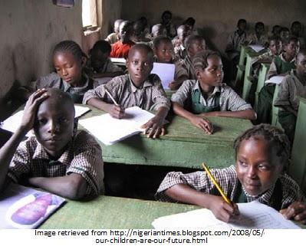
The last two decades have seen a massive growth in the education sector of Nigeria. The high school growth rate is 3.2 percent, and the high school age population has 47 percent of students under the age of fifteen. These statistics are in part affected by the decreased infant mortality rates and increased fertility rates (“Embassy,” 2004). Also, the constitution signed in 1979 made primary education of the Nigerians the responsibility of the states. Education continuing after primary education is the combined responsibility of the state and federal government.
These factors have allowed the adult illiteracy rates to drop to 35.9 percent (“Nigeria,” 2001). Though improved from previous years, this illiteracy could have also contributed to many of the negative health indicators. Without the ability to distribute written knowledge, information regarding prevention and treatment of diseases such as malaria and HIV/AIDS, is not able to reach the masses. Transmission of this knowledge must rely on word of mouth.
However, by the year 1994 Nigeria boasted 16,190,947 students learning in 38,649 primary schools, taught by 435,210 teachers. Secondary schools hosted 4,451,329 students taught by 152,592 teachers (“Nigeria,” 20071). Nigeria is also the home to over 30 Federal and State Universities, which graduated 70,000 individuals in various disciplines including pure sciences, engineering and technologies. Many Nigerians are also looking outside the country in many colleges in the United States, Canada, United Kingdom, Germany, France, Russia, Japan and China to further their education. Unfortunately, less than one percent of the gross domestic product was in education expenditures in 1991 (“Nigeria,” 2001).
Health and Economic Status and Poverty
Nigeria has a gross domestic product of 36 billion dollars annually. Nigeria has much potential in its economy as it has many human and natural resources; however, inefficiency and distortion have stunted much of its growth. Oil makes up forty percent of the gross domestic product and over 95 percent of the country’s exports (“Embassy,” 2004). Nigeria is the world’s sixth largest exporter of oil. Also, the economy has been crippled by military rule and corruption. For example, in 1996 it was discovered that two billion dollars in oil revenue was diverted into a secret bank account owned by the government. The last dictatorship ended in 1999 when a former political prisoner was elected president. The president promised to eliminate corruption and improve overall health status; however progress has been very slow (“Embassy,” 2004).
In 2002, the national external debt was 31.1 billion dollars (“Nigeria,” 2001). During the same year, the government finally began to privatize state-owned enterprises in an attempt to balance the national budget. In 2003, more economic progress was made in that four of the nation’s oil refineries were also privatized. However, the rate of HIV infection and income inequality is on the rise in the country (“Nigeria,” 2001). The increasing rate of HIV infection will play an important role in determining the labor force the country has available, and the unemployment rate was almost five percent in 2007 (CIA, 2007).
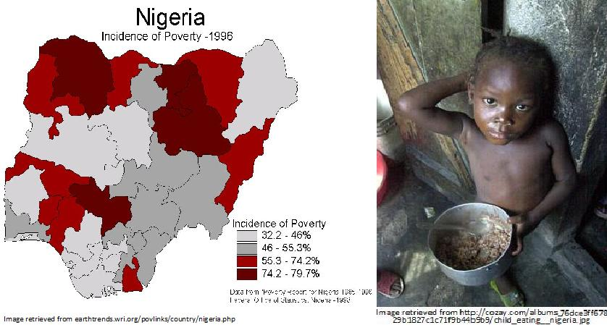
Poverty is a widespread economic factor in Nigeria, and is closely linked to the negative health factors in the country. In 2007, this income inequality was demonstrated as an estimated seventy percent of the population was living below the poverty line (CIA, 2007). A third of the population is living on less than one U.S. dollar a day, and two thirds are living on less than two U.S. dollars a day (Johnson, 2000).
Poverty is more widespread in the northern regions of the country, and is related to unbalanced investments in the country’s infrastructure and social services. For instance, eighty percent of the entire country’s hospital beds are located in the southern part of the country. The vast majority of the country’s medical resources are located in the richer parts of the country (Johnson, 2000). This limits drastically the medical treatment that the Northern Nigerians have access to, and thus, reduces the chances of the individuals requiring medical attention have of having a good outcome in their care.
Current Health System
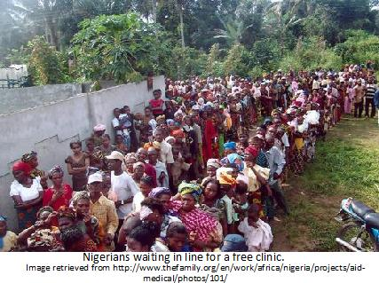
Nigeria’s current healthcare system is based on a networking of three tiers including primary, secondary and tertiary facilities (“Nigeria,” 2001). National policy in the country has a primary goal of a comprehensive health care system; however there is serious lacking of proper facilities and providers in the country (“Healthcare,” 2002). Primary health care is mostly the responsibility of the local government. Private medical professionals are also providing health at this primary level. Secondary medical care is specialized services that require a referral from a primary health provider such as laboratory services, diagnostic tests, blood bank services, rehabilitation therapy and physiotherapy (“Healthcare,” 2002). These services are at the district, divisional and zonal levels of the states.
Tertiary care is even more specialized than secondary services. These services are usually provided by teaching hospitals, and allotments of resources to these facilities from the government are supposed to be evenly distributed throughout the country; however, there is a very uneven distribution of wealth and services within the country (“Healthcare,” 2002). The Nigerian government works closely with voluntary agencies, private practitioners and other non-governmental organizations for primary health care services (“Healthcare,” 2002).
Access to Healthcare Services
Access to healthcare services is difficult for many Nigerians. Funding is the largest barrier most Nigerians have in obtaining health care. Most government run facilities lack the finances to maintain 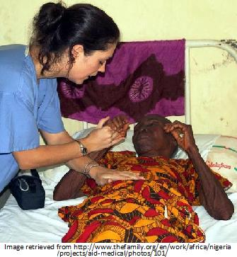proper facilities and adequate trained staff “Nigeria,” 2001). In the northern parts of the country, where poverty is worse, there are higher cases of illness and illness-related deaths. The most serious outbreaks of malaria, tuberculosis, and cerebrospinal meningitis occur in the northern regions of Nigeria (“Nigeria,” 2001). Nigeria's child malaria mortality includes over 300,000 preventable deaths per year (“Background Note: Nigeria,” 2010). The average maternal mortality rate in Nigeria is approximately 800 per 100,000 live births, but the rate is at least three times higher in the northern states (“Background Note: Nigeria,” 2010).
Even the country as a whole has a very poor health outlook. Nigeria had the greatest number of measles in 1995 of all the nations of Africa, and in the same year, diarrheal disease claimed over 200,000 lives (“Nigeria,” 2001). Nigeria also has the largest tuberculosis cases in the entire continent of Africa (“Background Note: Nigeria,” 2010).
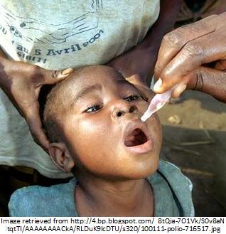This inadequacy of both the facilities and the staff of many government funded primary care centers has led to the development of a limited number of privately funded care centers including hospitals that cater to only those that can pay for their services (“Nigeria,” 2001). Many Nigerian opt to either not receive treatment or they resort to paying unskilled providers for health services. Approximately one-third of Nigerian women receive no prenatal care, even though maternal death in Nigeria is high (“Nigeria,” 2001). Also, two-thirds of deliveries take place in the home, not in a medical facility, and only one-third of those deliveries have a trained medical professional present (“Nigeria,” 2001).
Culture and Health
Like many other developing countries, Nigeria suffers from widespread poverty, illnesses, and an inadequate health care system. Poverty alone causes many Nigerian to move away from modern medical treatments that are too costly and depend on more traditional forms of health (Curry, 2003). Poor government funding also makes modern health care inaccessible to many Nigerians. As such, health in this country is very closely related to Nigerian culture, especially in the rural areas (Curry, 2003).
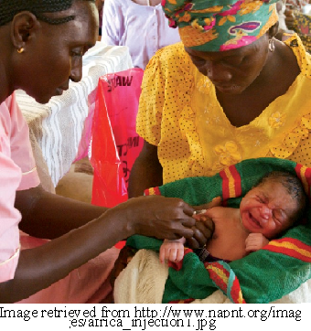Traditional healing and medicine is called juju, and is very common throughout the northern and rural areas of Nigeria (Curry, 2003). These practitioners use herbs and plants in their healings and cures. These healers often focus on maintaining a balance between deities, ancestral spirits, and other beings in the "other" world (Early, McKinney, & Murray, 2000). Spirits and deities remain an important part of the traditional medicine, as the presence of disease is perceived as a warning sign of an imbalance with the natural or the spirit world (Early, McKinney, & Murray, 2000). Also, many families have their own secret cures for various ailments and minor illnesses. Many people are mistrustful of Western-style medications and treatments, and prefer to use the traditional ways (Curry, 2003). Modern medicine is sought only as a secondary source, when traditional methods have failed. This is especially true for culture-bound disorders such as "Ode Ori" (Early, McKinney, & Murray, 2000). This disorder includes a variety of somatic complaints, and depression and anxiety (Early, McKinney, & Murray, 2000).
Although sometimes the traditional methods are effective, there are some illness and conditions in which traditional methods of healing are damaging more than helpful. This can lead to conflict between the government-run health care system and traditional ways. Some health centers are even trying to combine the two medicines to encourage more people to come to the health centers for treatment (Curry, 2003).
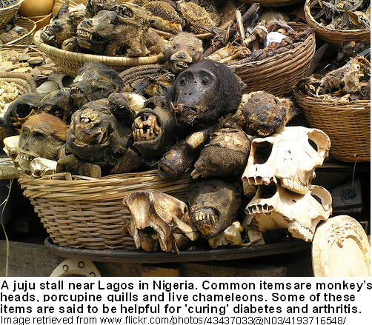
Gender Norms
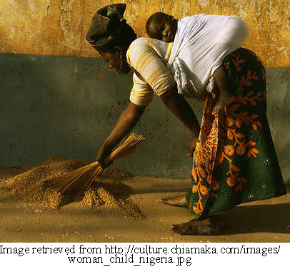 Nigeria is mainly a patriarchal society, with men dominating women in virtually all areas of society. Women have less legal rights then men, and wives are often seen as possessions of their husbands. Polygamy is a legal practice in Nigeria (Early, McKinney, & Murray, 2000). The Nigerian Penal Code even allows the men to beat their wives as long as no permanent physical injury is sustained (Curry, 2003). However, in most ethnic groups throughout the region, some women have great say in the lives of their sons and brothers (Curry, 2003). Mothers are the main caregivers of the family, but they will also rely on extended family for support (Early, McKinney, & Murray, 2000). This influence women have over some men only resides in the blood relationships unfortunately (Curry, 2003).
Labor is also divided by gender in Nigeria. Few women are in the political and professional arenas. Even those that have entered the professional workplace in the last few years are greatly outnumbered by men (Curry, 2003). This does not mean that women do not work. In rural areas, women are expected to contribute significantly to the family income, and they farm or sell homemade goods in the local market. However, in the Igbo ethnic regions, yams are men's crops, but beans and cassava are women's crops (Curry, 2003).
Cultural Practices
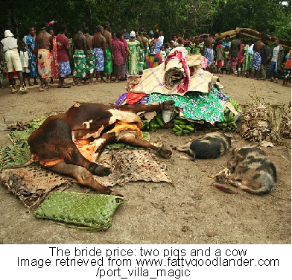Bride Price
One common culture practice among many Nigerian ethnic groups is the practice of offering something of value, a “price,” for an intended wife. This is known as offering a bride price. The bride price can be many things of value such as money, cattle, wine, or other good, but it can also be contributed money to the education of the intended wife, or helping the intended wife establish a business or other endeavor (Curry, 2003). The bride price is usually paid to the woman’s family before the marriage can take place, as compensation to the family. This is beneficial to the woman’s health, because it usually indicates some wealth and ability of the intended husband (Curry, 2003). The price is presented to the woman as part of the courting process, and allows the woman to ensure that her needs for sustenance will be provided, such as food, clothing, and access to services. Health is directed related to income in this country, so the woman can determine her future health by the man’s ability to offer the bride price and the amount of the price offered (Curry, 2003).
Polygamy
Another cultural practice that influences health is the practice of polygamy in Nigeria. In Nigeria a man may take up to four wives in a traditional or religious marriage. Polygamy has both its advantages and disadvantages within Nigerian society and health (Curry, 2003). First, 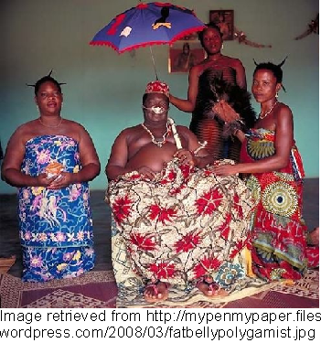polygamy can be a divisive force within a family, with one wife against another, and this might lead to the mistreatment or harm to another wife or another’s children (Curry, 2003). Also, in a country were seventy percent of the population lives below the poverty line, having to support the additional people on a limited income can be disastrous to the health of the family (Johnson, 2000). However, some claim that polygamy can also create a support system within the family. This can allow better care to be provided to the children, improving their overall health (Curry, 2003).
Female Circumcision
The cultural practice of female circumcision, or female genital mutilation, is practiced in Nigeria and is very harmful to a woman’s health. Female circumcision involves the removal of all or part of the prepuce, clitoris, and labia minora (“Report,” 2005). It is estimated that approximately sixty percent of adult women in Nigeria have undergone this female circumcision. Fortunately, the number of women participating in this practice is decreasing, especially in the urban regions (Early, McKinney, & Murray, 2000). This practice puts women at risk for infection, disfigurement, tetanus, and other disease. Women who have undergone this practice are more likely to have difficulties during childbirth and the babies were more likely to die (“Report,” 2005). 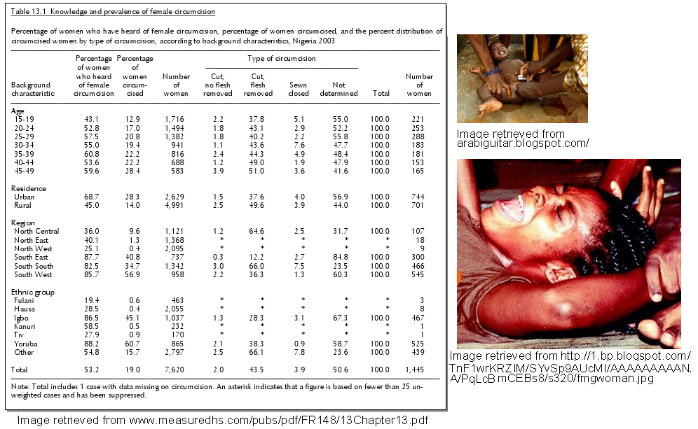 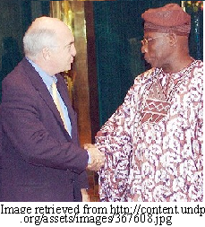 Specific Cultural Facts and Taboos
There are some specific cultural information and taboos that are important to note, especially when traveling to the area. First, age is highly respected in this country. Especially when the life expectancy is low on average, Nigerians who are older are seen with greater respect and social admiration. Age is respected in both men and women. Social greetings are also very important in Nigerian culture (Curry, 2003). It is expected that along with a polite social handshake, that a long list of well wishes for the other’s family is given, even if the people have only known each other for a short time. This greeting is expected regardless of who the person is, businessman or friend, before any business is conducted. It is important to note that shaking hands or eating with the left hand is very rude and not acceptable. The left hand is considered by most of Africa as dirty, as it is used for personal toiletries (Curry, 2003).
Factors Affecting Health
There are many factors that affect health. Occupational factors affect ones health in that certain professions have specific health risks associated with the occupation. For example, mine workers are predisposed to lung conditions because of the dust and toxins the workers are exposed to in the mines. Environmental factors also contribute to the health of an individual. If an individual does not have access to proper housing, clothing, sanitation, and water, his or her health suffers directly from it. Likewise, nutritional factors are critical in a person’s health. To achieve optimal health, a person must have adequate nutrition to foster growth, tissue repair, and immunity.
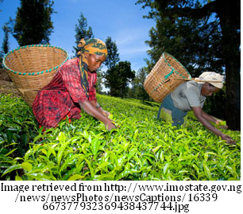Occupational Factors
The occupational factors related to health in Nigeria are determinant on the working population. In this country, seventy percent of people are employed in agriculture (WaterAid, 2010). Only 24,000 of the 118 million people in Nigeria work in the oil industry, where the country produces most of its profits (Omokhodion, 2009). However, any records of occupational disease instances or cases are few and often poorly documented. This is primarily related to the fact that most industries do not report cases to the appropriate government agency (Omokhodion, 2009).
A recent survey of the occupational diseases that were reported show that the most common conditions include conjunctivitis, chronic bronchitis, dermatitis, musculoskeletal disorders and injuries (Omokhodion, 2009). Basic agricultural hazards like sharp tools and snake bites that are present can cause debilitating wounds and fatalities (Cole, 2006). Another study of women agricultural workers, in mixed cropping systems, found that the majority of those studied suffered from intense muscular fatigue, heat exhaustion, and skin disorders. These conditions forced them to take unpaid days off from their work (Cole, 2006).
Environmental Factors
One of the largest environmental factors that has a direct impact on Health in Nigeria is human fecal waste disposal. Unsanitary disposal of human waste can lead to many health concerns. In Nigeria, more than half of the population disposes of fecal waste in unhygienic pit-latrines. Fourteen percent are completely without toilet facilities, and dispose waste either in streams or other places. This improper waste disposal is the direct cause for many illnesses (Esin, Ikurekong, & Udofia, 2008).
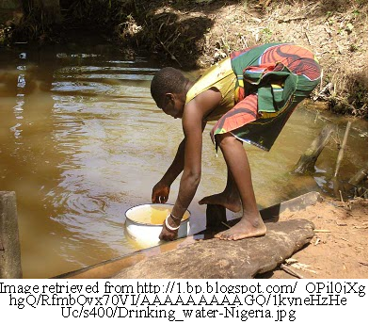Between the years 1998 to 2005, human fecal related diseases accounted for almost sixty percent of the average disease occurrence: typhoid accounted for 19.99 percent, diarrhea amounted to 18.83 percent, dysentery accounted for 12.09 percent, hepatitis accounted 9.30 percent, polio accounted for 0.03 percent, and schistosomiasis accounted 0.02 percent (Esin, Ikurekong, & Udofia, 2008). Also, less than fifty percent of the population has access to drinking water that is safe, so the spread of water-borne illness such as bacterial and protozoal diarrhea, hepatitis A and E, and typhoid fever, are frequent and widespread (CIA, 2007).
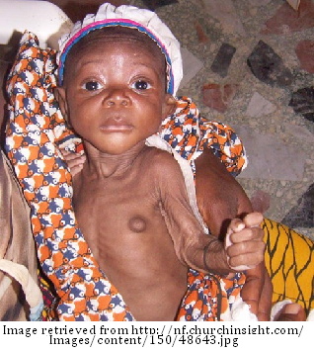Nutritional Factors
In Nigeria, past military rule has worsened poverty, helping create a situation where undernourishment is common in children. 29% of Nigerian children fewer than five years of age are underweight (Unicef, 2006). Nigeria has an estimated 6 million children under five years of age that are underweight. Undernourished children have lower resistance to infection. It is estimated that malnutrition alone contributes to over fifty percent to mortality among children aged under-five years (Unicef, 2006).
Also, these children are lacking in essential vitamins, such as vitamin A, which is critical for the development immune and visual systems. In 2004, it was estimated that 25% of Nigerian children are growing up with lower immunity, which leads to frequent ill health and poor growth, directly due to vitamin A deficiency (Unicef, 2006). For women in Nigeria, many do not breastfeed. Only 17.2 % of Nigerian infants fewer than six months of age are exclusively breastfed. The United Nations Children's Fund recommends that babies are exclusively breastfed during the first six months of life (Unicef, 2006). In addition, forty percent of pregnant Nigerians did not take supplemental iron during pregnancy. This lack of iron can cause anemia and increases the risk of infant mortality, while the lack of folic acid can cause severe birth defects (Unicef, 2006).
Health Promotion
To improve nutritional health, Nigeria initiated its National Policy on Food and Nutrition in 2002, with the primary goal of improving the nutritional status of all Nigerians. This policy sets specific key goals, which include reduction of severe and moderate malnutrition in children under five by 30% by 2010, and reduction of nutrient deficiencies by 50% by 2010 (Unicef, 2006). Health promotion activities in this country also focus on improving its sanitation. The Nigerian Government has committed to increasing the priority of water and sanitation services; however, it faces any challenges in achieving the Millennium Development Goals (MDGs) of reducing the proportions of people without access to safe water and sanitation between 1990 and 2015 (WaterAid, 2010). WaterAid, an international nongovernmental organization, is assisting the Nigerian government wiht meeting the MDGs of the country. Its main goal is to assist 84,000 people gain access to water, sanitation and hygiene education by 2011 (WaterAid, 2010).
Common Communicable Diseases
Common communicable diseases in Nigeria are AIDS/HIV, tuberculosis, and malaria. A research study in Port Harcourt, Nigeria found that of all medical admissions, communicable diseases accounted for 43.8 percent (Agomuoh & Unachukwu, 2007). In Nigeria, the most concerning communicable disease is the HIV/AIDS virus. It is estimated than 3.6 percent of the population is living with HIV/AIDS, which means that within this country there are three million people living with the disease. Also in 2009, approximately 192,000 people died from the disease (Avert, 2010). This high death rate has dropped the average life expectancy in the country six years since 1991 (Avert, 2010). Nigeria has the world’s fourth largest tuberculosis (TB) burden. There were more than 460,000 new cases of the disease in 2007. According to the World Health Organization, 42 percent of the new TB cases in 2007 were sputum smear-positive, meaning that they have the ability to infect others (USAID, 2009). Malaria is also a concerning communicable disease in the country. Currently, there are 110 million clinically diagnosed cases of malaria, in a population of only 151 million. Malaria kills 250,000 children under the age of five each year. Malaria is the cause of eleven percent of maternal deaths (Chester, 2010).
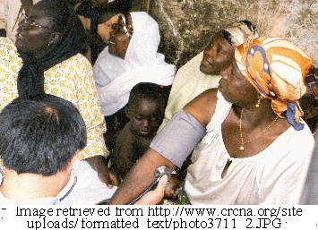Common Non-Communicable Diseases
Non-communicable diseases are a main component in the disease burden of many developing countries. In South Africa, among the top ten mortality diseases and conditions were heart disease, stroke, hypertension, and diabetes mellitus. 65,000 lives are lost each year in South Africa to these diseases (Parker, Puoane, Sanders & Tsolekile, 2008). A research study in Port Harcourt, Nigeria found that of all medical admissions, various non-communicable diseases accounted for 56.2 percent (Agomuoh & Unachukwu, 2007). Of these medical admissions, cardiovascular disorders accounted for 35.7 percent, endocrine disorders accounted for 18.5 percent, and renal disorders accounted for 16.8 percent. High blood pressure (hypertension), diabetes mellitus, and chronic renal failure were the most common cardiovascular, endocrine and renal disorders seen, respectively (Agomuoh & Unachukwu, 2007).
Challenges to Prevention and Control

There are many challenges that face Nigeria in prevention and control of HIV, TB, and malaria. Nigeria is plagued by many factors that promote infection and disease such as poverty, crowded living conditions, poor sanitation, acute ignorance, alcoholism, opportunistic infections, and homelessness (Edohasim, 2010). In Nigeria, disease is more prevalent in densely populated areas, due to their high level of poor hygiene and crowded environments, than the urban areas, where the inhabitants have the money to maintain sanitation, hygiene, and medical care (Edohasim, 2010). Many Nigerian cities are heavily congested and over crowded. A family in poverty will have ten people living in one small room that has little ventilation. This creates the opportunity for any of them infected with TB to easily infect others, perhaps in ignorance (Edohasim, 2010).

Lack of clean, safe water predisposes people to water-borne infections, which lowers the immune system and prolongs recovery time. Access to health services is rare for people in poverty, as they cannot afford medications or medical supplies (Edohasim, 2010). Also, the health services that are available are not equipped properly. In 2007 in Nigeria, only three percent of health facilities had HIV testing and counseling services (Avert, 2010). Poverty also prevents many from purchasing other safety items such as insecticide treated nets to prevent malaria from mosquitoes. In 2008, a survey found that only eight percent of homes owned at least one insecticide treated net (Chester, 2010).

There are also many obstacles that face Nigeria in prevention and control of non-communicable diseases. Nigeria does not comprehensively address chronic diseases as part of national health agendas (Okotcha, 2006). This is due to a lack of resources for healthcare expenditures, limited capacity of the health system, and the threat that national-level programs will weaken the local systems. There has been no systematic surveillance for risk factors of non-communicable diseases in Nigeria even though the Federal Ministry of Health has a National Expert Committee on of non-communicable diseases (Okotcha, 2006).

Current/Potential Measures of Control and Prevention

In 2010 the National Action Committee on AIDS launched its strategy for the years 2010 to 2015. This strategy will require approximately 56 billion to implement. Goals include reaching eighty percent of sexually active adults and eighty percent of most at-risk populations with HIV counseling and testing by 2015 (Avert, 2010). Also the strategy plans to ensure eighty percent of eligible adults and a hundred percent of eligible children are receiving treatment by 2015. The committee would also like to improve access to quality care and support services in at least fifty percent of people living with the virus by 2015 (Avert, 2010).

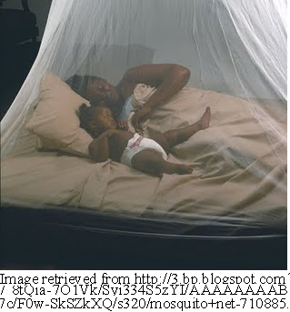The National TB and Leprosy Control Program controls all the strategic direction for TB in Nigeria. The Federal Ministry of Health acknowledged TB as a national emergency in April 2006, and inducted the National TB/HIV/AIDS Working Group two months later (USAID, 2009). TB case detection has risen twelve percentage points since 2002 to 23 percent; however, this detection rate is still far short of World Health Organization’s target of seventy percent. The current treatment success rate is 76 percent (USAID, 2009).

In May 2009, Nigeria’s National Malaria Control Program and the Kano State Government launched the national bed net distribution campaign with the goal of reducing by half the number of malaria deaths in the next few years. By the end of 2010, over 60 million treated bed nets will have been distributed (World Bank, 2009). The partnership is also focusing on “improving diagnosis, getting highly effective anti-malarial drugs quickly to all who need them, spraying interior walls of houses with long-lasting insecticide so mosquitoes die when they land there to rest, and giving pregnant women two doses of an anti-malarial to prevent them from getting malaria,” (World Bank, 2009).

In 2008, Lagos, Nigeria launched a free state-wide screening exercise for diabetes and hypertension several times throughout the year. Highlights of the results from the screening exercise included a total of 50,598 people were screened with 61.7 percent being female and 38.3 percent males (Okojie, 2008). Out of those screened, 4.2 percent were found to be diabetic and 17 percent hypertensive. 13.3 percent of the individuals screened were referred for further treatment (Okojie, 2008).
References
Agomuoh, D. & Unachukwu, C. (2007) “Pattern of Diseases among Medical Admissions in Port Harcourt, Nigeria.” Nigerian Journal of Clinical Practice. 51/3/45-50 Retrieved 5 July 2010 from http://www.ncbi.nlm.nih.gov/pubmed/18689132
Avert (2010) “HIV and AIDS in Nigeria” Avert.org. Retrieved 5 July 2010 from http://www.avert.org/aids-nigeria.htm
Background Note: Nigeria,” 2010. US Department of State. Retrieved 24 May 2010 from http://www.state.gov/r/pa/ei/bgn/2836.htm
Chester, P. (2010) “Malaria kills: Distributing 63 million bed nets in Nigeria with rapid SMS” MobileActive.org. Retrieved 5 July 2010 from http://mobileactive.org/malaria-kills-getting-63-million-bednets-nigerians-rapidsms
Cole, D. (2006) “Occupational Health Hazards of Agriculture” Understanding the Links between Agriculture and Health. Brief 8 of 16, focus 13. Retrieved 17 June 2010 from www.mtnforum.org/rs/ol/counter_docdown.cfm?fID=4397.pdf
Curry, T. (2003) “Nigeria” Every Culture.com. Retrieved 7 June 2010 from http://www.everyculture.com/Ma-Ni/Nigeria.html
Early, E., McKinney, S., & Murray, J. (2000) “Nigerians” Baylor University. Retrieved 7 June 2010 from http://bearspace.baylor.edu/Charles_Kemp/www/nigerian_refugees.htm
Edohasim, E. (2010) “Nigeria: Curtaling Spread of Tuberculosis”All Africa Global Media. AllAfrica.com Retrieved 5 July 2010 from http://allafrica.com/stories/ 201006180618.html
“Embassy” (2004) Embassy of the Federal Republic of Nigeria. Retrieved 26 May 2010 from http://www.nigeriaembassyusa.org/thisisnigeria.shtml
Esin, J., Ikurekong, E., & Udofia, E. (2008) “Faecal Waste Disposal and Environmental Health Status in a Nigerian Coastal Settlement of Oron” TAF Preventative Medicine Bulletin 7(5). Retrieved 17 June 2010 from www.korhek.org/khb/khb_007_05-363.pdf
“Healthcare” (2002). Motherland Nigeria: Healthcare. Retrieved 4 June 2010 from http://www.motherlandnigeria.com/health.html
“Nigeria” (2001) Encyclopedia of the Nations: Nigeria. Retrieved 27 May 2010 from http://www.nationsencyclopedia.com/Africa/Nigeria.html
Okojie, G. (2008) “Nigeria: Lagos Develops Strategies to Halt Non-Communicable Diseases” All Africa Global Media. AllAfrica.com Retrieved 5 July 2010 from http://allafrica.com/stories/printable/200808250929.html
Okotcha, N. (2006) “Proposing a National Surveillance for Behavioral Risk Factors of Chronic Diseases in Nigeria” NigeriaVillageSquare.com Retrieved 5 July 2010 from http://www.nigeriavillagesquare.com/index.php?option=com_content&view=article&id=7912&catid=67&Itemid=46
Omokhodion, F. (2009) “Occupational Health in Nigeria” Oxford Occupational Medicine Journal. Volume 59, Number 3. Retrieved 17 June 2010 from http://occmed.oxfordjournals.org/cgi/content/full/59/3/201
Parker, W., Puoane, T., Sanders, D., & Tsolekile, L. (2008) “Chronic Non-Communicable Diseases” Retrieved 5 July 2010 from www.hst.org.za/uploads /files/chap5_08.pdf
Johnson, D. (2000)“Nigeria: Country Health Briefing Paper” DFID’s Health Systems Resource Center for the UK Department for International Development. Retrieved 26 May 2010 from www.dfidhealthrc.org/publications/Country_health/Nigeria.pdf
“Report: (2005) “Report on Female Genital Mutilation (FGM) or Female Genital Cutting (FGC)” OnlineNigeria.com Retrieved 8 June 2010 from http://www.onlinenigeria.com/links/adv.asp?blurb=551
Unicef (2006) “Information Sheet: Nutrition” UNICEF, Nigeria. Retrieved 16 June 2010 from www.unicef.org/wcaro/WCARO_Nigeria_Factsheets_Nutrition.pdf
USAID (2009) “Infectious Diseases: Nigeria.” USAID.gov. Retrieved 5 July 2010 from http://www.usaid.gov/our_work/global_health/id/tuberculosis/countries/africa/nigeria_profile.html
WaterAid (2010) “WaterAid's plans in Nigeria” WaterAid.org. Retrieved 19 June 2010 from http://www.wateraid.org/international/what_we_do /where_we_work/nigeria/3583.asp
World Bank (2009) “Malaria Prevention Program in Nigeria Aims at Universal Bed Net Coverage” World
Bank.org Retrieved 5 July 2010 from http://web.worldbank.org/WB SITE/EXTERNAL/COUNTRIES/AFRICAEXT/NIGERIAEXTN/0,,contentMDK:22178832~menuPK:368902~pagePK:2865066~piPK:2865079~theSitePK:368896,00.html

