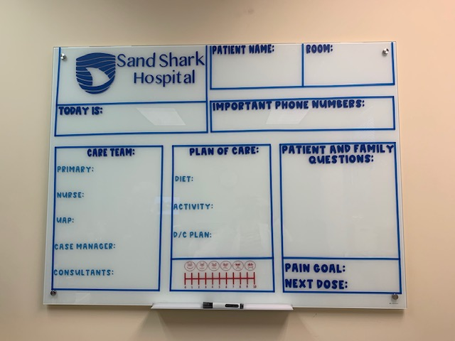

Supplemental Digital Content Figure 1

