Deaf Culture
(Popov, n.d.)
Social Organization
Regardless of who in the family is deaf, all family members are affected because family relationships are built on communication. Only 8.9% of deaf children are born to deaf parents (Frank, 2017). Deaf children born to deaf parents are more likely to grow up learning American Sign Language (ASL) and attend schools for deaf students compared to deaf children born to hearing parents. Some of the biggest concerns for deaf individuals expressed by their family members include inadequate education, poor quality healthcare, and social development. Deaf individuals whose family does not use ASL typically feel disconnected from family. Individuals who have grown up in a household with hearing family members often miss out on bonding moments such as conversations at the dinner table because communication is limited (Lesch et al., 2019). Quality education and employment status are difficult to acquire for deaf individuals. In fact, deaf individuals are 1.98 times higher to be unemployed versus hearing counterparts.
Social Understanding
There two distinctions and meanings of deaf: deaf and Deaf (Reagan, 2020). The lowercase “d” deaf indicates the medical condition implying that a person cannot hear, whereas the uppercase “D” Deaf implies the culture of being deaf. Uppercase D Deaf individuals do not view themselves as having a disability that needs to be fixed and instead choose to view their deafness as a good quality.
(Toey n.d.)
Stigma
Stigmas associated with deaf individuals include cognitive capacity, inability to function independently, and marginalization because of unique communication (i.e., ASL) (Lesch et al., 2019). Assumptions made regarding deaf client’s capability of carrying out informed health related decisions diminish deaf individuals’ cognitive capacity and ability to function independently. English and ASL are two different languages, therefore deaf individuals do not understand all aspects of the English language. Many deaf individuals feel judged by others regarding their flawed use of English.
Challenges in Treatment
Deaf patients are at higher risk of treatment without proper consent (Lesch et al., 2019). Deaf individuals report inadequate knowledge regarding illness transmission and prevention as well. Difficulty interpreting prescriptions, understanding medical terminology, and inadequate instructions regarding medications can lead to poor and dangerous health outcomes. Challenges to treatment can be associated with misperceptions about what constitutes effective communication. There is inconsistent access to ASL interpreters, so physicians often rely on writing, lip reading, or family members to translate. However, not using a trained ASL interpreter causes miscommunication and can lead to misdiagnosis and poor-quality healthcare.
Challenges in Access to Healthcare
Deaf individuals report a lower health status and are at higher risk for obesity, suicide, and domestic violence (Lesch et al., 2019). Deaf individuals have difficulty communicating over the phone, with the office staff, and with healthcare providers. Due to inadequate communication deaf patients are less likely to have a primary care physician and seek healthcare on a regular basis. “In a survey conducted in 2005, one third of Deaf participants did not trust that their physicians were competently managing their health needs and did not fully understand their doctor’s advice or what they were expected to do next” (Lesch et al., 2019, p. 240).
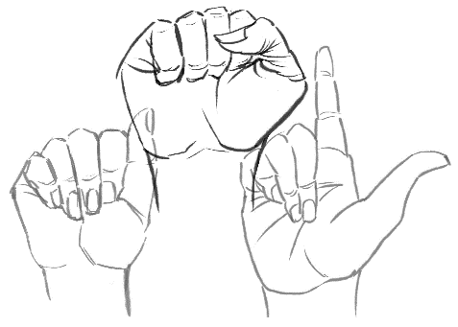
(Zhao, 2019)
Healthcare disparities
People in the deaf community experience poor health literacy compared to people who are not deaf (Naseribooriabadi et al., 2017). Poor health literacy is 6.9 times more likely in people of the deaf community (Malebranche et al., 2020). People in the deaf community often have a health care team with a “lack of cultural competence” (Meraz, 2019, para. 4). In health care, the deaf community will also have an inadequate supply of resources available (Meraz, 2019). Often in healthcare, individuals of the deaf community will have to face healthcare team individuals that have preconceived notions and biases about their own care.
Health Risks
Individuals who are deaf usually are at a greater risk for:
- Decreased cardiovascular Health (Malebranche et al., 2020 & BU School of Public Health, 2018)
- Decreased mental health (Malebranche et al., 2020)
- Men who are deaf are at a higher risk for testicular cancer (BU School of Public Health, 2018).
- Women who are deaf are at a higher risk of complications during pregnancy and delivery of a baby (BU School of Public Health, 2018).
(Elnur, n.d.)
How to provide culturally sensitive care
Understand that not all deaf community members read lips and not all use sign language for communication (Malebranche et al., 2020).
Determine the method of communication the specific deaf induvial prefers prior to interaction with the deaf individual (Meraz, 2019).
Provide the proper interpreter for the patient (Meraz, 2019).
Figure out the best environment and environmental factors to enhance communication with the deaf individual (Meraz, 2019).
Make health learning programs centered around, and specifically for, the deaf community to improve health literacy (Naseribooriabadi et al., 2017).

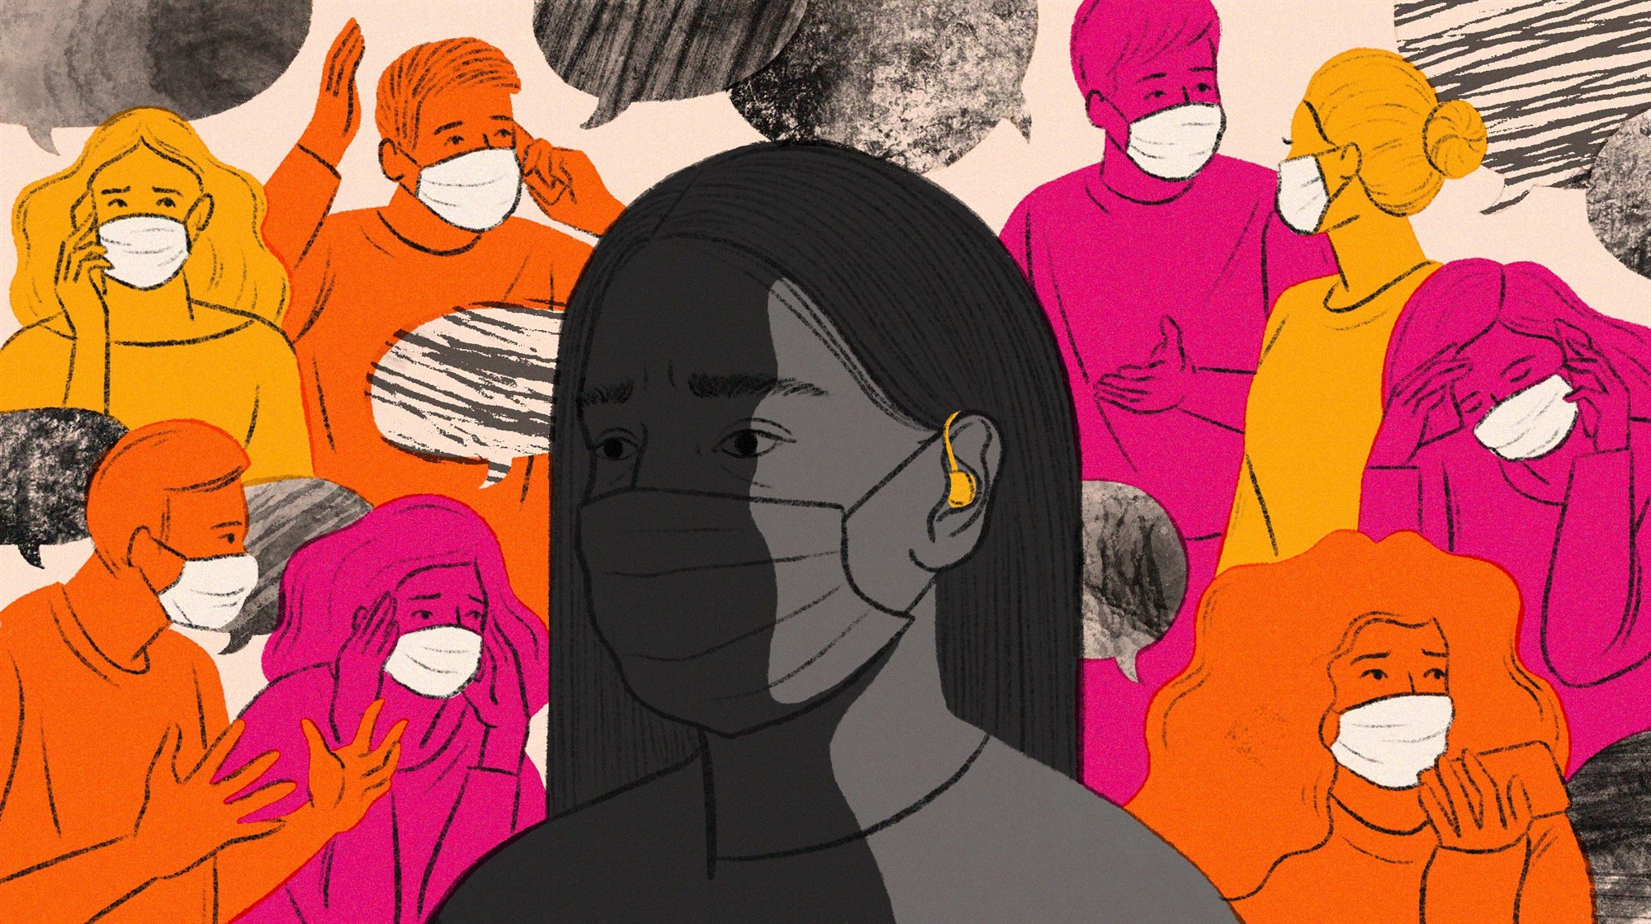
(Le, 2020)

References
BU School of Public Health. (2018, October 11). Healthcare language barriers affect deaf people, too. https://www.bu.edu/sph/news/articles/2018/healthcare-language-barriers-affect-deaf-people-too/
Elnur. (n.d.). Deaf-mute female patient visiting young male doctor [Photograph]. Shutterstock. https://www.shutterstock.com/image-photo/deafmute-female-patient-visiting-young-male-1275220414
Frank, A. (2017). Deaf families’ unique experiences and obstacles. Journal of Social Work in Disability & Rehabilitation. https://doi.org/10.1080/1536710X.2017.1372238
Le, N. (2020). Deaf coronavirus think cover main [Photograph]. NBC News. https://media2.s-nbcnews.com/j/newscms/2020_20/3351396/200515-deaf-coronavirus-think-cover-main-cs_12e32738ca6cf1116e69314cab148157.fit-2000w.jpg
Lesch, H., Burcher, K., Wharton, T., Chapple, R., & Chapple, K. (2019). Barriers to healthcare services and supports for signing deaf older adults. Rehabilitation Psychology 64(2), 237-244. http://dx.doi.org/10.1037/rep0000252
Malebranche, M., Morisod, K., & Bodenmann, P. (2020). Deaf culture and health care. CMAJ, 192(50), E1809-E1809. https://doi.org/10.1503/cmaj.200772
Meraz, J. (2019, June 18). Barriers that restrict healthcare access for the deaf community and interventions for improved patient quality care [Poster Presentation]. The Grace Peterson Nursing Research Colloquium, Chicago, IL. https://via.library.depaul.edu/nursing-colloquium/2019/spring/20/
Naseribooriabadi, T., Sadoughi, F., & Sheikhtaheri, A. (2017). Barriers and facilitators of health literacy among D/deaf individuals: A review article. Iranian Journal of Public Health, 46(11), 1465–1474. https://www.ncbi.nlm.nih.gov/pmc/articles/PMC5696685/
Popov, A. (n.d.) Couple Communicating with Sign Language [Photograph]. Adobe Stock.
Reagan, T. (2020). Social justice, audism, and the d/Deaf: Rethinking linguistic and cultural differences. In: Papa R. (Ed.) Handbook on Promoting Social Justice in Education (pp. 1479-1510). Springer, Cham. https://doi.org/10.1007/978-3-030-14625-2_108
Toey, T. (n.d.). Asian Child with Hearing Aid Can Help Her to Hear More Clearly [Photograph]. Shutterstock. https://www.shutterstock.com/image-photo/asian-child-hearing-aid-can-help-1397954756
Zhao, D. (2019). ASL [photograph]. The Brown Daily Herald. https://www.browndailyherald.com/wp-content/uploads/2019/01/ASL-1024x731.jpg

