Student Word Clouds and Captions
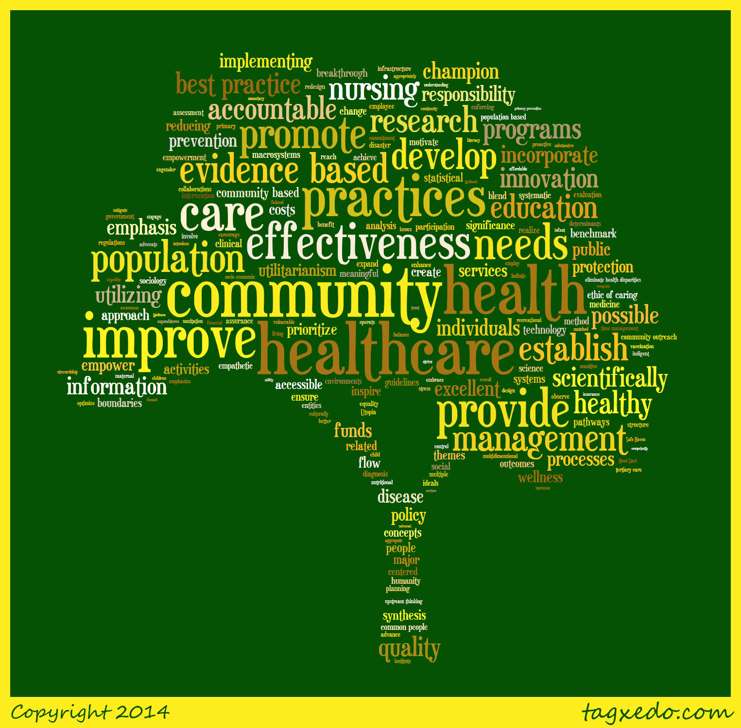
Caption: Evidence-based healthcare practice within the community setting is built upon the implementation of the scientific process and the subsequent development of meaningful healthcare policy. As these evidence-based health care practices emerge and evolve, they redirect the health care system toward upstream thinking and simultaneously refocus its goals on primary prevention, utilitarianism, and universal healthcare. In order to achieve such equity and quality in community healthcare, analytical innovation must be utilized to effectively unite the art of nursing, the science of medicine, and the humanity of sociology.

Word cloud created by Lindsay Martin, RN
Published with permission, http://www.tagxedo.com

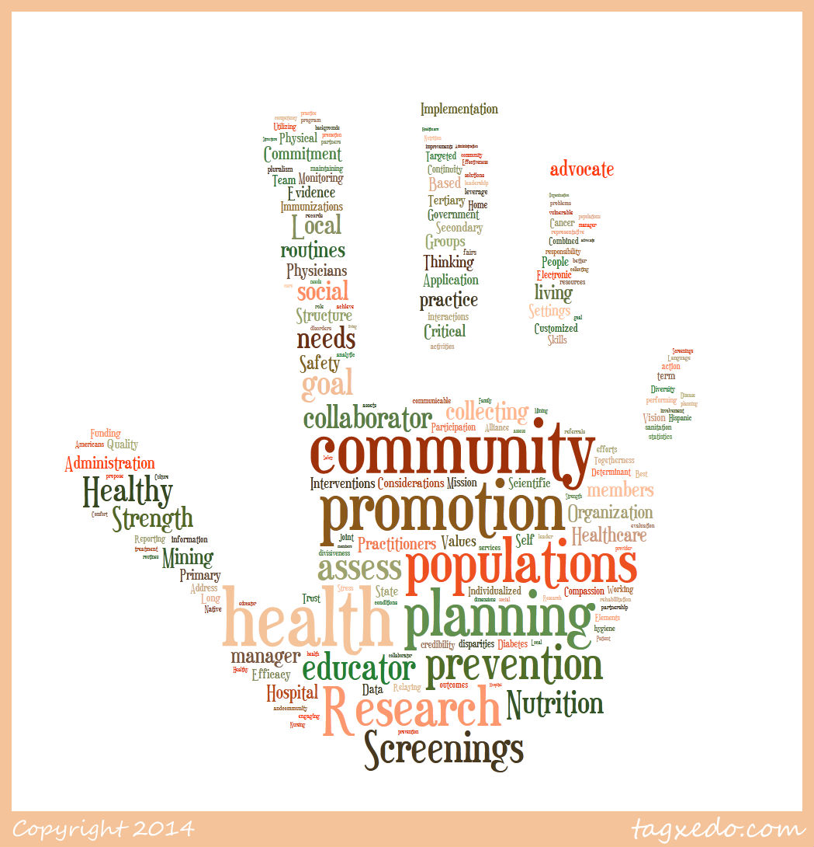

Caption: Community health care providers focus on the community as a whole, promoting healthy behaviors and preventative measures for the overall health of the entire population. Community health care providers are also responsible for effective and continued education with their patients, as encouraging healthy behaviors and disease and injury prevention techniques is important. Collaboration with other health care providers and community members ensures quality and continuity of care. Data collection and research is important in keeping the community provider up-to-date and allows them to look for trends within their community’s populations.

Word cloud created by Ashley Edgar, RN
Published with permission, http://www.tagxedo.com

