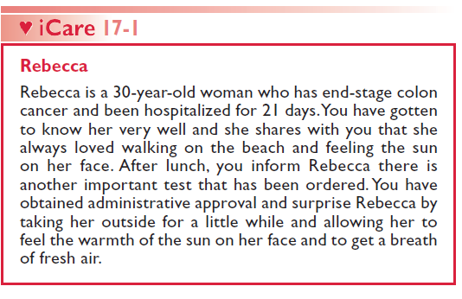
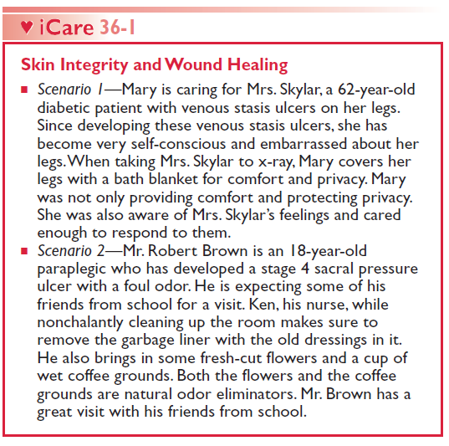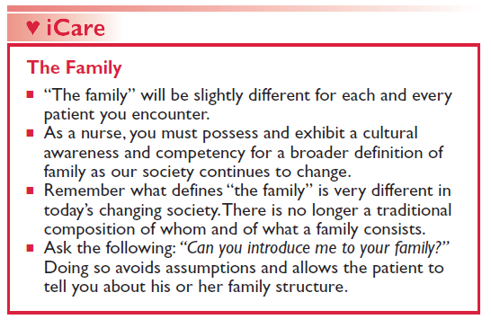
From Treas, L., Wilkinson, J., Barnett, K., Smith, M. (2018). Basic Nursing: Thinking, Doing, and Caring 2e. Philadelphia, PA: F.A. Davis Company, with permission.

