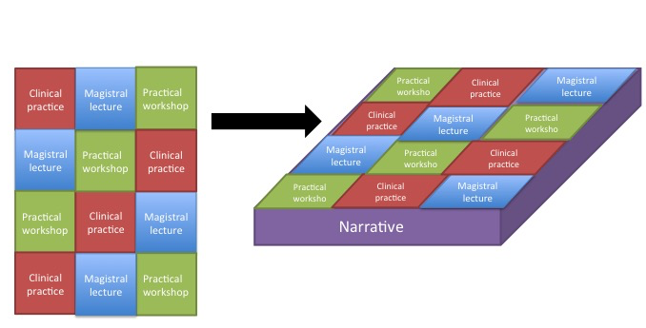
Figure: From a pixelated to a voxelated curriculum

