Figure 1
Online Faculty Learning Community – Modules
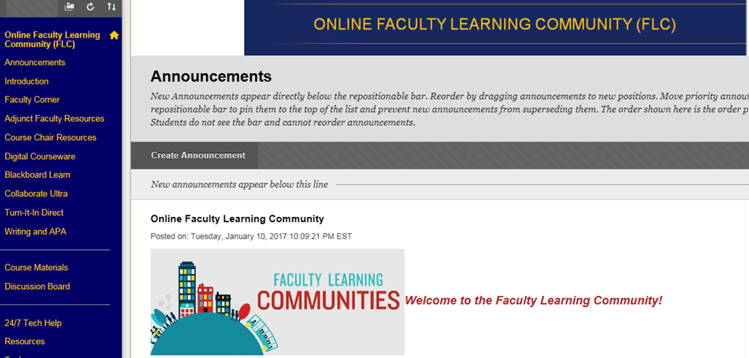
Figure 1 Online Faculty Learning Community Modules: The modules are located in the blue panel of the LMS from Faculty Corner down to Writing and APA

