Northwestern Objective Microanastomosis Assessment Tool (NOMAT)

I. Operator positioning and posture.

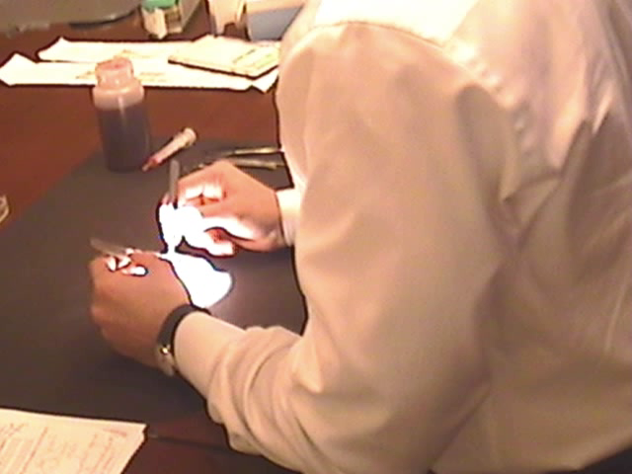

**Optimally ergonomic and relaxed posture**

**Economy of movements**

**Movement is confined to the wrists and fingers**

**Good posture and positioning at first but deteriorates by the end of the procedure**

**Rarely makes wide-range movements**

**Hunched back, twisted wrists, shrugged shoulders**

**Wide range of movements**

**Notes to the Evaluator:**

This item is included to evaluate how natural the feel of using the microscope is to the participant. It is included to promote smooth and minimalistic movements and to focus on an ergonomically correct body posture that will allow the participant to spend hours at a time seated at work in the future.

II. Use of the surgical microscope

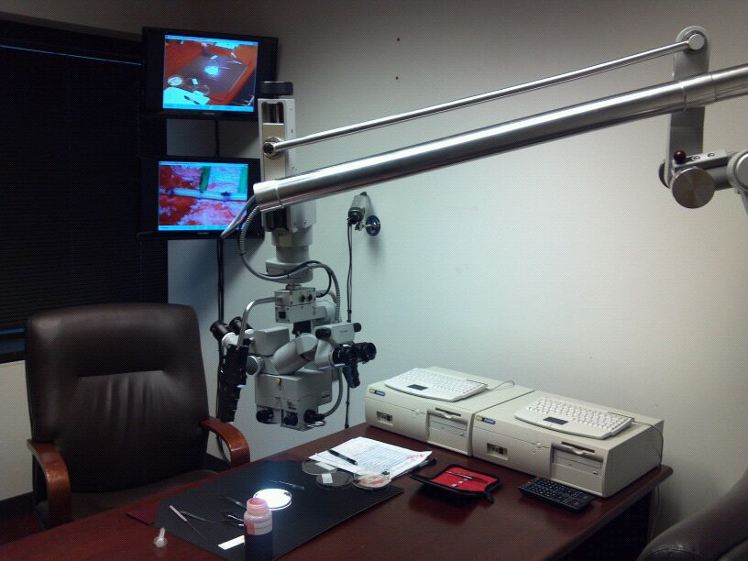

**Optimizes zoom, focus, and optical settings at the beginning of the task and adjusts only when needed**

**Focused most of the time but re-adjusts at multiple instances**

**Familiar with the use of the microscope but not yet** **proficient**

**Re-adjusts positioning, focus, and working distance frequently**

**Frequently out of focus or using a magnification level that impedes proper field navigation**

**Moves the surgical setting instead of navigating it with the scope**

**Notes to the evaluator:**

This item is included to evaluate and promote familiarity with the microscope. It will assess the ability of the participant to optimally setup the microscope from the beginning of the operation. Since most of the work is done in a single plane, frequent re-adjustment and optimization are not necessary in this experiment and should be avoided.

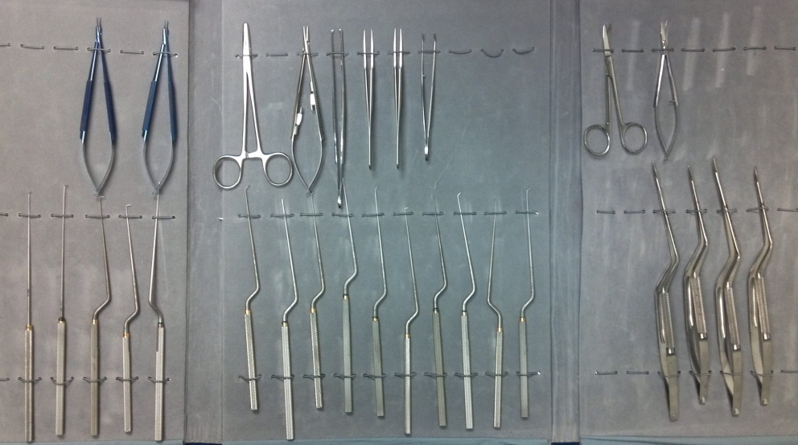

III. Understanding of the surgical equipment

**Repetitively uses the wrong instrument for the task.**

**Uses the correct instrument for the task most of the time**

**Quickly switches to the correct instrument after a mistake.**

**Perfect matching of instruments and tasks at hand**

**Knows the instruments well, and chooses according to the surgical need.**

**Notes to the evaluator:**

This item is included to test the participant’s familiarity with the surgical instruments. Available instruments will include macro-and micro-instruments in order to confuse the participant. Errors that are repeated and that are not recognized should be judged harshly (1) while errors that are quickly rectified should be considered with more leniency (3)

IV- Handling of the surgical instruments

**Repeatedly makes unnecessary passes or awkward moves with the instruments**

**Superfluous movements**

**Competent use of instruments although occasionally appears stiff or awkward**

**Fluid and effortless movements with the instruments**

**Economy of motion, with punctual and targeted movements**

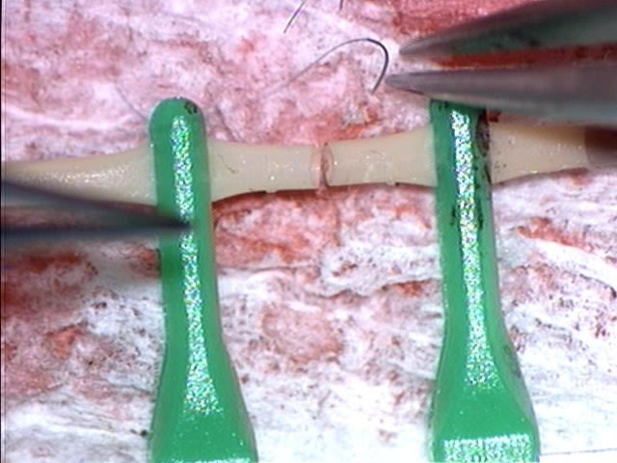

**Notes to the evaluator:**

This step is included to evaluate the participant’s dexterity when it comes to microscopic movements. Every motion should appear effortless, precise and straight to its intended target. Normal physiological tremor is not a factor that is evaluated in this step, but instead awkwardness, hesitation, and waste of motion.

V- Vessel handling and respect for tissue

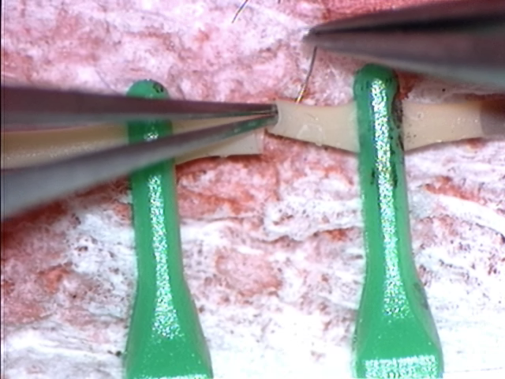

**Frequently damages the vessel by inappropriate use of force, with perforation or tearing of the wall**

**Tearing of the vessel by inappropriate needle or instrument handling or during knot tying**

**Acceptable/occasional accidental damage that does not affect the structural integrity of the vessel but could theoretically promote thrombosis and/or intimal damage**

**Rough movements at the anastomotic line during knot tying**

**Vessel almost intact at the end of the procedure**

**Absence of movements that may promote intimal endothelial damage or thrombosis**

**High handling proficiency**

**Notes to the evaluator:**

This item is included to evaluate the awareness and the control of the participants when handling microvessels, and how carefully they manipulate endothelial membranes. Movements considered damaging to the endothelium include excessive stretching of the vessel, rough grabbing of the intimal layer, or excessive compression of the vascular wall. In brief any action that may compromise endothelial health and promote thrombosis.

VI- Needle handling and care

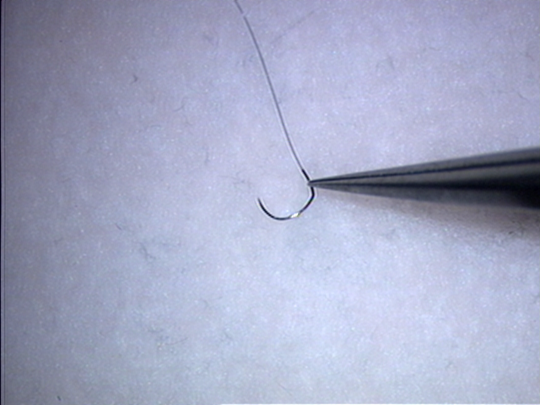

**Irreparable damage to the needle requiring a new suture thread to complete the anastomosis**

**The needle is moderately damaged and deformed but still functional**

**The needle is undamaged and un-deformed at the end of the procedure**

**Notes to the evaluator:**

This item is included to evaluate the participant’s control when using the micro-needle. Although micro-anastomosis on live patients usually uses multiple sutures, only one suture is allowed per anastomosis in this experiment.

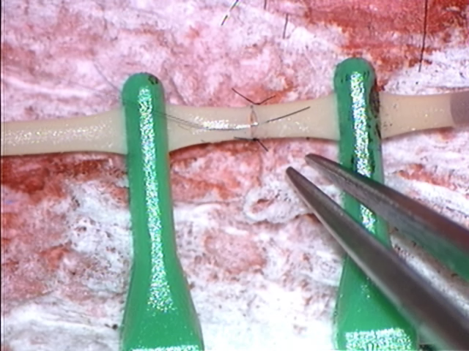

VII- Needle bite uniformity

**Needle bites are very uneven between the two edges of the anastomosis**

**Needle bites are very irregular from suture point to suture point**

**Approximately 50 % of needle bites are even and regular**

**All needle bites are even and regular**

**Notes to the evaluator:**

This item is included to evaluate the uniformity of needle bites on both sides of the anastomotic line. Even and sufficient bites on both edges of the anastomosis will allow the correct apposition of the two vessels, while excessive and uneven bites may lead to kinking or torsion.

VIII- Spacing of the sutures

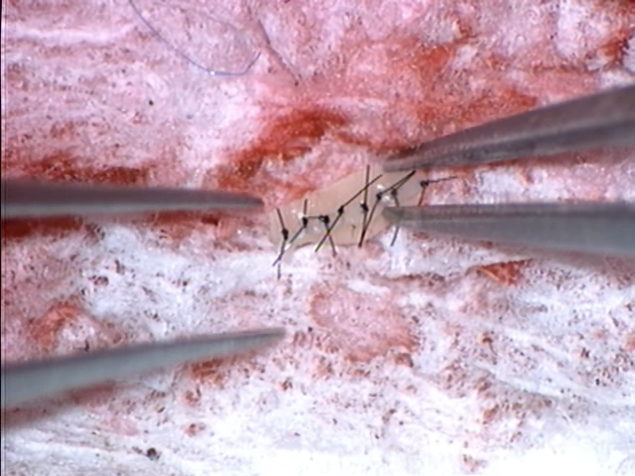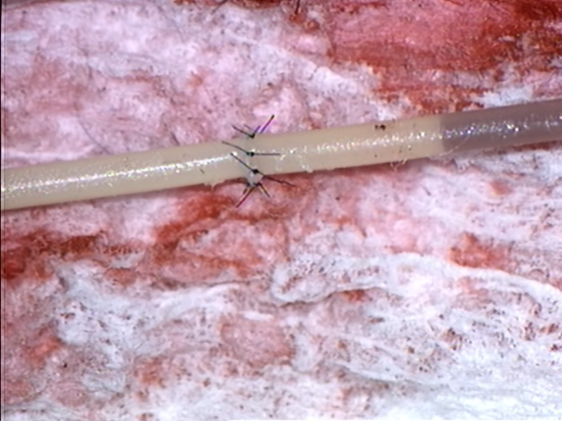

**Constantly irregular intervals**

**A suboptimal number of suture points is used to complete the anastomosis**

**(more or less than 10-12 for 3mm and 6-8 for 1mm)**

**>50% of intervals are equal and regular but a suboptimal number of suture points is used to complete the anastomosis**

**(more or less than 10-12 for 3mm and 6-8 for 1mm)**

**Intervals are equal**

**The number of suture points is appropriate to vessel size and matches the recommended number of suture points to use (10-12 for 3mm and 6-8 for 1mm)**

**Notes to the evaluator:**

This item is included to evaluate the uniformity of needle bites on both sides of the anastomotic line. Equidistant bites on both edges of the anastomosis (provided that the operator is using the recommended number of suture points for the selected vessel size) will allow the correct apposition of the two vessels, while excessive and uneven bites may lead to kinking or torsion.

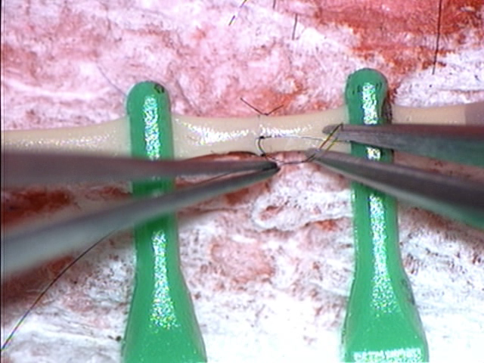

IX- Knot-Tying

**Perfect square knots with good knot strength and tension**

**Appropriate suture length**

**Finished the entire anastomosis using only one suture thread**

**Knots are too loose and could potentially be undone**

**Knots are tight enough to cut through or shred the vessel**

**Wastes a lot of thread and requires multiple (>3 total) new suture threads to finish the anastomosis**

**Acceptable knot quality but uneven or irregular**

**The sutures are cut at an inappropriate length**

**Requires 1 additional suture thread to finish the anastomosis**

**Notes to the evaluator:**

This item is included to evaluate the control and the capacity of the participant to tie strong square knots without injuring the vessel in the process or wasting sutures.

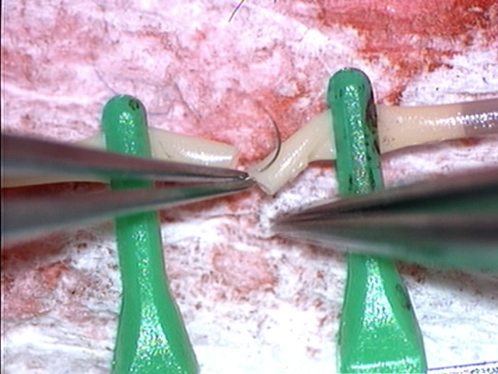

X- Microsurgical efficiency with the needle

**No wasted moves, grasps only once**

**Economy of movement and efficiency**

**Mostly single attempts/passes to successfully bite the tissue**

**Few unnecessary moves**

**Few attempts to successfully grasp the needle**

**Few passes are required to successfully bite the tissue**

**Many unnecessary moves**

**Multiple attempts needed to grasp the needle**

**Multiple passes required to successfully bite the tissue**

**Loses the needle frequently in the surgical field**

**Notes to the evaluator:**

This item is included to assess the operator’s dexterity using the micro-needle. Emphasis should be placed on economy of time and motion, and ease of manipulation of the needle.

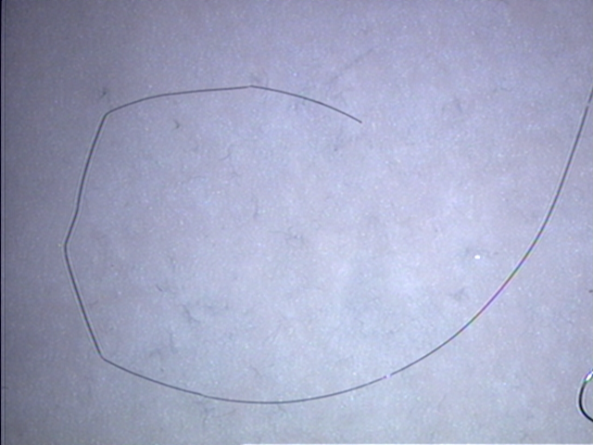

XI- Microsurgical efficiency with knot tying

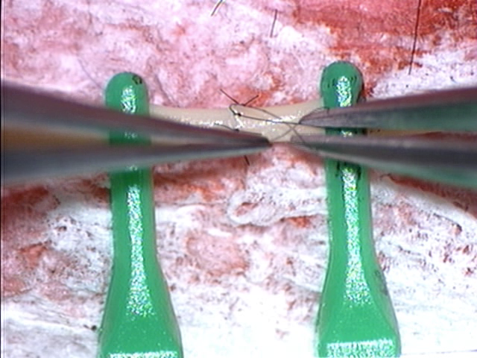

**No wasted moves**

**Economy of movement and efficiency**

**Mostly single attempts/passes to successfully tie a knot**

**Few unnecessary moves**

**Few attempts to successfully grasp the suture**

**Minimal breaks that do not impede knot tying**

**Many unnecessary moves**

**Multiple attempts needed to grasp the suture and tie the knot**

**Multiple suture breaks or kinks from excessive force**

**Notes to the evaluator:**

This item is included to assess the operator’s dexterity using the micro-thread. Emphasis should be placed on economy of time and motion, and ease of manipulation of the thread specifically during knot-tying. Breaks in the nylon thread specific to this experiment are indicative of a use of excessive force, and can severely impede knot tying.

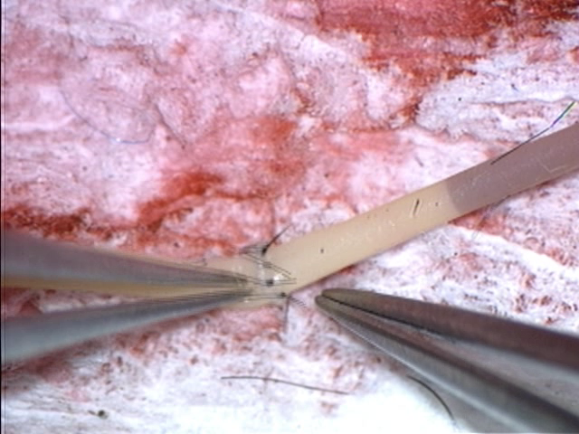

XII- Evaluation of the completed anastomosis- Off-pump

**Good anastomotic line**

**Anastomosis predicted to be functional**

**No vascular torsion**

**Mild vessel kinking**

**Severe vessel kinking, angulation, or torsion**

**Vessel Completely Deformed**

**Did not complete the anastomosis**

**Notes to the evaluator:**

This item is included to evaluate the general aspect of the anastomosis, and detect any structural imperfection that may be a predictor of suboptimal functioning.

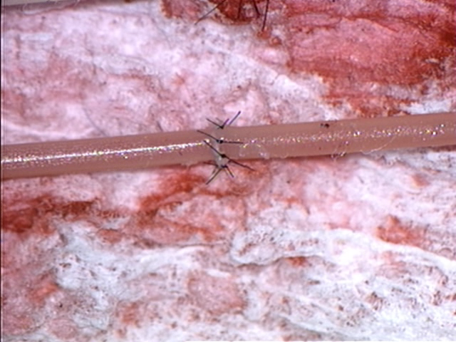

XIII- Evaluation of the completed anastomosis- On-pump

**Slight oozing originating mostly from needle entry and exit points that would be controlled in vivo by the application of cotton**

**Moderate oozing without specific focus points**

**Jet of fluid originating from between adjacent sutures**

**Profuse oozing without specific focus point**

**Vessel Sewn shut: No flow**

**Notes to the evaluator:**

This item is included to evaluate the tightness of the anastomotic line. Since slight oozing is recognized as a good prognostic sign.

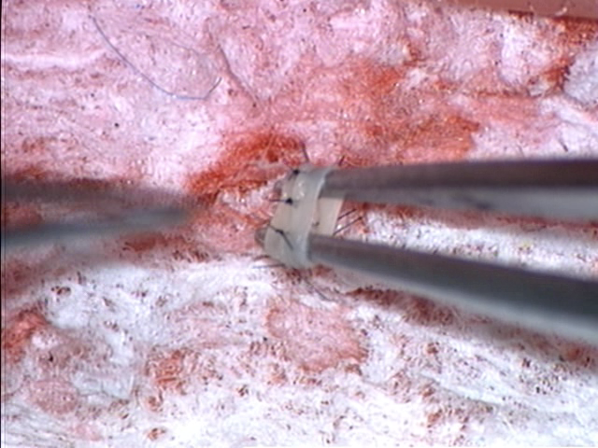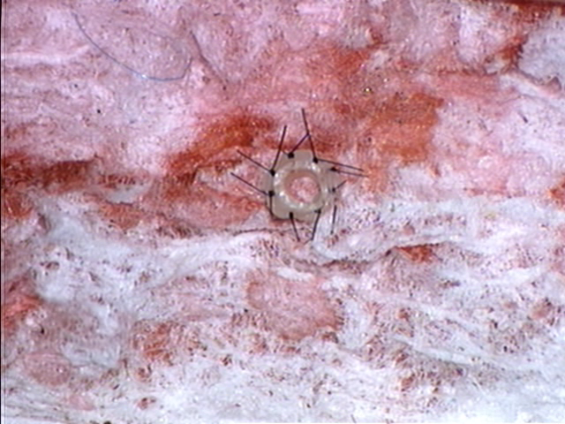

XIV- Evaluation of the completed anastomosis- Examination of the lumen

**No considerable stenosis that would restrict the vessel and blood flow**

**10 to 50% lumen stenosis**

**Overlapping vessel edges with minimal compromise**

**Free back wall**

**>70% lumen stenosis,**

**Back wall caught by a suture point**

**Notes to the evaluator:**

This step is included to evaluate the patency of the anastomosis. After the anastomosis is completed, the vessel is dissected in a ring-like fashion to allow a look inside the lumen. Passive dilation using the jeweler pickups will also be attempted to demonstrate elasticity of the anastomotic region.

|  |  |  |
| --- | --- | --- |
| Decision | Pass: | Fail: |
| Overall grade on 100 |  | |

**Notes to the evaluator:**

Please provide a pass-fail judgment of the overall performance of the operator based on whether or not you believe the final product would be viable in vivo.

Please also provide an overall score for the operator’s performancect to be viablepass-fail judgment on the overall performance of the operator based on whether or not you believe the final prod