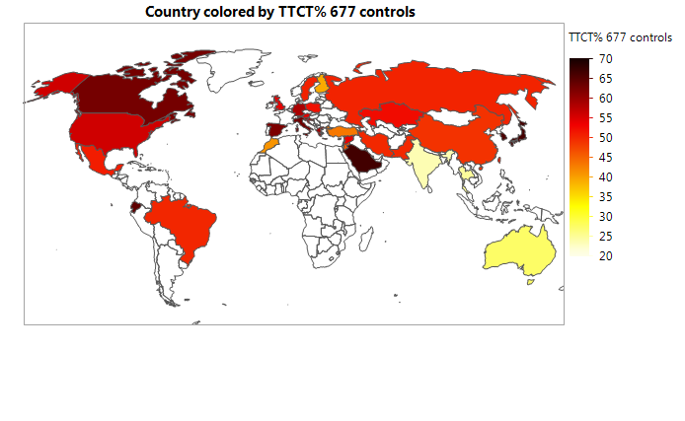
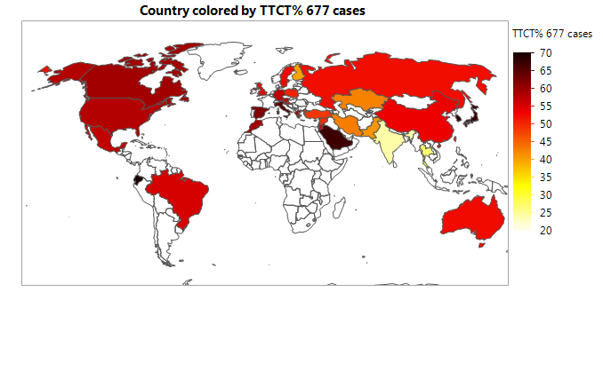
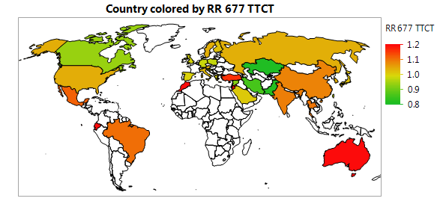
Figure S3. Geographic information maps for total percentage of mutations on MTHFR 677 TT and CT genotypes per control and breast cancer (BC) groups, and BC risks.

