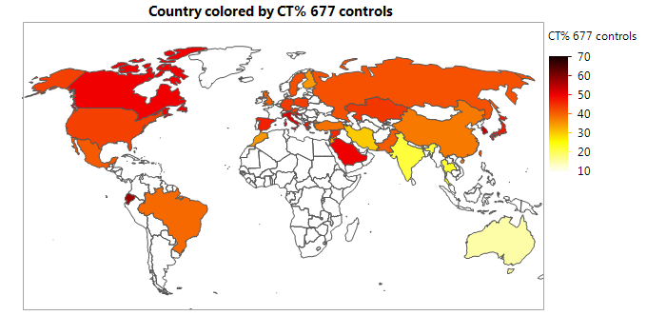
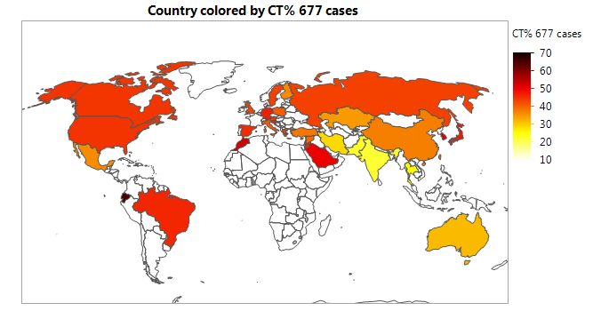
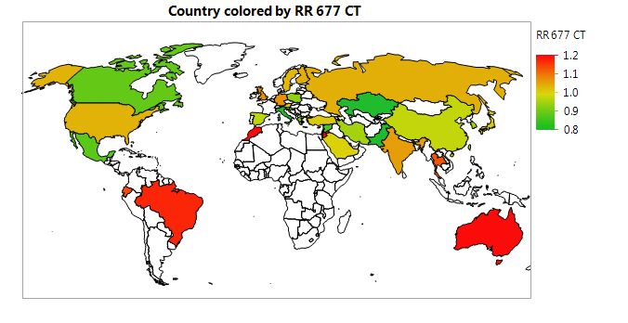
Figure S5. Geographic information maps for percentage of mutations of MTHFR 677 CT genotype per control and breast cancer (BC) groups, and BC risks.

