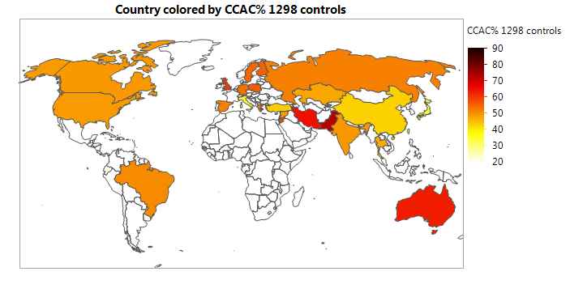
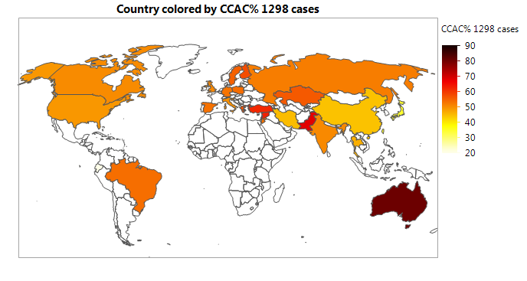
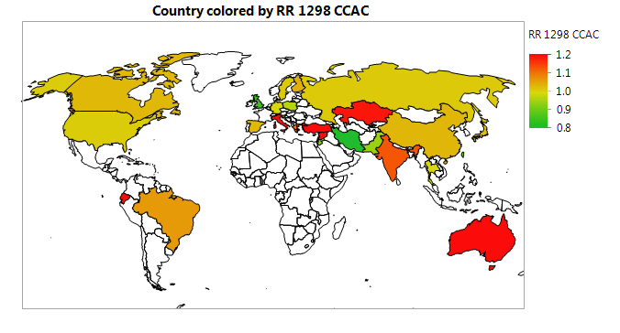
Figure S7. Geographic information maps for total percentage of mutations of MTHFR 1298 CC and AC genotypes per control and breast cancer (BC) groups, and BC risks.

