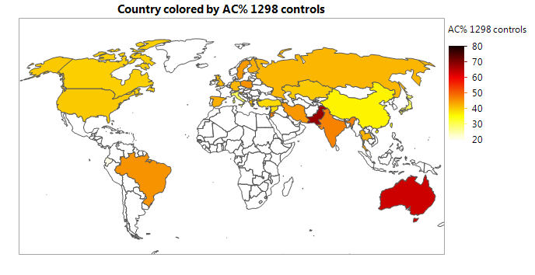
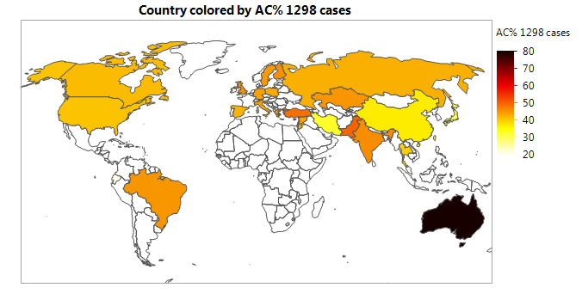
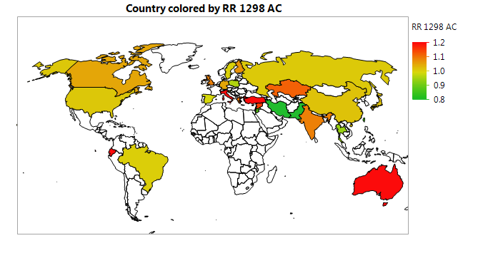
Figure S9. Geographic information maps for percentage of mutations of MTHFR 1298 AC genotype per control and breast cancer (BC) groups, and BC risks.

