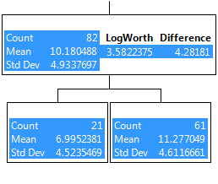
APdeath3(3,4)
APdeath3(2)
All Rows
Figure S13. Recursive partition tree of MTHFR 677 homozygous TT % for the control group by death from air pollution.

