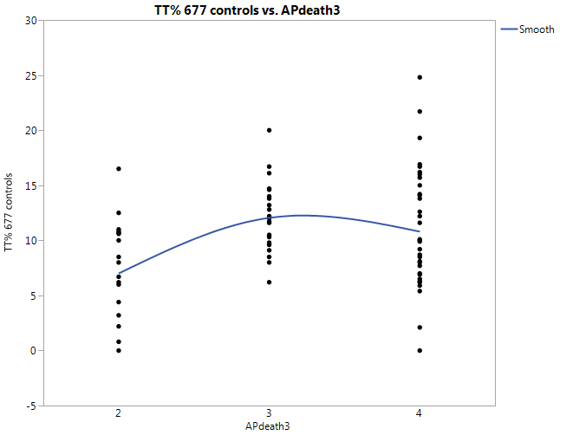
Figure S14a. Nonlinear fit of MTHFR 677 TT mutation with death from air pollution
(APdeath: Death rates from air pollution; Levels per million: 2 = < 100, 3 = 101-250, 4 = 251-400 and greater).

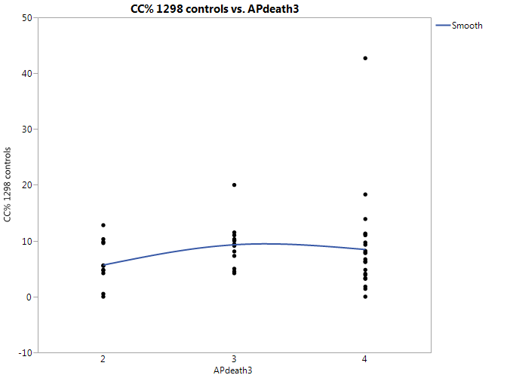

Figure S14b. Nonlinear fit of MTHFR 1298 CC mutation with death from air pollution (APdeath: Death rates from air pollution; Levels per million: 2 = < 100, 3 = 101-250, 4 = 251-400 and greater).

