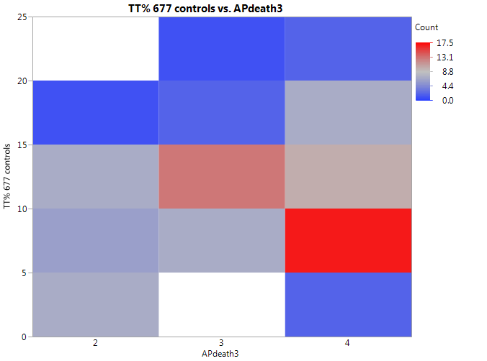

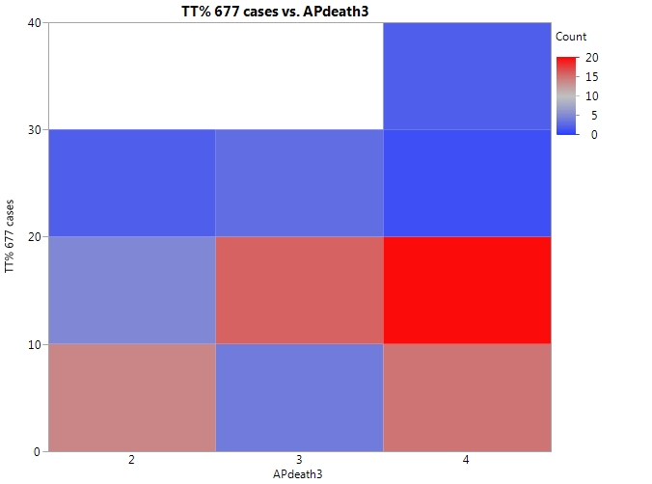

Figure S15. Heat maps of mutations of MTHFR 677 homozygous TT genotype for control and case groups in association with death from air pollution (APdeath: Death rates from air pollution; Levels per million: 2 = < 100, 3 = 101-250, 4 = 25-400 and greater).

