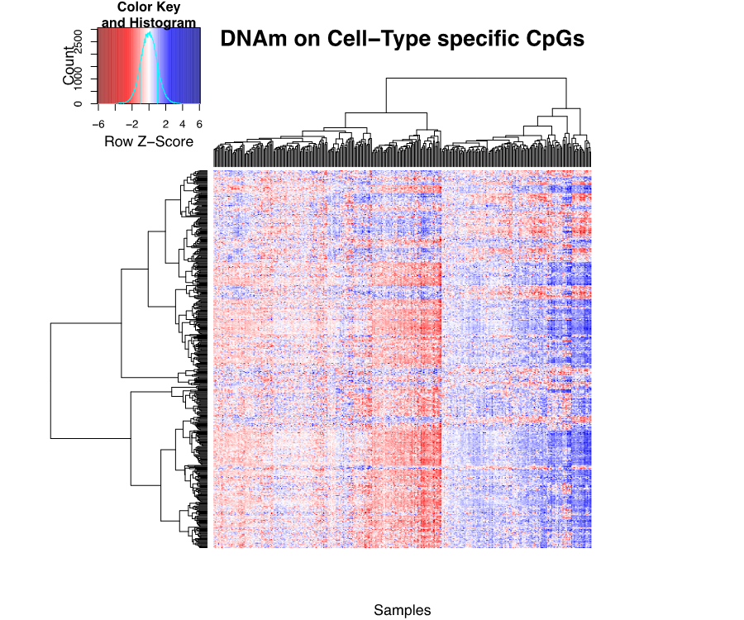

Supplementary Figure 1. Hierarchical clustering of 341 neonate cord blood samples on 500 blood cell-type specific CpGs. Rows are 500 CpGs determined using Houseman et al.’s (2012) method as those showing largest differences between cell sorted samples of six blood cell types in adult blood. Columns correspond to 341 neonate samples. Measurements are DNAm for the 341 neonate samples on these 500 CpGs. Measurements are row-wise centered and scaled.

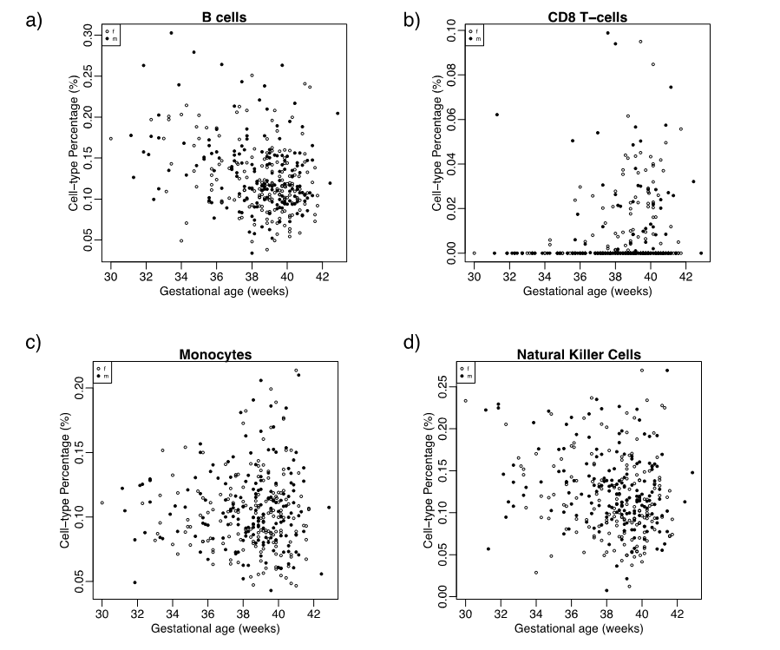

Supplementary Figure 2. Blood cell-type percentage by gestational age for four blood cell types. Each point corresponds to one of 341 neonate cord blood DNAm samples. Percentage of each cell type for each of the 341 samples was estimated from DNAm using Houseman’s deconvolution method. Each panel shows estimated percentage for each cell type against each sample’s gestational age. Panels correspond to estimates for a) B cells, b) CD8 T cells, c) monocytes, and d) NK cells.

