Supplemental Table 1. Correlations between Estimated Nutrition Score (without energy criterion) and Price, at 11 Casual Restaurants in the Boston Metropolitan Area.
 | All entrées
Restaurantª | # items (n=619) | Spearman’s rho | P-value^{b}
J | 58 | 0.22 | 0.10
E | 95 | 0.11 | 0.30
H | 29 | 0.02 | 0.91
K | 52 | -0.11 | 0.45
C | 87 | -0.12 | 0.32
G | 71 | -0.15 | 0.21
I | 42 | -0.20 | 0.20
D | 35 | -0.24 | 0.17
F | 63 | -0.27 | 0.04
B | 50 | -0.31 | 0.03*
A | 37 | -0.37 | 0.03*
ª Restaurants ordered from highest positive correlation to lowest negative correlation.
^{b} * signals statistical significance at P ≤0.05.

Supplementary Figure 1. Scatter Plot Showing the Relationship between Entrée Price and Estimated Nutrition Score at 11 Casual Restaurants in the Boston Metropolitan Area.
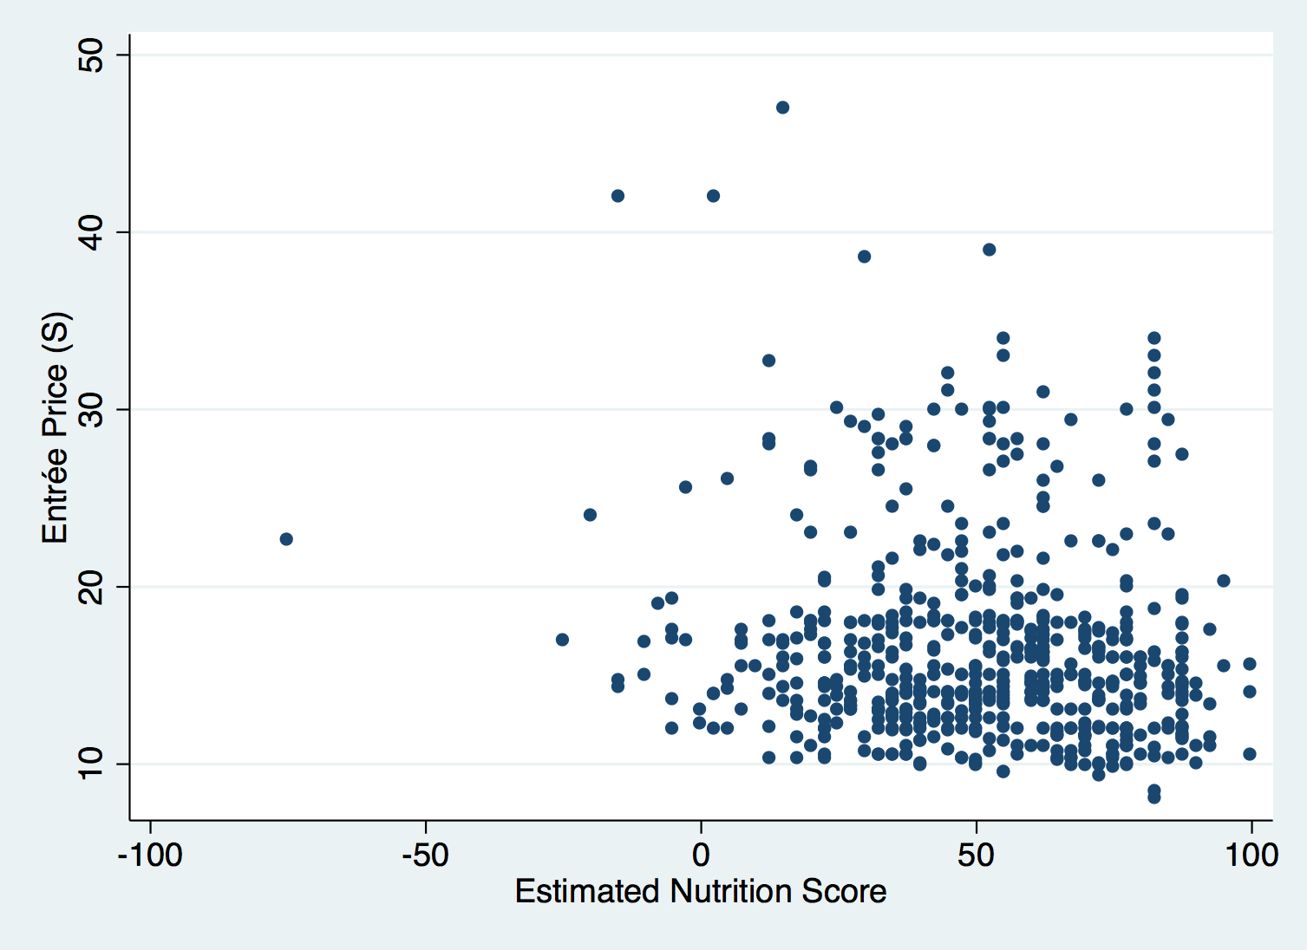

Of note, the outlier in the lower left in this figure was a fried seafood platter listed as containing 4100 kcals. The 3 most expensive items (top center) were steak and lobster entrees that ranged between 1710 and 2590 kcal

