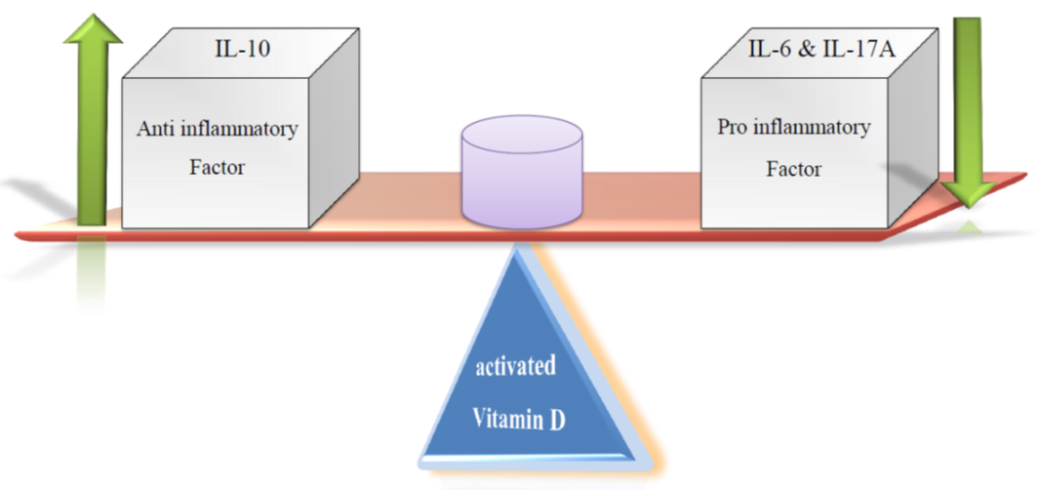
Figure e-1. See – Saw model. In sufficient amount of circulating level of vit D₃, anti (IL-10) or pro (IL-17A & IL-6) inflammatory interleukins will cause Up- or Down- regulation, respectively and in this way the See-Saw model would be produced. In fact, in presence of vitamin D, IL-10 as a major anti-inflammatory prohibit the expression of pro-inflammatory cytokines and lead to body from pro-inflammatory state to tolerogenic immune status. But, in deficiency or insufficient level of vit D₃, pro-inflammatory cytokines, especially IL-17A, increases. IL-17A mediates BBB dysfunction (so pro-inflammatory cytokines can cross the BBB) and induces secretion of IL-6 by BBB endothelial. However, after production of IL-6, it has positive feed-back effect in increasing IL-17A secretion, too. Meanwhile, increased expression of IL-6 augments axon damage.

