Supplementary information for

Shared Genetic Contributions to Atrial Fibrillation and Ischemic Stroke Risk

Sara L. Pulit, Lu-Chen Weng, Patrick F McArdle, Ludovic Trinquart, Seung Hoan Choi, Braxton D. Mitchell, Jonathan Rosand, Paul I W de Bakker, Emelia J Benjamin, Patrick T Ellinor, Steven J Kittner, Steven A Lubitz*, Christopher D Anderson*, on behalf of the Atrial Fibrillation Genetics Consortium and the International Stroke Genetics Consortium.

Code and data release

For access to information related to this project, including code, sample identifiers, SNP identifiers, links to summary-level data, and SNP weights used in the construction of the polygenic risk score, please see this GitHub repository: https://github.com/UMCUGenetics/Afib-Stroke-Overlap.

Table of Contents

Supplementary Figures | Pages 3-11
Supplementary Tables | Pages 12-25
Supplementary Methods | Pages 26-33
Supplementary Results | Page 34
Appendix I: Atrial Fibrillation Genetics (AFGen) Consortium members | Pages 35-38
Appendix II: Stroke Genetics Network (SiGN)  Consortium members | Pages 39-42
References | Pages 43-45

Supplementary Figures

Supplementary Figure 1 | Genome-wide association study (GWAS) of atrial fibrillation in SiGN. (A) We performed a GWAS of 3,190 cases with atrial fibrillation, or paroxysmal atrial fibrillation, as well as other diagnoses suggestive of underlying atrial fibrillation, including left atrial thrombus, sick sinus syndrome, and atrial flutter. We additionally included 28,026 referents. We used a linear mixed model and adjusted the model for principal components and sex. The majority of atrial fibrillation risk loci identified through previous GWAS efforts were identified here at nominal significance or better (see Supplementary Table 2). The Manhattan plot only shows QC-passing SNPs with minor allele frequency > 1% and imputation quality score > 0.8. (B) Quantile-quantile (QQ) plot indicating SNPs stratified by minor allele frequency and the corresponding genomic inflation factor (lambda, λ) for each stratum. (C) QQ plot showing SNPs stratified by imputation quality and the corresponding lambda for each stratum. Figures D-F are identical to those of A-C, but for the analysis performed in atrial fibrillation cases only (N = 1,751). We performed this is an internal sensitivity analysis only, to ensure that more broadly defining the atrial fibrillation phenotype was not introducing additional phenotypic noise.

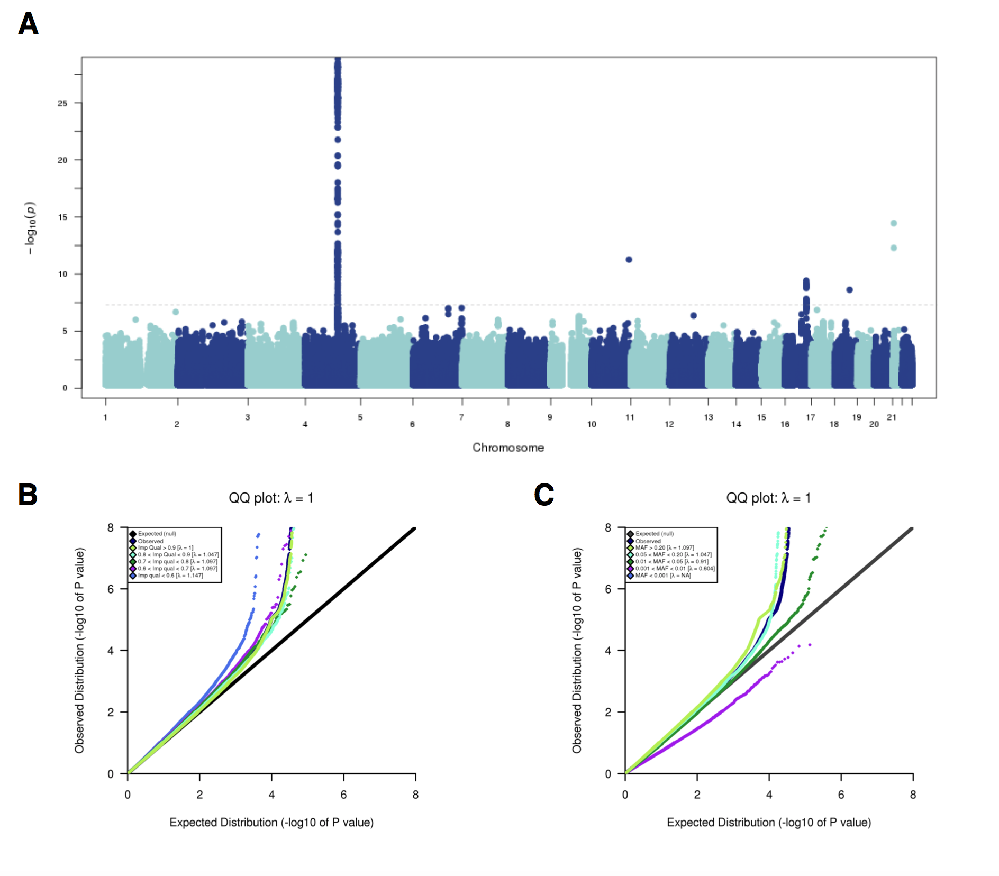

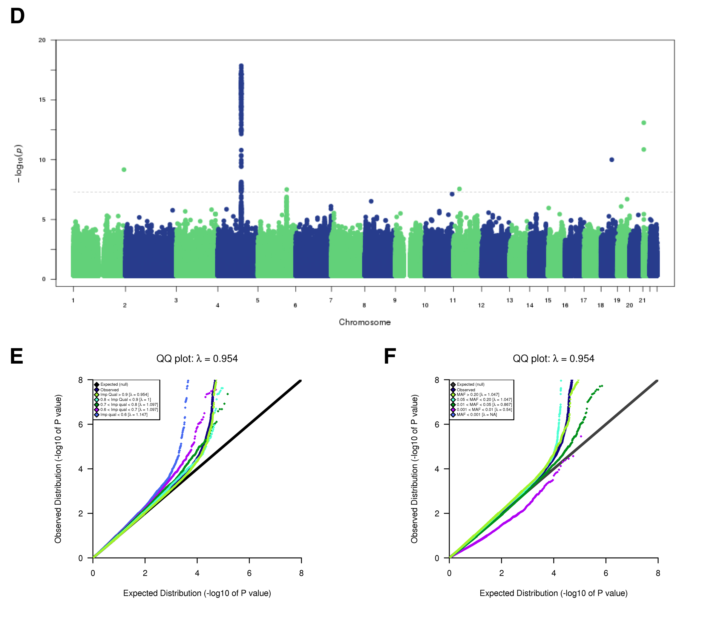

Supplementary Figure 2 | Genetic correlation and phenotypic correlation of atrial fibrillation and stroke subtypes in SiGN. (a) Using genome-wide SNP effects extracted from GWAS of atrial fibrillation, all stroke, and stroke subtypes, we calculated the Pearson’s correlation (r) between each pair of available phenotypes (blue indicates strong negative correlation; orange indicates strong positive correlation). Here, we show all correlations. Correlations are indicated by circle size in the upper half of the square, and the exact correlation values are shown in the lower half of the square.
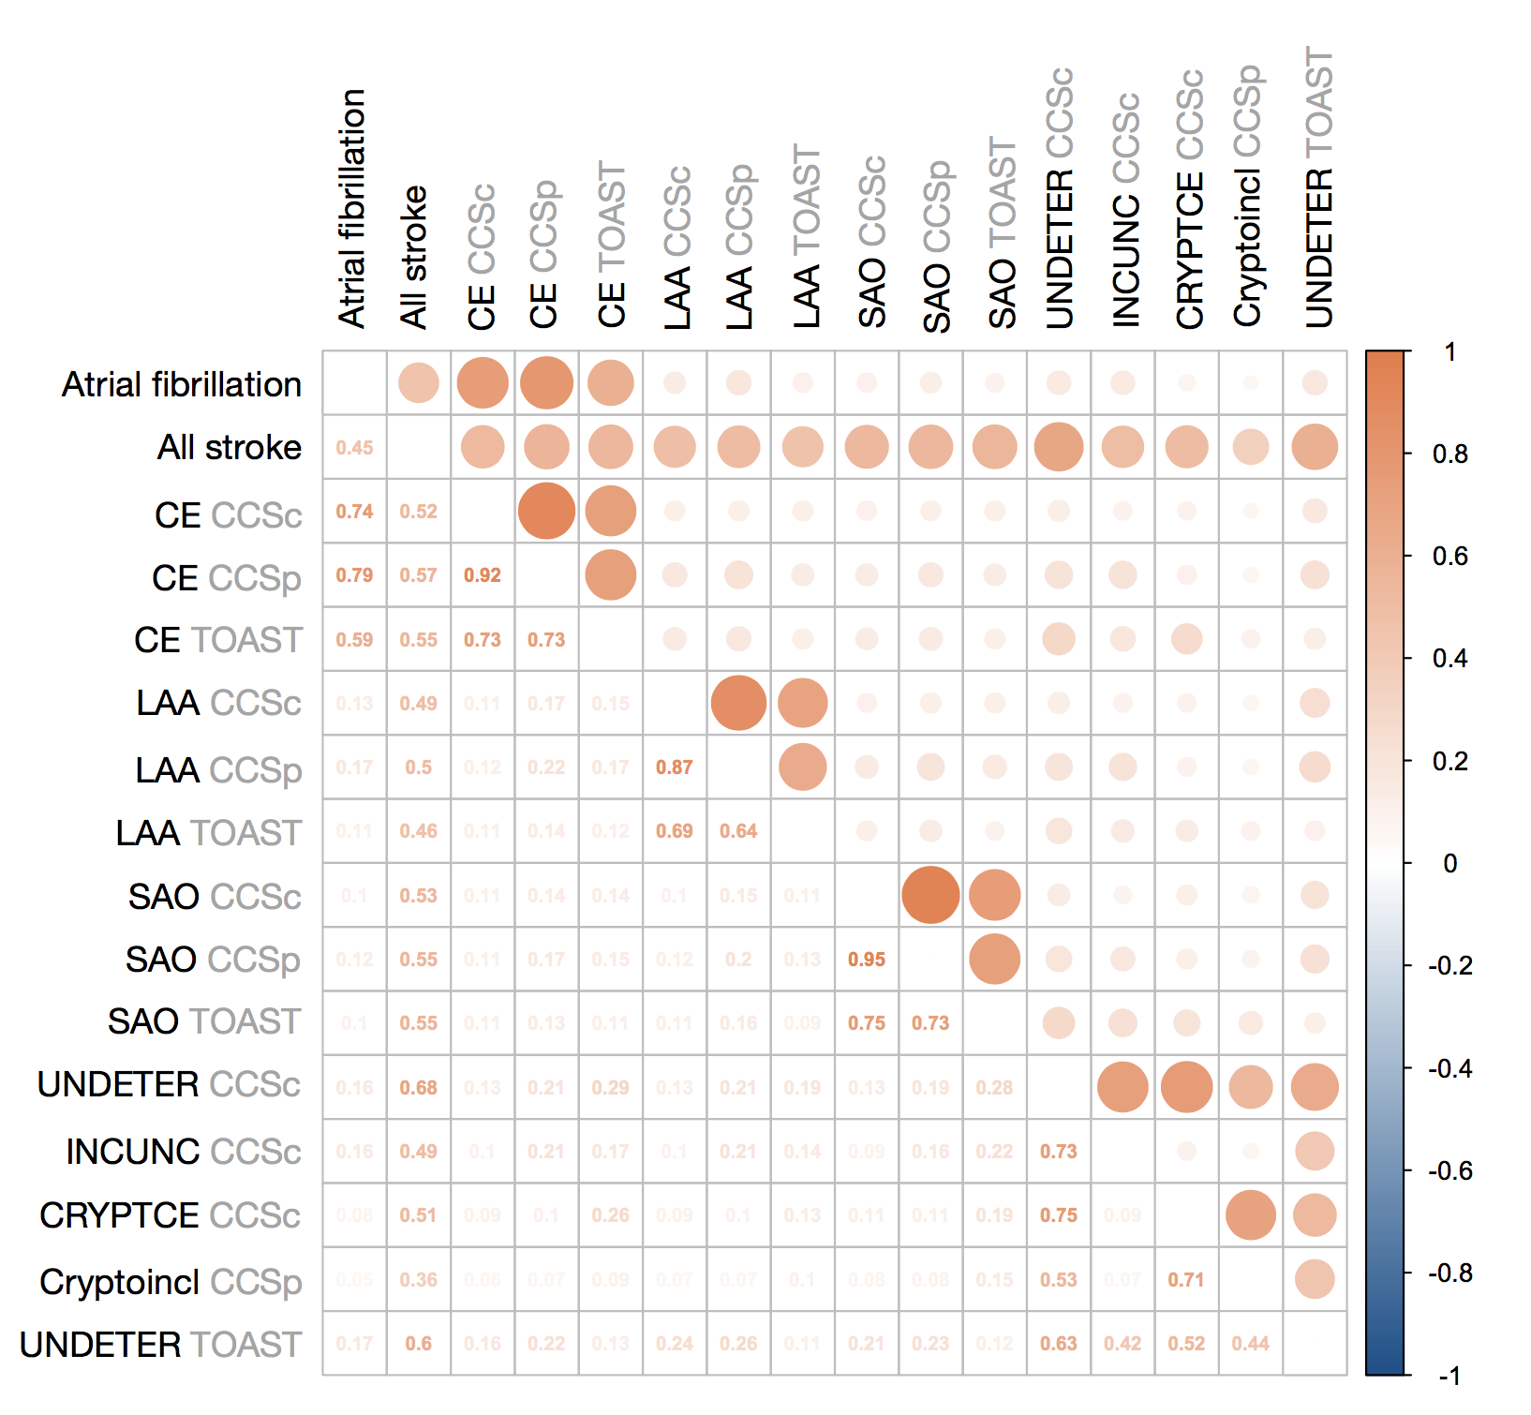
a.

CE, cardioembolic stroke; LAA, large artery atherosclerosis; SAO, small artery occlusion; UNDETER, undetermined; INCUNC, incomplete/unclassified; CRYPTCE, cryptogenic and CE minor; Cryptoincl, cryptogenic; CCSc, CCS Causative subtyping system; CCSp, CCS Phenotypic subtyping system; TOAST, TOAST subtyping system.

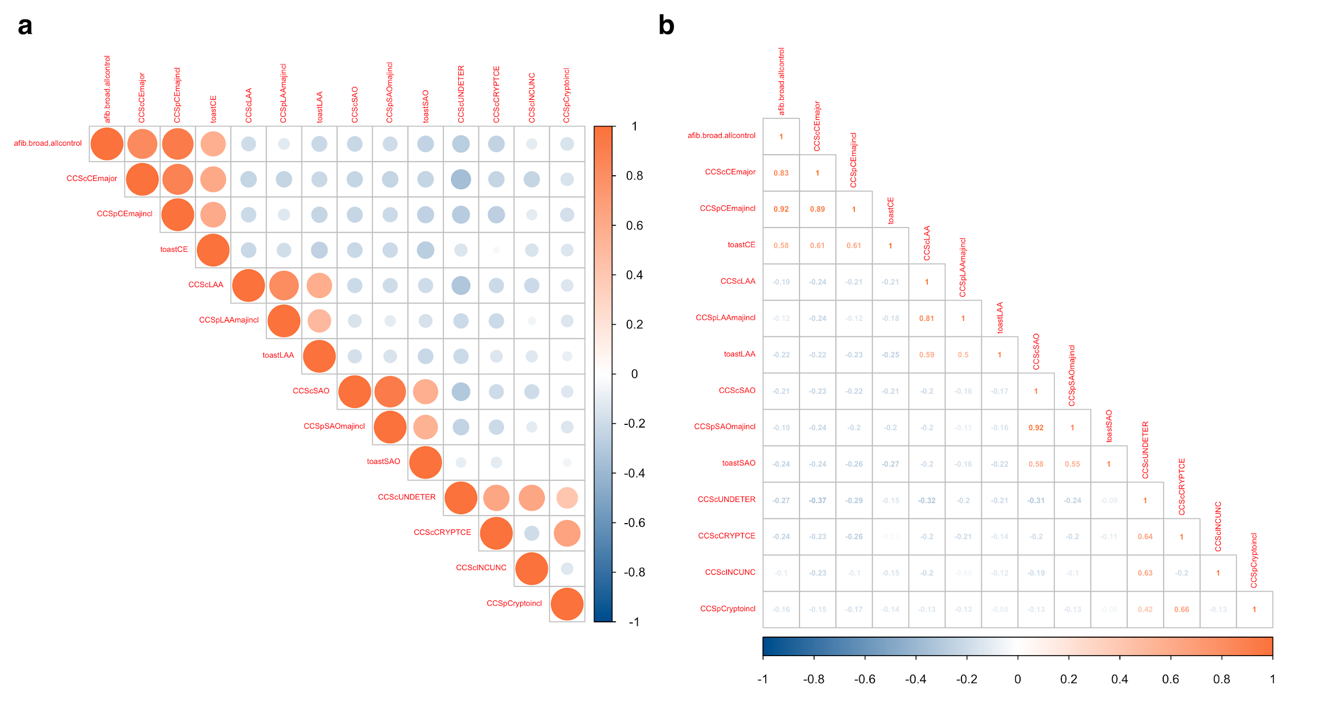
b. Same correlation calculations as in (a), but this time using the phenotypic data only (and looking in cases only, as all controls have the same phenotype). Note that the atrial fibrillation phenotypes and cardioembolic stroke phenotypes are highly correlated in the SiGN data (r = 0.83 between atrial fibrillation and cardioembolic stroke as determined by the CCS Causative subtype system).

CE, cardioembolic stroke; LAA, large artery atherosclerosis; SAO, small artery occlusion; UNDETER, undetermined; INCUNC, incomplete/unclassified; CRYPTCE, cryptogenic and CE minor; Cryptoincl, cryptogenic; CCSc, CCS Causative subtyping system; CCSp, CCS Phenotypic subtyping system; TOAST, TOAST subtyping system.
Supplementary Figure 3 | Genetic correlations between atrial fibrillation and ischemic stroke subtypes. To estimate genetic correlation between atrial fibrillation and ischemic stroke subtypes, we calculated Pearson's r between SNP z-scores in the AFGen GWAS of atrial fibrillation and in GWAS of ischemic stroke subtypes and atrial fibrillation performed here in the SiGN data. Here, we present data identical to that shown in Figure 2 of the main manuscript, but removing ±2Mb around the two most significant loci discovered in atrial fibrillation and cardioembolic stroke: the region around PITX2 (chromosome 4) and the region around ZFHX3 (chromosome 16). (a) Genome wide, atrial fibrillation in AFGen and in SiGN correlate with increasing strength as the z-score in AFGen increases. Educational attainment is included here as a null comparator. (b) Genetic signal in cardioembolic stroke also correlates strongly with atrial fibrillation genetic signal in AFGen, but we do not observe correlation between atrial fibrillation and the other primary stroke subtypes. (c) Removing the PITX2 and ZFHX3 regions leaves only somewhat modest correlation between the incomplete/unclassified undetermined subtype and atrial fibrillation. Panels (d-f) show underlying data.

Correlations restricted to those SNPs used in the polygenic risk score for atrial fibrillation were: AFGen vs atrial fibrillation in SiGN, r = 0.78; AFGen vs. cardioembolic stroke in SiGN, r = 0.75.

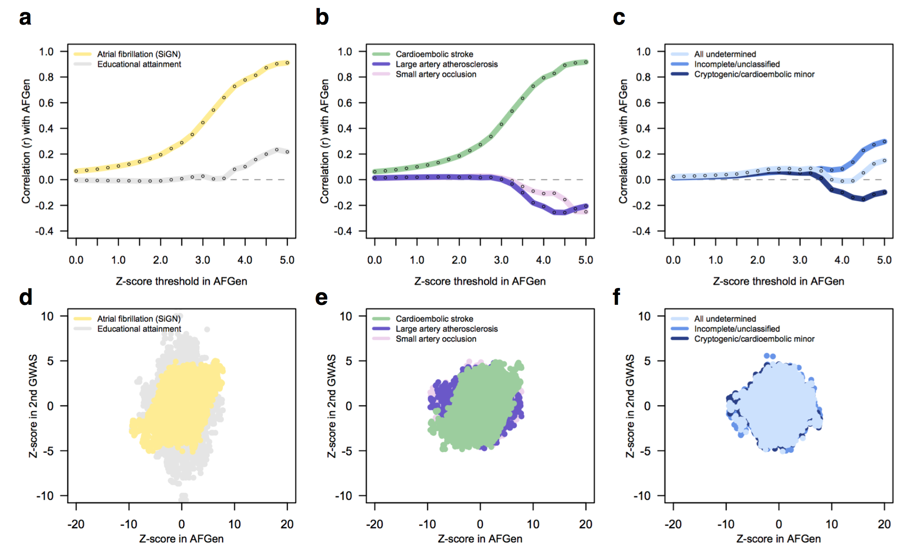
Supplementary Figure 4 | Estimated heritability of ischemic stroke subtypes and atrial fibrillation. Using all available stroke cases in SiGN, we estimated SNP-based heritability of the ischemic stroke subtypes (as sub-typed by the CCS Causative subtyping system) and atrial fibrillation (using the subset of 3,190 cases with atrial fibrillation) using BOLT-LMM and a genetic relationship matrix of high-quality SNPs converted to best-guess genotypes (imputation quality > 0.8, minor allele frequency > 0.01, and pruned at a linkage disequilibrium threshold of 0.2). We assumed a trait prevalence of 1% for all phenotypes. We found heritability estimates in cardioembolic stroke (green) and atrial fibrillation (yellow) to be approximately similar.
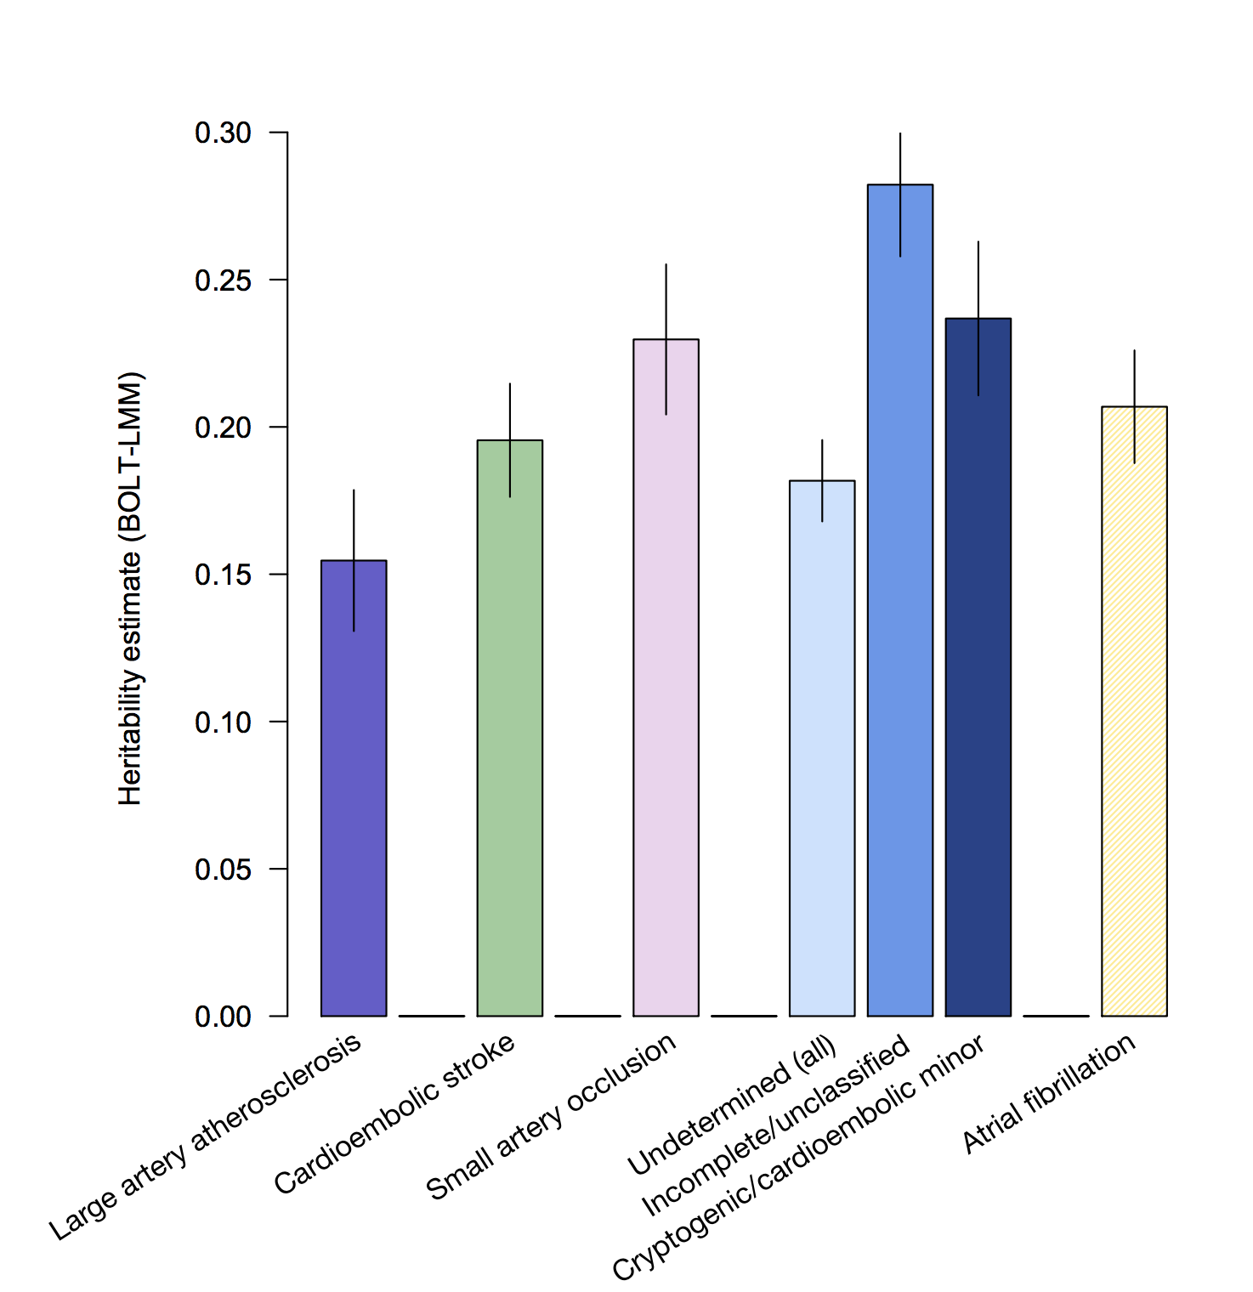

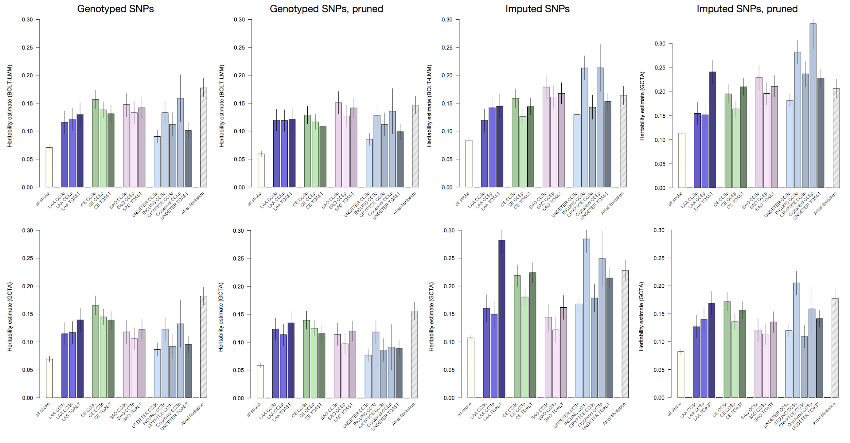
Supplementary Figure 5 | Heritability of ischemic stroke, its subtypes, and atrial fibrillation. We computed the SNP-based heritability of all stroke, all stroke subtypes, and atrial fibrillation using BOLT-LMM (top row) and GCTA (bottom row). All SNPs used for analysis had a minor allele frequency > 1% and imputation quality > 0.8 (for imputed SNPs). Imputed SNPs were converted to best-guess genotypes. We assumed a trait prevalence of 1% for all phenotypes and tested the robustness of $h_{g}^{2}$ estimates to SNPs included in the GRM by using four different GRMs: (a) genotyped SNPs only; (b) genotyped, pruned, and filtered (see Supplemental Methods); (c) imputed; and (d) imputed, pruned, and filtered. We converted the imputed SNPs to hard-call genotypes before performing heritability analyses. Estimates are shown below, including error bars. The underlying data for these figures are provided in Supplementary Table 3.

LAA, large artery atherosclerosis; CE, cardioembolic stroke; SAO, small artery occlusion; UNDETER, undetermined; INCUNC, incomplete/unclassified; CRYPTCE, cryptogenic and CE minor; Cryptoincl, cryptogenic; CCSc, CCS Causative subtyping system; CCSp, CCS Phenotypic subtyping system; TOAST, TOAST subtyping system.

Supplementary Figure 6 | Comparison of heritability estimates from BOLT-LMM and GCTA. We computed the heritability of all stroke, all stroke subtypes, and atrial fibrillation using BOLT-LMM and GCTA, as shown in Supplementary Figure 2. Below, you will find a comparison of the two methods, with BOLT-REML on the x-axis and GCTA estimates on the y-axis. Error bars are shown for the respective estimates.

AF, atrial fibrillation; CE, cardioembolic stroke; LAA, large artery atherosclerosis; SAO, small artery occlusion; UNDETER, undetermined; INCUNC, incomplete/unclassified; CRYPTCE, cryptogenic/CE minor; c, CCS Causative; p, CCS Phenotypic; t, TOAST.

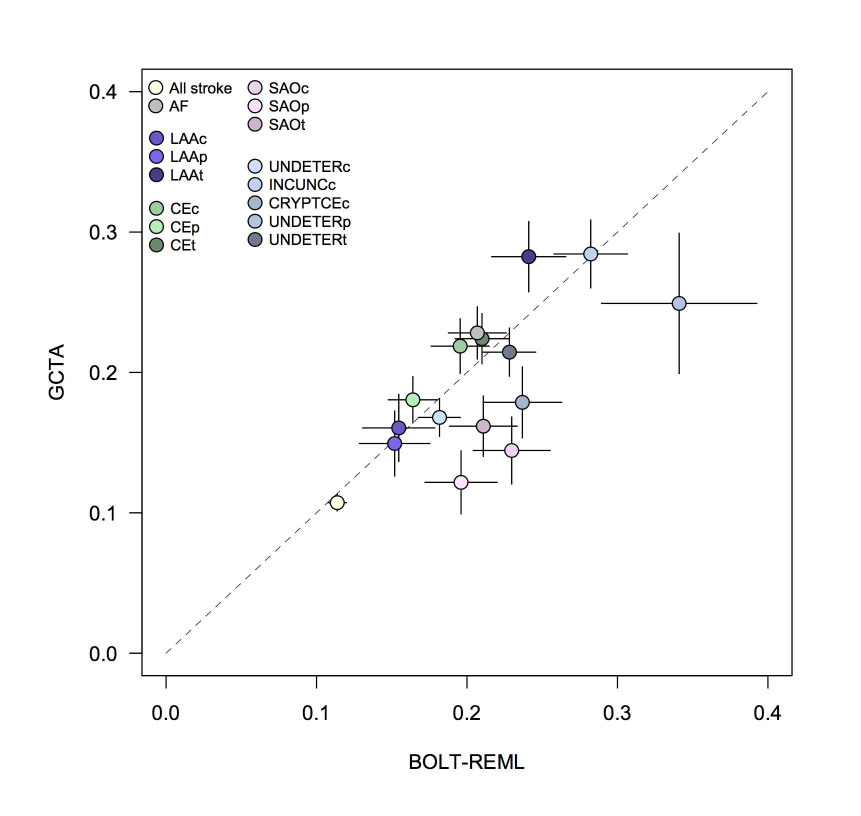

Supplementary Figure 7 | Association of atrial fibrillation polygenic risk score in ischemic stroke subtypes. We constructed a polygenic risk score (PRS) from atrial fibrillation-associated SNPs, and tested for association between the score and ischemic stroke subtypes using (a) all available controls (N = 28,026) and (b) controls without atrial fibrillation (N = 3,861). All subtypes from all available subtyping systems are shown here. The PRS strongly associated to cardioembolic stroke (subtypes highlighted in green font) in both sets of controls. In the atrial fibrillation-free set of controls (b) we observed nominal association of the PRS to incomplete/unclassified stroke. Undetermined subtypes are indicated in blue font.

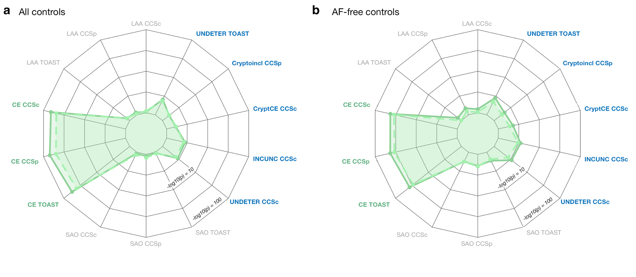
CE, cardioembolic stroke; LAA, large artery atherosclerosis; SAO, small artery occlusion; UNDETER, undetermined; INCUNC, incomplete/unclassified; CRYPTCE, cryptogenic and CE minor; Cryptoincl, cryptogenic; CCSc, CCS Causative subtyping system; CCSp, CCS Phenotypic subtyping system; TOAST, TOAST subtyping system.

Supplementary Tables

Supplementary Table 1 | Atrial fibrillation cases and controls available from the Stroke Genetics Network (SiGN) Consortium.

As classified by the CCS Causative system (note that this table is a repeat of Table 1 from the main manuscript):

Phenotype | Total | Cardioembolic | Large artery athero-  sclerosis | Small artery occlusion | Undetermined
 |  |  |  |  | Incomplete/  unclassified | Cryptogenic/  CE minor
Atrial fibrillation | 1,751 | 1,495 | 63 | 32 | 151 | 0
Paroxysmal atrial fibrillation | 1,315 | 1,088 | 52 | 23 | 138 | 0
Left atrial thrombus | 48 | 37 | 3 | 3 | 4 | 0
Sick sinus syndrome | 79 | 65 | 5 | 3 | 4 | 0
Atrial Flutter | 106 | 90 | 4 | 2 | 10 | 0
Total | 3,190 | 2,684 | 123 | 61 | 298 | 0

As classified by the CCS Phenotypic system (note that this system allows a case to be classified into more than one subtype):

Phenotype | Total | Cardioembolic | Large artery atherosclerosis | Small artery occlusion | Undetermined
Atrial fibrillation | 1,751 | 1,751 | 161 | 58 | 0
Paroxysmal atrial fibrillation | 1,315 | 1,315 | 126 | 61 | 0
Left atrial thrombus | 48 | 48 | 7 | 4 | 0
Sick sinus syndrome | 79 | 79 | 8 | 4 | 0
Atrial Flutter | 106 | 106 | 11 | 3 | 0
Total | 3,190 | 3,190 | 302 | 126 | 0

As classified by the TOAST system:

Phenotype | Total | Cardioembolic | Large artery atherosclerosis | Small artery occlusion | Undetermined
Atrial fibrillation | 1,751 | 1,254 | 26 | 23 | 170
Paroxysmal atrial fibrillation | 1,315 | 880 | 25 | 19 | 178
Left atrial thrombus | 48 | 35 | 1 | 1 | 9
Sick sinus syndrome | 79 | 48 | 0 | 1 | 13
Atrial Flutter | 106 | 75 | 2 | 3 | 12
Total | 3,190 | 2,207 | 54 | 47 | 371

Overlap of atrial fibrillation and cardioembolic stroke in the three subtyping systems in SiGN (CCSc, CCS Causative; CCSp, CCS Phenotypic; TOAST):

Phenotype | CCSc Cardioembolic | CCSp Cardioembolic | TOAST Cardioembolic
Atrial fibrillation | 1,495 | 1,751 | 1,254
Paroxysmal atrial fibrillation | 1,088 | 1,315 | 880
Left atrial thrombus | 37 | 48 | 35
Sick sinus syndrome | 65 | 79 | 48
Atrial Flutter | 90 | 106 | 75
No atrial fibrillation phenotypes | 316 | 418 | 903
Total | 3,000 | 3,608 | 3,333

Supplementary Table 2 | Look-up of previously-associated atrial fibrillation SNPs in SiGN. After performing a GWAS of atrial fibrillation in the SiGN data, we looked up the 26 known genetic risk loci for atrial fibrillation, as identified in the latest GWAS.¹ Twenty-four of the 25 signals present in the SiGN data were directionally consistent with the previous GWAS. The only signal not directionally consistent was discovered through eQTL analysis. One signal, a rare variant burden signal, was absent from our data (all SNPs here have allele frequency > 1%).

Supplementary Table 2 is provided as a separate, downloadable Excel spreadsheet as well as a tab-delimited text available at the project GitHub repository (download: https://github.com/saralpulit/Afib-Stroke-Overlap/blob/master/SupplementaryTable2.afib.hits.SiGN-lookup.txt). The first 14 columns are taken from Christophersen, et al.¹ Those columns are:

SNP single-nucleotide polymorphism; rs identifier
CHR chromosome
BP basepair (hg19)
Genes Closest gene(s)
Location Where the SNP resides relative to the listed gene
Risk Risk allele
Ref Reference allele
RAF Risk allele frequency
OR Odds ratio
CI95_1 95% confidence interval for the odds ratio (lower bound)
CI95_2 95% confidence interval for the odds ratio (upper bound)
Pval Association p-vlaue
Mean_imp Imputation quality
Analysis The analysis the variant or gene was discovered in (ExWAS,
expression QTL analysis; Meta, meta-analysis; RVAS, rare
variant association study)

The remaining columns provided are data points extracted from the atrial fibrillation GWAS in SiGN. They are:

SiGN_RAF Risk allele frequency in SiGN
SiGN_INFO Imputation quality (info score) in SiGN
SiGN_BOLT_BETA Beta of the SNP taken from BOLT-LMM; note that this is a beta
that results from a linear mixed model
SiGN_LIAB_BETA The beta, converted to the liability scale
SiGN_OR Odds ratio in SiGN
SiGN_SE Standard error of SIGN_BOLT_BETA
SiGN_P_BOLT P-value from BOLT-LMM (for the infinitesimal model only)

Supplementary Table 3 | Genetic correlations between atrial fibrillation and ischemic stroke subtypes. To estimate genetic correlation between atrial fibrillation and ischemic stroke subtypes, we calculated Pearson's r between SNP z-scores in the Atrial Fibrillation Genetics (AFGen) GWAS of atrial fibrillation and in GWAS of ischemic stroke subtypes and atrial fibrillation performed here in the SiGN data. The correlation calculations are provided in this table, which is split into two parts and is available to download in text format here:

Part A: correlations calculated across all genome-wide SNPs https://github.com/saralpulit/Afib-Stroke-Overlap/blob/master/SuppTable4.partA.SiGN.AFGen.trait.correlations.txt

Part B: correlations calculated across all genome-wide SNPs except those ±2Mb from the PITX2 and ZFHX3 index SNPs provided in Supplementary Table 2
https://github.com/saralpulit/Afib-Stroke-Overlap/blob/master/SuppTable4.partB.SiGN.AFGen.trait.correlations.drop-pitx2-zfhx3.txt

The headers of the two files are exactly the same:
Column | Definition
Z.threshold | Z-score threshold used to subset AFGen SNPs
EduYrs.Z | Correlation with z-scores from educational attainment GWAS
afib.broad.Z | Correlation with z-scores from atrial fibrillation (broadly defined phenotype) GWAS
allstroke.Z | Correlation with z-scores from all stroke GWAS
CCScCEmajor.Z | Correlation with z-scores from CCSc CE GWAS
CCScCRYPTCE.Z | Correlation with z-scores from CCSc CRYPTCE GWAS
CCScINCUNC.Z | Correlation with z-scores from CCSc INCUNC GWAS
CCScLAA.Z | Correlation with z-scores from CCSc LAA GWAS
CCScSAO.Z | Correlation with z-scores from CCSc SAO GWAS
CCScUNDETER.Z | Correlation with z-scores from CCSc UNDETER GWAS
CCSpCEmajincl.Z | Correlation with z-scores from CCSp CE GWAS
CCSpCryptoincl.Z | Correlation with z-scores from CCSp Cryptogenic GWAS
CCSpLAAmajincl.Z | Correlation with z-scores from CCSp LAA GWAS
CCSpSAOmajincl.Z | Correlation with z-scores from CCSp SAO GWAS
toastCE.Z | Correlation with z-scores from TOAST CE GWAS
toastLAA.Z | Correlation with z-scores from TOAST LAA GWAS
toastSAO.Z | Correlation with z-scores from TOAST SAO GWAS
toastUNDETER.Z | Correlation with z-scores from TOAST UNDETER GWAS

CCSc, CCS Causative subtyping system; CCSp, CCS Phenotypic subtyping system; TOAST, TOAST subtyping system; CE, cardioembolic stroke; LAA, large artery atherosclerosis; SAO, small artery occlusion; UNDETER, undetermined; INCUNC, incomplete/unclassified; CRYPTCE, cryptogenic and CE minor.
Supplementary Table 4 | Heritability calculations in atrial fibrillation and ischemic stroke subtypes. (a) We calculated the SNP-based heritability ($h_{g}^{2}$) of atrial fibrillation, all ischemic stroke, and the stroke subtypes using GCTA². All SNPs used had minor allele frequency > 1% and imputation quality > 0.8 (for imputed SNPs). Imputed SNPs were converted to best-guess genotypes. We assumed a trait prevalence of 1% for all phenotypes and tested the robustness of $h_{g}^{2}$ estimates to SNPs included in the GRM by using four different GRMs: (i) genotyped only; (ii) genotyped, pruned, and filtered (see Supplemental Methods); (iii) imputed; and (iv) imputed, pruned, and filtered. (b) We performed the exact same analysis but using BOLT-LMM to estimate $h_{g}^{2}$. BOLT-LMM estimates were converted to the liability scale (see Supplemental Methods).

Geno, genotyped; SE, standard error; CCSc, CCS Causative; CCSp, CCS Phenotypic

- $h_{g}^{2}$ estimates in GCTA

Subtype | Subtyping  system | Cases | Geno $h_{g}^{2}$ (SE) | Geno, filtered $h_{g}^{2}$ (SE) | Imputed h² (SE) | Imputed, filtered $h_{g}^{2}$ (SE)
Large artery athero-  sclerosis | CCSc | 2,385 | 0.115 (0.020) | 0.124 (0.020) | 0.127 (0.020) | 0.160 (0.024)
 | CCSp | 2,449 | 0.117 (0.020) | 0.113 (0.019) | 0.140 (0.020) | 0.149 (0.023)
 | TOAST | 2,318 | 0.139 (0.021) | 0.135 (0.021) | 0.169 (0.022) | 0.282 (0.025)
Cardio-  embolic | CCSc | 3,000 | 0.166 (0.017) | 0.139 (0.016) | 0.172 (0.017) | 0.219 (0.019)
 | CCSp | 3,608 | 0.145 (0.014) | 0.125 (0.014) | 0.136 (0.014) | 0.181 (0.016)
 | TOAST | 3,333 | 0.139 (0.015) | 0.115 (0.015) | 0.156 (0.016) | 0.224 (0.018)
Small artery occlusion | CCSc | 2,262 | 0.118 (0.021) | 0.114 (0.020) | 0.121 (0.021) | 0.144 (0.024)
 | CCSp | 2,419 | 0.106 (0.020) | 0.097 (0.019) | 0.114 (0.019) | 0.122 (0.022)
 | TOAST | 2,631 | 0.122 (0.019) | 0.120 (0.018) | 0.135 (0.019) | 0.162 (0.021)
Undeter-  mined | CCSc | 4,574 | 0.087 (0.012) | 0.077 (0.011) | 0.120 (0.012) | 0.168 (0.014)
 | CCSc (INCUNC) | 2,280 | 0.123 (0.021) | 0.118 (0.021) | 0.205 (0.022) | 0.284 (0.024)
 | CCSc (CRYPTCE) | 2,294 | 0.092 (0.021) | 0.086 (0.020) | 0.109 (0.021) | 0.179 (0.025)
 | CCSp | 1,096 | 0.132 (0.042) | 0.091 (0.040) | 0.159 (0.041) | 0.249 (0.050)
 | TOAST | 3,479 | 0.096 (0.015) | 0.089 (0.014) | 0.141 (0.015) | 0.214 (0.017)
-- | All stroke | 13,390 | 0.069 (0.005) | 0.059 (0.005) | 0.082 (0.005) | 0.107 (0.006)
-- | Atrial fibrillation | 3,190 | 0.182 (0.016) | 0.156 (0.015) | 0.178 (0.016) | 0.228 (0.019)

- $h_{g}^{2}$ estimates in BOLT-LMM

Subtype | Subtyping  system | Cases | Geno $h_{g}^{2}$ (SE) | Geno, filtered $h_{g}^{2}$ (SE) | Imputed h² (SE) | Imputed, filtered $h_{g}^{2}$ (SE)
Large artery athero-  sclerosis | CCSc | 2,385 | 0.116 (0.020) | 0.120 (0.020) | 0.120 (0.020) | 0.155 (0.024)
 | CCSp | 2,449 | 0.121 (0.020) | 0.119 (0.019) | 0.142 (0.020) | 0.152 (0.023)
 | TOAST | 2,318 | 0.130 (0.021) | 0.121 (0.020) | 0.145 (0.021) | 0.241 (0.025)
Cardio-  embolic | CCSc | 3,000 | 0.157 (0.017) | 0.129 (0.016) | 0.159 (0.017) | 0.195 (0.019)
 | CCSp | 3,608 | 0.138 (0.014) | 0.117 (0.014) | 0.127 (0.014) | 0.164 (0.016)
 | TOAST | 3,333 | 0.131 (0.015) | 0.108 (0.015) | 0.144 (0.015) | 0.210 (0.018)
Small artery occlusion | CCSc | 2,262 | 0.147 (0.021) | 0.151 (0.020) | 0.179 (0.022) | 0.230 (0.026)
 | CCSp | 2,419 | 0.133 (0.020) | 0.127 (0.019) | 0.161 (0.020) | 0.196 (0.024)
 | TOAST | 2,631 | 0.142 (0.019) | 0.142 (0.018) | 0.168 (0.019) | 0.211 (0.022)
Undeter-  mined | CCSc | 4,574 | 0.090 (0.012) | 0.086 (0.011) | 0.130 (0.012) | 0.182 (0.014)
 | CCSc (INCUNC) | 2,280 | 0.133 (0.021) | 0.118 (0.021) | 0.128 (0.021) | 0.282 (0.024)
 | CCSc (CRYPTCE) | 2,294 | 0.112 (0.021) | 0.112 (0.021) | 0.143 (0.021) | 0.237 (0.026)
 | CCSp | 1,096 | 0.159 (0.042) | 0.136 (0.041) | 0.213 (0.042) | 0.341 (0.052)
 | TOAST | 3,479 | 0.101 (0.015) | 0.099 (0.014) | 0.153 (0.015) | 0.228 (0.017)
-- | All stroke | 13,390 | 0.169 (0.012) | 0.059 (0.005) | 0.084 (0.005) | 0.114 (0.006)
-- | Atrial fibrillation | 3,190 | 0.169 (0.016) | 0.140 (0.015) | 0.156 (0.016) | 0.200 (0.018)

Supplementary Table 5 | Association between the atrial fibrillation polygenic risk score and ischemic stroke subtypes. We tested the association between a polygenic risk score (PRS) constructed from atrial fibrillation-associated SNPs and all stroke subtypes. The results of those association tests are shown here. We used two groups of controls: all available controls (N = 28,026 in the model without clinical covariates; N = 14,357 in the model with clinical covariates) and all controls that were free of atrial fibrillation (AF, N = 3,860 in the model without clinical covariates; N = 3,786 in the model with clinical covariates). All analyses were adjusted for sex and principal components (PCs). Regression analyses were optionally adjusted for clinical covariates (age, cardiovascular disease, type 2 diabetes status, smoking status, and hypertension).

Significant results (p = 0.0062, Bonferroni-corrected for four subtype groups and two independent subtyping classifications -- CCS and TOAST -- are bolded).

SE, standard error; CCSc, CCS Causative; CCSp, CCS Phenotypic; covar, covariates.

Large artery atherosclerosis (LAA):
All controls included in model without clinical covariates, N = 28,026; with clinical covariates, N = 14,357
Non-AF controls included in model without clinical covariates, N = 3,860; with clinical covariates, N = 3,786

Case definition | Control definition | Cases |  | Logistic regression, adjusted for PCs and sex |  |  | Logistic regression, adjusted for PCs, sex, and clinical covariates
 |  | w/out clinical covars | with clinical covars | Beta | SE | P-value | Beta | SE | P-value
CCSc LAA | Non-AF controls | 2,385 | 2,093 | 0.008 | 0.015 | 0.600 | 0.002 | 0.018 | 0.929
CCSc LAA | All controls | 2,385 | 2,093 | -0.002 | 0.012 | 0.885 | -0.004 | 0.013 | 0.786
CCSp LAA | Non-AF controls | 2,449 | 2,149 | 0.016 | 0.016 | 0.315 | 0.010 | 0.018 | 0.570
CCSp LAA | All controls | 2,449 | 2,149 | 0.004 | 0.011 | 0.694 | 0.002 | 0.013 | 0.850
TOAST LAA | Non-AF controls | 2,318 | 1,884 | 0.010 | 0.016 | 0.528 | 0.000 | 0.018 | 0.980
TOAST LAA | All controls | 2,318 | 1,884 | -0.006 | 0.012 | 0.594 | -0.008 | 0.014 | 0.550
Results after standardizing PRS to a z-score
CCSc LAA | Non-AF controls | 2,385 | 2,093 | 0.016 | 0.030 | 0.600 | 0.003 | 0.035 | 0.929
CCSc LAA | All controls | 2,385 | 2,093 | -0.003 | 0.022 | 0.885 | -0.007 | 0.026 | 0.786
CCSp LAA | Non-AF controls | 2,449 | 2,149 | 0.031 | 0.030 | 0.315 | 0.020 | 0.035 | 0.570
CCSp LAA | All controls | 2,449 | 2,149 | 0.009 | 0.022 | 0.694 | 0.005 | 0.026 | 0.850
TOAST LAA | Non-AF controls | 2,318 | 1,884 | 0.019 | 0.031 | 0.528 | -0.001 | 0.036 | 0.980
TOAST LAA | All controls | 2,318 | 1,884 | -0.012 | 0.023 | 0.594 | -0.016 | 0.027 | 0.550

Cardioembolic stroke (CE):
All controls included in model without clinical covariates, N = 28,026; with clinical covariates, N = 14,357
Non-AF controls included in model without clinical covariates, N = 3,860; with clinical covariates, N = 3,786

Case definition | Control definition (N) | Cases |  | Logistic regression, adjusted for PCs and sex |  |  | Logistic regression, adjusted for PCs, sex, and clinical covariates
 |  |  |  | Beta | SE | P-value | Beta | SE | P-value
CCSc CE | Non-AF (3,869) | 3,000 | 2,725 | 0.187 | 0.014 | 1.59E-42 | 0.218 | 0.018 | 1.40E-34
CCSc CE | All (28,026) | 3,000 | 2,725 | 0.169 | 0.010 | 1.01E-65 | 0.173 | 0.012 | 1.45E-48
CCSp CE | Non-AF (3,869) | 3,608 | 3,281 | 0.178 | 0.013 | 6.98E-43 | 0.203 | 0.017 | 8.34E-34
CCSp CE | All (28,026) | 3,608 | 3,281 | 0.161 | 0.009 | 2.43E-70 | 0.163 | 0.011 | 1.05E-49
TOAST CE | Non-AF (3,869) | 3,333 | 3,074 | 0.171 | 0.013 | 3.17E-37 | 0.172 | 0.015 | 3.22E-29
TOAST CE | All (28,026) | 3,333 | 3,074 | 0.149 | 0.009 | 3.00E-56 | 0.146 | 0.011 | 4.43E-41
Results after standardizing PRS to a z-score
CCSc CE | Non-AF (3,869) | 3,000 | 2,725 | 0.365 | 0.027 | 1.59E-42 | 0.425 | 0.035 | 1.40E-34
CCSc CE | All (28,026) | 3,000 | 2,725 | 0.329 | 0.019 | 1.01E-65 | 0.337 | 0.023 | 1.45E-48
CCSp CE | Non-AF (3,869) | 3,608 | 3,281 | 0.348 | 0.025 | 6.98E-43 | 0.397 | 0.033 | 8.34E-34
CCSp CE | All (28,026) | 3,608 | 3,281 | 0.315 | 0.018 | 2.43E-70 | 0.318 | 0.021 | 1.05E-49
TOAST CE | Non-AF (3,869) | 3,333 | 3,074 | 0.334 | 0.026 | 3.17E-37 | 0.335 | 0.030 | 3.22E-29
TOAST CE | All (28,026) | 3,333 | 3,074 | 0.291 | 0.018 | 3.00E-56 | 0.284 | 0.021 | 4.43E-41

Small artery occlusion (SAO):
All controls included in model without clinical covariates, N = 28,026; with clinical covariates, N = 14,357
Non-AF controls included in model without clinical covariates, N = 3,860; with clinical covariates, N = 3,786

Case definition | Control definition (N) | Cases |  | Logistic regression, adjusted for PCs and sex |  |  | Logistic regression, adjusted for PCs, sex, and clinical covariates
 |  |  |  | Beta | SE | P-value | Beta | SE | P-value
CCSc SAO | Non-AF (3,869) | 2,262 | 2,124 | 0.023 | 0.017 | 0.170 | 0.026 | 0.019 | 0.163
CCSc SAO | All (28,026) | 2,262 | 2,124 | 0.002 | 0.012 | 0.842 | 0.006 | 0.013 | 0.660
CCSp SAO | Non-AF (3,869) | 2,419 | 2,267 | 0.025 | 0.016 | 0.124 | 0.029 | 0.018 | 0.109
CCSp SAO | All (28,026) | 2,419 | 2,267 | 0.003 | 0.012 | 0.787 | 0.007 | 0.013 | 0.602
TOAST SAO | Non-AF (3,869) | 2,631 | 2,415 | 0.021 | 0.016 | 0.209 | 0.019 | 0.018 | 0.289
TOAST SAO | All (28,026) | 2,631 | 2,415 | 0.001 | 0.011 | 0.902 | 0.003 | 0.013 | 0.826
Results after standardizing PRS to a z-score
CCSc SAO | Non-AF (3,869) | 2,262 | 2,124 | 0.046 | 0.033 | 0.170 | 0.051 | 0.036 | 0.163
CCSc SAO | All (28,026) | 2,262 | 2,124 | 0.005 | 0.023 | 0.842 | 0.012 | 0.026 | 0.660
CCSp SAO | Non-AF (3,869) | 2,419 | 2,267 | 0.049 | 0.032 | 0.124 | 0.057 | 0.035 | 0.109
CCSp SAO | All (28,026) | 2,419 | 2,267 | 0.006 | 0.023 | 0.787 | 0.013 | 0.025 | 0.602
TOAST SAO | Non-AF (3,869) | 2,631 | 2,415 | 0.040 | 0.032 | 0.209 | 0.037 | 0.035 | 0.289
TOAST SAO | All (28,026) | 2,631 | 2,415 | 0.003 | 0.022 | 0.902 | 0.005 | 0.025 | 0.826

Undetermined strokes:
All controls included in model without clinical covariates, N = 28,026; with clinical covariates, N = 14,357
Non-AF controls included in model without clinical covariates, N = 3,860; with clinical covariates, N = 3,786

Case definition | Control definition (N) | Cases |  | Logistic regression, adjusted for PCs and sex |  |  | Logistic regression, adjusted for PCs, sex, and clinical covariates
 |  |  |  | Beta | SE | P-value | Beta | SE | P-value
CCSc UNDETER | Non-AF (3,869) | 4,574 | 4,169 | 0.036 | 0.013 | 0.004 | 0.031 | 0.014 | 0.022
CCSc UNDETER | All (28,026) | 4,574 | 4,169 | 0.021 | 0.009 | 0.013 | 0.021 | 0.010 | 0.030
CCSc INCUNC | Non-AF (3,869) | 2,280 | 2,093 | 0.046 | 0.016 | 0.003 | 0.045 | 0.017 | 0.010
CCSc INCUNC | All (28,026) | 2,280 | 2,093 | 0.028 | 0.012 | 0.015 | 0.029 | 0.013 | 0.025
CCSc CRYPTCE | Non-AF (3,869) | 2,294 | 2,076 | 0.030 | 0.016 | 0.051 | 0.026 | 0.017 | 0.124
CCSc CRYPTCE | All (28,026) | 2,294 | 2,076 | 0.015 | 0.012 | 0.212 | 0.017 | 0.013 | 0.192
CCSp Crypto | Non-AF (3,869) | 1,096 | 972 | 0.035 | 0.020 | 0.090 | 0.029 | 0.022 | 0.195
CCSp Crypto | All (28,026) | 1,096 | 972 | 0.019 | 0.016 | 0.258 | 0.021 | 0.018 | 0.245
TOAST UNDETER | Non-AF (3,869) | 3,479 | 3,216 | 0.033 | 0.013 | 0.015 | 0.028 | 0.014 | 0.055
TOAST UNDETER | All (28,026) | 3,479 | 3,216 | 0.021 | 0.010 | 0.027 | 0.022 | 0.011 | 0.042
Results after standardizing PRS to a z-score
CCSc UNDETER | Non-AF (3,869) | 4,574 | 4,169 | 0.071 | 0.025 | 0.004 | 0.061 | 0.027 | 0.022
CCSc UNDETER | All (28,026) | 4,574 | 4,169 | 0.041 | 0.017 | 0.013 | 0.041 | 0.019 | 0.030
CCSc INCUNC | Non-AF (3,869) | 2,280 | 2,093 | 0.090 | 0.030 | 0.003 | 0.088 | 0.034 | 0.010
CCSc INCUNC | All (28,026) | 2,280 | 2,093 | 0.055 | 0.023 | 0.015 | 0.056 | 0.025 | 0.025
CCSc CRYPTCE | Non-AF (3,869) | 2,294 | 2,076 | 0.059 | 0.030 | 0.051 | 0.051 | 0.033 | 0.124
CCSc CRYPTCE | All (28,026) | 2,294 | 2,076 | 0.028 | 0.023 | 0.212 | 0.033 | 0.025 | 0.192
CCSp Crypto | Non-AF (3,869) | 1,096 | 972 | 0.068 | 0.040 | 0.090 | 0.057 | 0.044 | 0.195
CCSp Crypto | All (28,026) | 1,096 | 972 | 0.036 | 0.032 | 0.258 | 0.041 | 0.035 | 0.245
TOAST UNDETER | Non-AF (3,869) | 3,479 | 3,216 | 0.064 | 0.026 | 0.015 | 0.054 | 0.028 | 0.055
TOAST UNDETER | All (28,026) | 3,479 | 3,216 | 0.042 | 0.019 | 0.027 | 0.042 | 0.021 | 0.042

UNDETER, undetermined; INCUNC, incomplete and unclassified; CRYPTCE, cryptogenic and CE minor; Crypto, cryptogenic

Supplementary Table 6 | Sensitivity analysis for the atrial fibrillation polygenic risk score. As a sensitivity analysis for the polygenic risk score (PRS), we constructed 3 additional PRSs, including SNPs +/- 25kb, +/- 50kb, and +/- 100kb from the SNPs included in the original score. All scores remain highly significant when tested for association with cardioembolic stroke (using a logistic regression model). P-values after additionally adjusting for clinical covariates are also shown. Clinical covariates: age, cardiovascular disease, type 2 diabetes status, smoking status, and hypertension.

PCs, principal components; MAF, minor allele frequency; INFO, imputation (info) score.

PRS SNPs | Filters | Total SNPs | PRS p-value
 |  |  | Adjusted for PCs, sex | Adjusted for PCs, sex, clinical covariates
Original SNPs | MAF > 1%  Info > 0.8 | 975 | 1.01 x 10⁻⁶⁵ | 1.44 x 10⁻⁴⁸
Original SNPs +/- 25kb | MAF > 1%  Info > 0.8 | 146,631 | 9.13 x 10⁻⁵⁰ | 1.32 x 10⁻³⁷
Original SNPs +/- 50kb | MAF > 1%  Info > 0.8 | 258,870 | 5.76 x 10⁻⁴⁸ | 1.40 x 10⁻³⁶
Original SNPs +/- 100kb | MAF > 1%  Info > 0.8 | 462,146 | 4.47 x 10⁻⁴⁴ | 1.77 x 10⁻³²

Supplementary Table 7 | Clinical covariates available in the SiGN data. We adjusted our analyses of a polygenic risk score for a series of clinical covariates that are associated with atrial fibrillation. Summary-statistics on these covariates are shown below for those samples classified as (a) cardioembolic stroke or (b) undetermined stroke. The number of samples with missing data are provided in parentheses where relevant.

Cardioembolic

Phenotype | CCS Causative | CCS Phenotypic | TOAST
Female | 1,588 | 1,859 | 1,618
Male | 1,247 | 1,541 | 1,520
Age: mean (sd) | 74.7 (12.4) | 74.5 (12.3) | 71.0 (15.1)
Hypertensive (missing) | 2,195 (18) | 2,665 (21) | 2,272 (16)
Diabetes mellitus (missing) | 763 (26) | 950 (29) | 799 (8)
CAD (missing) | 989 (64) | 1206 (83) | 911 (119)
Smoking  Current  Former  Never | 379  694  1,737 | 468  865  2,055 | 513  776  1,905
Total | 3,000 | 3,608 | 3,333

Undetermined

Phenotype | CCS Causative | CCS Causative | CCS Causative | CCS Phenotypic | TOAST
Female | 1,880 | 1,024 | 856 | 420 | 1,445
Male | 2,151 | 1,014 | 1,137 | 543 | 1,635
Age: mean (sd) | 63.9 (15.4) | 67.7 (13.9) | 69.0 (15.9) | 58.9 (15.7) | 63.7 (16.1)
Hypertensive (missing) | 2,833 (23) | 1,512 (14) | 1,321 (9) | 612 (3) | 2,110 (29)
Diabetes mellitus (missing) | 958 (26) | 513 (14) | 445 (12) | 202 (4) | 708 (25)
CAD (missing) | 739 (169) | 421 (86) | 318 (83) | 115 (46) | 573 (100)
Smoking  Current  Former  Never | 1,090  1,050  2,202 | 582  516  1,081 | 508  534  1,121 | 239  235  548 | 813  772  1,711
Total | 4,574 | 2,280 | 2,294 | 1,096 | 3,479
Supplementary Table 8: Variance explained by the atrial fibrillation polygenic risk score in cardioembolic stroke. To determine the variance explained by the atrial fibrillation polygenic risk score (PRS) in cardioembolic stroke, we constructed a model in BOLT-LMM that consisted of two variance components: (1) a variance component made up of SNPs for the genetic relationship matrix, and (2) a variance component made up of SNPs from the PRS. After computing the estimated variance explained for each component in BOLT-LMM, we converted the estimate to the liability score. Below is variance explained for each of the cardioembolic stroke phenotypes as determined by the three subtyping systems available in SiGN: CCS Causative, CCS Phenotypic, and TOAST. Standard errors of each estimate appear in parentheses. Explained variance is shown for a PRS including the PITX2 (chromosome 4) and ZFHX3 (chromosome 16) loci, as well as excluding ±2Mb around these loci (see https://github.com/UMCUGenetics/Afib-Stroke-Overlap for lists of SNPs that fall in these regions). Because a large number of SNPs is needed to construct a variance component to calculate variance explained, we performed the calculation using the atrial fibrillation PRS including SNPs ±100kb from the original PRS SNPs, and then pruning SNPs a linkage disequilibrium of 0.2.

CE, cardioembolic; PRS, polygenic risk score; AF, atrial fibrillation

Subtyping System | $h_{g}^{2}$ CE stroke | $h_{g}^{2}$ atrial fibrillation PRS ±100kb | Proportion of CE $h_{g}^{2}$ explained by AF PRS
PRS including the PITX2 and ZFHX3 loci
CCSc | 0.195 (0.019) | 0.045 (0.010) | 23.1%
CCSp | 0.164 (0.016) | 0.040 (0.008) | 24.4%
TOAST | 0.210 (0.018) | 0.051 (0.01) | 24.3%
PRS excluding the PITX2 and ZFHX3 loci
CCSc | 0.195 (0.019) | 0.037 (0.010) | 19.0%
CCSp | 0.164 (0.016) | 0.032 (0.008) | 19.5%
TOAST | 0.210 (0.018) | 0.044 (0.009) | 21.0%

Supplementary Methods

GitHub repository and data availability

- GitHub repository and additional supporting data

Relevant code for the analyses performed in this paper can be found here: https://github.com/saralpulit/Afib-Stroke-Overlap.

This repository primarily consists of:

Call to BOLT-LMM to run GWAS
Call to GCTA and BOLT-LMM to calculate heritability
Call to PLINK^{3,4} to calculate the polygenic risk score (PRS)
An R script for converting observed heritability in BOLT-LMM to the liability scale (see below)
A script in R to check association between the PRS and various phenotypes.
A call to PLINK^{3,4} to calculate a GRM to run GCTA
Sample identifiers for those individuals analyzed in this paper
SNP identifiers and weights for those markers included in the construction of the polygenic risk score

A complete README accompanies the GitHub repository.

- Sample and SNP identifiers used in these analyses

A file containing:

the dbGaP sample identifiers
the cohort the sample is drawn from
the continental group the sample is in (as determined in the first SiGN GWAS effort⁵)
a list of quality control-passing SNPs used in the initial GWAS

is available on this paper’s GitHub repository.

- Downloadable summary-level genome-wide association study data

The summary-level data from the original SiGN GWAS has been made publicly available through the Cerebrovascular Disease Knowledge Portal, which can be accessed here: http://www.cerebrovascularportal.org/

These summary-level results are available for cardioembolic stroke (CE), large artery atherosclerosis (LAA), small artery occlusion (SAO), and undetermined (UNDETER) stroke, for three different subtyping systems (TOAST, CCS Causative, CCS Phenotypic).

The summary-level results for the atrial fibrillation genome-wide association studies (performed in broadly-defined or strictly-defined cases versus all controls) are available here:

Broadly-defined atrial fibrillation cases vs. all referents:
https://doi.org/10.5281/zenodo.1035871

Strictly-defined atrial fibrillation cases vs. all referents:
https://doi.org/10.5281/zenodo.1035873

The Stroke Genetics Network (SiGN) and genome-wide association study of ischemic stroke subtypes

The full list of cohorts that are included in the SiGN genome-wide association study can be found in the Supplementary Material of “Loci associated with ischaemic stroke and its subtypes (SiGN): a genome-wide association study,”⁵ which can be accessed here: https://paperpile.com/shared/nvNXQf.

SiGN is comprised of several case cohorts with pre-existing genotyping data. Newly-collected cases, as well as a small number of matched referents, were genotyped on the Illumina 5M array⁶. The majority of referents included were drawn from publicly-available genotyping data.

- Referent (control) datasets

Referent datasets downloaded from the Database of Genotypes and Phenotypes (dbGaP) are:

 | dbGAP accession #
Genetics Resource with the Health and Retirement Study | phs000428.v2.p2
Whole Genome Association Study of Visceral Adiposity in the HABC study | phs000169.v1.p1

- Case datasets

A large number of cases and a small number of controls (from Belgium and Poland) were genotyped at the initiation of the SiGN GWAS. These data have been uploaded to dbGaP and are available here:

The National Institute of Neurological Disorders and Stroke (NINDS) Stroke Genetics Network (SiGN) (phs000615.v1.p1)

- Phenotyping in SiGN

There are three primary subtype definitions of ischemic stroke: cardioembolic stroke, large artery atherosclerotic stroke, and small artery occlusion. The SiGN consortium used the CCS system to attempt to assign each case to one of these three categories. Additionally, ~74% of cases were also classified using the Trial of Org 10 172 in Acute Stroke Treatment (TOAST)^{7,8} system, which classifies stroke cases based on clinical decision-making and clinically-ascertained information. The CCS and TOAST subtyping systems yield moderately-to-strongly correlated phenotyping results (Supplementary Figure 5)⁹. Use of these traits in a GWAS setting also yields concordant association results, as previously shown ⁶. These subtypes are similarly defined in CCS and TOAST, though determined differently across the two subtyping systems.

In addition to the three primary subtypes, both the CCS and TOAST classification systems generate two additional subtypes: “undetermined” and “other.” The “other” classification was small in sample size (N_{cases} = 595, 719 and 374 in CCS Causative, CCS Phenotypic and TOAST, respectively), and was therefore not included in the original SiGN GWAS and was not tested here⁶. The “undetermined” classification, though named the same in CCS and TOAST, is defined differently across the two subtyping systems^{8,10}. In TOAST, patients with conflicting subtype classifications are placed in the undetermined category^{6,8}. In contrast, the CCS undetermined classification includes patients with cryptogenic embolism, other cryptogenic cases, patients with an incomplete evaluation, or samples with competing subtypes¹⁰.

- Brief summary of data quality control in SiGN

SiGN samples represent three continental populations (European-ancestry; African-ancestry; and non-European ancestry and non-African ancestry samples, primarily of admixed ancestry from Latin American populations, labelled ‘Hispanic’). In total, the study contains 13 case-referent analysis groups: 10 of European ancestry, two of African ancestry, and one Hispanic⁶.

For quality control (QC) and downstream association testing, cases and referents were matched by genotyping array and PCA-determined ancestry. European-ancestry samples were imputed with IMPUTE2¹¹ using a reference panel built from whole-genome sequence data collected by the 1000 Genomes Project (Phase 1)¹² and the Genome of the Netherlands¹³ project; African-ancestry and Hispanic samples were imputed with the 1000 Genomes Project data only.¹² Due to data-sharing restrictions regarding the referents used for the Hispanic set of samples, only the European- and African-ancestry samples were analyzed here, totaling 13,390 cases and 28,026 referents distributed across 12 case-control analysis groups.

Before performing genome-wide association testing, for those SNPs that were genotyped in a subset of the SiGN study strata but imputed in others, we compared the frequency of the SNP across the various strata. We removed any SNP with a frequency difference > 15% within ancestral group or >50% across ancestral groups comparing imputed and genotyped data, likely induced by sequencing errors in the imputation reference panel(s).

Constructing a genetic relationship matrix for genome-wide association testing in BOLT-LMM

To construct the genetic relationship matrix (GRM) implemented in BOLT-LMM, we used SNPs that were (i) common (MAF > 5%), (ii) with missingness < 5%, (iii) linkage disequilibrium (LD) pruned at an r² threshold of 0.2, (iv) on the autosomal chromosomes only, (v) and not in stratified areas of the genome (i.e., not in the major histocompatibility complex (MHC), the inversions on chromosomes 8 and 17, or in the lactase (LCT) locus on chromosome 2). After association testing, we additionally removed SNPs with imputation quality (info score) < 0.8, due to excess inflation of the test statistic in those SNPs (Supplementary Figure 1).
Running a genome-wide association study using BOLT-LMM

We implemented a linear mixed model to perform association testing using BOLT-LMM.¹⁴ Linear mixed models can account for structure in the data, such as that due to (familial or cryptic) relatedness and population structure, while improving power for discovery.^{15–17} Due to extensive structure in the SiGN data,⁶ induced by both study design and population ancestry, we adjusted the BOLT-LMM model for the top ten principal components (PCs) and sex, in addition to the genetic relationship matrix used as a random effect in the linear mixed model.¹⁴ We calculated PCs in EIGENSTRAT¹⁸ using a similar set of SNPs to that used in the genetic relationship matrix but using a missingness threshold of 0.1%. To construct the GRM, we first identified the set of SNPs with imputation quality > 0.8 and MAF > 1%. More than 5.5M SNPs passed these QC criteria, so we randomly selected 20% of the data (~1.1M SNPs) for computational efficiency in calculating the GRM. We also identified SNPs outside the MHC and LCT regions, outside the inversions on chromosomes 8 and 17, and LD pruned (r² = 0.2). These filtering steps resulted in ~250,000 SNPs available for the GRM. We used Plink 1.9^{3,4} to convert imputed dosages to best-guess genotypes and then compute the GRM.

SNP-based heritability calculations in GCTA and BOLT-LMM

We used the GRM from our GWAS analyses (described in the section above) to estimate heritability. We adjusted all heritability analyses for 10 PCs and sex. To test the robustness of our heritability estimates, we calculated three additional GRMs to re-estimate heritability, and additionally estimated heritability using a second software (GCTA²).

To check the robustness of the heritability calculations to the SNPs included in the GRM, we calculated heritability using the GRM described above, as well as three additional GRMs: (i) using the ~1.1M SNPs with imputation quality > 0.8 and MAF > 1% (and without LD pruning); (ii) using the SNPs that were genotyped across all study strata (~155,000 SNPs); and (iii) the set of genotyped SNPs with the MHC, LCT locus, inversions on chromosomes 8 and 17 removed, and LD pruned at r² = 0.2.

Additionally, we computed heritability in GCTA² using the same GRMs and assuming a trait prevalence of 1%. We compared the results to the BOLT-based $h_{g}^{2}$ estimates (Supplementary Table 3 and Supplementary Figures 2-3). As genome-wide heritability estimates need a large number of SNPs to be accurate, we report in the paper all estimates using a GRM containing imputed, pruned SNPs. Estimates resulting from all GRMs are presented here, in the Supplementary Information.

To test the effect of changing the GRM (referred to by the --bfile and ‘modelSNPs’ option in BOLT-LMM), we selected SNPs for the GRM in four ways:

- Genotyped SNPs only (minor allele frequency > 1%) (115,553 SNPs total)

- Genotyped SNPs, pruned at a linkage disequilibrium threshold (r2 threshold) of 0.2, and removing the MHC, LCT locus, and two chromosomal inversions. (60,432 SNPs total)

- Imputed SNPs (minor allele frequency > 1% and imputation info > 0.8) converted to best-guess genotypes. (1,128,985 SNPs total)

- Imputed SNPs (minor allele frequency > 1% and imputation info > 0.8); pruned at a linkage disequilibrium threshold (r2 threshold) of 0.2; removing the MHC, LCT locus, and two chromosomal inversions; and converted to best-guess genotypes. (250,209 SNPs total)

The GRM in (4) is the GRM used for all heritability results presented in the main manuscript.

As calculating GRMs in GCTA can be extremely computationally intensive, we calculated the GRMs using PLINK 1.9 and then used those GRMs to estimate heritability. A script that shows how to do this is included in the GitHub repository noted above.

The genomic locations (hg19) for excluded markers are as follows:

The lactase (LCT) locus | Chromosome 2  positions 129,883,530 - 140,283,530
The major histocompatibility complex (MHC) | Chromosome 6  positions 24,092,021 - 38,892,022
Inversion 1 | Chromosome 8  positions 6,612,592 - 13,455,629
Inversion 2 | Chromosome 17  positions 40,546,474 - 44,644,684
All non-autosomal SNPs | --

BOLT-LMM produces heritability estimates on the observed scale. To convert to the liability scale (i.e., the scale on which GCTA produces heritability estimates) we performed a conversion in R. Running the conversion requires knowing the trait prevalence, total cases analyzed, total controls analyzed, and the heritability on the observed scale. This code snippet is available in the accompanying GitHub repository for this paper.

Quality control in genome-wide data for correlation calculations

We used summary-level data from the latest Atrial Fibrillation Genetics (AFGen) Consortium meta-analysis of atrial fibrillation¹ to calculate a z-score for each SNP in that GWAS. Additionally, we calculated a z-score for each SNP in a GWAS of each stroke subtype in SiGN as well as in the GWAS of atrial fibrillation we performed in the SiGN data. Finally, as a null comparator, we downloaded SNP z-scores from a GWAS of educational attainment¹⁹ available through LDHub (http://ldsc.broadinstitute.org/, accessed 11-1-2017). We aligned z-score signs based on the risk allele reported in each study. SNPs with an allele frequency difference >5% between AFGen and SiGN (all stroke analysis) were removed from the AFGen data (25,784 SNPs); similarly, SNPs with an allele frequency difference >5% between the educational attainment GWAS and SiGN (all stroke) were also removed (27,866 SNPs). Finally, we calculated Pearson’s r between z-scores from two traits to evaluate correlation.

Constructing an atrial fibrillation polygenic risk score

To construct an atrial fibrillation polygenic risk score (PRS), we used SNPs from a previously-derived atrial fibrillation PRS.²⁰ Briefly, the PRS was derived using results from a recent GWAS of atrial fibrillation, comprised of 17,931 cases and 115,142 referents¹ and testing various sets of SNPs based on their p-value from that GWAS (varying from p < 5 x 10⁻⁸ to p < 0.001) and using varied linkage disequilibrium thresholds (0.1 - 0.9).²⁰ These sets of SNPs were used to generate various PRSs, which were then independently tested for association to atrial fibrillation in an independent sample from the UK Biobank; the best-performing PRS (defined as the PRS with the lowest Akaike’s Information Criterion) comprised 1,168 SNPs with p < 1 x 10⁻⁴ in the atrial fibrillation GWAS and LD pruned at an r² threshold of 0.5.²⁰

Of these 1,168 SNPs, we identified 934 SNPs in the SiGN dataset with imputation info > 0.8 and MAF > 1%. We used these 934 SNPs to construct the atrial fibrillation PRS in the SiGN dataset by weighting the imputed number of risk-increasing alleles carried by an individual at a given SNP (i.e., 0-2 risk-increasing alleles) and then weighting the dosage by the effect of the allele, as determined by the most recent GWAS.¹ We computed the final PRS for each individual by summing across all of the weighted genotypes and performed association testing in R.

We calculated the odds ratio of the PRS for an increase of one standard deviation in the score by first converting the PRS per individual to a z-score, where:

PRS_{z-score} = $\frac{PRS - mean(PRS)}{standard deviation(PRS)}$

We then recalculated the association between PRS_{z-score} and the phenotype, and converted the resulting regression coefficients (i.e., betas) of the PRS to odds ratios.

To ensure that our analyses of the PRS were robust to ancestral heterogeneity, we additionally tested the PRS in the subset of European-ancestry samples only (the data were essentially identical to our finding in the complete sample and are therefore not provided).

Supplementary Results

Including age as a covariate in the GWAS of atrial fibrillation

To check for the effects of age on our initial GWAS findings, we ran a GWAS of atrial fibrillation including age as a covariate. Controls without age information were dropped from this analysis. Given the structure of the SiGN dataset -- which includes groups of cases and controls that have been carefully matched on genotyping array and ancestry -- we also dropped the cases for which their matched controls were missing age information.

Our age-adjusted analysis included 2,487 atrial fibrillation cases and 22,072 controls. We performed the GWAS in BOLT-LMM, adjusting for 10 PCs, sex and age. We then checked the correlation between the SNP effects (betas) from the GWAS unadjusted for age and the SNP effects from the GWAS adjusted for age. Correlation was strong (r = 0.83).

Appendix I

Members of the Atrial Fibrillation Genetics (AFGen) Consortium

Please note that the AFGen Consortium participants evolve over time. Further
information on the AFGen Consortium can be found at www.afgen.org.

Ingrid E. Christophersen, MD, PhD^{1–3}
Michiel Rienstra, MD, PhD⁴
Carolina Roselli, MSc^{1,5,6}
Xiaoyan Yin, PhD^{7,8}
Bastiaan Geelhoed, PhD⁴
John Barnard, PhD⁹
Honghuang Lin, PhD^{7,8}
Dan E. Arking, PhD¹⁰
Albert V. Smith, PhD^{11,12}
Christine M. Albert, MD, MPH¹³
Mark Chaffin, MSc¹
Nathan R. Tucker, PhD^{1,2}
Molong Li, MD²
Derek Klarin, MD¹
Nathan A Bihlmeyer, BS,¹⁴
Siew-Kee Low, PhD¹⁵
Peter E. Weeke, MD, PhD^{16,17}
Martina Müller-Nurasyid, PhD^{5,18,19}
J. Gustav Smith, MD, PhD^{1,20}
Jennifer A. Brody, BA²¹
Maartje N. Niemeijer MD²²
Marcus Dörr, MD^{23,24}
Stella Trompet, PhD²⁵
Jennifer Huffman, PhD²⁶
Stefan Gustafsson, PhD²⁷
Claudia Schurmann, PhD^{28,29}
Marcus E. Kleber, PhD³⁰
Leo-Pekka Lyytikäinen, MD³¹
Ilkka Seppälä, MD³¹
Rainer Malik, PhD³²
Andrea R. V. R. Horimoto, PhD³³
Marco Perez, MD³⁴
Juha Sinisalo, MD, PhD³⁵
Stefanie Aeschbacher, MSc^{36,37}
Sébastien Thériault, MD, MSc^{38,39}
Jie Yao, MS⁴⁰
Farid Radmanesh, MD, MPH^{1,41}
Stefan Weiss, PhD^{24,42}
Alexander Teumer, PhD^{24,43}
Seung Hoan Choi, PhD¹
Lu-Chen Weng, PhD^{1,2}
Sebastian Clauss, MD^{2,18}
Rajat Deo, MD, MTR⁴⁴
Daniel J. Rader, MD⁴⁴
Svati Shah, MD, MHS,⁴⁵
Albert Sun, MD⁴⁵
Jemma C. Hopewell, PhD⁴⁶
Stephanie Debette, MD, PhD^{47–50}
Ganesh Chauhan, PhD^{47,48}
Qiong Yang, PhD⁵¹
Bradford B. Worrall, MD, MSc⁵²
Guillaume Paré, MD, MSc^{38,39}
Yoichiro Kamatani, MD, PhD¹⁵
Yanick P. Hagemeijer, MSc⁴
Niek Verweij, PhD⁴
Joylene E. Siland, BSc,⁴
Michiaki Kubo, MD, PhD⁵³
Jonathan D. Smith, PhD⁹
David R. Van Wagoner, PhD⁹
Joshua C. Bis, PhD²¹
Siegfried Perz, MSc⁵⁴
Bruce M. Psaty, MD, PhD^{21,55–57}
Paul M. Ridker, MD, MPH¹³
Jared W. Magnani, MD, MSc^{7,58}
Tamara B. Harris, MD, MS⁵⁹
Lenore J. Launer, PhD⁵⁹
M. Benjamin Shoemaker, MD, MSCI¹⁶
Sandosh Padmanabhan, MD⁶⁰
Jeffrey Haessler, MS⁶¹
Traci M. Bartz, MS⁶²
Melanie Waldenberger, PhD^{19,54,63}
Peter Lichtner, PhD⁶⁴
Marina Arendt, MSc⁶⁵
Jose E. Krieger, MD, PhD³³
Mika Kähönen, MD, PhD⁶⁶
Lorenz Risch, MD, MPH⁶⁷
Alfredo J. Mansur, MD, PhD⁶⁸
Annette Peters, PhD^{19,54,69}
Blair H. Smith, MD⁷⁰
Lars Lind, MD, PhD⁷¹
Stuart A. Scott, PhD⁷²
Yingchang Lu, MD, PhD^{28,29}
Erwin B. Bottinger, MD^{28,73}
Jussi Hernesniemi, MD, PhD^{31,74}
Cecilia M. Lindgren, PhD⁷⁵
Jorge A Wong, MD⁷⁶
Jie Huang, MD, MPH⁷⁷
Markku Eskola, MD, PhD⁷⁴
Andrew P. Morris, PhD^{75,78}
Ian Ford, PhD⁷⁹
Alex P. Reiner, MD, MSc^{61,80}
Graciela Delgado, MSc³⁰
Lin Y. Chen, MD, MS⁸¹
Yii-Der Ida Chen, PhD⁴⁰
Roopinder K. Sandhu, MD, MPH⁸²
Man Li, PhD^{83,84}
Eric Boerwinkle, PhD⁸⁵
Lewin Eisele, MD⁶⁵
Lars Lannfelt, MD, PhD⁸⁶
Natalia Rost, MD, MPH, FAAN,^{1,87}
Christopher D. Anderson, MD, MMSc^{1,41}
Kent D. Taylor, PhD⁴⁰
Archie Campbell, MA,⁸⁸
Patrik K. Magnusson, PhD⁸⁹
David Porteous, PhD⁸⁸
Lynne J. Hocking, PhD⁹⁰
Efthymia Vlachopoulou, PhD⁹¹
Nancy L. Pedersen, MA, PhD⁸⁹
Kjell Nikus, MD, PhD⁷⁴
Marju Orho-Melander, PhD⁹²
Anders Hamsten, MD, PhD⁹³
Jan Heeringa, MD, PhD²²
Joshua C. Denny, MD¹⁶
Jennifer Kriebel, PhD^{54,63,69}
Dawood Darbar, MD⁹⁴
Christopher Newton-Cheh, MD,MPH^{1,2}
Christian Shaffer, BS,¹⁶
Peter W. Macfarlane, PhD, DSc⁹⁵
Stefanie Heilmann, PhD^{96,97}
Peter Almgren, MSc⁹²
Paul L. Huang, MD, PhD²
Nona Sotoodehnia, MD, MPH⁹⁸
Elsayed Z. Soliman, MD, MSc, MS⁹⁹
Andre G. Uitterlinden, PhD¹⁰⁰
Albert Hofman, MD, PhD²²
Oscar H. Franco, MD, PhD²²
Uwe Völker, PhD^{24,42}
Karl-Heinz Jöckel, PhD⁶⁵
Moritz F. Sinner, MD, MPH^{18,19}
Henry J. Lin, MD⁴⁰
Xiuqing Guo, PhD⁴⁰
Martin Dichgans, MD^{32,101,102}
Erik Ingelsson, MD, PhD^{27,103}
Charles Kooperberg, PhD⁶¹
Olle Melander, MD, PhD¹⁰⁴
Ruth J. F. Loos, PhD^{28,29,105}
Jari Laurikka, MD, PhD¹⁰⁶
David Conen, MD, MPH^{36–38}
Jonathan Rosand, MD, MSc^{1,41}
Pim van der Harst, MD, PhD⁴
Marja-Liisa Lokki, PhD⁹¹
Sekar Kathiresan, MD¹
Alexandre Pereira, MD, PhD¹⁰⁷
J. Wouter Jukema, MD, PhD^{25,108,109}
Caroline Hayward, PhD²⁶
Jerome I. Rotter, MD¹¹⁰
Winfried März, MD¹¹¹
Terho Lehtimäki, MD, PhD³¹
Bruno H. Stricker, MD, PhD¹¹²
Mina K. Chung, MD⁹
Stephan B. Felix, MD^{23,24}
Vilmundur Gudnason, MD, PhD^{11,12}
Alvaro Alonso, MD, PhD¹¹³
Dan M. Roden, MD¹⁶
Stefan Kääb, MD, PhD^{18,19}
Daniel I. Chasman, PhD^{1,114}
Susan R. Heckbert, MD, PhD^{55,56}
Emelia J. Benjamin, MD, ScM^{7,58,115}
Toshihiro Tanaka, MD, PhD^{116,117}
Kathryn L. Lunetta, PhD^{7,8}
Steven A. Lubitz, MD, MPH^{1,2,118}
Patrick T. Ellinor, MD, PhD^{1,2,118}
AFGen Consortium Member Affiliations
- Program in Medical and Population Genetics, The Broad Institute of MIT and Harvard, Cambridge, MA, USA.
- Cardiovascular Research Center, Massachusetts General Hospital, Boston, MA, USA.
- Department of Medical Research, Bærum Hospital, Vestre Viken Hospital Trust, Norway.
- Department of Cardiology, University of Groningen, University Medical Center Groningen, Groningen, The Netherlands.
- Institute of Genetic Epidemiology, Helmholtz Zentrum München - German Research Center for Environmental Health, Neuherberg, Germany.
- Institute of Medical Informatics, Biometry and Epidemiology, Chair of Genetic Epidemiology, Ludwig-Maximilians-Universität, Munich, Germany.
- NHLBI and Boston University’s Framingham Heart Study, Framingham, MA, USA.
- Department of Biostatistics, Boston University School of Public Health, Boston, MA, USA.
- Departments of Cardiovascular Medicine, Cellular and Molecular Medicine, Molecular Cardiology, and Quantitative Health Sciences, Cleveland Clinic, Cleveland, OH, USA.
- McKusick-Nathans Institute of Genetic Medicine, Johns Hopkins University School of Medicine, Baltimore, MD, USA.
- Icelandic Heart Association, Kopavogur, Iceland.
- Faculty of Medicine, University of Iceland, Reykavik, Iceland.
- Divisions of Preventive and Cardiovascular Medicine, Brigham and Women’s Hospital & Harvard Medical School, Boston, MA, USA.
- Predoctoral Training Program in Human Genetics, McKusick-Nathans Institute of Genetic Medicine, Johns Hopkins University School of Medicine, Baltimore, MD, USA.
- Laboratory for Statistical Analysis, RIKEN Center for Integrative Medical Sciences, Yokohama, Japan.
- Department of Medicine, Vanderbilt University Medical Center, Nashville, TN, USA.
- The Heart Centre, Department of Cardiology, Copenhagen University Hospital, Rigshospitalet, Copenhagen, Denmark.
- Department of Medicine I, University Hospital Munich, Ludwig-Maximilians-University, Munich, Germany.
- DZHK (German Centre for Cardiovascular Research), partner site: Munich Heart Alliance, Munich, Germany.
- Molecular Epidemiology and Cardiology, Clinical Sciences, Lund University, Lund, Sweden.
- Cardiovascular Health Research Unit, Department of Medicine, University of Washington, Seattle, WA, USA.
- Department of Epidemiology, Erasmus University Medical Center Rotterdam, Rotterdam, the Netherlands.
- Department of Internal Medicine B, University Medicine Greifswald, Greifswald, Germany.
- DZHK (German Centre for Cardiovascular Research), partner site: Greifswald, Germany.
- Department of Cardiology, Leiden University Medical Center, The Netherlands.
- MRC Human Genetics Unit, Institute of Genetics and Molecular Medicine, University of Edinburgh, UK.
- Department of Medical Sciences, Molecular Epidemiology and Science for Life Laboratory, Uppsala University, Uppsala, Sweden.
- The Charles Bronfman Institute for Personalized Medicine, Icahn School of Medicine at Mount Sinai, New York, NY, USA.
- The Genetics of Obesity and Related Metabolic Traits Program, Icahn School of Medicine at Mount Sinai, New York, NY, USA.
- Vth Department of Medicine, Medical Faculty Mannheim, Heidelberg University, Germany.
- Department of Clinical Chemistry, Fimlab Laboratories and University of Tampere School of Medicine, Tampere, Finland.
- Institute for Stroke and Dementia Research, Klinikum der Universität München, Ludwig-Maximilians University, München, Germany.
- Laboratory of Genetics and Molecular Cardiology, Heart Institute, University of Sao Paulo, Sao Paulo, Brazil.
- Stanford University, Stanford, CA, USA.
- Heart and Lung Center HUS, Helsinki University Central Hospital, Helsinki, Finland.
- University Hospital Basel, Switzerland.
- Cardiovascular Research Institute Basel, Switzerland.
- Population Health Research Institute, Hamilton, Canada.
- Department of Pathology and Molecular Medicine, McMaster University, Hamilton, Canada.
- Institute for Translational Genomics and Population Sciences, Department of Pediatrics, LABioMed at Harbor-UCLA Medical Center, Torrance, CA, USA.
- Center for Human Genetics Research, Massachusetts General Hospital, Boston, MA, USA.
- Interfaculty Institute for Genetics and Functional Genomics, University Medicine and Ernst-Moritz-Arndt-University Greifswald, Greifswald, Germany.
- Institute for Community Medicine, University Medicine Greifswald, Greifswald, Germany.
- Division of Cardiovascular Medicine, Department of Medicine, Perelman School of Medicine at the University of Pennsylvania, Philadelphia, PA, USA.
- Division of Cardiology, Department of Medicine, Duke University School of Medicine, Durham, NC, USA.
- CTSU - Nuffield Department of Population Health, University of Oxford, Oxford, UK.
- Inserm Center U1219 (Bordeaux Population Health Centre), Bordeaux, France.
- University of Bordeaux, Bordeaux, France.
- Department of Neurology, Bordeaux University Hospital, Bordeaux, France.
- Department of Neurology, Boston University School of Medicine, Boston, MA, USA.
- Biostatistics Department, School of Public Health, Boston University, Boston, MA, USA.
- University of Virginia Health System, Departments of Neurology and Public Health Science, Charlottesville, VA, USA.
- RIKEN Center for Integrative Medical Sciences, Yokohama, Japan.
- Institute of Epidemiology II, Helmholtz Zentrum München - German Research Center for Environmental Health, Neuherberg, Germany.
- Department of Epidemiology and Cardiovascular Health Research Unit, University of Washington, Seattle, WA, USA.
- Group Health Research Institute, Group Health Cooperative, Seattle, WA, USA.
- Department of Health Services, University of Washington, Seattle, WA, USA.
- Department of Medicine, Boston University School of Medicine, Boston, MA, USA.
- Laboratory of Epidemiology, Demography, and Biometry, National Institute on Aging, Bethesda, MD, USA.
- Institute of Cardiovascular and Medical Sciences, BHF Glasgow Cardiovascular Research Centre, University of Glasgow, Glasgow, UK.
- Fred Hutchinson Cancer Research Center, University of Washington, Seattle, WA, USA.
- Cardiovascular Health Research Unit, Departments of Medicine and Biostatistics, University of Washington, Seattle, WA, USA.
- Research unit of Molecular Epidemiology, Helmholtz Zentrum München - German Research Center for Environmental Health, Neuherberg, Germany.
- Institute of Human Genetics, Helmholtz Zentrum München - German Research Center for Environmental Health, Neuherberg, Germany.
- Institute for Medical Informatics, Biometry, and Epidemiology, University Hospital, University Duisburg-Essen, Germany.
- Department of Clinical Physiology, Tampere University Hospital and University of Tampere School of Medicine, Tampere, Finland.
- University Institute of Clinical Chemistry, University of Bern, Switzerland and labormedizinisches zentrum Dr. Risch, Schaan, Liechtenstein.
- Heart Institute, University of Sao Paulo, Sao Paulo, Brazil.
- German Center for Diabetes Research, Neuherberg, Germany.
- Division of Population Health Sciences, University of Dundee, Scotland, UK.
- Department of Medical Sciences, Cardiovascular Epidemiology, Uppsala University, Uppsala, Sweden.
- Department of Genetics and Genomic Sciences , Icahn School of Medicine at Mount Sinai, New York, NY, USA.
- Department of Pharmacology and Systems Therapeutics, Icahn School of Medicine at Mount Sinai, New York, NY, USA.
- Department of Cardiology, Heart Hospital, Tampere University Hospital and University of Tampere School of Medicine, Tampere, Finland.
- Wellcome Trust Centre for Human Genetics, University of Oxford, Oxford, UK.
- Division of Cardiology, Hamilton Health Sciences, McMaster University, Hamilton, Ontario, Canada.
- Boston VA Research Institute, Inc., Boston, MA, USA.
- Department of Biostatistics, University of Liverpool, Liverpool, UK.
- Robertson Center for Biostatistics, University of Glasgow, Glasgow, UK.
- Department of Epidemiology, University of Washington, Seattle, WA, USA.
- Cardiovascular Division, Department of Medicine, University of Minnesota Medical School, Minneapolis, MN, USA.
- Division of Cardiology, University of Alberta, Edmonton, Canada.
- Department of Epidemiology, Johns Hopkins University, Baltimore, MD, USA.
- Division of Nephrology & Hypertension, Internal Medicine, School of Medicine, University of Utah, UT, USA.
- Human Genome Sequencing Center, Baylor College of Medicine, Houston, TX, USA.
- Department of Public Health and Caring Sciences, Geriatrics, Uppsala University, Uppsala, Sweden.
- Acute Stroke Services, Massachusetts General Hospital, Boston, MA, USA.
- Generation Scotland, Centre for Genomic and Experimental Medicine, Institute of Genetics and Molecular Medicine, University of Edinburgh, UK.
- Department of Medical Epidemiology and Biostatistics, Karolinska Institutet, Stockholm, Sweden.
- Musculoskeletal Research Programme, Division of Applied Medicine, University of Aberdeen, Aberdeen, UK.
- Transplantation Laboratory, Medicum, University of Helsinki, Helsinki, Finland.
- Department of Clinical Sciences, Lund University, Malmö, Sweden.
- Cardiovascular Genetics and Genomics Group, Atherosclerosis Research Unit, Department of Medicine Solna, Karolinska Institutet, Stockholm, Sweden.
- University of Illinois, Chicago, IL, USA.
- Institute of Health and Wellbeing, College of Medical, Veterinary and Life Sciences, University of Glasgow, UK.
- Institute of Human Genetics, University of Bonn, Germany.
- Department of Genomics, Life & Brain Research Center, University of Bonn, Germany.
- Cardiovascular Health Research Unit, University of Washington Medical Center, Seattle, WA, USA.
- Epidemiological Cardiology Research Center (EPICARE), Wake Forest School of Medicine, Winston Salem, NC, USA.
- Department of Epidemiology and Internal Medicine, Erasmus University Medical Center Rotterdam, the Netherlands.
- Munich Cluster for Systems Neurology (SyNergy), München, Germany.
- German Center for Neurodegenerative Diseases (DZNE), Munich, Germany.
- Department of Medicine, Division of Cardiovascular Medicine, Stanford University School of Medicine, Stanford, CA, USA.
- Department of Internal Medicine, Clinical Sciences, Lund University, Malmö, Sweden.
- The Mindich Child Health and Development Institute, Icahn School of Medicine at Mount Sinai, New York, NY, USA.
- Department of Cardio-Thoracic Surgery, Heart Hospital, Tampere University Hospital and University of Tampere School of Medicine, Tampere, Finland.
- Laboratory of Genetics and Molecular Biology, Heart Institute, University of Sao Paulo, Sao Paulo, Brazil and Department of Genetics, Harvard Medical School, Boston, MA, USA.
- Durrer Center for Cardiogenetic Research, Amsterdam, The Netherlands.
- Interuniversity Cardiology Institute of the Netherlands, Utrecht, The Netherlands.
- Institute for Translational Genomics and Population Sciences, Departments of Pediatrics and Medicine, LABioMed at Harbor-UCLA Medical Center, Torrance, CA, USA.
- Clinical Institute of Medical and Chemical Laboratory Diagnostics, Medical University of Graz, Graz, Austria and Synlab Academy, Synlab Services GmbH, Mannheim, Germany.
- Department of Epidemiology and Internal Medicine, Erasmus University Medical Center Rotterdam, the Netherlands and Inspectorate of Health Care, Utrecht, the Netherlands.
- Department of Epidemiology, Rollins School of Public Health, Emory University, Atlanta, GA, USA.
- Divisions of Preventive Medicine and Genetics, Brigham and Women’s Hospital & Harvard Medical School, Boston, MA, USA.
- Department of Epidemiology, Boston University School of Public Health, Boston, MA, USA.
- Laboratory for Cardiovascular Diseases, RIKEN Center for Integrative Medical Sciences, Yokohama, Japan.
- Department of Human Genetics and Disease Diversity, Tokyo Medical and Dental University Graduate School of Medical and Dental Sciences, Tokyo, Japan.
- Cardiac Arrhythmia Service, Massachusetts General Hospital, Boston, MA, USA.

Appendix II

Members of the International Stroke Genetics Consortium (ISGC)

Please note that ISGC participants evolve over time. Further information on the ISGC can be found at http://www.strokegenetics.org/.

Sylvia Smoller, PhD¹
John Sorkin, MD²
Xingwu Wang, MD³
Magdy Selim, MD, PhD⁴
Aleksandra Pikula, MD, PhD⁵
Philip Wolf, MD, PhD⁵
Stephanie Debette, MD⁵
Sudha Seshadri, MD⁵
Paul de Bakker, PhD⁶
Sara L. Pulit, PhD⁶
Daniel Chasman, MD⁷
Kathryn Rexrode, MD⁷
Ida Chen, MD⁸
Jerome Rotter, MD⁸
May Luke, MD⁹
Michelle Sale, MD¹⁰
Tsong-Hai Lee, MD¹¹
Ku-Chou Chang, MD¹¹
Mitchell Elkind, MD, MS¹²
Larry Goldstein, MD, PhD¹³
Michael Luke James, MD¹³
Monique Breteler, MD¹⁴
Chris O'Donnell, MD¹⁵
Didier Leys, MD¹⁶
Cara Carty, MD¹⁷
Chelsea Kidwell, MD¹⁸
Jes Olesen, MD¹⁹
Pankaj Sharma, MD, PhD²⁰
Stephen Rich, MD, PhD²¹
Turgot Tatlisumak, MD²²
Olli Happola, MD²²
Philippe Bijlenga, MD²³
Carolina Soriano, MD²⁴
Eva Giralt, MD²⁴
Jaume Roquer, MD²⁴
Jordi Jimenez-Conde, MD²⁴
Ioana Cotlarcius, MD²⁵
John Hardy, MD²⁶
Michal Korostynski, MD²⁷
Giorgio Boncoraglio, MD²⁸
Elena Ballabio, MD²⁸
Eugenio Parati, MD²⁸
Adamski Mateusz, MD²⁹
Andrzej Urbanik, MD²⁹
Tomasz Dziedzic, MD²⁹
Jeremiasz Jagiella, MD²⁹
Jerzy Gasowski, MD²⁹
Marcin Wnuk, MD²⁹
Rafael Olszanecki, MD²⁹
Joanna Pera, MD²⁹
Agnieszka Slowik, MD²⁹
Karol Jozef Juchniewicz, MD²⁹
Christopher Levi, MD³⁰
Paul Nyquist, MD, PhD³¹
Iscia Cendes, MD³²
Norberto Cabral, MD³²
Paulo Franca, MD³²
Anderson Goncalves, MD³²
Lina Keller, MD³³
Milita Crisby, MD³³
Konstantinos Kostulas, MD³³
Robin Lemmens, MD³⁴
Kourosh Ahmadi, MD³⁴
Christian Opherk, MD³⁵
Marco Duering, MD³⁵
Martin Dichgans, MD³⁵
Rainer Malik, PhD³⁵
Mariya Gonik, MD³⁵
Julie Staals, MD³⁶
Olle Melander, MD, PhD³⁷
Philippe Burri, MD³⁷
Ariane Sadr-Nabavi, MD³⁸
Javier Romero, MD, PhD³⁹
Alessandro Biffi, MD³⁹
Chris Anderson, MD³⁹
Guido Falcone, MD³⁹
Bart Brouwers, MD³⁹
Jonathan Rosand, MD, MSc³⁹
Natalia Rost, MD, MSc³⁹
Rose Du, MD³⁹
Christina Kourkoulis, BA³⁹
Thomas Battey, BA³⁹
Steven Lubitz, MD, PhD³⁹
Bertram Mueller-Myhsok, MD⁴⁰
James Meschia, MD⁴⁰
Thomas Brott, MD, PhD⁴¹
Guillaume Pare, MD⁴²
Alexander Pichler, MD⁴³
Christian Enzinger, MD⁴³
Helena Schmidt, MD⁴³
Reinhold Schmidt, MD⁴³
Stephan Seiler, MD⁴³
Susan Blanton, MD⁴⁴
Yoshiji Yamada, MD⁴⁵
Anna Bersano, MD⁴⁶
Tatjana Rundek, MD⁴⁷
Ralph Sacco, MD⁴⁷
Yu-Feng Yvonne Chan, MD⁴⁸
Andreas Gschwendtner, MD, PhD³⁵
Zhen Deng, MD⁴⁹
Taura Barr, MD⁵⁰
Katrina Gwinn, MD⁵⁰
Roderick Corriveau, MD⁵⁰
Andrew Singleton, MD, PhD⁵⁰
Salina Waddy, MD⁵⁰
Lenore Launer, MD⁵⁰
Christopher Chen, MD⁵¹
Kim En Le, MD⁵¹
Wei Ling Lee, MD⁵¹
Eng King Tan, MD⁵¹
Akintomi Olugbodi, MD⁵²
Peter Rothwell, MD, PhD⁵³
Sabrina Schilling, MD⁵⁴
Vincent Mok, MD⁵⁵
Elena Lebedeva, MD⁵⁶
Christina Jern, MD⁵⁷
Katarina Jood, MD⁵⁷
Sandra Olsson, MD⁵⁷
Helen Kim, MD⁵⁸
Chaeyoung Lee, MD⁵⁹
Laura Kilarski, MD⁶⁰
Hugh Markus, MD⁶⁰
Jennifer Peycke, MD⁶⁰
Steve Bevan, PhD⁶⁰
Wayne Sheu, MD⁶¹
Hung Yi Chiou, MD⁶²
Joseph Chern, MD⁶²
Elias Giraldo, MD⁶³
Muhammad Taqi, MD⁶³
Vivek Jain, MD⁶⁴
Olivia Lam, MD⁶⁵
George Howard, MD⁶⁶
Daniel Woo, MD⁶⁷
Steven Kittner, MD⁶⁸
Braxton Mitchell, PhD, MPH⁶⁸
John Cole, MD⁶⁸
Jeff O'Connell, MD⁶⁸
Dianna Milewicz, MD⁶⁹
Kachikwu Illoh, MD⁷⁰
Bradford Worrall, MD²¹
Colin Stine, MD⁷⁰
Bartosz Karaszewski, MD⁷¹
David Werring, MD⁷¹
Reecha Sofat, MD⁷¹
June Smalley, MD⁷¹
Arne Lindgren, MD⁷²
Bjorn Hansen, BA⁷²
Bo Norrving, MD⁷²
Gustav Smith, MD⁷²
Juan Jose Martin, MD⁷³
Vincent Thijs, MD⁷⁴
Karin Klijn, MD⁷⁵
Femke van't Hof, MD, PhD⁷⁵
Ale Algra, MD⁷⁵
Mary Macleod, MD⁷⁶
Rodney Perry, MD⁷⁷
Donna Arnett, MD⁷⁷
Alessandro Pezzini, MD⁷⁸
Alessandro Padovani, MD⁷⁸
Steve Cramer, MD, PhD⁷⁹
Mark Fisher, MD⁷⁹
Danish Saleheen, MD⁸⁰
Joseph Broderick, MD⁸¹
Brett Kissela, MD⁸¹
Alex Doney, MD⁸²
Cathie Sudlow, MD⁸³
Kristiina Rannikmae, MD⁸³
Scott Silliman, MD⁸⁴
Caitrin McDonough, MD⁸⁴
Matthew Walters, MD⁸⁵
Annie Pedersen, MD⁸⁶
Kazuma Nakagawa, MD⁸⁷
Christy Chang, MD⁸⁸
Mark Dobbins, MD⁸⁸
Patrick McArdle, PhD⁸⁸
Yu-Ching Chang, MD⁸⁸
Robert Brown, MD⁸⁹
Devin Brown, MD⁸⁹
Elizabeth Holliday, MD⁹⁰
Raj Kalaria, MD⁹¹
Jane Maguire, MD⁹¹
John Attia, MD⁹¹
Martin Farrall, MD⁹²
Anne-Katrin Giese, MD⁹³
Myriam Fornage, MD⁹⁴
Jennifer Majersik, MD⁹⁵
Mary Cushman, MD⁹⁶
Keith Keene, MD⁹⁷
Siiri Bennett, MD⁹⁸
David Tirschwell, MD, MSc⁹⁸
Bruce Psaty, MD⁹⁸
Alex Reiner, MD⁹⁸
Will Longstreth, MD⁹⁹
David Spence, MD¹⁰⁰
Joan Montaner, MD¹⁰¹
Israel Fernandez-Cadenas, MD¹⁰²
Carl Langefeld, MD¹⁰²
Cheryl Bushnell, MD¹⁰²
Laura Heitsch, MD¹⁰³
Jin-Moo Lee, MD, PhD¹⁰³
Kevin Sheth, MD¹⁰⁴

ISGC Consortium Member Affiliations

- Albert Einstein College of Medicine, Bronx, NY, USA
- Baltimore VA Medical Center, Baltimore, MD, USA
- Beijing Hypertension League Institute, Beijing, China
- Beth Israel Deaconess Medical Center, Boston, MA, USA
- Boston University Medical Center, Boston, MA, USA
- University Medical Center Utrecht, Utrecht, The Netherlands
- Brigham and Women's Hospital, Boston, MA, USA
- Cedars Sinai Medical Center, Los Angeles, CA, USA
- Celera, Alameda, CA, USA
- University of Virginia, Charlottesville, VA, USA
- Chang Gung Memorial Hospital, Linkou Medical Center, Guishan District, Taoyuan City, Taiwan
- Columbia University, New York, NY, USA
- Duke University, Durham, NC, USA
- Erasmus University, Rotterdam, Zuid Holland, The Netherlands
- Framingham Heart Study, Framingham, MA, USA
- Université du Droit et de la Santé Lille, Lille, France
- Fred Hutchinson Cancer Research Center, Seattle, WA, USA
- Georgetown University, Georgetown, MD, USA
- Glostrup Hospital, Glostrup, Denmark
- Hammersmith Hospitals & Imperial College London, London, UK
- University of Virginia Health System, Charlottesville, VA, USA
- Helsinki University Central Hospital, Helsinki, Finland
- Hìpitaux Universityersitaires de Genäve, Geneva, Switzerland
- IMIM-Hospital del Mar, Barcelona, Spain
- Imperial College London, London, UK
- Institute of Neurology, University College London, London, UK
- Institute of Pharmacology, Krakow, Poland
- IRCCS Istituto Neurologico Carlo Besta, Milan, Italy
- Jagiellonian University, Krakow, Poland
- John Hunter Hospital, University of Newcastle, Newcastle, New-South-Wales, Australia
- Johns Hopkins School of Medicine, Baltimore, MD, USA
- Joinville Biobank, Joinville, Brazil
- Karolinska Institutet, Karolinska, Sweden
- Leuven University, Leuven, Belgium
- Ludwig-Maximilians-Universitat, Munchen, Germany
- Maastricht University Medical Centre, Maastricht, the Netherlands
- Malmo University Hospital, Malmo, Sweden
- Mashhad University of Medical Sciences, Masshad, Iran
- Massachusetts General Hospital, Boston, MA, USA
- Max Planck Institute of Psychiatry, Munich, Germany
- Mayo Clinic, Rochester, MN, USA
- McMaster University, Hamilton, Canada
- Medical University Graz, Graz, Austria
- Miami Institute of Human Genomics, University of Miami Miller School of Medicine, Miami, FL
- Mie University, Tsu, Japan
- Milan University, Milan, Italy
- University of Miami, Miami, FL, USA
- Mount Sinai Medical Center, Miami Beach, FL, USA
- Nanfang Hospital, Southern Medical University, Guangdong, China
- National Institutes of Health, Bethesda, MD, USA
- National Neuroscience Institute, Singapore General Hospital, Singapore
- Obafemi Awolowo University, Ile-Ife, Nigeria
- Radcliffe Infirmary, Oxford University, Oxford, UK
- University of Bordeaux, Bordeaux, France
- Prince of Wales Hospital, The Chinese University of Hong Kong, Hong Kong
- Ulm University, Ulm, Germany
- Sahlgrenska University Hospital, Gothenburg, Sweden
- Center for Cerebrovascular Research, San Francisco General Hospital, San Francisco, CA, USA
- Soongsil University, Seoul, South Korea
- St. George's University of London, London, UK
- Taichung Veterans General Hospital, Taichung City, Taiwan
- Taipei Medical University, Taipei City, Taiwan
- The University of Tennessee Health Science Center at Memphis, Memphis, TN, USA
- University of California Irvine Medical Center, Irvine, CA, USA
- University of California San Francisco, San Francisco, CA, USA
- University of Alabama School of Public Health
- University of Cincinnati, Cincinnati, OH, USA
- University of Maryland School of Medicine, Baltimore, MD, USA
- University of Texas Medical School at Houston, Houston, TX, USA
- University of Texas-Houston, Houston, TX, MA
- University College London, London, UK
- University Hospital Lund, Lund, Sweden
- University Hospital Sanatorio Allende, Cordoba, Argentina
- University Hospital Leuven, Leuven, Belgium
- University Medical Center Utrecht, Utrecht, The Netherlands
- University of Aberdeen, Aberdeen, Scotland
- University of Alabama at Birmingham School of Public Health, Birmingham, AL, USA
- University of Brescia, Brescia, Italy
- University of California Irvine, Irvine, CA, USA
- University of Pennsylvania, Philadelphia, PA, USA
- University of Cincinnati, Cincinnati, OH, USA
- University of Dundee, Dundee, Scotland
- University of Edinburgh, Western General Hospital, Edinburgh, Scotland
- University of Florida, Gainesville, FL, USA
- University of Glasgow, Glasgow, Scotland, UK
- University of Gothenburg, Gothenburg, Sweden
- University of Hawaii, Honolulu, HI, USA
- University of Maryland, Baltimore, MD, USA
- University of Newcastle, New-South-Wales, Australia
- Wellcome Trust Center for Human Genetics, University of Oxford, Oxford, UK
- University of Rostock, Rostock, Germany
- University of Texas-Houston, Health Sciences Center, Houston, TX, USA
- University of Utah, Salt Lake City, UT, USA
- University of Vermont and Fletcher Allen Health Care, Burlington, VT, USA
- University of Virginia, Charlottesville, VA, USA
- University of Washington, Seattle, WA, USA
- University of Washington, Harborview Medical Center, Seattle, WA, USA
- University of Western Ontario, Robarts Research Institute, Ontario, Canada
- Vall d’Hebron Hospital, Barcelona, Spain
- Wake Forest University, Winston-Salem, NC, USA
- Washington University of St. Louis, St. Louis, MO, USA
- Yale New Haven Hospital, Yale School of Medicine, Yale, CT, USA

References
1. Christophersen IE, Rienstra M, Roselli C, et al. Large-scale analyses of common and rare variants identify 12 new loci associated with atrial fibrillation. Nat Genet. 2017;57:289.
2. Yang J, Lee SH, Goddard ME, Visscher PM. GCTA: A tool for genome-wide complex trait analysis. Am J Hum Genet. The American Society of Human Genetics; 2011;88:76–82.
3. Purcell S, Neale B, Todd-Brown K, et al. PLINK: a tool set for whole-genome association and population-based linkage analyses. Am J Hum Genet. 2007;81:559–575.
4. Chang CC, Chow CC, Tellier LC, Vattikuti S, Purcell SM, Lee JJ. Second-generation PLINK: rising to the challenge of larger and richer datasets. Gigascience. 2015;4:1–16.
5. NINDS Stroke Genetics Network (SiGN), International Stroke Genetics Consortium. Loci associated with ischaemic stroke and its subtypes (SiGN): a genome-wide association study. Lancet Neurol. Elsevier Ltd; 2015;15:4–7.
6. Pulit SL, McArdle PF, Wong Q, Malik R, Gwinn K, Achterberg S, Algra A, Amouyel P, Anderson CD, Arnett DK, Arsava EM, Attia J, Ay H, Bartz TM, Battey T, Benavente OR, Bevan S, Biffi A, Bis JC, Blanton SH, Boncoraglio GB, Brown Jr RD, Burgess AI, Carrera, Smith SNC, Chasman DI, Chauhan G, Chen WM, Cheng YC, Chong M, Cloonan LK, Cole JW, Cotlarciuc I, Cruchaga C, Cuadrado-Godia E, Dave T, Dawson J, Debette S, Delavaran H, Dell CA, Dichgans M, Doheny KF, Dong C, Duggan DJ, Engström G, Evans MK, Pallejà XE, Faul JD,Fernández-Cadenas I, Fornage M, Frossard PM, Furie K, Gamble DM, Gieger C, Giese AK, Giralt-Steinhauer E, González HM, Goris A, Gretarsdottir S, Grewal RP, Grittner R, Gustafsson S, Han B, Hankey GJ, Heitsch L, Higgins P, Hochberg MC, Holliday E, Hopewell EC, Horenstein RB, Howard G, Ikram MA, Ilinca A, Ingelsson E, Irvin MR, Jackson RD, Jern C, Conde JJ, Johnson JA, Jood K, Kahn MS, Kaplan R, Kappelle LJ, Kardia SLR, Keene KL, Kissela BM, O Kleindorfer D, Koblar S, Labovitz D, Launer LJ, Laurie CC, Laurie CA, Lee CH, Lee JM, Lehm M, Lemmens R, Levi C, Leys D, Lindgren A, Longstreth Jr WT, Maguire J, Manichaikul Ani, Markus HS, McClure LA, McDonough CW, Meisinger C, Melander O, Meschia JF, Mola-Caminal M, Montaner J, Mosley TH, Müller-Nurasyid M, Nalls MA, O’Connell JR, O’Donnell M, Ois A, Papanicolaou GJ, Paré G, Peddareddygari LR, Pedersén A, Pera J, Peters A, Poole D, Psaty BM, Rabionet R, Raffeld MR, Rannikmäe K, Rasheed A, Redfors P, Reiner AP, Rexrode K, Ribasés M, Rich SS, Robberecht W, Rodriguez-Campello A, Rolfs A, Roquer J, Rose LM, Rosenbaum D, Rost NS, Rothwell PM, Rundek T, Ryan KA, Sacco RL, Sale MM, Saleheen D, Salomaa V, Sánchez-Mora C, Schmidt CO, Schmidt H, Schmidt R, Schürks M, Scott R, Segal HC, Seiler S, Seshadri S, Sharma P, Shuldiner AR, Silver B, Slowik A, Smith JA, Söderholm M, Soriano C, Sparks MJ, Stanne T, Stefansson K, Stine OC, Strauch K, Sturm J, Sudlow CLM, Tajuddin SM, Talbert RL, Tatlisumak T, Thijs V, Thorleifsson G, Thorsteindottir U, Tiedt S, Traylor M, Trompet S, Valant V, Waldenberger M, Walters M, Wang L, Wassertheil-Smoller S, Weir DR, Wiggins KL, Williams SR, Wloch-Kopec D, Woo D, Woodfield D, Wu O, Xu H, Zonderman AB, Australian Stroke Genetics Consortium, Cervical Artery Dissection and Ischemic Stroke Patients (CADISP) study, Cohorts of Heart and Aging Research in Genomic Epidemiology (CHARGE) consortium, Consortium of Minority Population genome-wide Association Studies of Stroke (COMPASS), METASTROKE consortium, Wellcome Trust Case-Control Consortium, Worrall BB, de Bakker PIW, Kittner SJ, Mitchell BD, Rosand J. Loci associated with ischaemic stroke and its subtypes (SiGN): a genome-wide association study. Lancet Neurology. 2015;15:174–184.
7. Goldstein LB, Jones MR, Matchar DB, et al. Improving the reliability of stroke subgroup classification using the Trial of ORG 10172 in Acute Stroke Treatment (TOAST) criteria. Stroke. 2001;32:1091–1098.
8. Adams HP Jr, Birgitte H. Bendixen P, Jaap Kappelle L, et al. Classification of Subtype of Acute Ischemic Stroke: Definitions for Use in a Multicenter Clinical Trial. Stroke. 1993;24:35–41.
9. McArdle PF, Kittner SJ, Ay H, et al. Agreement between TOAST and CCS ischemic stroke classification: the NINDS SiGN study. Neurology. 2014;83:1653–1660.
10. Ay H, Benner T, Arsava EM, et al. A computerized algorithm for etiologic classification of ischemic stroke: The causative classification of stroke system. Stroke. 2007;38:2979–2984.
11. Howie B, Fuchsberger C, Stephens M, Marchini J, Abecasis GR. Fast and accurate genotype imputation in genome-wide association studies through pre-phasing. Nat Genet. Nature Publishing Group; 2012;44:955–959.
12. Auton A, Abecasis GR, Altshuler DM, et al. A global reference for human genetic variation. Nature. 2015;526:68–74.
13. Francioli LC, Menelaou A, Pulit SL, et al. Whole-genome sequence variation, population structure and demographic history of the Dutch population. Nat Genet. 2014;46:818–825.
14. Loh P-R, Tucker G, Bulik-Sullivan BK, et al. Efficient Bayesian mixed-model analysis increases association power in large cohorts. Nat Genet. 2015;47:284–290.
15. Lippert C, Listgarten J, Liu Y, Kadie CM, Davidson RI, Heckerman D. FaST linear mixed models for genome-wide association studies. Nat Methods. Nature Publishing Group; 2011;8:833–835.
16. Widmer C, Lippert C, Weissbrod O, et al. Further improvements to linear mixed models for genome-wide association studies. Sci Rep. 2014;4:6874.
17. Yang J, Zaitlen NA, Goddard ME, Visscher PM, Price AL. Advantages and pitfalls in the application of mixed-model association methods. Nat Genet. 2014;46:100–106.
18. Price AL, Patterson NJ, Plenge RM, Weinblatt ME, Shadick NA, Reich D. Principal components analysis corrects for stratification in genome-wide association studies. Nat Genet. 2006;38:904–909.
19. Okbay A, Beauchamp JP, Fontana MA, et al. Genome-wide association study identifies 74 loci associated with educational attainment. Nature. Nature Publishing Group, a division of Macmillan Publishers Limited. All Rights Reserved.; 2016;533:539.
20. Weng L-C, Preis SR, Hulme OL, et al. Genetic Predisposition, Clinical Risk Factor Burden, and Lifetime Risk of Atrial Fibrillation. Circulation [online serial]. Epub 2017 Nov 12. Accessed at: http://dx.doi.org/10.1161/CIRCULATIONAHA.117.031431.

