Supplemental Data

Search strategy
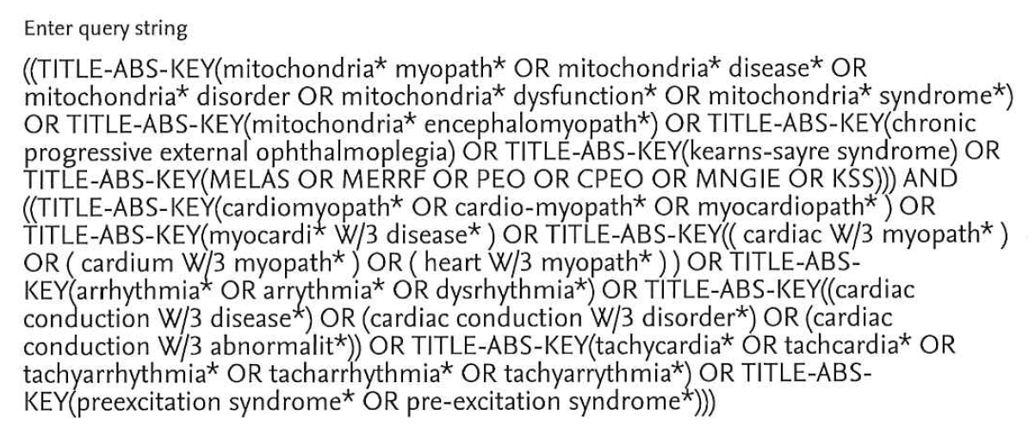

Figure e-1
Figure e-2

Figure e-3

Figure e-4

Table e-1
Relationship between the most commonly reported mutations/syndromes and the prevalence of common abnormalities found in ECG or echo in adults
 | m.8344A>G or MERRF | m.3243A>G or MELAS | CPEO or other syndromes
 | Number of patients | Number of patients | Number of patients
BBBª | 3/29 | 3/25 | 19/107
LVH^{b} | 5/32 | 68/265 | 0
Ventricular Pre-excitationª | 6/30 | 25/126 | 0
Abnormal LV systolic function^{b} | 1/13 | 7/22 | 2/5
Inverted T waveª | 2/3 | 5/10 | 15/60
ST depressionª | 3/7 | 2/6 | 11/87
LV dilation^{b} | 6/16 | 9/234 | 2/5
LV dysfunction^{b} | 6/29 | 10/105 | 2/11

BBB= bundle branch block
LVH = left ventricle hypertrophy
LV= left ventricle
ª = findings from ECG
^{b} = findings from Echocardiography

