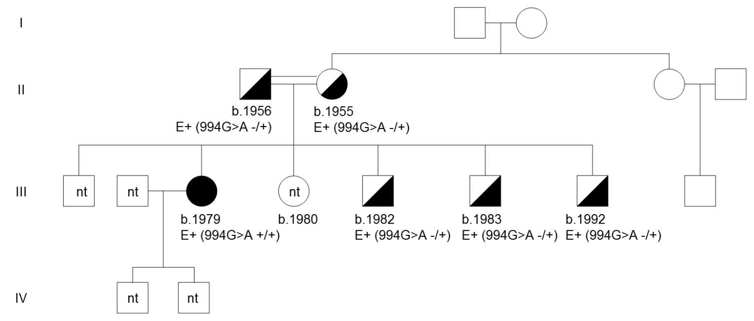
a)

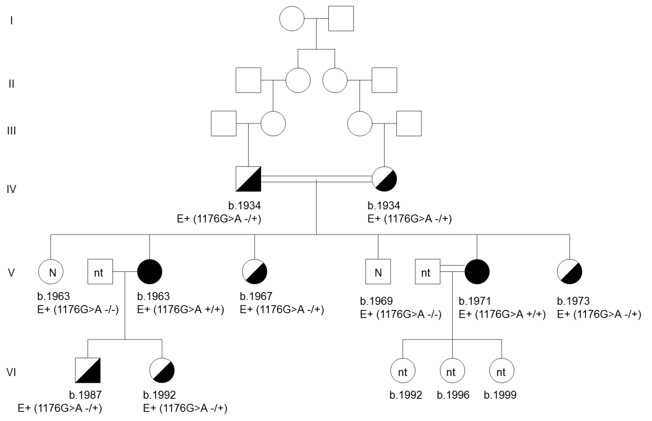
b)

Figure e-1. Figure 1. Pedigrees with the validation state of CAPN1 mutations in two SPG76 families (three patients).
: affected, : unaffected carriers, N: normal; nt: not tested.

