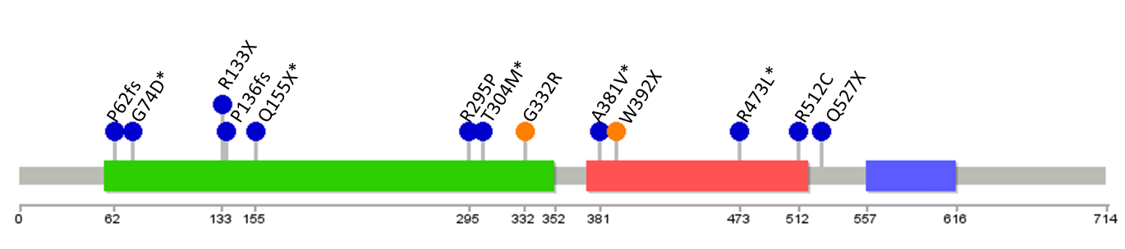
a)
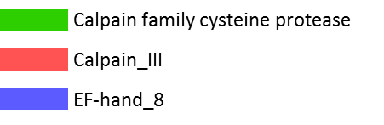
b)

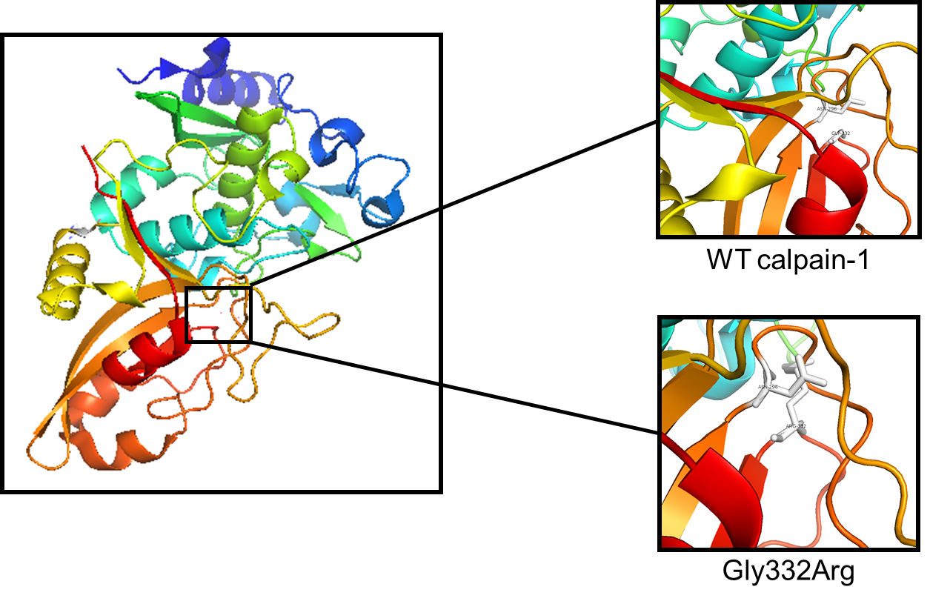

c)
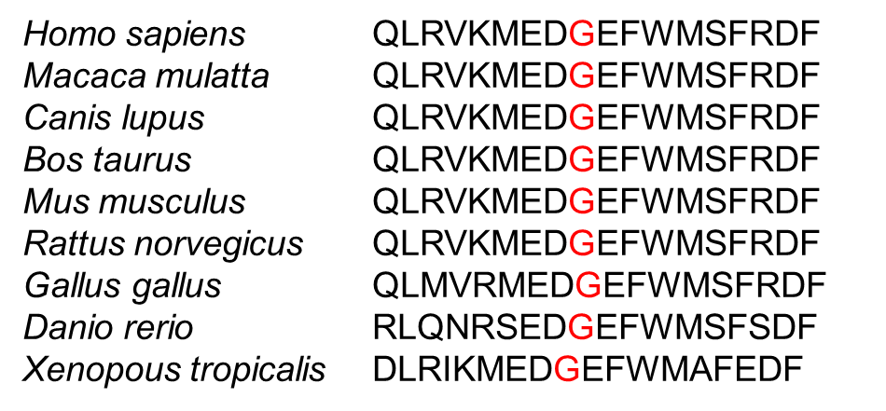

Figure e-2. Location of the mutations and the characteristics of the missense variant. a) Domains and the localization of the mutations within the calpain-1 protein, orange: identified in this study, blue: mutations identified in previous studies^{1–5}, *: compound heterozygous mutations b) Three-dimensional model of calpain-1 and the location of the Gly332Arg substitution in proximity to the active site Asn296 (PDB: 2ARY). c) Multiple sequence alignment and conservation of Gly332 in different species.

References
1. Gan-Or, Z. et al. Mutations in CAPN1 Cause Autosomal-Recessive Hereditary Spastic Paraplegia. Am. J. Hum. Genet. 98, 1038–1046 (2016).
2. Wang, Y. et al. Defects in the CAPN1 Gene Result in Alterations in Cerebellar Development and Cerebellar Ataxia in Mice and Humans. Cell Rep. 16, 79–91 (2016).
3. Tadic, V. et al. CAPN1 mutations are associated with a syndrome of combined spasticity and ataxia. J. Neurol. 264, 1008–1010 (2017).
4. Travaglini, L. et al. Expanding the clinical phenotype of CAPN1- associated mutations: A new case with congenital-onset pure spastic paraplegia. J. Neurol. Sci. 378, 210–212 (2017).
5. van de Warrenburg, B. P. et al. Clinical exome sequencing for cerebellar ataxia and spastic paraplegia uncovers novel gene–disease associations and unanticipated rare disorders. Eur. J. Hum. Genet. 24, 1–7 (2016).

