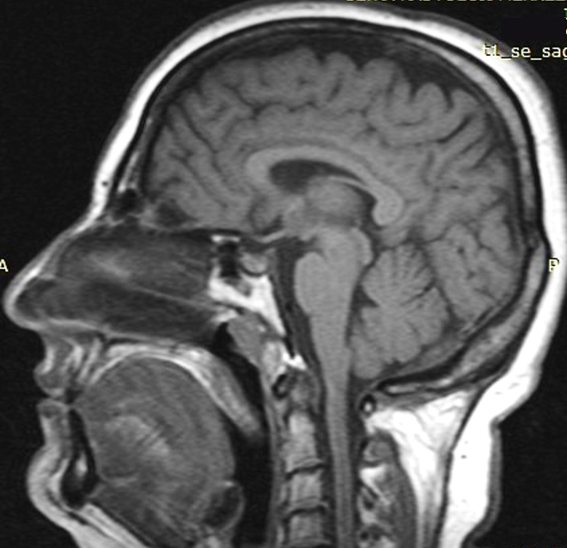
Figure e-3. T1 weighted sagittal magnetic resonance brain image of the 54 year-old patient (Family 2) is within normal limits.

