Supplementary Material

Amino acid change | Nucleotide change | Domain | Reference
c.97G>A | p.G33S | TPR1 | De Michele et al.#
c.170C>T | p.P57L | TPR2 | Lieto et al.
c.199G>A | p.A67T | TPR2 | Lieto et al.
c.673C>T | p.R225* | U-box | Lieto et al.
c.682C>T | p.P228S | U-box | De Michele et al.
c.689_692delACCT | p.Y230Cfs*9 | U-box | Lieto et al.
c.721C>T | p.R241W | U-box | Lieto et al.
c.731_732delGC | p.C244Yfs*24 | U-box | Current study#
c.791_792delTG | p.V264Gfs*4 | U-box | Lieto et al.
c.818_819dupGC | p.P274Afs*3 | U-box | Lieto et al.
c.823_824delCT | p.L275Dfs*16 | U-box | Genis et al.#, Lieto et al., Palvadeau et al.
Table e-1. Overview of the 11 heterozygous STUB1 gene mutations reported up till now in SCA48
The majority of the mutations is located in the U-box domain.
#extensive segregation analysis including >2 patients in ≥2 branches of the pedigree.
References
1. De Michele G, Lieto M, Galatolo D, et al. Spinocerebellar ataxia 48 presenting with ataxia associated with cognitive, psychiatric, and extrapyramidal features: A report of two Italian families. Parkinsonism Relat Disord 2019;65:91-96.
2. Genis D, Ortega-Cubero S, San Nicolas H, et al. Heterozygous STUB1 mutation causes familial ataxia with cognitive affective syndrome (SCA48). Neurology 2018;91:e1988-e1998.
3. Lieto M, Riso V, Galatolo D, et al. The complex phenotype of spinocerebellar ataxia type 48 in eight unrelated Italian families. Eur J Neurol 2019.
4. Palvadeau R, Kaya-Gulec ZE, Simsir G, et al. Cerebellar cognitive-affective syndrome preceding ataxia associated with complex extrapyramidal features in a Turkish SCA48 family. Neurogenetics 2020;21:51-58.

Sanger sequencing validation
To confirm the identified novel mutation, and to check for segregation within the family, a fragment containing the STUB1 mutation (NM_005861:exon6:c.731_732delGC:p.Cys244Tyrfs*24) was PCR amplified for all the available samples from the family, and sequenced in an ABI3730 sequencer (Applied Biosystems). The primers used are shown below. The sequencing results of the STUB1 mutation of two family members (one affected, one unaffected) are presented in Figure 1. Chromatograms of the other family members are available upon request.
 | Sequence (5’-3’)
STUB1-Ex6-Forward | TTCAGCCTCTGACCGTGTGC
STUB1-Ex6-Reverse | CACGCTGCAGTGACAAGAAGG
Primers used for PCR amplification and sequencing of the STUB1 gene mutation.
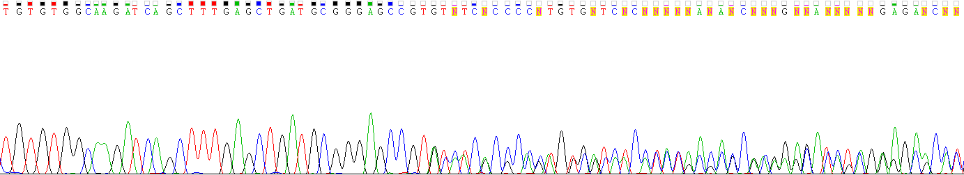
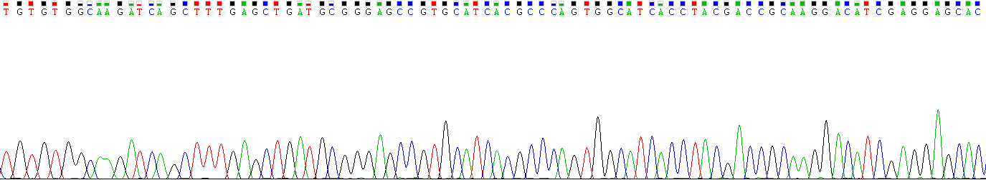
Figure e-1: Chromatogram showing the results of the Sanger DNA sequencing of the affected carrier III-13 (upper panel) and the unaffected non-carrier III-15 (lower panel). The red bar indicates the location of the mutation.

