Supplemental Data

Expanding the Phenotypic and Molecular Spectrum of RNA Polymerase III-Related Leukodystrophy

Stefanie Perrier,* Laurence Gauquelin,* Catherine Fallet-Bianco, Megan K. Dishop, Mackenzie A. Michell-Robinson, Luan T. Tran, Kether Guerrero, Lama Darbelli, Myriam Srour, Kevin Petrecca, Deborah L. Renaud, Michael Saito, Seth Cohen, Steffen Leiz, Bader Alhaddad, Tobias B. Haack, Ingrid Tejera-Martin, Fernando I. Monton, Norberto Rodriguez-Espinosa, Daniela Pohl, Savithri Nageswaran, Annette Grefe, Emma Glamuzina, and Geneviève Bernard

Supplemental Methods

Genetic Analysis
Pathogenic variants in POLR3A were assigned by the RefSeq sequence NM_007055.3, and the ClinVar accession numbers are as follows: SCV000987272, SCV000987273, SCV000987274, SCV000987275, SCV000987276, and SCV000987277.

Neuropathology
Tissues were analyzed initially during autopsy, followed by a second specialized neuropathological examination. During autopsy, the right cerebral hemisphere was fixed in 20% formalin for 2 weeks prior to coronal sectioning, and the left cerebral hemisphere was frozen for research. Fixed tissue was processed on a Leica ASP300 automated processor using standard protocols, and routine histologic sections were obtained at 4 µm thickness. Sections were stained with Hematoxylin and Eosin on a Leica H&E stainer, and CD68 stain was completed using the Ventana Benchmark automated immunohistochemistry stainer using Ventana anti-CD68 (KP-1) antibody. Luxol fast blue staining, Periodic acid Schiff staining, von Kossa calcium staining, and Bielschowsky staining were also completed.
For the second specialized neuropathological examination, tissue fragments were collected from the frontal, occipital and parietal white matter, basal ganglia (anterior region), cerebellum (cortex and dentate nucleus), cingular gyrus, centrum ovale, and the corpus callosum (genu, body, and splenium). Sections were embedded in paraffin, cut at 7 µm thickness, and stained with Hemalun-Phloxin and Luxol-Fast-Blue-Cresyl-Violet (Klüver-Barrera stain). Immunohistochemistry was also completed with antibodies for GFAP (Anti-Glial Fibrillary Acidic Protein, polyclonal rabbit antibody, DAKO), IBA1 (Anti-Ionized Calcium-Binding Adapter Molecule 1, Wako (Sodobis) lot PDK 6188), and SMI32 (Anti-Neurofilament non-phosphorylated, Calbiochem).

Cell Culture and Cycloheximide Treatment
Primary fibroblasts derived from patient 2, as well as a control cell line, were cultured at 37°C under humidified 95% air and 5% CO₂ in Dulbecco’s modified Eagle’s medium (DMEM, Wisent) supplemented with 10% fetal bovine serum (FBS, Wisent). Fibroblasts were plated in 6-well plates (0.5 million cells, samples in triplicate), and grown in the presence and absence of cycloheximide (CHX, 100 ng/µl) for 20 hours to inhibit translational elongation and downstream nonsense-mediated decay of variant transcripts ^{1, 2}. RNA was isolated from each sample (QIAamp RNA Blood Mini Kit, Qiagen), and cDNA was reverse-transcribed from 500 ng of RNA (BioRad iScript Reverse Transcription Supermix) following manufacturer’s protocols. PCR amplification was performed with primers in POLR3A (exons 11 [5'-CCACCGGACCTTCAGATTTA-3'] and 15 [5'-TGCCACTCATCAACTCACTG-3']), as well as β-actin as a loading control (exons 1 [5'-GCTCGTCGTCGACAACGGCTC-3'] and 2 [5'-CAAACATGATCTGGGTCATCTTCTC-3']), using the following PCR cycling conditions: 95°C for 10 minutes, followed by 40 cycles of [95°C for 15 seconds, 58°C for 20 seconds, and 72°C for 45 seconds], and 72°C for 10 minutes. PCR products were then separated using agarose gel electrophoresis (2.5% agarose gel; 120V, 30 minutes). Gel imaging was completed using the Gel Doc EZ System (BioRad) using ImageLab Software (BioRad, Version 6.0.1). Visible bands were excised, products were extracted and purified (QIAquick Gel Extraction kit), and Sanger sequencing was performed to characterize the differentially spliced mRNAs.

Western Blot
Western blotting was completed with protein extracts from independent samples of cortical grey matter or subcortical white matter of patient 2 and an age/sex matched control. Control brain tissue was collected in the context of surgery for intractable epilepsy associated with PIK3CA mosaicism in a 14-month old girl with hemimegalencephaly. Protein lysates were prepared from brain tissues extracted in standard radioassay immunoprecipitation (RIPA) buffer (Thermo Scientific Pierce #89901) containing protease inhibitors (Sigma cOmplete EDTA-free protease inhibitor cocktail #4693132001) for 30 minutes, and lysates were sonicated for 2.5 minutes in ten second bursts with 10 seconds rest. Protein concentrations were determined using the Bradford assay and normalized correspondingly ³. Normalized lysates were combined in Laemmli buffer and electrophoresed using standard sodium dodecyl sulfate-polyacrylamide gel electrophoresis (SDS-PAGE) techniques on 1.5 mm, 7.5% tris-glycine gels and blotted onto polyvinylidene difluoride (PVDF) membrane using a standard semi-dry protein-transfer at 25V, 2.5A for 10 minutes (Biorad Trans-Blot Turbo Transfer System). Immunoblots were incubated with a primary antibody targeted to the POLR3A amino acid residues 607-698 (Anti-POLR3A rabbit polyclonal antibody [Abcam ab247007]; 0.4 ug/mL), or with β-tubulin as a loading control (Anti-tubulin mouse polyclonal antibody [Sigma, T8328]; dilution 1:2000), with goat anti-rabbit (dilution 1:5000) or goat anti-mouse (dilution 1:10000) secondary antibodies. Blots were incubated with enhanced chemiluminescent substrate (ECL Prime, Amersham) for 5 minutes and imaged on a Chemidoc XRS+ Imaging System (Biorad) using ImageLab Software (BioRad, Version 6.0.1). Full unedited blots are provided in Supplementary Fig. 1.
Western Blot quantification was performed using ImageLab Software (BioRad, Version 6.0.1). Chemiluminescent band intensity of four replicates from each sample was measured for POLR3A at 164 kDa, normalized to the β-tubulin signal at 51 kDa, and averaged for patient 2 and control samples. Average percent decrease was calculated for each tissue type, and average reduction of protein expression levels between grey matter and white matter were compared. Confidence intervals (95%) were calculated for each mean difference in protein expression. Effect size estimations were calculated using Cohen’s d, with pooled standard deviation calculations. Statistical analysis was performed using GraphPad Prism 8 for Windows (GraphPad Software Inc. La Jolla, CA).

Supplemental References
1. Carter MS, Doskow J, Morris P, et al. A regulatory mechanism that detects premature nonsense codons in T-cell receptor transcripts in vivo is reversed by protein synthesis inhibitors in vitro. J Biol Chem 1995;270:28995-29003.
2. Schneider-Poetsch T, Ju J, Eyler DE, et al. Inhibition of eukaryotic translation elongation by cycloheximide and lactimidomycin. Nat Chem Biol 2010;6:209-217.
3. Bradford MM. A rapid and sensitive method for the quantitation of microgram quantities of protein utilizing the principle of protein-dye binding. Anal Biochem 1976;72:248-254.

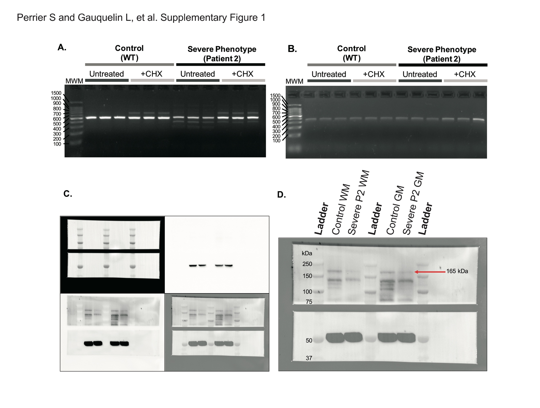
Figure e-1: Additional gel and blot images. (A-B) Images of full agarose gels (uncropped) demonstrating RT-PCR products with primers to amplify (A) POLR3A exons 11-15, and (B) β-Actin. (C) Individual exposures used for assembling the composite western blot image to assess molecular weight (bottom right) including top illumination to capture the protein ladder (top-left), six second chemiluminescence exposure to capture β-tubulin for data analysis (top-right), and 400 seconds to capture POLR3A for data analysis (bottom-left). (D) Composite image showing molecular weights of protein ladder and band of interest at 164 kDa, the predicted size of POLR3A. CHX; cycloheximide. MWM; molecular weight marker. GM; grey matter. WM; white matter.

Table e-1: Additional clinical characteristics and demographic information for patients included in this study.

 | Demographic characteristics |  |  | Clinical characteristics
ID | Pheno-type | Sex | Ethnicity | Age of onset | Failure to thrive | Develop-mental delay | Age at walking without support | Cognitive impairment | Seizures | Age at motor regression | Dysphagia / Age at G-tube | Dys-autonomia | Respiratory insufficiency | Ocular abnormalities | Dental abnormalities | Hypogonadotropic hypogonadism | Microcephaly | Upper motor neuron signs | Prominent tremor | Dystonia | Age of death
Patient 1 | Severe | F | Caucasian | 1 mo | + | + | Not achieved | Too young | - | 10 mo | + / 5 mo | + | + L S T | Cortical visual impairment | Delayed dentition | Too young | + | Spasticity | - | + | 15 mo
Patient 2 | Severe | F | Asian/  Ashkenazi Jewish | 2 mo | + | + | Not achieved | Too young | - | 7 mo | + / 7 mo | - | - | - | - | Too young | + | Spasticity | - | + | 13 mo
Patient 3ª | Severe | F | Maori/  Cook Island Maori/  New Zealand European | 1 mo | + | + | Not achieved | Too young | - | 2 mo | + / 7 mo | - | + L S | Hyperopia | Delayed dentition | Too young | - | Hyperreflexia | - | + C | 21 mo
Patient 4ª | Severe | M | Maori/  Cook Island Maori/  New Zealand European | 3 mo | + | + | Not achieved | Too young | - | 6 mo | + / - | + | + L | Hyperopia | Delayed dentition | Too young | - | - | - | + C | 38 mo
Patient 5 | Severe | M | Russian | 3 mo | + | + | Not achieved | Too young | N/A | 3 mo | + / 15 mo | - | - | - | - | Too young | + | Spasticity | - | + C | N/A (Currently  5 y)
Patient 6 | Severe | M | Hispanic/  American | 3 mo | + | + | Not achieved | Too young | - | 12 mo | + / 12 mo | - | + | Cortical visual impairment | N/A | Too young | + | Spasticity and hyperreflexia | - | + C | N/A (Currently  3 y)
ª : Patients 3 and 4 are from the same family; C: Choreoathetosis; L: Laryngomalacia; N/A: Not available; mo: Months; S: Supraglottoplasty; T: Tracheostomy; y: Years.

