Supplementary Table. Clinical and radiological characteristics of adult-onset leukoencephalopathies¹ compared with present patient.
 | Hereditary diffuse leukoencephalopathy with spheroids (HDLS) | Progressive leukodystrophy with ovarian failure (LKENP) | Leukoencephalopathy with vanishing white matter  (VWMD) | Globoid cell leukodystrophy  (GLD; Krabbe disease) | Metachromatic leukodystrophy  (MLD) | X-linked adrenoleukodystrophy  (X-ALD) | Present patient
Gene(s) | CSF1R | AARS2 | EIF2B1-5 | GALC | ARSA | ABCD1 | LAMB1
Inheritance | AD | AR | AR | AR | AR | XR | AR
Biochemical findings | - | - | - | Galactocerebrosidase deficiency in leukocytes or fibroblasts | Decreased arylsulfatase A activity, elevated urinary sulfatides | Elevated saturated very long chain fatty acid in serum | -
Clinical findings
Neurological symptoms | Cognitive and psychiatric disturbances, spastic-ataxic gait, seizures, bladder dysfunction | Ataxia, spasticity, cognitive decline | Spastic paraparesis, psychiatric symptoms, ataxia | Spastic tetraparesis, ataxia, polyneuropathy, cognitive impairment | Psychosis, cognitive decline, polyneuropathy | Behavioral changes, psychosis | Intellectual disability, spastic gait
Extraneurological symptoms | - | Ovarian dysfunction | Optic nerve atrophy, ovarian dysfunction | Optic nerve atrophy | Optic nerve atrophy, gallbladder dysfunction | Optic nerve atrophy | Retinal vascular abnormality, ovarian dysfunction
MRI findings
Diffuse cerebral | - | - | + | - | + | - | +
Periventricular  predominance | - | - | - | + | + | - | +
Asymmetric lesions | + | - | + | - | - | - | -
Cerebellum and/or middle  cerebellar peduncles | - | + | - | - | - | + | -
Frontal predominance | + | - | - | - | + | + | -
Parieto-occipital predominance | - | - | - | + | - | + | -
Multifocal lesions | + | - | - | - | - | - | -
Cystic lesions | - | - | + | - | - | - | -
Contrast enhancement | - | + | - | - | - | - | -
Corpus callosum thinning | + | + | + | - | - | - | -
Long-tract involvement | - | + | - | + | - | - | -
AD, autosomal dominant; AR, autosomal recessive; XR, X-linked recessive.

Supplementary Figure. Brain MRI of the present patient at age 40.
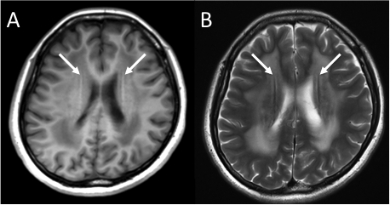
Periventricular rims with high signal on T1-weighted image (A) and low signal on T2-weighted image (B) are shown (white arrows). These findings have been reported in the patients with infantile- and juvenile-onset Alexander disease.²

Supplementary References
- Kohler W, Curiel J, Vanderver A. Adulthood leukodystrophies. Nat Rev Neurol 2018;14:94-105.
- van der Knaap MS, Naidu S, Breiter SN, et al. Alexander disease: diagnosis with MR imaging. AJNR Am J Neuroradiol 2001;22:541-552.

