A) RFC1 repeat analysis results for a patient with a bi-allelic expansion of the AAGGG repeat
Flanking PCR
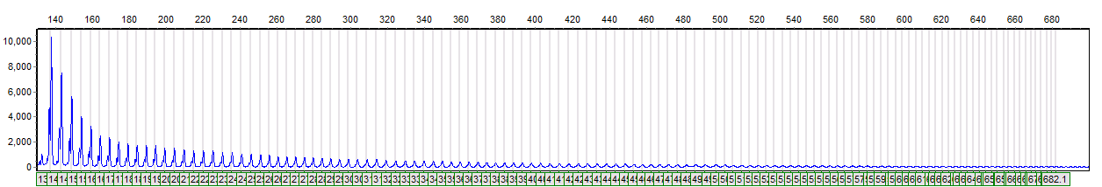
(AAAAG) repeat-prime PCR
(AAGGG) repeat-prime PCR

B) RFC1 repeat analysis results for a patient heterozygous for the AAGGG expansion

Flanking PCR

(AAAAG) repeat-prime PCR

(AAGGG) repeat-prime PCR

C) RFC1 repeat analysis results for a normal patient (absent for the AAGGG repeat)
Flanking PCR
(AAAAG) repeat-prime PCR

(AAGGG) repeat-prime PCR

Figure e-2. Examples of Flanking PCR, Repeat Primed AAAAG-repeat detection, and Repeat Primed AAGGG-repeat detection.
A) In a patient with bi-allelic expansion of the AAGGG repeat, no amplification product is obtained using flanking primers that amplify across the repeat region. The absence of an AAAAG allele is confirmed by repeat-prime PCR for the AAAAG repeat and the presence of an AAGGG expansion is demonstrated by repeat-prime PCR of the AAGGG repeat, confirming that the patient has a bi-allelic expansion of AAGGG. B) For the patient heterozygous for the AAGGG expansion, the flanking PCR shows a normal size product that corresponds to 11 AAAAG repeats. This is confirmed by repeat-prime PCR for the AAAAG repeat. The patient also has an expansion of the AAGGG repeat that is demonstrated by the repeat-prime PCR of the AAGGG repeat. C) For the normal patient with no bi-allelic expansion of the AAGGG repeat, the flanking PCR shows two normal sized products that correspond to 10 and 11 AAAAG repeats. This is confirmed by repeat-prime PCR for the AAAAG repeat. The absence of an AAGGG expansion is demonstrated by repeat-primed PCR for the AAGGG repeat that shows no amplification.

