Appendix e-1
Exclusion criteria
Children with transient varicella related cerebellitis, classic opsoclonus-myoclonus ataxia, clinically defined leukodystrophies (n=5, who were recruited to another research project), and acquired forms of ataxia, such as ataxia following brain trauma, brain tumors, congenital infection and ischemic anoxic lesions were excluded from this study.
Exome sequencing technical details
Exome sequencing was done with the Agilent V5 whole exome, the VCRome v2.1, Agilent Clinical Research kit, NimbleGen MedExome or the SureSelect Human All Exon V6 capture kit on an Illumina HiSeq sequencing platform.
Patients either prescreened or screened during the study for pathologically expanded trinucleotide repeats
ID | Group | Gene | Spinocerebellar ataxia (SCA) | Friedreich ataxia
P2 | Confirmed diagnosis | COQ8A | SCA1, 2, 7 | yes
P5 | Confirmed diagnosis | ITPR1 | affected mother tested for SCA1, 2, 3, 7, 8, 12, 17 | no
P13 | Confirmed diagnosis | CLN5 | SCA2, 7 | no
P14 | Confirmed diagnosis | NKX2-1 | no | yes
P15 | Confirmed diagnosis | STUB1 | SCA1, 7, 8 | no
P19 | Confirmed diagnosis | ATP1A3 | no | yes
P28 | No diagnosis |  | no | yes
P35 | No diagnosis |  | no | yes
P40 | No diagnosis |  | no | yes
P44 | No diagnosis |  | SCA1, 2, 6, 7, 8, 17 | no
P46 | No diagnosis |  | SCA6 | no
P49 | No diagnosis |  | SCA7 | no

Primers used in Sanger sequencing
Chr | pos | Gene | Forward | Reverse
1 | 43394882 | SLC2A1 | ttccctttagaccccaagcc | aacctagcaactcaccagca
1 | 227169808 | COQ8A | tatcaggtggggcttgcc | atcttgcccactgagctttg
1 | 227174171 | COQ8A | gtggagggctctggtgtc | acgggaatcaggttgtggat
2 | 166245891 | SCN2A | atgtacatcgcggtcatcct | tagcgtctgtaagccctctg
2 | 191116992 | HIBCH | ggtttgtgtgatctacggca | aagtctgtggctctcaacca
2 | 191159358 | HIBCH | cacacagtgtactcatctagca | tgattcagggagagagacaaca
2 | 219525942 | BCS1L | ccccacaaaaggagggtatt | gaatccatttcccccgatac
2 | 219526485 | BCS1L | ggcacagctccacctaattg | cttttcattcctcttaatctctgg
3 | 4687363 | ITPR1 | cttgggggcagcagtcta | ttgtaggatagagagagagagagccta
3 | 4709128 | ITPR1 | catcaggaaacattgctgctt | tcaaaaagcctctccagacc
3 | 4856866 | ITPR1 | atatccctcctggctgtgtc | tcccagcagaataaaggcca
6 | 131919485 | MED23 | acttctctatgcagggctcc | tagggaagtgacagcaatgc
8 | 145138112 | GPAA1 | ggactccgggtttaggtctc | agacacgaagggagcctctg
8 | 145139371 | GPAA1 | accacgtcctccattagcac | aggaagaaggactggtgcag
10 | 131640542 | EBF3 | cccagccagatattgcacac | agaacagaacgctacggaca
10 | 131676043 | EBF3 | agtgggttgagatggtaggc | tgcaccaattccagtttgct
10 | 131676045 | EBF3 | agtgggttgagatggtaggc | tgcaccaattccagtttgct
11 | 6636680 | TPP1 | tcccattgttccttttcgtc | tcagaaagtgcagccacatc
12 | 111057639 | TCTN1 | gcatctctgtaggcaaagca | tggacggtatggcttcagaa
12 | 111085142 | TCTN1 | cagtttcaggtgatgtcggc | agaaccatcgtcagtgtttct
12 | 52080889 | SCN8A | tcctcacttccttcctgctg | tgcttgccttctcccacata
13 | 77575055 | CLN5 | ttcaaaccacatttgccaac | ctgggtccaaaggtcctaca
14 | 36987093 | NKX2-1 | atcctaatgctctgacccgg | ttgtagcggtggttctggaa
16 | 732184 | STUB1 | cacaggacaagtacatggcg | gtccaacagcagaacttggg
16 | 732442 | STUB1 | cacaggacaagtacatggcg | gtccaacagcagaacttggg
17 | 57775212 | PTRH2 | aaacagggtgcaggcataag | atttttgcatgggccaataa
18 | 6950834 | LAMA1 | gaaacagttcccggcagac | tccctgccttcaagacttgt
18 | 6999503 | LAMA1 | tgggtggattgtcatgtgga | tcaccacttctttcccgaca
19 | 13346507 | CACNA1A | ttttcctgttggttggcttc | gcactgtcttcctcccttgt
19 | 42474691 | ATP1A3 | gcaggagaatggcgtgaac | agatagctcactggttggtcc
19 | 42474692 | ATP1A3 | gcaggagaatggcgtgaac | agatagctcactggttggtcc
X | 41495865 | CASK | ccctcatttcagattgcttacca | ccggcccctaattccaattc

P12/TCTN1 Western blot
P12 has compound heterozygous variants in TCTN1 and parental samples were unavailable to confirm that the variants segregated. This study used western blot with rabbit anti-TCTN1 (Proteintech Group Cat#15004-1-AP, RRID:AB_10644442) to show complete lack of TCTN1 in P12 fibroblasts. Antibody reference: Chih B, Liu P, Chinn Y, Chalouni C, Komuves LG, Hass PE, et al. A ciliopathy complex at the transition zone protects the cilia as a privileged membrane domain. Nature Cell Biology 2011; 14: 61.
Supplementary Figure 1. TCTN1 western blot of P12 fibroblasts
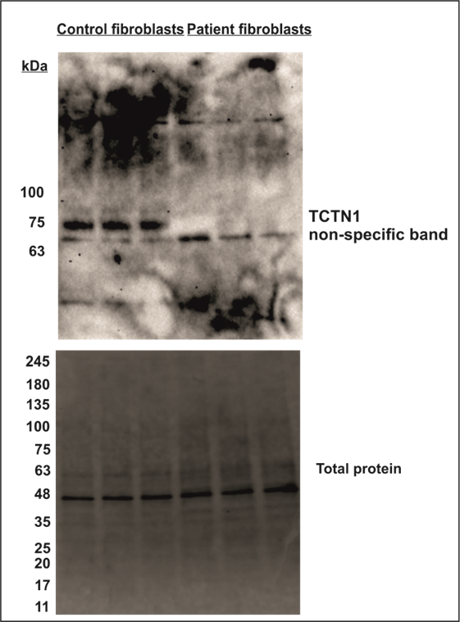
{Chih, 2011 #1714}P3/3-Hydroxyisobutyryl-CoA hydrolase (HIBCH) activity
HIBCH-enzyme activity in cultured skin fibroblasts was measured in a clinical laboratory and was found to be 2.1 nmol/(min.mg protein) (reference value 5.3-10.5.), reduced but not fully deficient.
Supplementary Figure 2. {Chih, 2011 #1714}P8/EBF3 Sanger sequencing chromatogram
Sanger sequencing of the EBF3 c.1183 C>T variant in P8 and the clinically unaffected parents of P8. In the mother the peak height of the variant allele is less than what is observed in a conventional heterozygote and raised suspicion of somatic mosaicism in the mother.

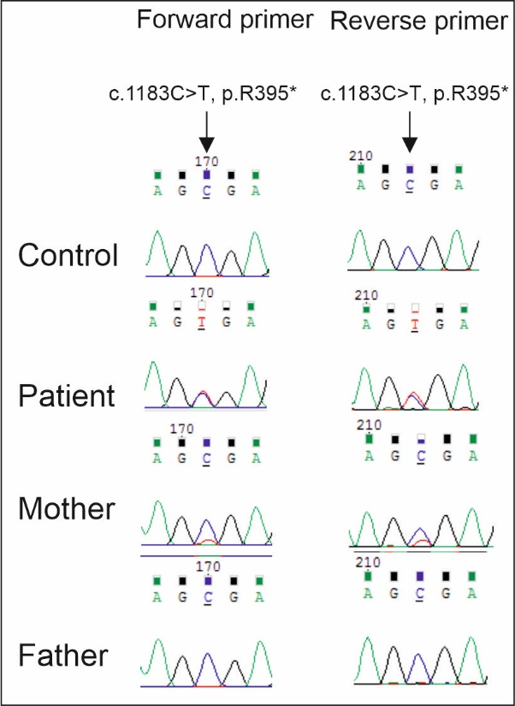

Proband phenotype
P27/MED23
P27 was found to have a de novo variant in MED23. She was investigated because of tremor, and was found to have hypotonia and upper limb predominating ataxia at the age of 1.5 years. At the age of six years old, her ataxia and tremor of the upper limbs has remained stable and she has a diagnosis of mixed disorder of scholastic skills. Brain MRI at the age of 2, 3 and 4 years of age was normal. Metabolic screening and other laboratory tests were within normal range. Molecular karyotype and testing for Fragile-X syndrome were normal.

