Supplemental Data
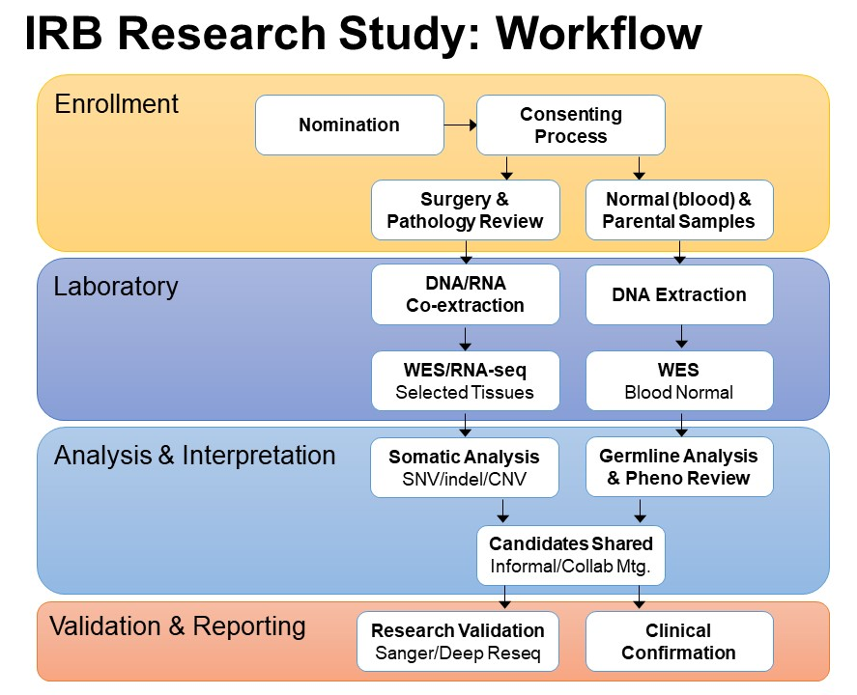
figure e-1. Overview of epilepsy research study workflow. As a NAEC Level 4 epilepsy center, our institution offers advanced epilepsy surgery services, including evaluation using intracranial electrodes and surgical excision of epileptogenic tissue. These neurosurgical procedures provide an opportunity to evaluate brain tissue for genomic alterations. We recently initiated an Institutional Review Board (IRB)-approved research protocol that compares high depth next generation sequencing of DNA extracted from brain tissue plus normal (blood) samples to identify somatic mosaicism in cases of intractable epilepsy. After sequencing and variant identification, we discuss results in an informal, collaborative meeting setting, which comprises neurosurgeons, pathologists, pediatric neurologists, bioinformaticians, genetic counselors and genomic scientists. We clinically confirm any candidate genomic alterations in our Clinical Laboratory Improvement Amendments (CLIA)-approved laboratory using validated assays, in order to record results in the patient’s electronic medical chart. CNV, copy number variation; SNV, single nucleotide variant; WES, whole exome sequencing
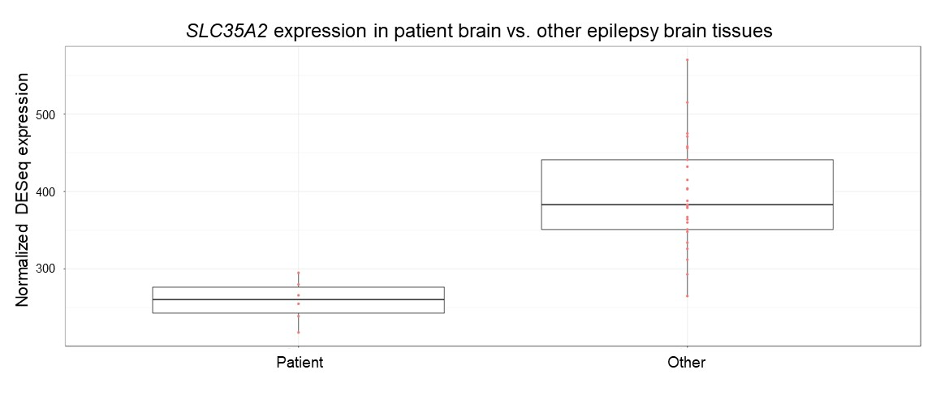
figure e-2. SLC35A2 expression in patient brain vs. other epilepsy brain tissues. DESeq2 normalized SLC35A2 expression values for six brain tissues from our patient, compared to expression of SLC35A2 in brain tissues from other epilepsy patients. Fold-change in patient relative to other is -1.5 (p < 0.0001). Six brain tissues from our patient include A1, A2, B, C, D1, and D2.
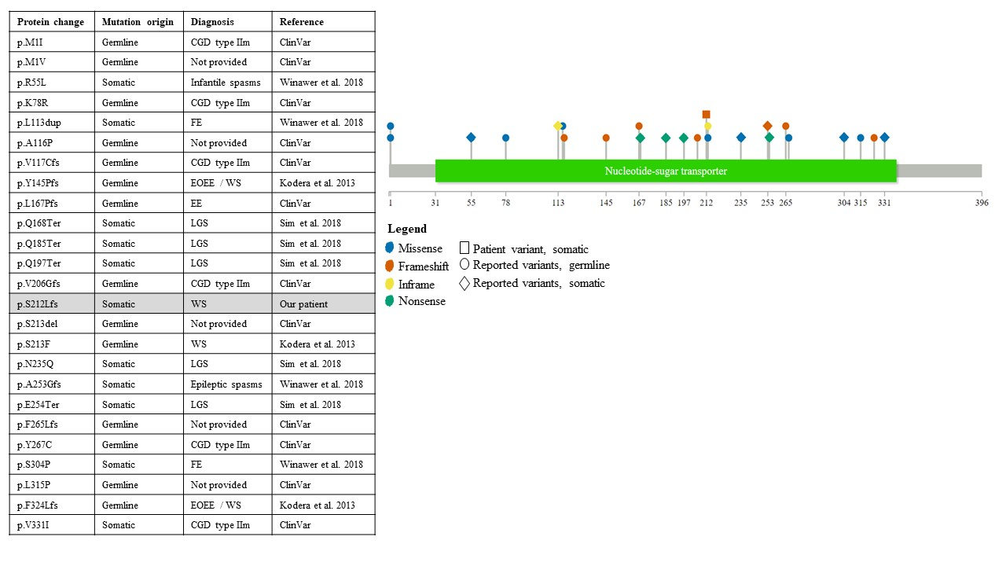
figure e-3. Plot of pathogenic and likely pathogenic sequence variants previously reported in SLC35A2. Lollipop-style variant diagram displaying all pathogenic and likely pathogenic variants previously reported in ClinVar or peer-reviewed literature (as of July 7, 2019). The protein changes relative to NP_001035963.1 and origin of each variant are listed along with diagnosis of the patient in which the alteration was detected. CGD, congenital disorder of glycosylation; EE, epileptic encephalopathy; EOEE, early-onset epileptic encephalopathy; FE, focal epilepsy; LGS, Lennox-Gastaut syndrome; WS, west syndrome
ID | Tissue Source | Histology | Sample Type
Normal | Blood | N/A | Frozen
A1 | Left Temporal Lobe | Cortical dyslamination | Frozen
A2 | Left Temporal Lobe | Cortical dyslamination | Frozen
B | Left Amygdala | Fragment of gray and white matter with gliosis | Frozen
C | Left Hippocampus | Fragment of gray and white matter with gliosis | Frozen
D1 | Left Occipital Lobe and Pole | Cortical dyslamination | Frozen
D2 | Left Occipital Lobe and Pole | Cortical dyslamination | Frozen
E | Left Superior Temporal Gyrus | Cortical dyslamination | FFPE
F | Left Inferior Occipital Lobe | Cortical dyslamination | FFPE
G1 | Left Medial Occipital Lobe | Cortical dyslamination | FFPE
G2 | Left Medial Occipital Lobe | Cortical dyslamination | FFPE
H1 | Left Inferior Parietal Cortex | Cortical dyslamination | FFPE
H2 | Left Inferior Parietal Cortex | Cortical dyslamination | FFPE

table e-1. Description of all tissues used for analysis. Details listed for each specimen include internally assigned ID (ID), anatomical origin (Tissue Source), histopathological assessment as determined by a board-certified neuropathologist (Histology), and preparation method used to preserve specimens (Sample Type). FFPE, formalin-fixed paraffin embedded
ID | Tissue Source | Sample Type | Total Reads | Mapped Reads | Mean Coverage | Bases Covered >= 20X | Duplicate Reads
Comparator | Blood | Frozen | 254,978,958 | 56.3% | 222x | 98.5% | 30.4%
A1 | Temporal Lobe | Frozen | 281,534,278 | 63.1% | 282x | 98.6% | 23.7%
A2 | Temporal Lobe | Frozen | 338,558,622 | 63.5% | 342x | 98.7% | 24.0%
B | Amygdala | Frozen | 334,317,104 | 64.9% | 347x | 98.8% | 22.1%
C | Hippocampus | Frozen | 372,460,026 | 64.5% | 384x | 98.8% | 22.9%
D1 | Occipital Lobe | Frozen | 312,807,558 | 64.7% | 323x | 98.7% | 21.8%
D2 | Occipital Lobe | Frozen | 311,161,848 | 62.5% | 309x | 98.7% | 25.2%
table e-2. Exome sequencing metrics for matched blood and affected brain tissues.

Genomic location (GRCh37) | Gene | HGVS cDNA | HGVS protein | Zygosity | Origin | Interpretation
14:102452850 | DYNC1H1 | NM_001376.4:c.2288C>T | p.Ala763Val | Heterozygous | Maternal | VUS
11:125831607 | CDON | NM_001243597.1:c.3643A>C | p.Met1215Leu | Heterozygous | Unknown | Poor phenotype fit
X:53223805 | KDM5C | NM_004187.3:c.3554C>T | p.Thr1185Ile | Hemizygous | Unknown | Poor phenotype fit
table e-3. Filtered list of inherited germline variants identified in exome sequencing. VUS, variant of unknown significance

Genomic location (GRCh37) | X:48762550 | 12:124970991 | 4:177605120 | 2:190584473 | 12:111886014
Gene | SLC35A2 | NCOR2 | VEGFC | ANKAR | SH2B3
HGVS cDNA | NM_005660.2:c.634_635del | *NM_006312.5:c.229G>A | *NM_005429.4:c.1220G>A | *NM_144708.3:c.2400C>A | *NM_005475.2:c.1636C>A
HGVS protein | p.Ser212LeufsTer9 | p.Glu77Lys | p.Arg407His | p.His800Gln | p.Pro546Thr
Interpretation | Pathogenic | VUS | VUS | VUS | VUS
Variant allele fraction
Alt/Total reads (VAF%)
Temporal lobe (A1) | 4/135 (3.0%) | 2/408 (0.5%) | 1/219 (0.5%) | 0 | 0
Temporal lobe (A2) | 6/184 (3.3%) | 2/532 (0.4%) | 0 | 4/228 (1.8%) | 0
Amygdala (B) | 23/184 (12.5%) | 11/513 (2.1%) | 5/237 (2.1%) | 0 | 4/343 (1.2%)
Hippocampus (C) | 57/206 (27.7%) | 1/536 (0.2%) | 5/279 (1.8%) | 0 | 0
Occipital lobe (D1) | 15/153 (9.8%) | 2/408 (0.5%) | 2/229 (0.9%) | 0 | 0
Occipital lobe (D2) | 1/166 (0.6%) | 1/414 (0.2%) | 0 | 0 | 0

table e-4. Filtered list of somatic variants identified in exome sequencing. VUS, variant of unknown significance; *these variants were not validated using a secondary sequencing method

