Supplemental Image 1: D-15 Farnworth Color Testing and Electrophysiology

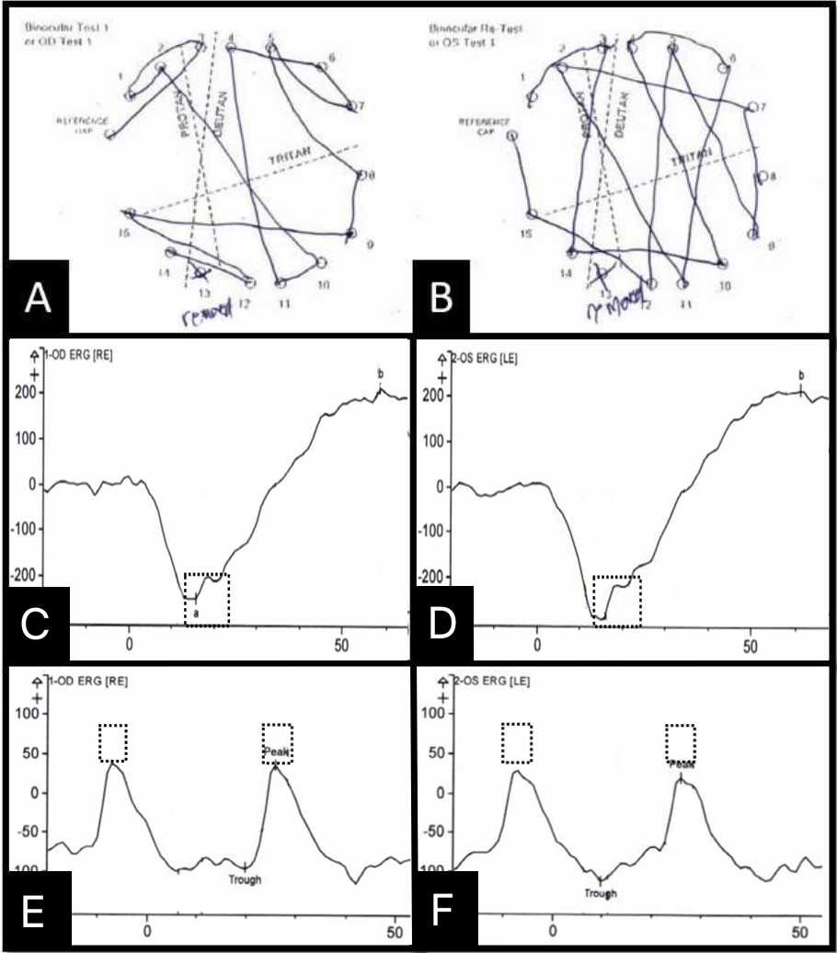

Supplemental figure 1. All panels from our patient. A-B: D-15 color test of the right and left eye respectively showing several errors, mostly in the deutan axis. C-D: Combined rod-cone responses of right and left eyes within normal limits (note that the peaks of the responses here fall within the normal reference value boxes). E-F: Cone-flicker of the right and left eyes showing abnormally low amplitudes; the peaks of the cone responses should fall within the reference value boxes if normal.

Supplemental Image 2: Normal Findings for Comparison

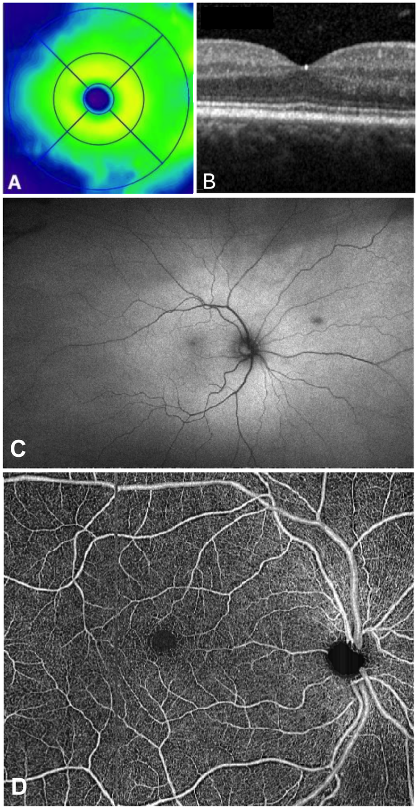

Supplemental figure 2. All panels from normal subjects. A: Retinal color thickness map. B. Optical coherence tomography b-scan showing normal retinal architecture. C: Fundus autofluorescence. D: Retinal vasculature as depicted by optical coherence tomography angiography.

