Supplementary material

Materials and Methods
DNA and RNA isolation
Genomic DNA from the patients and their parents was isolated from EDTA-blood or fibroblasts (in the case of the deceased patient) using the QIAamp DNA Midi Kit (Qiagen). For RNA analysis, 1x10⁷ fibroblasts, from both patients and parents, were cultured and total RNA was isolated using the RNeasy mini kit (Qiagen).
Molecular analysis of SLC12A2
Sanger sequencing of two variants in SLC12A2 was carried out following PCR amplification of genomic DNA, using the following M13-tagged primers: SLC12A2_8F:GGTAAACCATTGTCTCATAC, SLC12A2_9R:GAGCAACTCCATGTCTTTTT, SLC12A2_13F:TATGAAAGCTGGATGGTGGT and SLC12A2_13R:CTGTAAAGACAGACTTGGCA.
RT-PCR was performed on isolated RNA, using the High Capacity cDNA Reverse Transcription Kit (Applied Biosystems, Thermo Fisher) and the following M13-tagged primers: SLC12A2_cDNA_12F:GCTTTCCAGATGTTTGCTAA and SLC12A2_cDNA_14R:GTGATATCCACATGTTGTAG. Subsequent sequencing of the PCR products was carried out with M13 primers, using the BigDye version 3.1 sequencing kit (Applied Biosystems) on a 3500xl Genetic Analyzer (Applied Biosystems) with alignment to the reference sequence NM_001046.

Results
Clinical history of the proband (index patient)
The proband (II:3) (Fig. 1) is an 8-year-old girl born full-term with birthweight 3.2 kg after a normal pregnancy. She is the third child of non-consanguineous parents of Swedish descent. In addition to the deceased older sister (II:2) she has a healthy older brother. Delivery was unremarkable. She was transferred to a neonatal unit due to hypotonia and difficulties breastfeeding. At day 5, she had fever and a swollen left parotid gland. Broad-spectrum antibiotic treatment was started on the suspicion of septic parotitis. A blood culture confirmed Staphylococcus aureus septicemia. The infection seemed well controlled. Because of recurrent apneas, continuous positive airway pressure (CPAP) and oxygen treatment was started at the local hospital and the patient was transferred to our hospital’s paediatric intensive care unit (PICU) on day 9. She was afebrile, infection parameters had normalised and circulation was stable. Hypotonia persisted and she was fed through nasogastric tube.
Due to the history of the older deceased sister with similar symptoms, an extensive work-up for immunodeficiency and metabolic disease was started. Results came back negative. Respiration improved. CPAP treatment was stopped but had to be restarted due to respiratory insufficiency with carbon dioxide retention (pCO2 9,2 kPa) and short but repeated apneas. Antibiotic treatment was again started but infection could not be confirmed. With CPAP, pCO2 normalised, but central apneas continued. It was noted that the Moro reflex, previously normal, could not be elicited. Caffeine citrate was started, apneas gradually subsided and the patient was weaned off CPAP treatment. Thick airway mucus was treated with sodium chloride inhalations. A genetic test for cystic fibrosis was negative.
A neurological work-up was prompted by the muscle hypotonia, central apneas and the lack of Moro reflex. Magnetic resonance imaging (MRI) (figure 2A-E and 3A-E) and magnetic resonance spectroscopy (MRS) (Supplementary material; figure e-1A-B) of the brain revealed white matter and basal ganglia abnormalities. Lumbar puncture showed elevated albumin and increased damage biomarkers in cerebrospinal fluid (CSF) (Supplementary material; table e-1). Muscle biopsy for mitochondrial disease diagnostics (histology, ATP production, respiratory chain enzyme activity and mtDNA sequencing), POLG gene sequencing and array-CGH were normal. At age 7 weeks the patient was transferred to her local hospital in a stable condition. She was hypotonic with delayed motor development, made eye contact but did not smile.
The continued course has been without severe infections or other dramatic events. The patient shows dysmorphic facial features and strabismus. She has a broad and square lower face, broad chin with mandibular prognathia, wide mouth and narrow forehead (Fig. 3). Her head circumference and length are around -2,5 SD and weight -3,5 SD. The patient has severe intellectual disability and no verbal language. She still shows muscle hypotonia, cannot stand or walk but crawls and sits without support. She uses her hands to grasp objects. Her movements are slightly ataxic. Hearing impairment has been diagnosed and she tried but rejected hearing aids. A Schirmer test showed severely reduced tear fluid. She has a dry mouth with lack of saliva. An abnormal sympathetic skin response test confirmed the observed absence of sweating. Her respiratory mucosa is dry which necessitates frequent inhalations of hypertonic sodium chloride to prevent mucus plugs. An upper gastrointestinal contrast study revealed intestinal malrotation and she suffers from constipation. Follow-up MRI investigations of the brain have been performed at 2 months (figure 2F-J) and 4 years (figure 2K-O and 3F-J), and CSF analyses at 4 months and 4 years (Supplementary material; table e-1). At 4 months and 4 years of age albumin and damage biomarkers in CSF remained elevated, however, reduced compared to day 23. Glial fibrillary acidic protein (GFAP) was an exception, being increased at 4 months compared to day 23 (Supplementary material; Table 1).
Table e-1. CSF findings of the proband (II:3) at different ages.
CSF tests  reference range | Day 23 | 4 months | 4 years
Albumin, ref <225mg/L | 1970 | 1560 | 866
Albumin ratio (CSF/S), ref <6x10(-3) | 60 | 68 | 23
Tau protein, ref <400ng/L | 21400 | 7000 | -
GFAP, ref <450ng/L | 2247 | 2890 | -
NFL, ref <380ng/L | 1590 | 1360 | 1270
Table e-1. CSF findings of the proband (II:3) at different ages. CSF = cerebrospinal fluid, GFAP = glial fibrillary acidic protein, NFL = neurofilament light protein.

Figure e-1A-D. Magnetic resonance spectroscopy (MRS) of the proband (II:3)
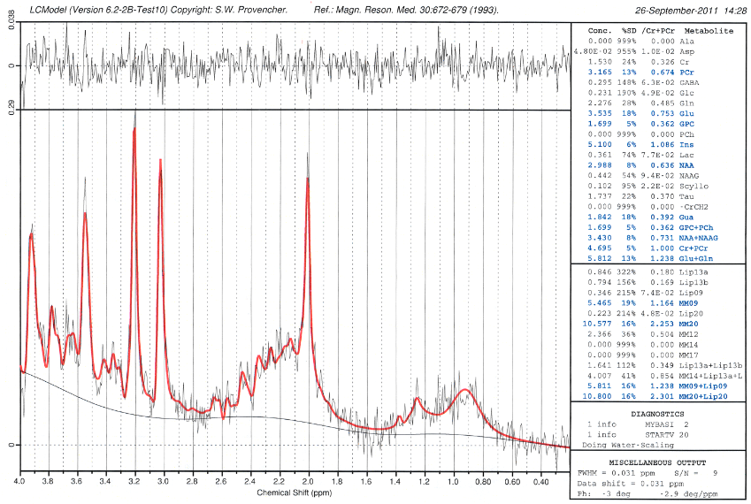  A | 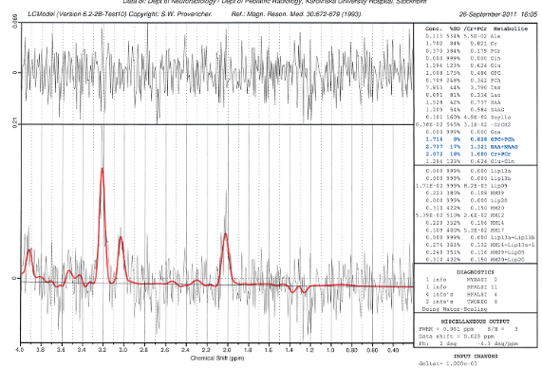
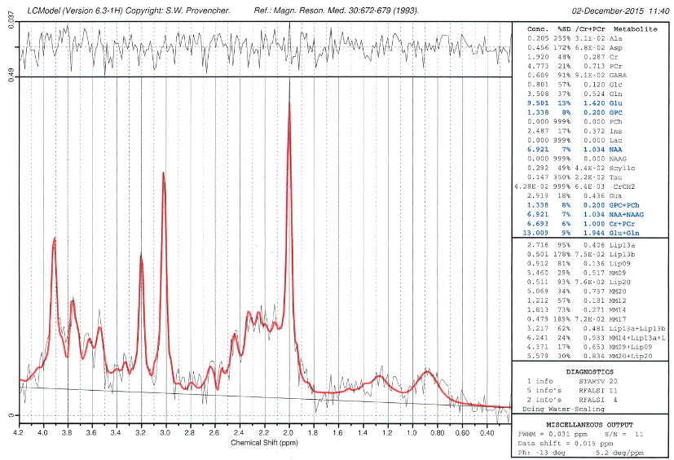  C | 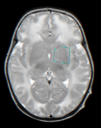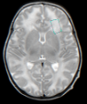  D  B

Figure e-1A-D. Magnetic resonance spectroscopy (MRS) of the proband (II:3). MRS quantification (LC Model, S Provencher) at 23 days in left basal ganglia TE30 (A), left frontal lobar white matter TE144 (B) and at 4 years in left basal ganglia TE35 (C). Localization of MRS voxel (D). In basal ganglia total NAA and Cr persistent lower than average for age while Cho is seen within normal (A, C). Initial low Glx is normalized. MRS in frontal white matter (B) detects normal Lac but low NAA and Cr.

