Figure e-2.
Schematic illustration of the cysteine and methionine catabolism pathway
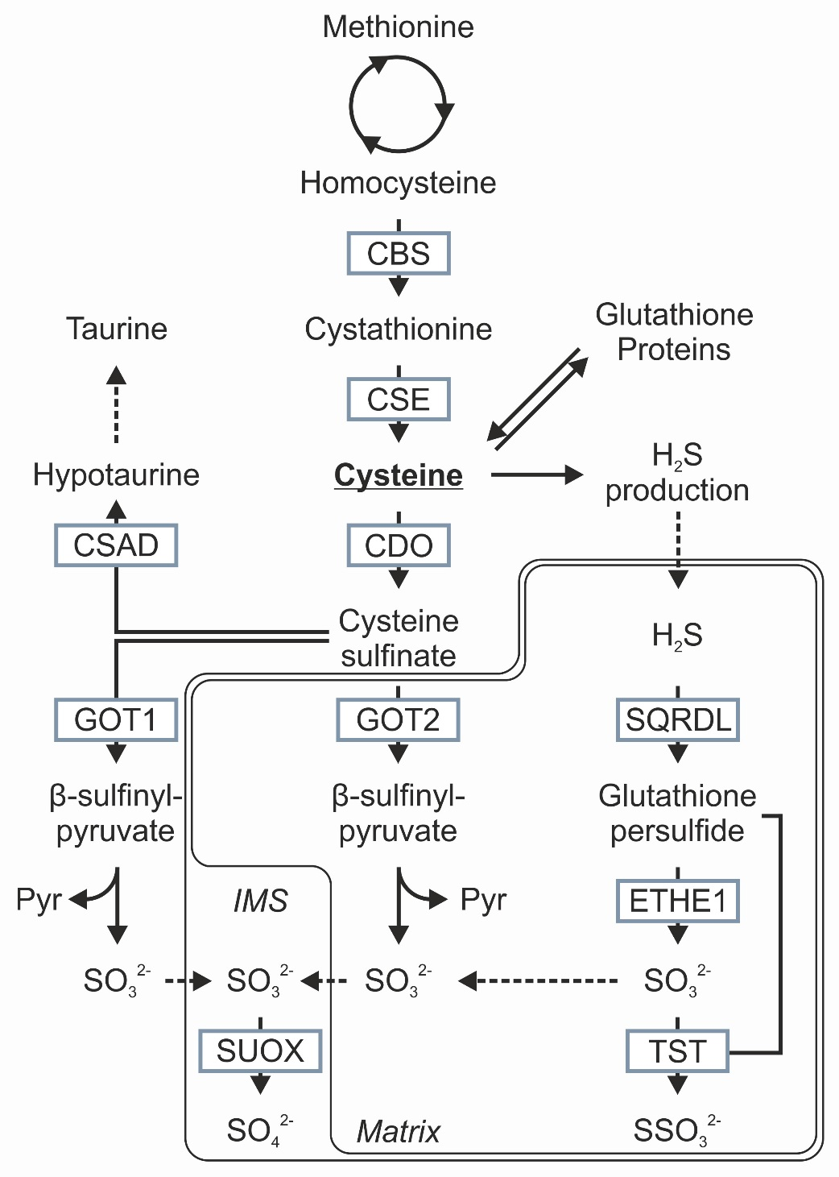

Sulfite oxidase (SUOX) is located in the inter mitochondrial membrane space (IMS) where it catalyzes the oxidation of sulfite (SO₃²⁻) to sulfate (SO₄²⁻). Pyr = pyruvate; SSO₃²⁻ = thiosulfate; H₂S = hydrogen sulfide.

