**Supplementary material**

‘Disease duration in autosomal dominant familial Alzheimer’s disease: A survival analysis’. Neurology, Genetics.I.M. Pavisic1,2#; J. Nicholas1,3; A. O’Connor1,2; H. Rice1,2; K. Lu1; N.C. Fox1,2*; N.S. Ryan1,2*

*1.Dementia Research Centre, Department of Neurodegenerative Diseases, UCL Queen Square Institute of Neurology, London, UK. 2.UK Dementia Research Institute at University College London, London, UK. 3.Department of Medial Statistics, London School of Hygiene and Tropical Medicine, London, UK*

*joint senior authors; #: corresponding author ([ivanna.pavisic.15@ucl.ac.uk](mailto:ivanna.pavisic.15@ucl.ac.uk))

**Methods**

**Procedures**

Intra-class correlation coefficient equation:

$$ICC=\frac{σ_{2}^{2}}{σ_{2}^{2}+σ_{1}^{2}}$$

Where:

* $σ_{2}^{2}$ is family membership variance or mutation specificity variance
* $σ_{1}^{2}$ is individual variance

For the Weibull accelerated failure time model the individual errors follow a Gumbel distribution with variance given by:

$$σ_{1}^{2}=\frac{π^{2}}{6p^{2}}$$

Where:

* *p=* ancillary parameter of the Weibull distribution

An ICC of zero indicates none of the variability in disease duration is explained by the random variable (e.g. family) while an ICC of one would indicate all of the variability is explained by the random variable.

**Results**

**Figure e-1 Flowchart of the inclusion process for the analysis**

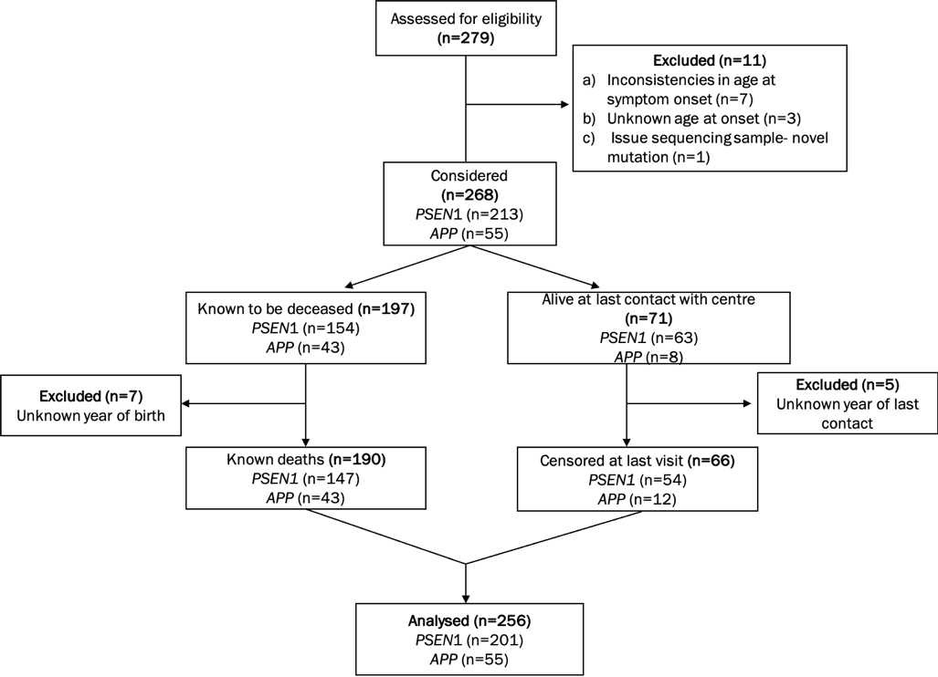

**Disease duration and age at onset**

**Figure e-2 Age at onset distribution in our cohort**

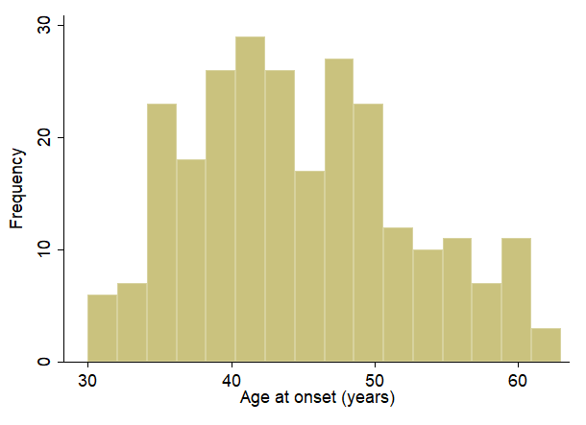

**Figure e-3 *PSEN1*: Symptom onset, age at death and disease duration by cognitive presentation**



Violin plots show the distribution of age at symptom onset, at death and disease duration by cognitive presentation: amnestic *vs* atypical. Data are median (line) with median IQR (upper and lower dotted lines). ‘*’ indicates significant difference between groups. Age at onset:41 [36-47] years vs 44 [41-50] years; age at death: 49 [44-56] years vs 62 [52-66] years and disease duration: 9 [7-12] years vs 14 [11-20] years. Green= amnestic presentations; Orange=atypical presentations.

**Figure e-4 *PSEN1* mutation carriers: Disease duration by exon position**

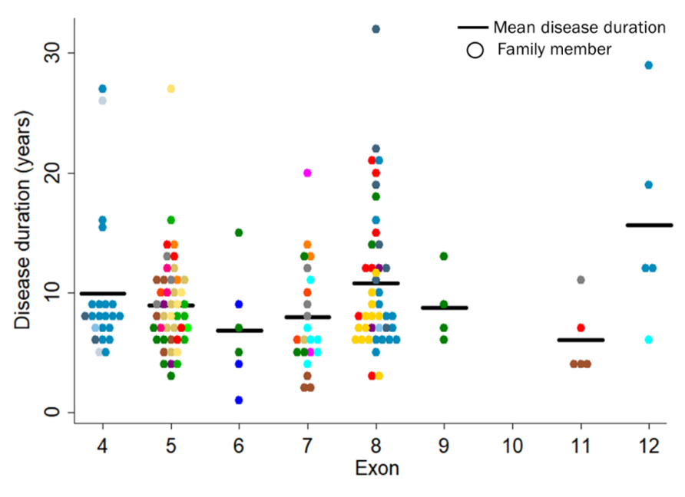

Each dot represents one individual’s disease duration. Within each exon, different colours represent separate families; multiple families with the same mutation are indicated by different shades of the same colour (blue, green, purple, or pink). Bars indicate mean disease duration (in years) for mutations involving each exon.

**Figure e-5 Disease duration distribution by *APOE* ε4 status**

|  |  |
| --- | --- |
| **A.** | |
| **B.** | **C.** |

**A.** Violin plots show the distribution of disease duration by *APOE* status: ε4 non-carrier *vs* ε4 carrier for *PSEN1* & *APP* genes together and *PSEN1* and *APP* separately. Data are median (line) with median IQR (upper and lower dotted lines).‘*’ indicates significant difference between groups. *PSEN1* & *APP*: 9 [6-12.4] years vs 11 [8.5-14.5]; *PSEN1*: 9 [7-12] years *vs* 14 [11-20] and *APP*: 12 [9-16] years *vs* 11.7[11-13]. **B.** Unadjusted Kaplan-Meier survival plots show the estimated survival probability by disease duration for *APOE* ε4 status within *PSEN1* mutations. **C**. Unadjusted Kaplan-Meier survival plots show the estimated survival probability by disease duration for *APOE* ε4 status within *APP* mutations.95% confidence intervals and number of individuals still alive per disease duration length: by 10 years, by 20 years and by 30 years are also shown. Blue=ε4 carriers; green=ε4 non-carrier*.*

**Figure e-6 *APOE* ε4 genotype by gene**

|  |  |
| --- | --- |
| **A.** | **B.** |

**A.** *PSEN1* mutations: disease durations by *APOE* ε4 status. Individual data is shown. Boxplot shows median values for each group and lower and upper percentiles [25-75]: ε4 non-carrier =8 years [6-12]; ε4 carrier=11 years [8-16]. **B.** *APP* mutations: disease durations by *APOE* ε4 status. Individual data is shown. Boxplot shows median values for each group and lower and upper percentiles [25-75]: ε4 non-carrier =12 years [9-16]; ε4 carrier=11.6 years [11-39]. ε4 homozygous carriers are indicated with red crosses in both groups.

**Table-e1*.*** Mutations carried by the individuals in our cohort (N=256).

|  |  |  |  |  |  |  |
| --- | --- | --- | --- | --- | --- | --- |
|  | **Exon** | **No. of families** | **No. affected individuals (range)** | **Mean age at onset, years (range)** | **Mean age at death, years (range)** | **Mean disease duration, years (range)** |
| ***APP*** |  |  | **N=55** |  |  |  |
| p.Ala692Gly | 17 | 1 | 4 | 46 (39-54) | 59 (51-65) | 12.8 (8-21) |
| p.Val715Ala | 17 | 1 | 1 | 42 | 51 | 9.0 |
| p.Val717Gly | 17 | 1 | 14 | 51 (40-61) | 64 (57-74) | 13.2 (6-23) |
| p.Val717Ile | 17 | 6 | 28 (1-10) | 52 (42-63) | 64 (54-75) | 10.2 (4-23) |
| p.Val717Leu | 17 | 1 | 5 | 49 (48-51) | 62 (60-64) | 12.5 (9-16) |
| p.Thr719Asn | 17 | 1 | 2 | 46 | 56 (55-56) | 9.5 (9-10) |
| p.Val717Phe | 17 | 1 | 1 | 38 | NA | NA |
| ***PSEN1*** |  |  | **N=201** |  |  |  |
| Intron 4 (g.23024delG) | 4 | 4 | 27 (2-21) | 38 (34-45) | 47 (41-69) | 9.9 (5-27) |
| p.Ala79Val | 4 | 1 | 1 | 52 | NA | NA |
| p.Tyr115Cys | 5 | 2 | 2 | 39 (34-44) | 50 (44-55) | 10.5 (10-11) |
| p.Tyr115His | 5 | 1 | 7 | 34 (30-40) | 42 (41-46) | 8.2 (5-11) |
| p.Thr116Asn | 5 | 1 | 1 | 34 | 43 | 9.0 |
| p.Glu120Lys | 5 | 2 | 7 (2-5) | 35.3 (31-39) | 43 .7(37-52) | 7.7 (3-16) |
| p.Ser132Ala | 5 | 1 | 3 | 59 (58-60) | 70 (67-73) | 11.0 (9-13) |
| p.Met139Val | 5 | 4 | 18 (3-8) | 40 (35-48) | 50 (41-75) | 10.1 (5-27) |
| p.Ile143Phe | 5 | 1 | 2 | 56 (53-59) | 60 | 7.0 |
| p.Met146Ile | 5 | 2 | 6 | 48 (43-50) | 55 (47-60) | 7.2 (3-12) |
| p.Leu153Val | 5 | 1 | 3 | 35 (35-36) | 44 (41-49) | 8.7 (6-13) |
| p.Tyr154Cys | 5 | 1 | 1 | 41 | NK | NK |
| p.Val142Ile | 5 | 1 | 2 | 51 (50-51) | 64 | 14.0 |
| p.Leu166Arg | 6 | 1 | 1 | 40 | NA | NA |
| p.Leu166del | 6 | 1 | 1 | 38 | NK | NK |
| Δ167 p.Ile168del | 6 | 1 | 1 | 43 | 52 | 9.0 |
| p.Leu171Pro | 6 | 1 | 5 | 42 (40-43) | 51 (47-57) | 9.0 (5-15) |
| p.Glu184Asp | 7 | 3 | 9 (1-5) | 41 (36-47) | 52 (48-58) | 10.8 (6-14) |
| p.Ile202Phe | 7 | 1 | 2 | 48 (47-48) | 60 (53-67) | 12.5 (5-20) |
| p.Gln222Pro | 7 | 1 | 1 | 45 | NK | NK |
| p.Gly206Val | 7 | 1 | 1 | 30 | 36 | 6.0 |
| p.Gly206Ala | 1 | 1 | 1 | 55 | NK | NK |
| p.Ile229Phe | 7 | 1 | 3 | 33 (32-34) | 35 (34-37) | 2.3 (2-3) |
| p.Leu235Val | 7 | 1 | 5 | 52.2 (44-59) | 61.3 (53-67) | 9.7 (8-12) |
| p.Phe237Leu | 7 | 1 | 1 | 47 | NK | NK |
| p.Leu250Ser | 7 | 1 | 7 | 52 (47-56) | 59 | 6.5 (4-11) |
| p.Ala246Cys | 7 | 1 | 4 | 55 (48-60) | 63.7 (53-73) | 7.7 (5-13) |
| p.Ala260Val | 8 | 1 | 1 | 40 | NK | NK |
| p.Cys263Phe | 8 | 1 | 1 | 59 | NK | NK |
| p.Pro264Leu | 8 | 3 | 5 (1-2) | 48 (44-56) | NK | NK |
| p.Pro267Ser | 8 | 1 | 3 | 39 (38-41) | 49 (45-52) | 9.5 (7-12) |
| p.Arg269His | 8 | 3 | 5 (1-2) | 56 (50-62) | 67 (64-69) | 16.0 (14-18) |
| p.Arg278Ile | 8 | 1 | 9 | 49 (41-59) | 64 (52-71) | 14.1 (8-21) |
| p.Glu280Gly | 8 | 3 | 22 (1-14) | 41 (38-49) | 53 (45-71) | 11.6 (5-32) |
| p.Phe283Leu | 8 | 1 | 11 | 46.9 (42-48) | 54.3 (48-58.6) | 7.6 (6-12) |
| p.Leu282Pro*** | 8 | 1 | 1 | 41 | NA | NA |
| p.Ser290Cys | 9 | 1 | 5 | 42 (41-44) | 51 (48-54) | 8.8 (6-13) |
| ΔE9* | 9 | 1 | 1 | 45 | NK | NK |
| p.Arg377Met | 11 | 1 | 1 | 38 | 49 | 11.0 |
| Gly378Val | 11 | 1 | 4 | 45.5 (41-50) | 50.3 (45-54) | 4.0 |
| p.Gly394Val | 11 | 1 | 1 | 40 | NK | NK |
| p.Pro436Ser | 12 | 1 | 6 | 46.3 (44-50) | 60.3 (56-69) | 14.3 (12-19) |
| p.Leu424Val | 12 | 1 | 1 | 45 | 51 | 6.0 |
| p.Pro433Ser*** | 12 | 1 | 1 | 37 | 66 | 29 |
| p.Thr291Ala and p.Ala434Thr** | 9 & 12 | 1 | 1 | 42 | 47 | 5.0 |
| **The exon 9 deletion (NM_000021.3:c.869–1G→T; p.Ser290Cys; Thr291_Ser319del) is commonly referred to as ΔE9. | | | | | | |
| ** One patient had both Thr291Ala on exon 9 and Ala434Thr on exon 12 (Ryan et al. 2016). | | | | | | |
| *** Novel mutations | | | | | | |

NA= not applicable as individuals were still alive. NK= not known.

**Table-e2.** Disease duration by *APOE* ε4 genotype in our cohort, estimated mean survival time, and effects from survival model.

|  |  |  |  |  |  |  |
| --- | --- | --- | --- | --- | --- | --- |
| ***APOE* ε4 genotype (N=127)** | **Disease duration:**  **Mean [SD] (years)** | **Disease duration: Range (years)** | **Estimated survival (years) [95%CI]** | **Time Ratio (TR)** | **TR: 95%CI** | ***p* value** |
| ***PSEN1* & *APP*** | | | | | |  |
| ε4 non-carriers | 10.4 [5.2] | 2-27 | 11.4 [10.0-12.8] | Reference | |  |
| ε4 heterozygous carriers | 13.2 [6.6] | 6-32 | 13.7 [11.3-16.0] | 1.20 | 1.00-1.46 | 0.056 |
| ***PSEN1*** |  |  |  |  |  |  |
| ε4 non-carriers | 9.5 [4.7] | 2-27 | 10.6 [9.0-12.1] | Reference | |  |
| ε4 heterozygous carriers | 13.4 [6.8] | 7-32 | 13.7 [11.1-16.3] | 1.30 | 1.04-1.62 | **0.023\*** |
| ***APP*** |  |  |  |  |  |  |
| ε4 non-carriers | 12.8 [5.8] | 4-23 | 13.5 [10.1-17.0] | Reference | |  |
| ε4 heterozygous carriers | 12.7 [6.3] | 6-23 | 12.3 [7.4-17.3] | 0.91 | 0.59-1.40 | 0.677 |

Disease duration was calculated from individuals with known ages at death only and estimated mean survival additionally included censored data. Times Ratio, 95%CI (confidence intervals) and *p* value encompass the effects of the survival model. Statistically significant values are referenced in bold and ‘*’.