MMP-degraded type I collagen is associated with APOE/TOMM40 variants and preclinical dementia
Tang MH^{1*}, Blair JPM^{1, 2}, Bager CL¹, Bay-Jensen AC³, Henriksen K⁴, Christiansen C³, Karsdal MA³.

¹ ProScion, Herlev, Denmark
² University of Copenhagen, Faculty of Health and Medical Sciences, Copenhagen, Denmark
³ ImmunoScience, Nordic Bioscience, Biomarkers and Research, Herlev, Denmark
⁴ Endocrinology, Nordic Bioscience, Biomarkers and Research, Herlev, Denmark
*Corresponding author:
Dr. Man-Hung Eric Tang
ProScion, Herlev Hovedgade 205-207
DK-2730
Herlev, Denmark
E-mail: met@nordicbio.com

Supplementary figures

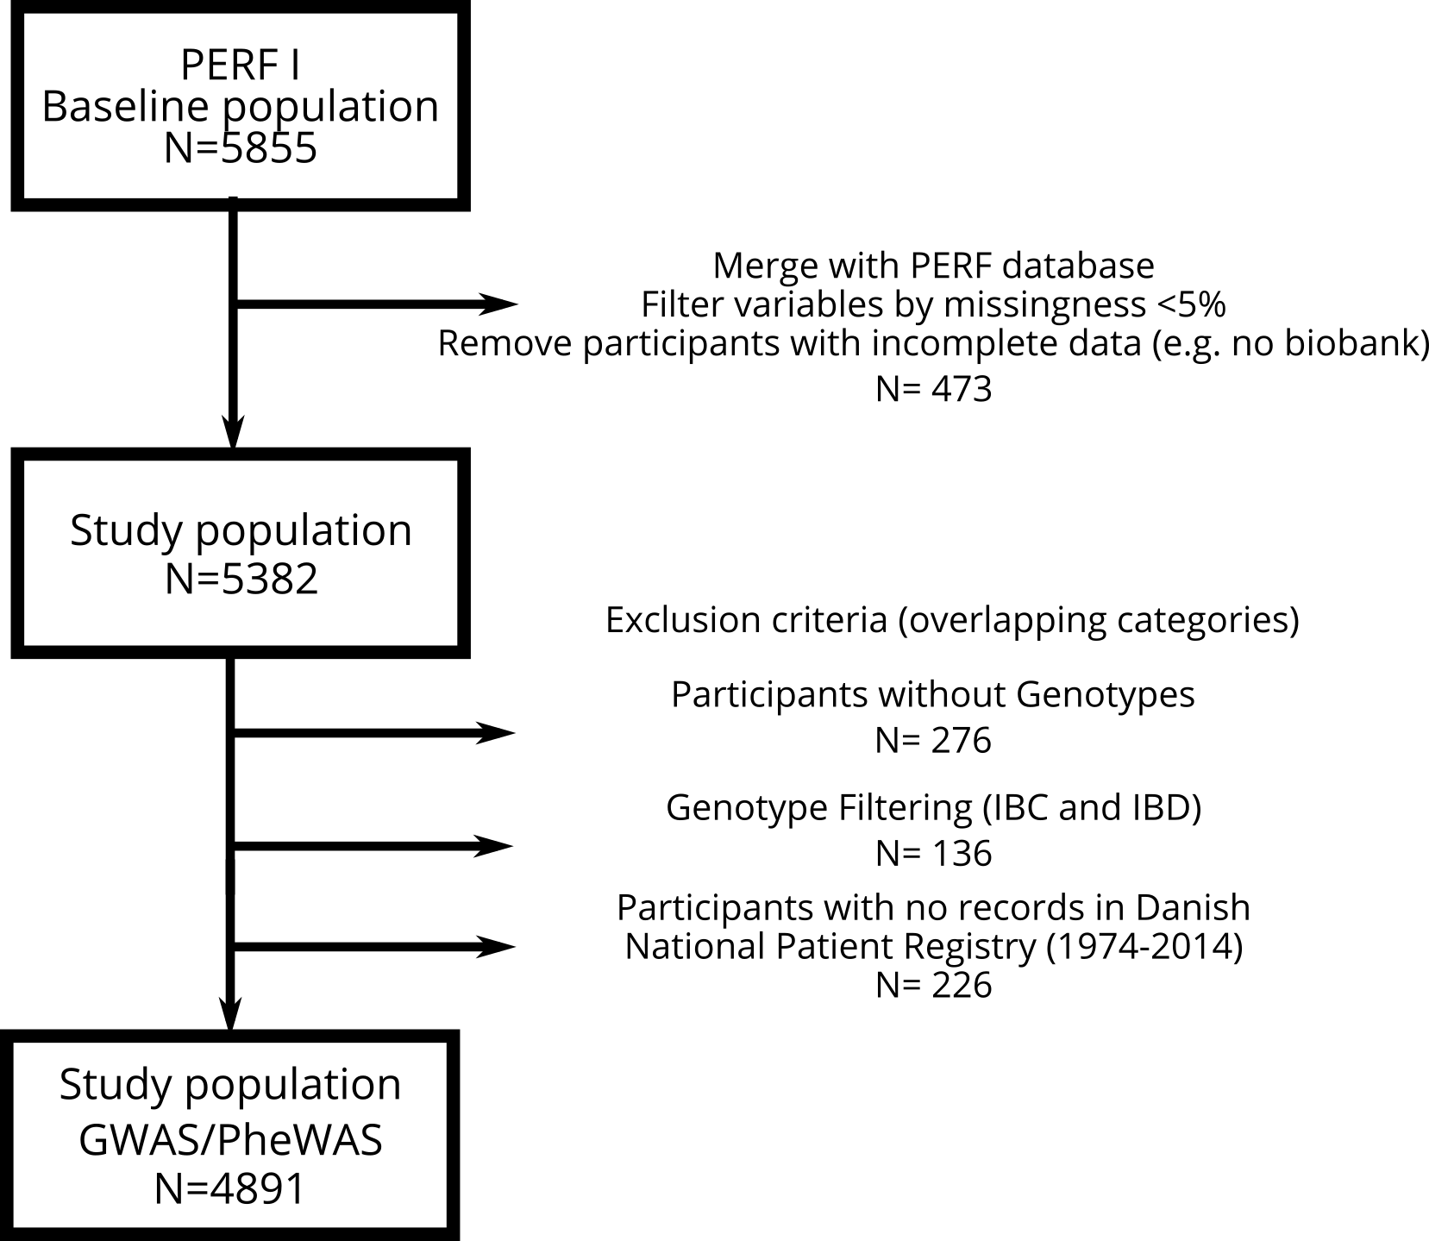

Figure e-1: Study participant inclusion flowchart.

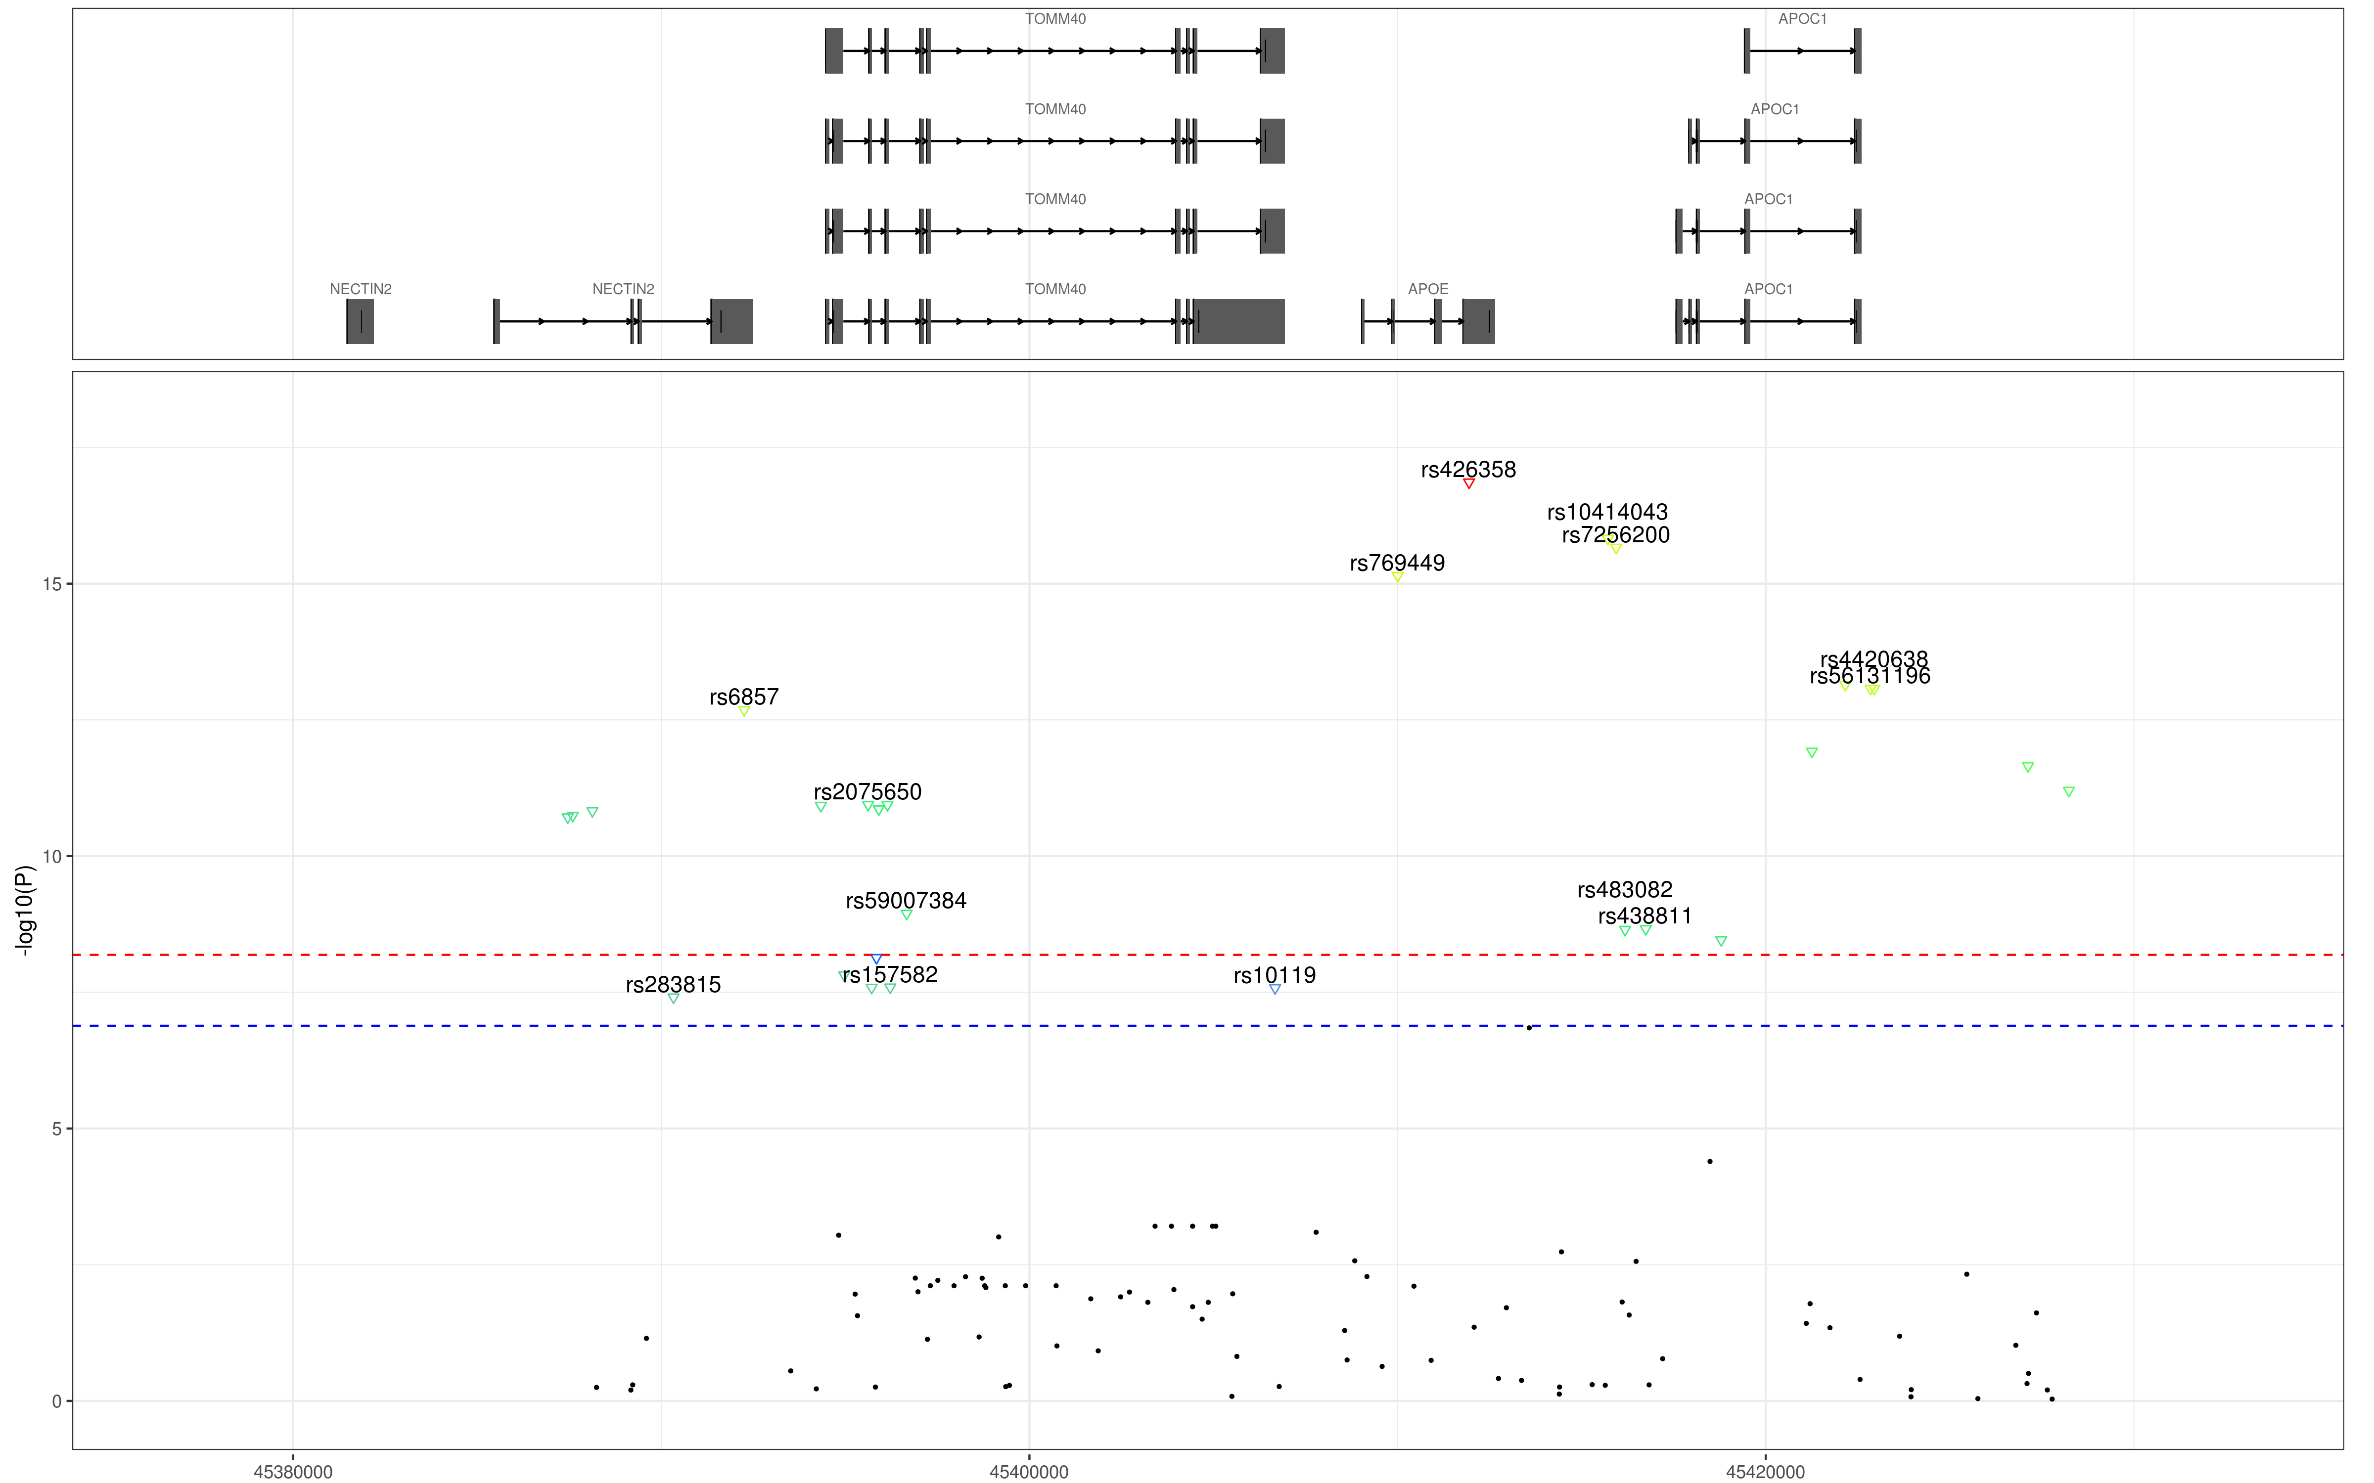
Figure e-2: Zoomed-in Manhattan plot of the chr19 APOE-C1/TOMM40 gene locus for GWAS screen for association with the biomarker C1M. The red and blue dotted-lines show the genome-wide and suggestive significance cut-offs, adjusted to the number of tests (6.5e-9 and 1.3e-7 respectively). Downward-pointing symbols indicate negative and upward-pointing symbols positive effect sizes of the association to the SNP. Symbols of the same color are in linkage between each other. Non-significant association are shown as small black dots.
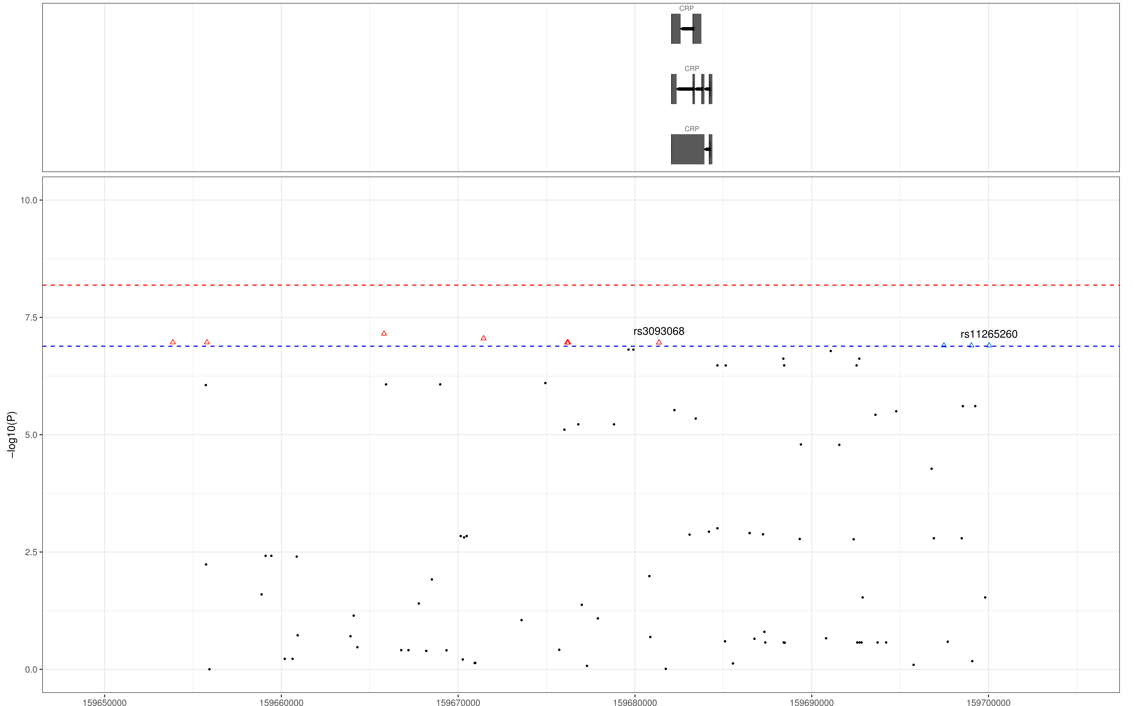
Figure e-3: Zoomed-in Manhattan plot of the chr1 CRP gene locus of the GWAS screen for association with the biomarker C1M. The red and blue dotted-lines show the genome-wide and suggestive significance cut-offs, adjusted to the number of tests (6.5e-9 and 1.3e-7 respectively). Downward-pointing symbols indicate negative and upward-pointing symbols positive effect sizes of the association to the SNP. Symbols of the same color are in linkage between each other. Non-significant association are shown as small black dots.

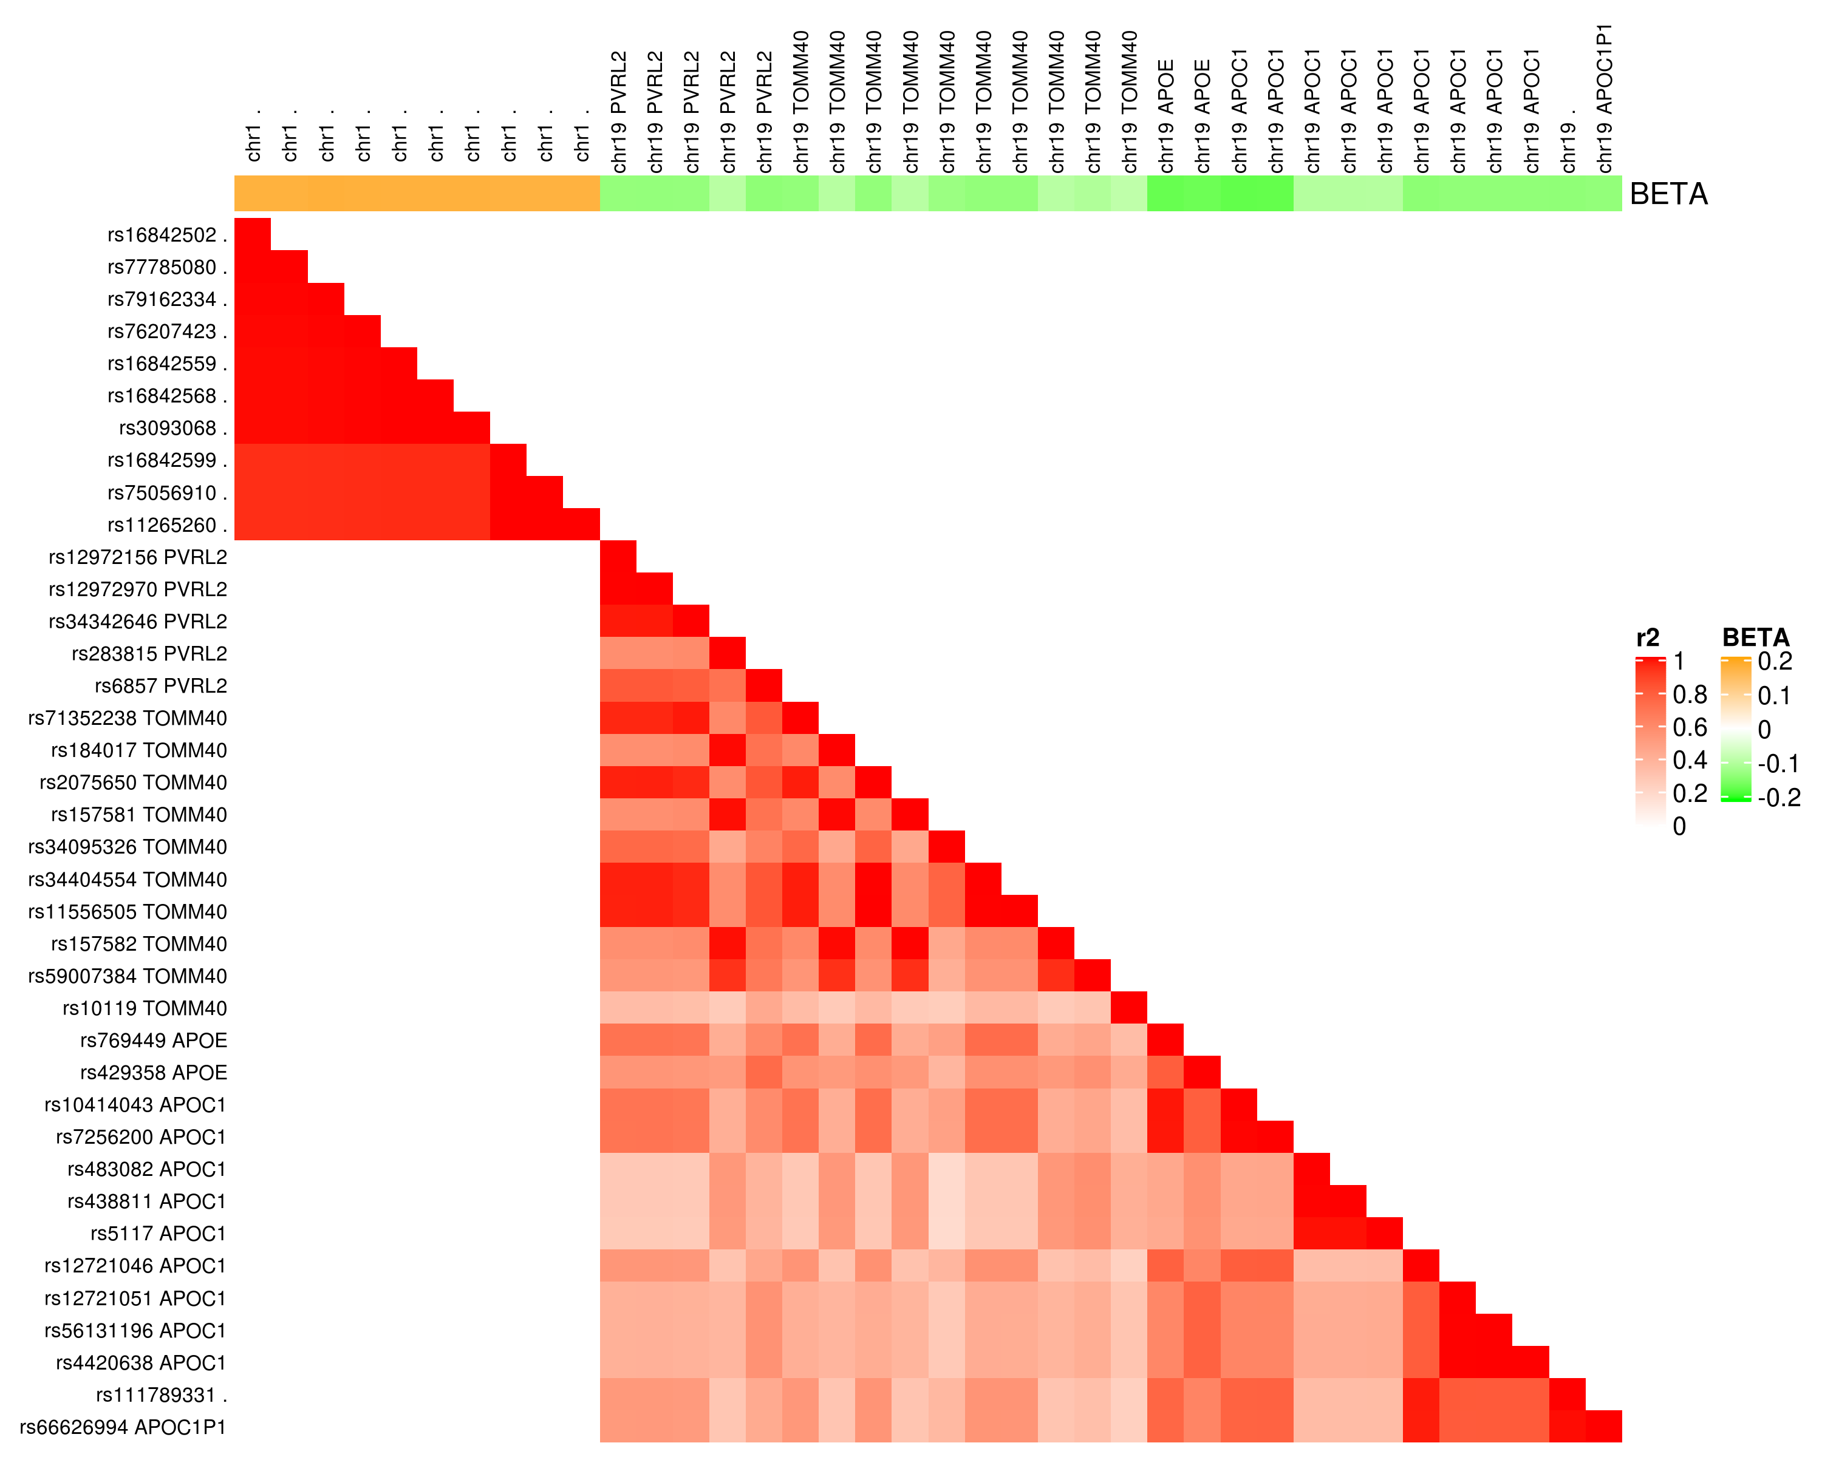
Figure e-4: Linkage Disequilibrium of the significant associations with C1M.
Variants in the plot are sorted in their genomic order and chromosome and satisfy the standard suggestive association threshold. Chromosome number and effect-size of the associations with C1M is shown on the horizontal annotation bar.

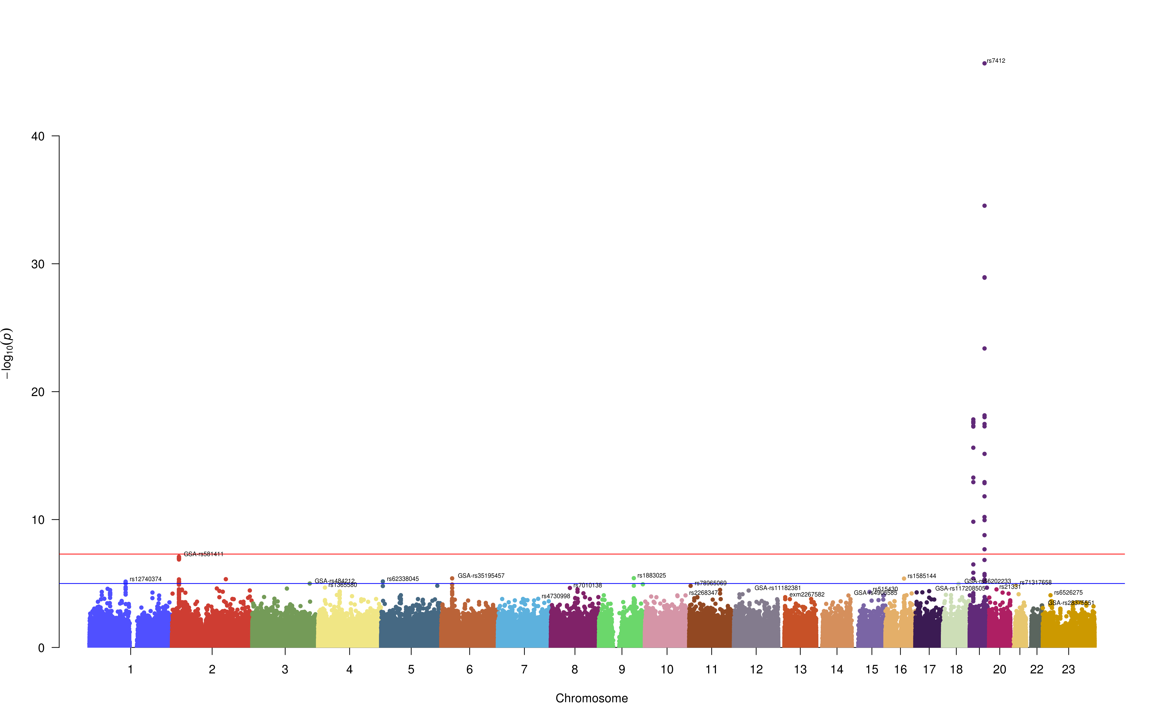
Figure e-5: Single Nucleotide Polymorphisms associated with log2 levels of total cholesterol in serum. Genome-wide and suggestive significance thresholds (5e-8 and 1e-5 respectively) are indicated by the red and blue lines.

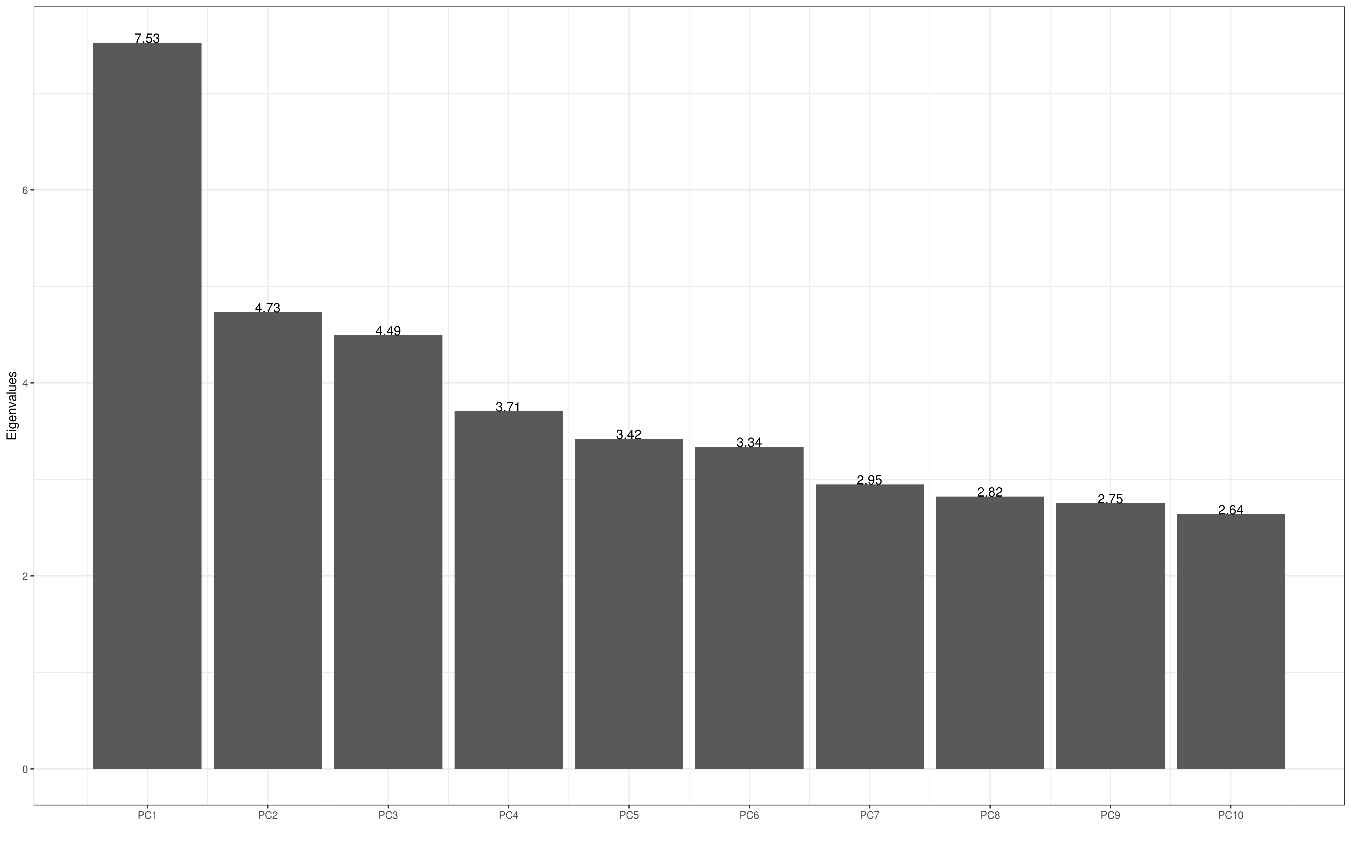
Figure e-6: Scree plot of the first 10 leading components of the PCA of the PERF genotypes (N=5106)
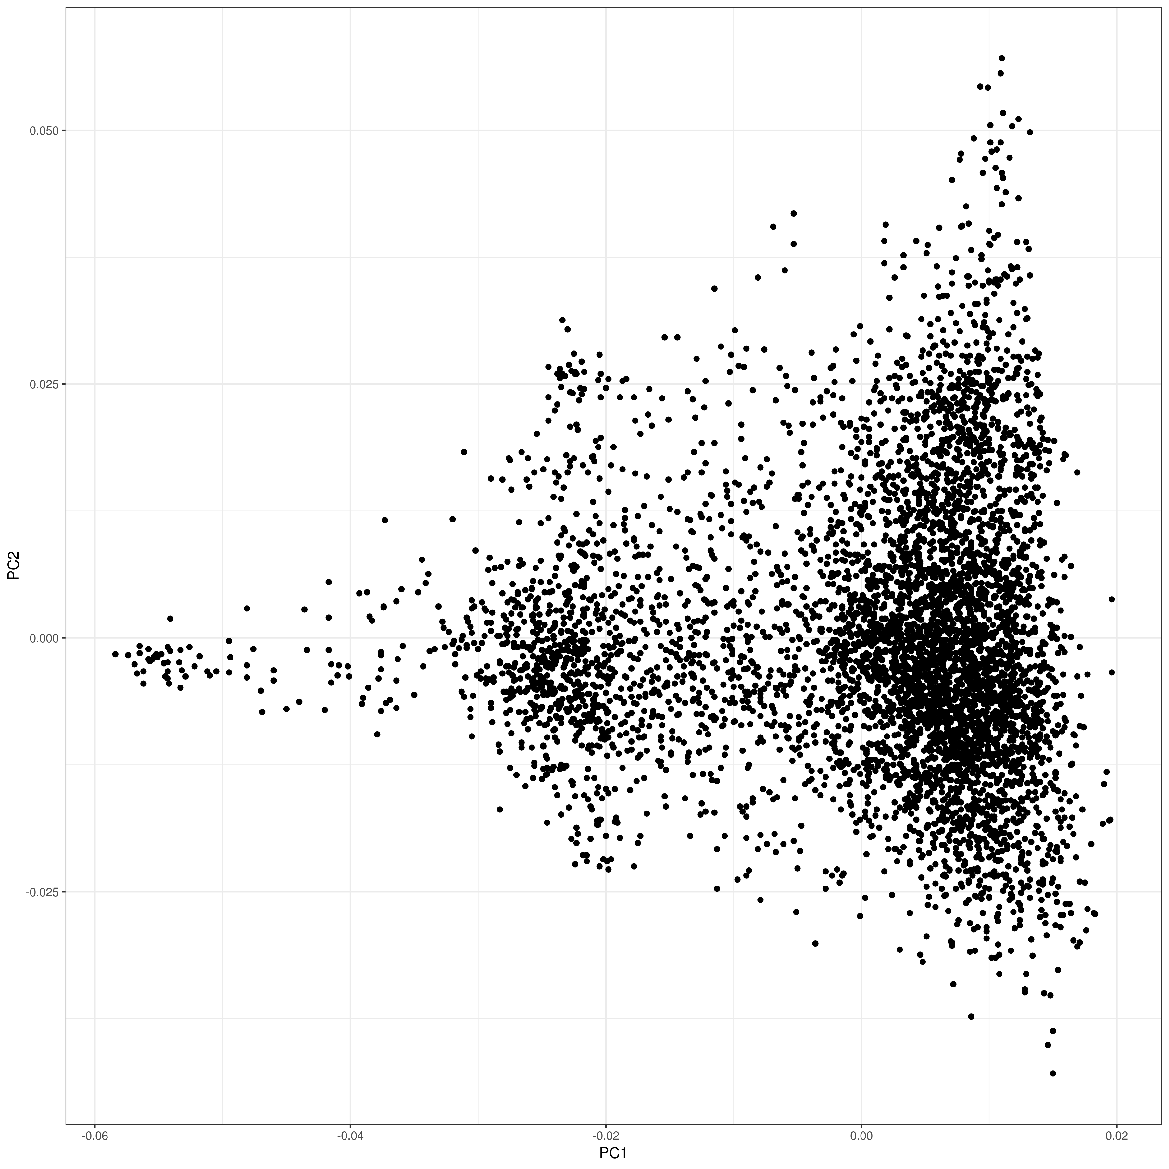
Figure e-7: Plot of the two leading principal components of the PERF genotypes (N=5106)

Supplementary tables

Table e-1: Genetic associations with C1M performed on imputed genotypes. p-values below 1.3e-7, effect sizes and minor allele frequencies and nearest genes are indicated for each associated SNP.
CHR | BP | Minor allele | Effect size | SE | L95 | U95 | P | MAF | Nearest Gene | Rsid | Imputed  position | Clump
19 | 45411941 | C | -0.1619 | 0.02 | -0.1989 | -0.1248 | 1.376E-17 | 0.16 | APOE | rs429358 | Y | 1
19 | 45415713 | A | -0.169 | 0.02 | -0.209 | -0.1291 | 1.489E-16 | 0.13 | APOC1 | rs10414043 | Y | 1
19 | 45415935 | T | -0.1682 | 0.02 | -0.2082 | -0.1282 | 2.17E-16 | 0.13 | APOC1 | rs7256200 | Y | 1
19 | 45410002 | A | -0.1658 | 0.02 | -0.2059 | -0.1256 | 7.149E-16 | 0.13 | APOE | rs769449 | N | 1
19 | 45422160 | G | -0.1327 | 0.02 | -0.1674 | -0.09809 | 7.133E-14 | 0.19 | APOC1 | rs12721051 | Y | 1
19 | 45422846 | A | -0.1323 | 0.02 | -0.167 | -0.09769 | 8.437E-14 | 0.19 | APOC1 | rs56131196 | N | 1
19 | 45422946 | G | -0.1323 | 0.02 | -0.167 | -0.09769 | 8.437E-14 | 0.19 | APOC1 | rs4420638 | N | 1
19 | 45392254 | T | -0.134 | 0.02 | -0.1697 | -0.09837 | 2.074E-13 | 0.18 | PVRL2 | rs6857 | N | 1
19 | 45421254 | A | -0.1359 | 0.02 | -0.1733 | -0.09851 | 1.198E-12 | 0.16 | APOC1 | rs12721046 | Y | 1
19 | 45427125 | A | -0.1333 | 0.02 | -0.1704 | -0.09619 | 2.217E-12 | 0.16 | . | rs111789331 | Y | 1
19 | 45428234 | A | -0.1307 | 0.02 | -0.1678 | -0.09349 | 6.255E-12 | 0.16 | APOC1P1 | rs66626994 | Y | 1
19 | 45395619 | G | -0.1307 | 0.02 | -0.1684 | -0.09308 | 1.144E-11 | 0.15 | TOMM40 | rs2075650 | Y | 1
19 | 45396144 | T | -0.1307 | 0.02 | -0.1684 | -0.09308 | 1.144E-11 | 0.15 | TOMM40 | rs11556505 | Y | 1
19 | 45394336 | C | -0.1303 | 0.02 | -0.1678 | -0.0927 | 1.186E-11 | 0.16 | TOMM40 | rs71352238 | Y | 1
19 | 45395909 | G | -0.1303 | 0.02 | -0.1679 | -0.09259 | 1.372E-11 | 0.15 | TOMM40 | rs34404554 | Y | 1
19 | 45388130 | A | -0.129 | 0.02 | -0.1664 | -0.09163 | 1.481E-11 | 0.16 | PVRL2 | rs34342646 | Y | 1
19 | 45387596 | A | -0.1294 | 0.02 | -0.167 | -0.09174 | 1.815E-11 | 0.15 | PVRL2 | rs12972970 | Y | 1
19 | 45387459 | G | -0.1292 | 0.02 | -0.1669 | -0.09158 | 1.927E-11 | 0.15 | PVRL2 | rs12972156 | Y | 1
19 | 45396665 | T | -0.1017 | 0.02 | -0.1344 | -0.06904 | 1.132E-09 | 0.23 | TOMM40 | rs59007384 | N | 1
19 | 45416741 | T | -0.09688 | 0.02 | -0.1285 | -0.06521 | 2.166E-09 | 0.25 | APOC1 | rs438811 | Y | 1
19 | 45416178 | T | -0.09685 | 0.02 | -0.1285 | -0.06517 | 2.236E-09 | 0.25 | APOC1 | rs483082 | Y | 1
19 | 45418790 | C | -0.09601 | 0.02 | -0.1278 | -0.06422 | 3.461E-09 | 0.25 | APOC1 | rs5117 | Y | 1
19 | 45395844 | A | -0.123 | 0.02 | -0.1646 | -0.08136 | 7.344E-09 | 0.12 | TOMM40 | rs34095326 | Y | 2
19 | 45394969 | G | -0.09382 | 0.02 | -0.1263 | -0.06138 | 1.521E-08 | 0.23 | TOMM40 | rs184017 | Y | 1
19 | 45396219 | T | -0.09216 | 0.02 | -0.1245 | -0.05978 | 2.557E-08 | 0.23 | TOMM40 | rs157582 | N | 1
19 | 45395714 | C | -0.09212 | 0.02 | -0.1245 | -0.05974 | 2.589E-08 | 0.23 | TOMM40 | rs157581 | Y | 1
19 | 45406673 | A | -0.08464 | 0.02 | -0.1144 | -0.05488 | 2.622E-08 | 0.29 | TOMM40 | rs10119 | Y | 3
19 | 45390333 | G | -0.09128 | 0.02 | -0.1238 | -0.05878 | 3.894E-08 | 0.23 | PVRL2 | rs283815 | N | 1
1 | 159665806 | A | 0.1737 | 0.03 | 0.1106 | 0.2367 | 7.053E-08 | 0.05 | . | rs79162334 | Y | 4
1 | 159671439 | A | 0.1725 | 0.03 | 0.1094 | 0.2356 | 8.874E-08 | 0.05 | . | rs76207423 | Y | 4
1 | 159653863 | A | 0.1711 | 0.03 | 0.108 | 0.2341 | 1.079E-07 | 0.05 | . | rs16842502 | N | 4
1 | 159655792 | G | 0.1711 | 0.03 | 0.108 | 0.2341 | 1.079E-07 | 0.05 | . | rs77785080 | Y | 4
1 | 159676171 | C | 0.1718 | 0.03 | 0.1085 | 0.2352 | 1.089E-07 | 0.05 | . | rs16842559 | N | 4
1 | 159676220 | G | 0.1718 | 0.03 | 0.1085 | 0.2352 | 1.089E-07 | 0.05 | . | rs16842568 | N | 4
1 | 159681364 | C | 0.1718 | 0.03 | 0.1085 | 0.2352 | 1.089E-07 | 0.05 | . | rs3093068 | Y | 4
1 | 159697475 | C | 0.1692 | 0.03 | 0.1065 | 0.2318 | 1.256E-07 | 0.05 | . | rs16842599 | N | 4
1 | 159699031 | C | 0.1692 | 0.03 | 0.1065 | 0.2318 | 1.256E-07 | 0.05 | . | rs75056910 | N | 4
1 | 159700039 | G | 0.1692 | 0.03 | 0.1065 | 0.2318 | 1.256E-07 | 0.05 | . | rs11265260 | Y | 4

Supplementary Table e-2: Phenotype definition criteria
Disease | Criteria
Hyperlipidemia | - Fasting serum cholesterol >7.5mm/L and/or
 | - Answered yes to having hyperlipidemia and/or
 | - E780-785 (ICD10 code) in the Danish patient registry or death registry
Diabetes | - Registered in the diabetes registry and/or
 | - Fasting serum glucose >= 7 mmol/L and/or
 | - Fasting serum HbA1c levels ≥48 mmol/mol and/or
 | - E10-E14, DO24, DH360 (ICD10 codes) in the death registry and/or
 | - Answered yes to having diabetes
Dementia | - F01-F03 G31-G32 or R54 (ICD10 code) in the Danish patient registry or death registry and/or
 | - The Short Blessed Test (SBT) ≥10 and the category fluency test with animal naming (CFT) ≤14 and/or
 | - Answered yes to having dementia
Alzheimer’s disease | - F00 + G30 (ICD10 code) in the Danish patient registry or death registry and/or
 | - Answered yes to having Alzheimer’s disease
Ischemic heart disease | - I21, 22, 24, 25 (ICD10 code) in the Danish patient registry or death registry and/or
 | - Answered yes to having ischemic heart disease
Peripheral arterial disease | - IDC10 I70.2, I73.9 (ICD10 code) in the Danish patient registry or death registry and/or
 | - Answered yes to having peripheral arterial disease
Congestive heart failure | - I50 (ICD10 code) in the Danish patient registry or death registry and/or
 | - Answered yes to having congestive heart failure
Cerebrovascular diseases | - I60-I69 (ICD10 code) in the Danish patient registry or death and/or registry
 | - Answered yes to having cerebrovascular disease
CVD | - I20-I25, I30-I52 or I60-69 (ICD10 code) in the Danish patient registry or death registry and/or
 | - Answered yes to having CVD
Respiratory diseases | - J00-J99 (ICD10 code) in the Danish patient registry or death registry and/or
 | - Answered yes to having respiratory disease
Digestive diseases | - K00-K99 (ICD10 code) in the Danish patient registry or death registry and/or
 | - Answered yes to having digestive disease
Genitourinary diseases | - N00-N99 (ICD10 code) in the Danish patient registry or death registry and/or
 | - Answered yes to having genitourinary disease
Musculoskeletal diseases | - M00-M99 (ICD10 code) in the Danish patient registry or death registry and/or
 | - Answered yes to having musculoskeletal disease
Neoplasms | - C00-C97 (except C44) or D37-48 (ICD10 code) in the Danish patient registry or death registry and/or
 | - Answered yes to having a neoplasm

Supplementary Table e-3: APOE genotype in the study population. All available genotypes were considered (N=5106)
Rs7412->  rs429358 | | 0 allele | 1 alleles | 2 alleles
0 allele | TC/TC  E3/E3  2860 (56.0%) | TT/TC  E2/E3  675 (13.2%) | TT/TT  E2/E2  37 (0.7%)
1 alleles | TC/CC  E3/E4  1275 (25.0%) | TT/CC  E2/E4  139 (2.7%) | TT/CT (not observed)
2 alleles | CC/CC  E4/E4  120 (2.4%) | CT/CC (not observed) | CT/CT (not observed)

Supplementary Table e-4: APOE allele distribution in PERF population with and without Alzheimer disease post baseline.
 | AD=0 | AD=1
E2/E2 | 36  0.8% | 0  0%
E2/E3 | 636  13.5% | 32  10.0%
E2/E4 | 124  2.6% | 9  2.9%
E3/E3 | 2690  57.2% | 120 38.9%
E3/E4 | 1126  24.0% | 122  39.6%
E4/E4 | 92  2.0% | 25  8.1%
Non E4 | 3362 | 152
E4 | 1342 | 156

Supplementary Table e-5: PheWAS association analysis of the 38 identified markers associated to C1M. Absolute Z-scores above 1.5 are reported.
rsid - Nearest gene | SNP | Phenotype | Z-score | p-value
rs429358 APOE | 19:45411941 | Alzheimers | 9.47 | 2.70E-21
rs7256200 APOC1 | 19:45415935 | Alzheimers | 9.16 | 5.01E-20
rs10414043 APOC1 | 19:45415713 | Alzheimers | 9.14 | 6.43E-20
rs769449 APOE | 19:45410002 | Alzheimers | 9.12 | 7.40E-20
rs429358 APOE | 19:45411941 | Dementia | 8.72 | 2.84E-18
rs12721051 APOC1 | 19:45422160 | Alzheimers | 8.32 | 8.59E-17
rs56131196 APOC1 | 19:45422846 | Alzheimers | 8.32 | 9.16E-17
rs4420638 APOC1 | 19:45422946 | Alzheimers | 8.32 | 9.16E-17
rs12721046 APOC1 | 19:45421254 | Alzheimers | 8.21 | 2.19E-16
rs111789331 . | 19:45427125 | Alzheimers | 8.19 | 2.62E-16
rs66626994 APOC1P1 | 19:45428234 | Alzheimers | 8.13 | 4.47E-16
rs12721051 APOC1 | 19:45422160 | Dementia | 7.89 | 2.98E-15
rs56131196 APOC1 | 19:45422846 | Dementia | 7.88 | 3.27E-15
rs4420638 APOC1 | 19:45422946 | Dementia | 7.88 | 3.27E-15
rs769449 APOE | 19:45410002 | Dementia | 7.83 | 4.72E-15
rs7256200 APOC1 | 19:45415935 | Dementia | 7.83 | 4.78E-15
rs10414043 APOC1 | 19:45415713 | Dementia | 7.79 | 6.77E-15
rs6857 PVRL2 | 19:45392254 | Alzheimers | 7.65 | 2.01E-14
rs34404554 TOMM40 | 19:45395909 | Alzheimers | 7.51 | 5.71E-14
rs2075650 TOMM40 | 19:45395619 | Alzheimers | 7.50 | 6.38E-14
rs11556505 TOMM40 | 19:45396144 | Alzheimers | 7.50 | 6.38E-14
rs12972156 PVRL2 | 19:45387459 | Alzheimers | 7.29 | 3.14E-13
rs12972970 PVRL2 | 19:45387596 | Alzheimers | 7.28 | 3.34E-13
rs71352238 TOMM40 | 19:45394336 | Alzheimers | 7.27 | 3.65E-13
rs12721046 APOC1 | 19:45421254 | Dementia | 7.20 | 5.99E-13
rs34342646 PVRL2 | 19:45388130 | Alzheimers | 7.13 | 9.94E-13
rs111789331 . | 19:45427125 | Dementia | 7.12 | 1.10E-12
rs66626994 APOC1P1 | 19:45428234 | Dementia | 7.10 | 1.28E-12
rs59007384 TOMM40 | 19:45396665 | Alzheimers | 7.07 | 1.60E-12
rs34095326 TOMM40 | 19:45395844 | Alzheimers | 6.95 | 3.70E-12
rs5117 APOC1 | 19:45418790 | Alzheimers | 6.94 | 3.92E-12
rs6857 PVRL2 | 19:45392254 | Dementia | 6.87 | 6.49E-12
rs483082 APOC1 | 19:45416178 | Alzheimers | 6.82 | 8.80E-12
rs438811 APOC1 | 19:45416741 | Alzheimers | 6.82 | 9.42E-12
rs157582 TOMM40 | 19:45396219 | Alzheimers | 6.55 | 5.79E-11
rs157581 TOMM40 | 19:45395714 | Alzheimers | 6.55 | 5.95E-11
rs184017 TOMM40 | 19:45394969 | Alzheimers | 6.51 | 7.36E-11
rs283815 PVRL2 | 19:45390333 | Alzheimers | 6.36 | 2.08E-10
rs6857 PVRL2 | 19:45392254 | Hyperlipidemia | 6.32 | 2.60E-10
rs34095326 TOMM40 | 19:45395844 | Hyperlipidemia | 6.32 | 2.62E-10
rs34404554 TOMM40 | 19:45395909 | Hyperlipidemia | 6.19 | 5.94E-10
rs2075650 TOMM40 | 19:45395619 | Hyperlipidemia | 6.17 | 6.63E-10
rs11556505 TOMM40 | 19:45396144 | Hyperlipidemia | 6.17 | 6.63E-10
rs71352238 TOMM40 | 19:45394336 | Hyperlipidemia | 6.01 | 1.82E-09
rs34404554 TOMM40 | 19:45395909 | Dementia | 6.00 | 2.01E-09
rs2075650 TOMM40 | 19:45395619 | Dementia | 5.97 | 2.31E-09
rs11556505 TOMM40 | 19:45396144 | Dementia | 5.97 | 2.31E-09
rs12972156 PVRL2 | 19:45387459 | Hyperlipidemia | 5.93 | 3.00E-09
rs12972970 PVRL2 | 19:45387596 | Hyperlipidemia | 5.91 | 3.39E-09
rs34342646 PVRL2 | 19:45388130 | Hyperlipidemia | 5.82 | 5.84E-09
rs12972156 PVRL2 | 19:45387459 | Dementia | 5.73 | 9.97E-09
rs12972970 PVRL2 | 19:45387596 | Dementia | 5.72 | 1.07E-08
rs10119 TOMM40 | 19:45406673 | Dementia | 5.66 | 1.48E-08
rs71352238 TOMM40 | 19:45394336 | Dementia | 5.62 | 1.86E-08
rs429358 APOE | 19:45411941 | Hyperlipidemia | 5.55 | 2.84E-08
rs59007384 TOMM40 | 19:45396665 | Dementia | 5.54 | 3.09E-08
rs34342646 PVRL2 | 19:45388130 | Dementia | 5.53 | 3.26E-08
rs10119 TOMM40 | 19:45406673 | Alzheimers | 5.46 | 4.89E-08
rs10414043 APOC1 | 19:45415713 | Hyperlipidemia | 5.40 | 6.61E-08
rs12721051 APOC1 | 19:45422160 | Hyperlipidemia | 5.39 | 7.12E-08
rs56131196 APOC1 | 19:45422846 | Hyperlipidemia | 5.37 | 7.77E-08
rs4420638 APOC1 | 19:45422946 | Hyperlipidemia | 5.37 | 7.77E-08
rs66626994 APOC1P1 | 19:45428234 | Hyperlipidemia | 5.29 | 1.20E-07
rs34095326 TOMM40 | 19:45395844 | Dementia | 5.29 | 1.21E-07
rs7256200 APOC1 | 19:45415935 | Hyperlipidemia | 5.29 | 1.23E-07
rs483082 APOC1 | 19:45416178 | Dementia | 5.29 | 1.24E-07
rs5117 APOC1 | 19:45418790 | Dementia | 5.29 | 1.25E-07
rs438811 APOC1 | 19:45416741 | Dementia | 5.27 | 1.34E-07
rs111789331 . | 19:45427125 | Hyperlipidemia | 5.18 | 2.20E-07
rs769449 APOE | 19:45410002 | Hyperlipidemia | 5.18 | 2.22E-07
rs12721046 APOC1 | 19:45421254 | Hyperlipidemia | 5.12 | 3.04E-07
rs157582 TOMM40 | 19:45396219 | Dementia | 5.07 | 3.90E-07
rs157581 TOMM40 | 19:45395714 | Dementia | 5.07 | 4.04E-07
rs184017 TOMM40 | 19:45394969 | Dementia | 4.93 | 8.19E-07
rs283815 PVRL2 | 19:45390333 | Dementia | 4.90 | 9.67E-07
rs10119 TOMM40 | 19:45406673 | Hyperlipidemia | 3.65 | 2.58E-04
rs429358 APOE | 19:45411941 | Neoplasms | -3.65 | 2.65E-04
rs6857 PVRL2 | 19:45392254 | Neoplasms | -3.36 | 7.90E-04
rs157582 TOMM40 | 19:45396219 | Hyperlipidemia | 3.19 | 1.43E-03
rs283815 PVRL2 | 19:45390333 | Hyperlipidemia | 3.15 | 1.66E-03
rs157581 TOMM40 | 19:45395714 | Hyperlipidemia | 3.14 | 1.71E-03
rs184017 TOMM40 | 19:45394969 | Hyperlipidemia | 3.13 | 1.73E-03
rs59007384 TOMM40 | 19:45396665 | Hyperlipidemia | 3.06 | 2.20E-03
rs769449 APOE | 19:45410002 | Neoplasms | -3.05 | 2.29E-03
rs56131196 APOC1 | 19:45422846 | Neoplasms | -3.03 | 2.46E-03
rs4420638 APOC1 | 19:45422946 | Neoplasms | -3.03 | 2.46E-03
rs12721051 APOC1 | 19:45422160 | Neoplasms | -3.01 | 2.60E-03
rs7256200 APOC1 | 19:45415935 | Neoplasms | -2.85 | 4.42E-03
rs10414043 APOC1 | 19:45415713 | Neoplasms | -2.81 | 5.02E-03
rs184017 TOMM40 | 19:45394969 | Neoplasms | -2.80 | 5.15E-03
rs157581 TOMM40 | 19:45395714 | Neoplasms | -2.79 | 5.21E-03
rs71352238 TOMM40 | 19:45394336 | Neoplasms | -2.78 | 5.48E-03
rs283815 PVRL2 | 19:45390333 | Neoplasms | -2.74 | 6.10E-03
rs157582 TOMM40 | 19:45396219 | Neoplasms | -2.74 | 6.14E-03
rs2075650 TOMM40 | 19:45395619 | Neoplasms | -2.70 | 7.04E-03
rs11556505 TOMM40 | 19:45396144 | Neoplasms | -2.70 | 7.04E-03
rs34404554 TOMM40 | 19:45395909 | Neoplasms | -2.68 | 7.46E-03
rs34342646 PVRL2 | 19:45388130 | Neoplasms | -2.62 | 8.76E-03
rs59007384 TOMM40 | 19:45396665 | Neoplasms | -2.53 | 1.15E-02
rs12972970 PVRL2 | 19:45387596 | Neoplasms | -2.50 | 1.24E-02
rs12972156 PVRL2 | 19:45387459 | Neoplasms | -2.48 | 1.31E-02
rs483082 APOC1 | 19:45416178 | Neoplasms | -2.41 | 1.59E-02
rs5117 APOC1 | 19:45418790 | Neoplasms | -2.40 | 1.63E-02
rs438811 APOC1 | 19:45416741 | Neoplasms | -2.39 | 1.69E-02
rs5117 APOC1 | 19:45418790 | Genitourinary.diseases | 2.28 | 2.26E-02
rs483082 APOC1 | 19:45416178 | Genitourinary.diseases | 2.26 | 2.36E-02
rs438811 APOC1 | 19:45416741 | Genitourinary.diseases | 2.25 | 2.47E-02
rs12721046 APOC1 | 19:45421254 | Neoplasms | -2.17 | 3.01E-02
rs66626994 APOC1P1 | 19:45428234 | Neoplasms | -2.14 | 3.20E-02
rs111789331 . | 19:45427125 | Neoplasms | -2.13 | 3.32E-02
rs12721051 APOC1 | 19:45422160 | Genitourinary.diseases | 2.05 | 4.01E-02
rs429358 APOE | 19:45411941 | CVD | -2.05 | 4.06E-02
rs56131196 APOC1 | 19:45422846 | Genitourinary.diseases | 2.02 | 4.33E-02
rs4420638 APOC1 | 19:45422946 | Genitourinary.diseases | 2.02 | 4.33E-02
rs34342646 PVRL2 | 19:45388130 | Peripheral.arterial.disease | 2.01 | 4.49E-02
rs10119 TOMM40 | 19:45406673 | Genitourinary.diseases | 1.94 | 5.30E-02
rs10414043 APOC1 | 19:45415713 | CVD | -1.93 | 5.35E-02
rs6857 PVRL2 | 19:45392254 | CVD | -1.91 | 5.57E-02
rs56131196 APOC1 | 19:45422846 | CVD | -1.90 | 5.68E-02
rs4420638 APOC1 | 19:45422946 | CVD | -1.90 | 5.68E-02
rs66626994 APOC1P1 | 19:45428234 | CVD | -1.90 | 5.72E-02
rs7256200 APOC1 | 19:45415935 | CVD | -1.88 | 5.94E-02
rs12721046 APOC1 | 19:45421254 | CVD | -1.88 | 6.07E-02
rs12972156 PVRL2 | 19:45387459 | Peripheral.arterial.disease | 1.88 | 6.08E-02
rs12721051 APOC1 | 19:45422160 | CVD | -1.87 | 6.15E-02
rs6857 PVRL2 | 19:45392254 | Genitourinary.diseases | 1.87 | 6.22E-02
rs12972970 PVRL2 | 19:45387596 | Peripheral.arterial.disease | 1.86 | 6.23E-02
rs111789331 . | 19:45427125 | CVD | -1.85 | 6.49E-02
rs34404554 TOMM40 | 19:45395909 | Peripheral.arterial.disease | 1.82 | 6.82E-02
rs769449 APOE | 19:45410002 | CVD | -1.82 | 6.92E-02
rs2075650 TOMM40 | 19:45395619 | Peripheral.arterial.disease | 1.81 | 7.05E-02
rs11556505 TOMM40 | 19:45396144 | Peripheral.arterial.disease | 1.81 | 7.05E-02
rs34095326 TOMM40 | 19:45395844 | CVD | -1.77 | 7.59E-02
rs429358 APOE | 19:45411941 | Genitourinary.diseases | 1.76 | 7.87E-02
rs71352238 TOMM40 | 19:45394336 | Peripheral.arterial.disease | 1.74 | 8.16E-02
rs59007384 TOMM40 | 19:45396665 | Genitourinary.diseases | 1.71 | 8.74E-02
rs16842599 . | 1:159697475 | CVD | 1.68 | 9.37E-02
rs75056910 . | 1:159699031 | CVD | 1.68 | 9.37E-02
rs11265260 . | 1:159700039 | CVD | 1.68 | 9.37E-02
rs59007384 TOMM40 | 19:45396665 | CVD | -1.67 | 9.44E-02
rs16842502 . | 1:159653863 | Alzheimers | -1.66 | 9.63E-02
rs77785080 . | 1:159655792 | Alzheimers | -1.66 | 9.63E-02
rs79162334 . | 1:159665806 | Alzheimers | -1.66 | 9.70E-02
rs184017 TOMM40 | 19:45394969 | CVD | -1.66 | 9.75E-02
rs111789331 . | 19:45427125 | Peripheral.arterial.disease | 1.65 | 9.83E-02
rs76207423 . | 1:159671439 | Alzheimers | -1.65 | 9.84E-02
rs16842559 . | 1:159676171 | Alzheimers | -1.64 | 1.00E-01
rs16842568 . | 1:159676220 | Alzheimers | -1.64 | 1.00E-01
rs3093068 . | 1:159681364 | Alzheimers | -1.64 | 1.00E-01
rs10119 TOMM40 | 19:45406673 | Musculoskeletal.diseases | -1.64 | 1.01E-01
rs34095326 TOMM40 | 19:45395844 | Musculoskeletal.diseases | -1.64 | 1.02E-01
rs16842599 . | 1:159697475 | Alzheimers | -1.63 | 1.02E-01
rs75056910 . | 1:159699031 | Alzheimers | -1.63 | 1.02E-01
rs11265260 . | 1:159700039 | Alzheimers | -1.63 | 1.02E-01
rs157581 TOMM40 | 19:45395714 | CVD | -1.63 | 1.03E-01
rs66626994 APOC1P1 | 19:45428234 | Peripheral.arterial.disease | 1.62 | 1.05E-01
rs12972156 PVRL2 | 19:45387459 | CVD | -1.62 | 1.06E-01
rs12972970 PVRL2 | 19:45387596 | CVD | -1.60 | 1.10E-01
rs34404554 TOMM40 | 19:45395909 | CVD | -1.59 | 1.13E-01
rs12721046 APOC1 | 19:45421254 | Digestive.diseases | -1.58 | 1.14E-01
rs157582 TOMM40 | 19:45396219 | CVD | -1.58 | 1.14E-01
rs283815 PVRL2 | 19:45390333 | CVD | -1.58 | 1.15E-01
rs2075650 TOMM40 | 19:45395619 | CVD | -1.57 | 1.17E-01
rs11556505 TOMM40 | 19:45396144 | CVD | -1.57 | 1.17E-01
rs12972156 PVRL2 | 19:45387459 | Musculoskeletal.diseases | -1.56 | 1.19E-01
rs12972970 PVRL2 | 19:45387596 | Musculoskeletal.diseases | -1.55 | 1.22E-01
rs483082 APOC1 | 19:45416178 | Cerebrovascular.diseases | 1.55 | 1.22E-01
rs157582 TOMM40 | 19:45396219 | Genitourinary.diseases | 1.53 | 1.25E-01
rs34342646 PVRL2 | 19:45388130 | Musculoskeletal.diseases | -1.53 | 1.26E-01
rs5117 APOC1 | 19:45418790 | Cerebrovascular.diseases | 1.53 | 1.27E-01
rs438811 APOC1 | 19:45416741 | Cerebrovascular.diseases | 1.52 | 1.27E-01
rs71352238 TOMM40 | 19:45394336 | CVD | -1.51 | 1.31E-01
rs34342646 PVRL2 | 19:45388130 | CVD | -1.51 | 1.31E-01
rs34095326 TOMM40 | 19:45395844 | Neoplasms | -1.50 | 1.33E-01

Supplementary Table e-6: Pathway enrichment analysis performed on genetic associations with C1M.
Pathway | N Genes Mapped | N Genes Used | N Samples | Empirical P | Genes
511721 GO:0050750 low-density lipoprotein particle receptor binding | 14 | 14 | 1000000 | 1,40E-05 | LDLRAP1, PCSK9, CRP, APOB, LANCL1, AP2M1, LRPAP1, MMP13, APOA5, SYT1, HSP90B1, SLC9A3R2, ARRB2, APOE
515258 GO:0070325 lipoprotein particle receptor binding | 18 | 16 | 500000 | 4,80E-05 | LDLRAP1, PCSK9, CRP, APOB, LANCL1, AP2M1, LRPAP1, RELN, MMP13, APOA1, LRP1, SYT1, HSP90B1, SLC9A3R2, ARRB2, APOE
519122 GO:2000482 regulation of interleukin-8 secretion | 14 | 12 | 100000 | 2,70E-04 | PTPN22, CD2, CRP, CD244, ANXA4, WNT5A, F2RL1, ANXA1, NLRP10, LGALS9, FFAR2, SSC5D
511933 GO:0051000 positive regulation of nitric-oxide synthase activity | 17 | 17 | 100000 | 3,10E-04 | NOS1AP, HTR2B, TERT, NPR3, DHFR, ESR1, NOD1, PTK2B, KRAS, SCARB1, GCH1, CALM1, AKT1, TERF2, FCER2, APOE, CALM3
501996 GO:0032770 positive regulation of monooxygenase activity | 24 | 24 | 100000 | 3,60E-04 | PARK7, NOS1AP, IL1B, HTR2B, TERT, NPR3, GDNF, DHFR, TNF, ESR1, NOD1, POR, PTK2B, KRAS, IFNG, SCARB1, GCH1, CALM1, AKT1, CDH3, TERF2, FCER2, APOE, CALM3
516736 GO:0071814 protein-lipid complex binding | 21 | 20 | 100000 | 4,00E-04 | LRP8, PCSK9, CRP, STAB1, CD36, MSR1, VLDLR, APOA1, SORL1, STAB2, SCARB1, THBS1, LIPC, CDH13, SCARF1, MAPT, COLEC12, LDLR, APOE, APOL2
492412 GO:0071813 lipoprotein particle binding | 21 | 20 | 100000 | 4,70E-04 | LRP8, PCSK9, CRP, STAB1, CD36, MSR1, VLDLR, APOA1, SORL1, STAB2, SCARB1, THBS1, LIPC, CDH13, SCARF1, MAPT, COLEC12, LDLR, APOE, APOL2
513958 GO:0060402 calcium ion transport into cytosol | 39 | 39 | 100000 | 4,70E-04 | XCL1, PTPRC, ATP2B4, RYR2, SLC8A1, PRKCE, HTR2B, ITPR1, PKD2, FGF2, F2R, ITPR3, IBTK, TRDN, ADRA1A, TRPA1, JPH1, TPCN2, DRD2, ITPR2, TPCN1, P2RX7, HTR2A, RASA3, JPH4, ERO1A, SLC8A3, TRPM1, RYR3, NOL3, PLCG2, JPH3, TRPV1, CCR7, MCOLN1, CHERP, RYR1, FKBP1A, JPH2
507890 GO:0045540 regulation of cholesterol biosynthetic process | 12 | 12 | 100000 | 5,00E-04 | APOB, SCAP, PRKAA1, FGF1, POR, PEX2, ERLIN1, SREBF1, APOE, SOD1, ABCG1, SEC14L2
1269246 R-HSA-173623 Classical antibody-mediated complement activation | 5 | 3 | 100000 | 5,10E-04 | C1QB, CRP, C1R
503576 GO:0034374 low-density lipoprotein particle remodeling | 9 | 9 | 50000 | 5,60E-04 | PLA2G2A, AGT, APOB, AGTR1, PLA2G7, LIPC, CETP, APOE, ABCG1
512105 GO:0051209 release of sequestered calcium ion into cytosol | 32 | 32 | 50000 | 5,80E-04 | XCL1, PTPRC, RYR2, PRKCE, HTR2B, ITPR1, PKD2, FGF2, F2R, ITPR3, IBTK, TRDN, TRPA1, TPCN2, DRD2, ITPR2, TPCN1, P2RX7, HTR2A, RASA3, ERO1A, RYR3, NOL3, PLCG2, JPH3, TRPV1, CCR7, MCOLN1, CHERP, RYR1, FKBP1A, JPH2
512169 GO:0051283 negative regulation of sequestering of calcium ion | 32 | 32 | 50000 | 6,20E-04 | XCL1, PTPRC, RYR2, PRKCE, HTR2B, ITPR1, PKD2, FGF2, F2R, ITPR3, IBTK, TRDN, TRPA1, TPCN2, DRD2, ITPR2, TPCN1, P2RX7, HTR2A, RASA3, ERO1A, RYR3, NOL3, PLCG2, JPH3, TRPV1, CCR7, MCOLN1, CHERP, RYR1, FKBP1A, JPH2
513957 GO:0060401 cytosolic calcium ion transport | 40 | 40 | 50000 | 6,60E-04 | XCL1, PTPRC, ATP2B4, RYR2, SLC8A1, PRKCE, HTR2B, ITPR1, PKD2, FGF2, F2R, ITPR3, IBTK, TRDN, ADRA1A, TRPA1, JPH1, TPCN2, DRD2, ITPR2, ATP2A2, TPCN1, P2RX7, HTR2A, RASA3, JPH4, ERO1A, SLC8A3, TRPM1, RYR3, NOL3, PLCG2, JPH3, TRPV1, CCR7, MCOLN1, CHERP, RYR1, FKBP1A, JPH2
503579 GO:0034377 plasma lipoprotein particle assembly | 14 | 11 | 50000 | 6,80E-04 | SOAT1, APOB, ACSL3, MTTP, APOM, ABCA1, APOA1, SOAT2, FECH, ABCA7, APOE
510293 GO:0048168 regulation of neuronal synaptic plasticity | 44 | 44 | 50000 | 8,20E-04 | EPHB2, BCAN, KCNJ10, CNTN2, AGT, RAB3GAP1, GSK3B, KIT, SNCA, CAMK2A, DRD1, DBN1, SYNGAP1, RIMS1, GRIK2, CAMK2B, UNC13B, GRIN1, EGR2, NEURL1, HRAS, GRM5, DRD2, KMT2A, KRAS, RAB11A, NPTN, RASGRF1, SHISA9, JPH3, DLG4, SHISA6, NF1, NETO1, RAB8A, UNC13A, RAB3A, APOE, SLC8A2, PPFIA3, SHISA7, S100B, SYNGR1, SHANK3
946901 GO:1902656 calcium ion import into cytosol | 33 | 33 | 50000 | 8,60E-04 | XCL1, PTPRC, ATP2B4, RYR2, PRKCE, HTR2B, ITPR1, PKD2, FGF2, F2R, ITPR3, IBTK, TRDN, TRPA1, TPCN2, DRD2, ITPR2, TPCN1, P2RX7, HTR2A, RASA3, ERO1A, RYR3, NOL3, PLCG2, JPH3, TRPV1, CCR7, MCOLN1, CHERP, RYR1, FKBP1A, JPH2
511969 GO:0051044 positive regulation of membrane protein ectodomain proteolysis | 14 | 14 | 50000 | 9,60E-04 | TNFRSF1B, NRDC, IL1B, SH3D19, GPLD1, TNF, SNX9, ADAM9, ADRA2A, ADAM8, IFNG, SNX33, FURIN, APOE

Supplementary methods

Genotyping and imputation
Out of 5553 DNA samples collected, 5516 have been genotyped successfully. Genotyping of 5516 PERF study baseline participants was performed on the collected DNA samples using a custom-made Illumina Global Screening Array version 2 (693143 probes) in collaboration with deCODE Genetics, Iceland. The probe annotation of this panel was in GRCh38 reference.
SNP Imputation was performed in two steps by first curating the genotype array files, mapped to the original GRCh37 annotation of the SNP array and correcting strand flips using HRC-1000G-check-bim-v4.2.10 [1], GenGen-1.0.1 [2] and checkvcf [3]. We then submitted the genotypes to the Michigan Imputation Server [4] https://imputationserver.sph.umich.edu/index.html#! , run date 2019-05-29. The reference panel used for this step is the HRC r1.1.2016, EUR population. Phasing was performed with ShapeIt2 and the imputation with Minimac3. SNP identifiers of variants in the HRC panels have been mapped to Entrez gene identifiers using the flat file available at ftp://ftp.ncbi.nih.gov/snp/redesign/pre_build152/Entrez/eLinks/snp_genes.gz . Conversion to HGNC symbols was performed using the ensembl97 GRCh37 reference.

Functional enrichment analysis
Pathway enrichment analysis has been performed on GWAS results obtained from the non-imputed SNP position, using the tool Vegas2v2 [5], using the default 0k window and the provided hg19 and Biosystems gene-pathway annotation files provided by the Vegas tool website. Associations with an empirical P less or equal to 0.001 are reported in Supplementary Table S6.

References

[1] HRC-1000G check-bim tool: https://github.com/eauforest/imputePrepSanger/blob/master/
[2] Gengen toolbox: http://gengen.openbioinformatics.org/en/latest/
[3] checkVCF tool: https://github.com/zhanxw/checkVCF
[4] Das S, Forer L, Schönherr S, Sidore C, Locke AE, Kwong A, Vrieze S, Chew EY, Levy S, McGue M, Schlessinger D, Stambolian D, Loh PR, Iacono WG, Swaroop A, Scott LJ, Cucca F, Kronenberg F, Boehnke M, Abecasis GR, Fuchsberger C. Next-generation genotype imputation service and methods. Nature Genetics 48, 1284–1287 (2016).
[5] Mishra A, Macgregor S. VEGAS2: Software for More Flexible Gene-Based Testing. Twin Research and Human Genetics,86-91 (2015).

