**Supplementary Figure 1**

**A.**

**SCN9A WT**

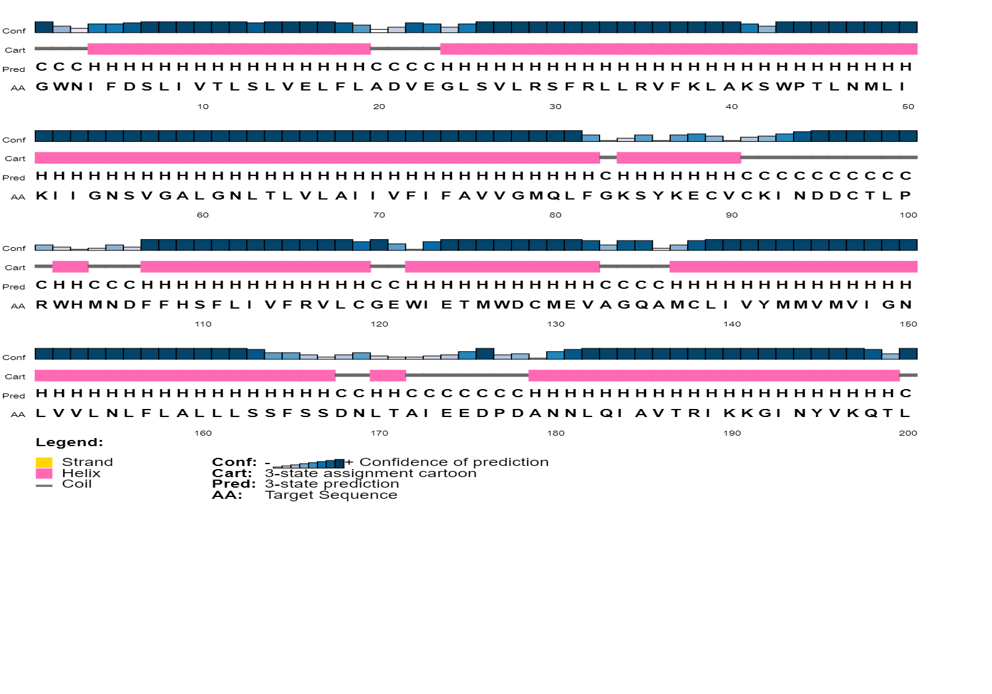

**SCN9A (p.Arg896W)**

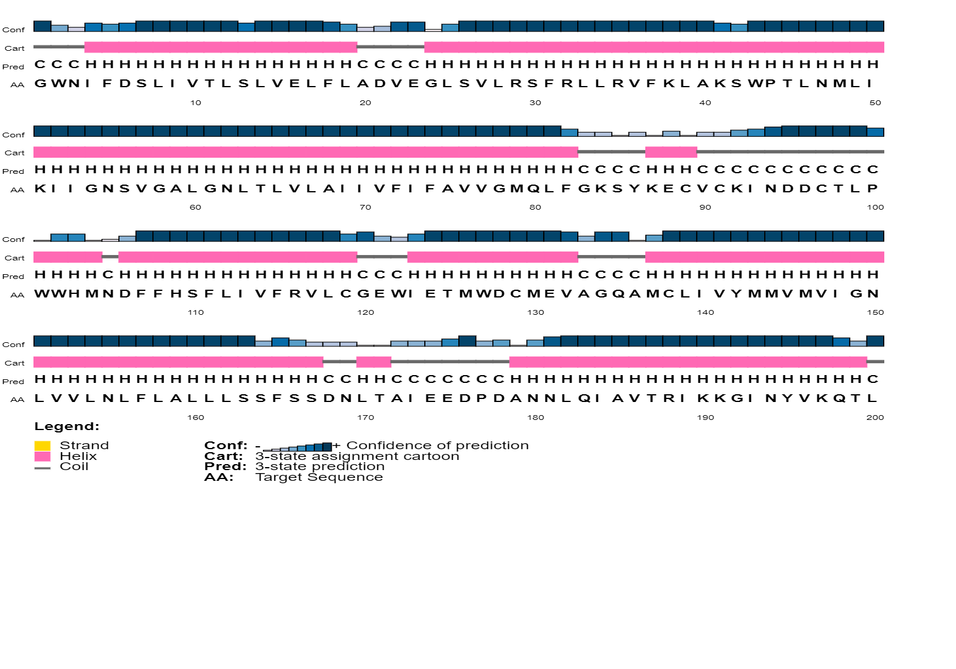

**B.**

**SCN10A WT**

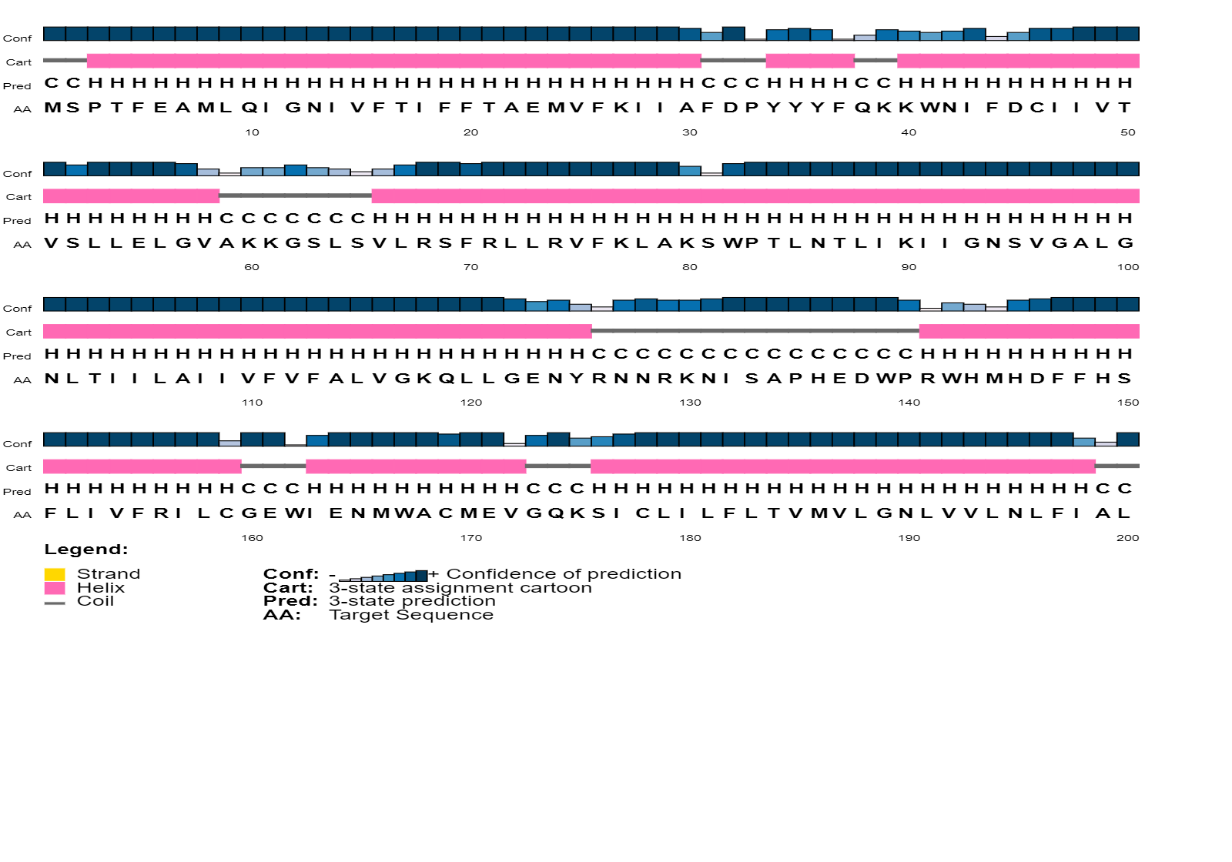

**SCN10A (p.Asn789Lys)**

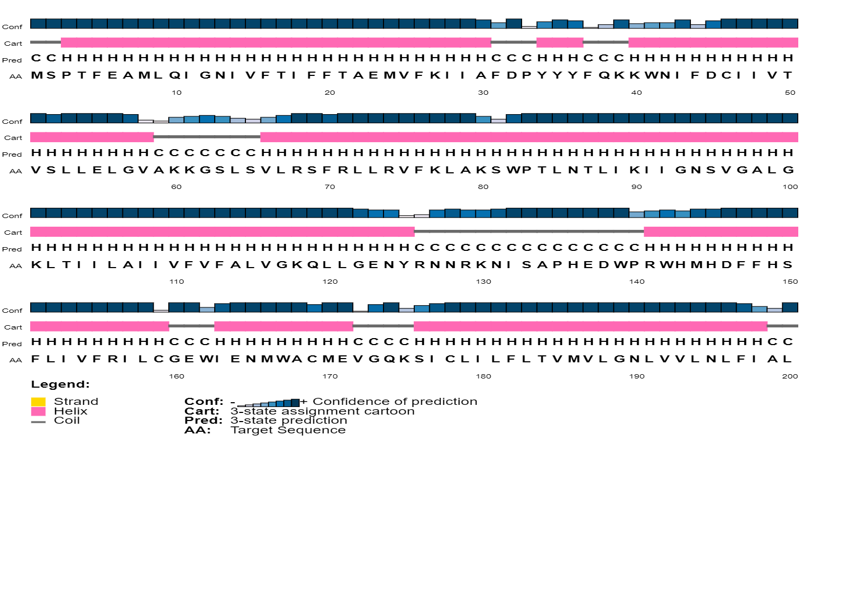

**C.**

**SCN11A WT**

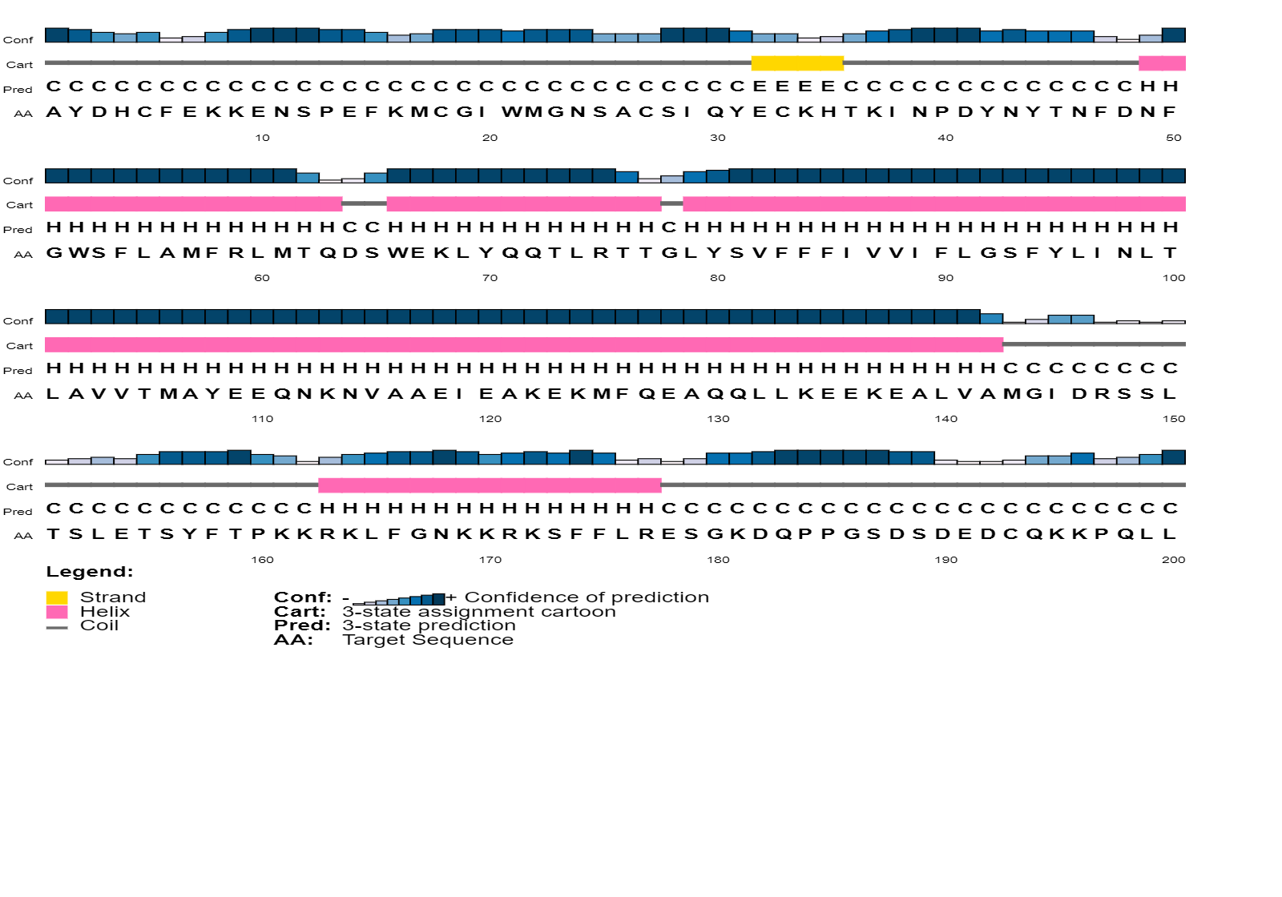

**SCN11A (p.Leu396Pro)**

