Supplementary materials

Supplementary Table

Table e-1: Diffusion-weighted scan sequences vendor, software version, and group
Sequence Description | Vendor | Software | Unaffected | PreDM1 | DM1 | Total
single shell - B1000 x 64dir | Siemens | vB17 | 11 | 2 | 6 | 19
2 runs single shell - B1000 x 64dir | Siemens | vB17 | 0 | 0 | 1 | 1
multishell - B1000 x 30dir, B2000 x 30dir; single shell - B1000 x 64dir | Siemens | vB17 | 1 | 0 | 0 | 1
multishell - B1000 x 30dir, B2000 x 30dir | GE | v25.0 | 10 | 2 | 7 | 19
multishell - B1000 x 30dir, B2000 x 30dir | GE | v25.1 | 21 | 2 | 8 | 31
multishell - B1000 x 30dir, B2000 x 30dir | GE | v26.0 | 13 | 1 | 2 | 16
multishell - B1000 x 30dir, B2000 x 30dir | Siemens | vB17 | 4 | 1 | 1 | 6
multishell - B1000 x 29dir, B2000 x 30dir | Siemens | vB17 | 1 | 0 | 1 | 2
multishell - B1000 x 30dir, B2000 x 29dir | Siemens | vB17 | 2 | 0 | 0 | 2
multishell - B1000 x 29dir, B2000 x 30dir; single shell - B1000 x 64dir | Siemens | vB17 | 3 | 4 | 3 | 10
multishell - B1000 x 30dir, B2000 x 29dir; single shell - B1000 x 64dir | Siemens | vB17 | 2 | 1 | 5 | 8

Supplementary Figures

Figure e-1 Density plots of whole brain white matter FA as a function of scanner vendor (GE vs. Siemens) and software updated (v1 through v3). The top panel shows values prior to harmonization and the lower panel depicts normalized values.
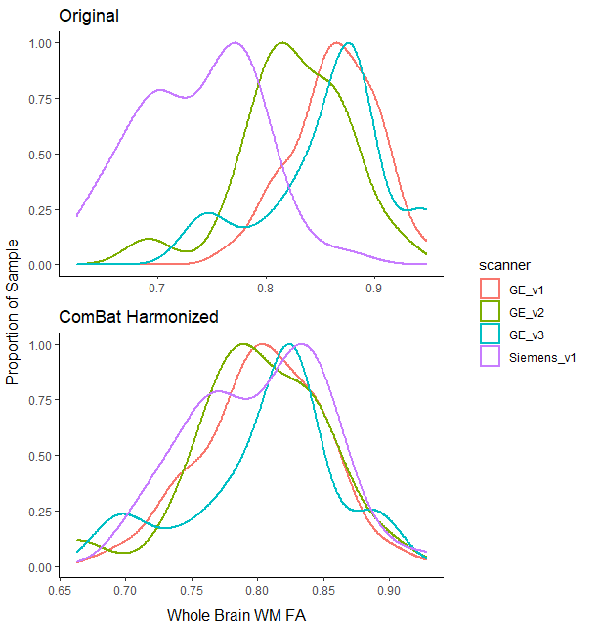

Figure e-2 Regional white matter FA across groups
The graph shows estimated marginal means (x-axis) across regions of interest (y-axis) for PreDM1 (diamonds) and manifest DM1 (circles). The vertical, dotted line represents control adults. Black indicates regions for which the DM1 groups were statistically different from healthy adults at p<0.05.

