SUPPLEMENTAL DATA
eTable 1. Long-range PCR conditions for amplifying the TAF1 SVA insertion.
Reagents | 1X Volume (µL)
HPLC H₂O | 2.26
2X Xtreme Buffer | 5.00
dNTPs | 1.00
KOD F Primer  (5’-GTTCCATTGTGTGGTTGTACCAGCGTTTGTTC-3’) | 0.30
KOD R Primer  (5’-CACATGAAAAGATGCCCAACATCATTAGCCATTAG-3’) | 0.30
KOD Xtreme Hot Start DNA polymerase | 0.14
Template DNA (75 pg) | 1.00
Total | 10.00

DNA was amplified using the following conditions:
94° C for 2 min,
5x (98°C for 10 s, 74°C for 3 min 30 s),
5x (98°C for 10 s, 72°C for 3 min 30 s),
5x (98°C for 10 s, 70°C for 3 min 30 s),
20x (98°C for 10 s, 68°C for 3 min 30 s),
68°C for 7 min
4°C forever

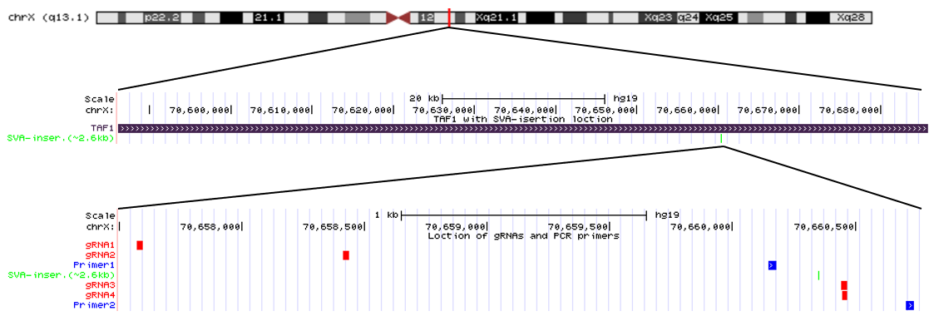
eFigure 1. Location of guide RNAs and PCR primers. The tracks indicate the position of the TAF1 gene (lilac) the SVA-retrotransposon insertion (green) on the chromosome X as well as of the guide RNA used for the Cas9-targeted nanopore sequencing (gRNA1-4, red) and the PCR primers used for deep nanopore sequencing (Primer1-2, blue).

eFigure 2. Histogram distribution of the number of (CCCTCT)_{n} repeats in blood-, basal-ganglia- and cerebellum-derived DNA from L-7995. Repeat number detected in DNA with (A-C) Southern blot from blood, basal ganglia or cerebellum; (D-F) Cas9-targeted enrichment and Oxford Nanopore sequencing from blood, basal ganglia or cerebellum; (G-I) PCR amplicon-based Oxford Nanopore sequencing from blood, basal ganglia or cerebellum. SB= Southern blot

