Supplementary material

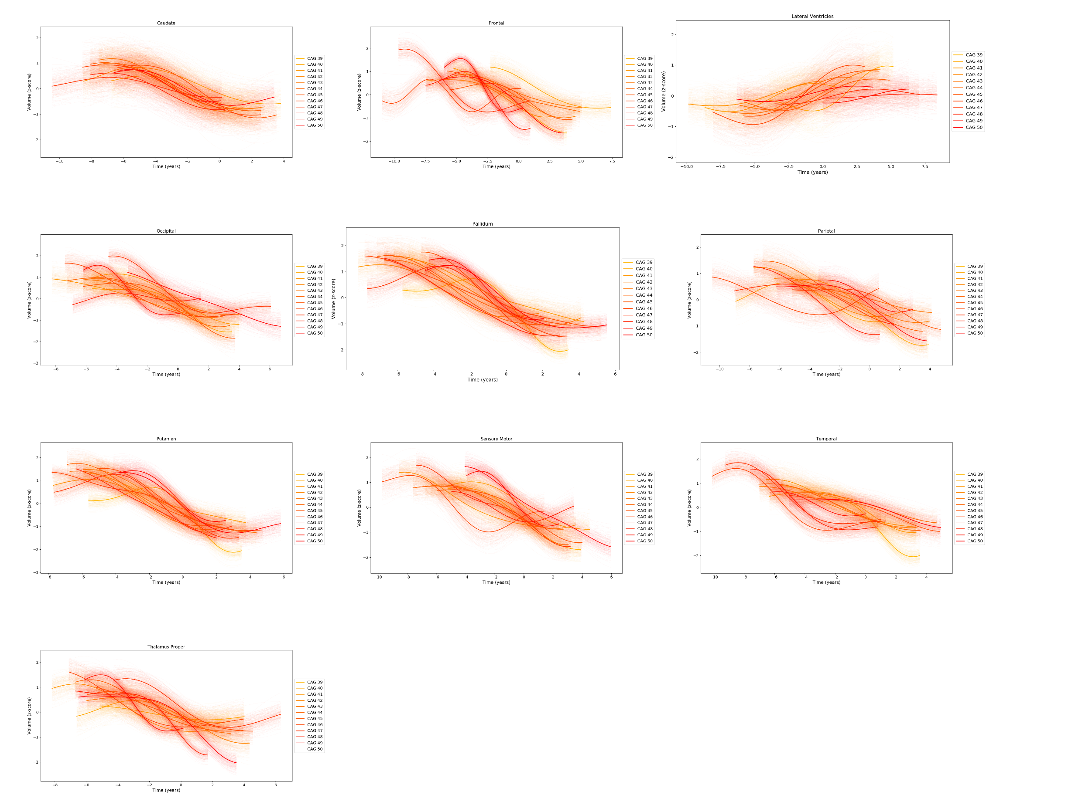
Supplementary Figure 1. Regional brain volume trajectories inferred by GPPM from gene-positive (PreHD and HD) individuals from the TRACK-HD cohort, grouped by CAG repeat count. Standardised volumes (y-axis) are shown, and the time-scale (x-axis) is centred such that t=0 when the fitted trajectory is equal to the mean value of the HD group. Uncertainty in the fit is shown as light shading about the mean and was estimated using 200 samples from the posterior. GPPM: Gaussian Process Progression Model; PreHD: pre-manifest HD; HD: manifest HD; CAG: cytosine-adenine-guanine.

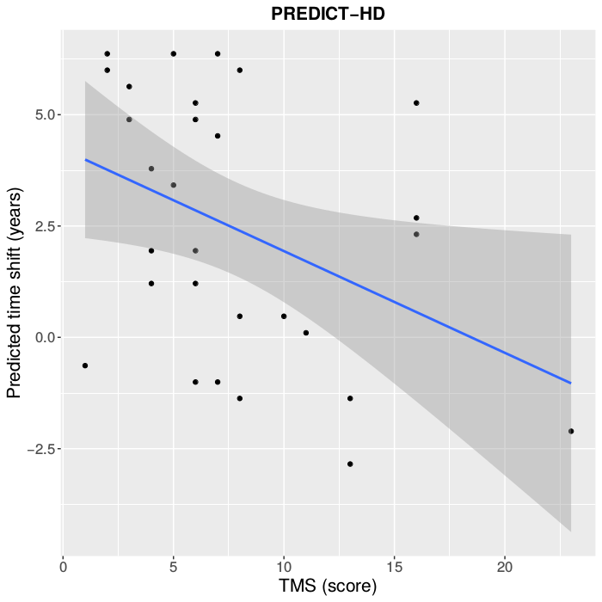
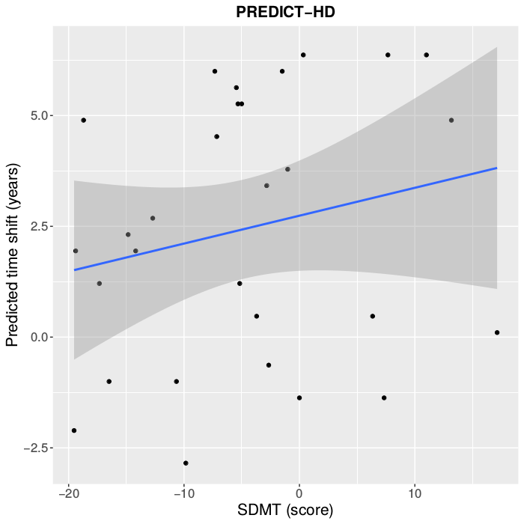
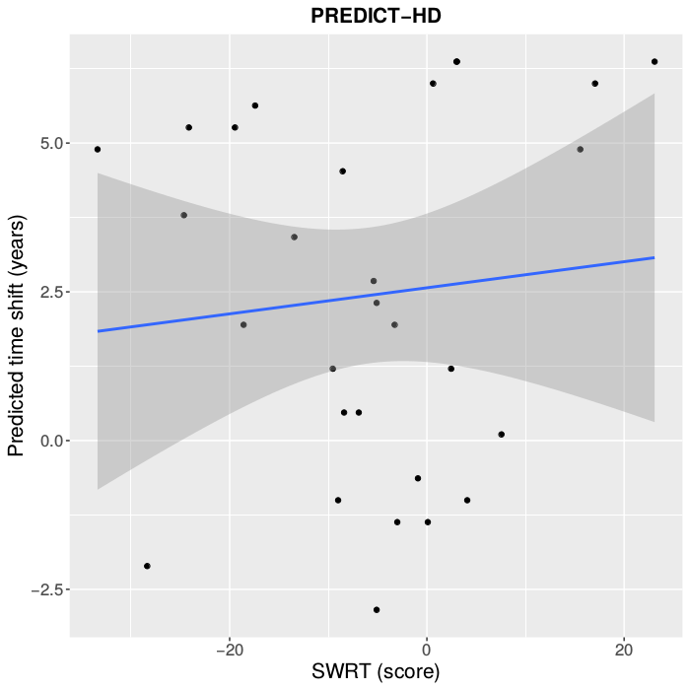

Supplementary Figure 2. From left to right: Predicted time-to-onset versus Total Motor Score (TMS), Symbol Digit Modalities Test (SDMT), Stroop Word Reading Test (SWRT), in the PREDICT-HD cohort. SDMT and SWRT were adjusted for years of education.

Supplementary Table 1. Number of individuals in each CAG repeat group in the TRACK-HD cohort.
CAG | 39 | 40 | 41 | 42 | 43 | 44 | 45 | 46 | 47 | 48 | 49 | 50
N | 5 | 15 | 21 | 33 | 35 | 31 | 19 | 7 | 5 | 3 | 3 | 5

