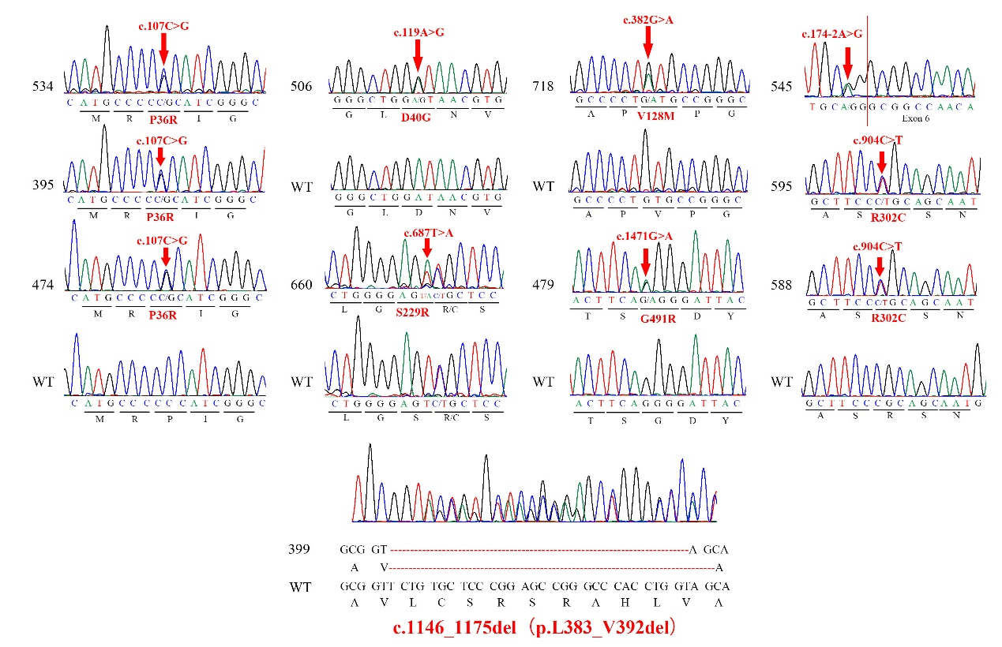
Figure e-1 Sanger sequencing traces of the eight detected mutations in ANXA11 gene
Partial chromatograms of mutations in ANXA11. Six heterozygous missense mutations and one splice site mutation were identified in 10 unrelated ALS and ALS-FTD patients. Additionally, a deletion mutation was found in a clinically undefined patient (Case 399). Each mutation position is marked with red arrows.

