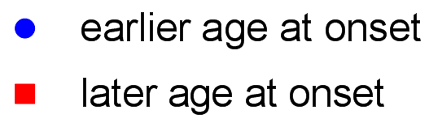
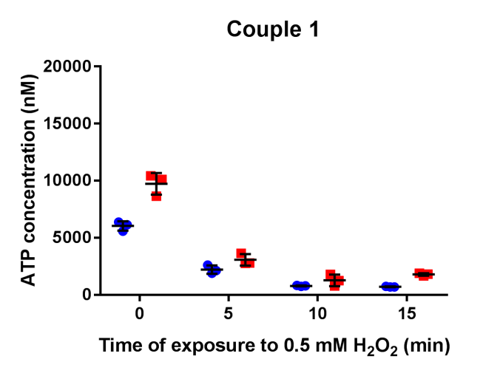
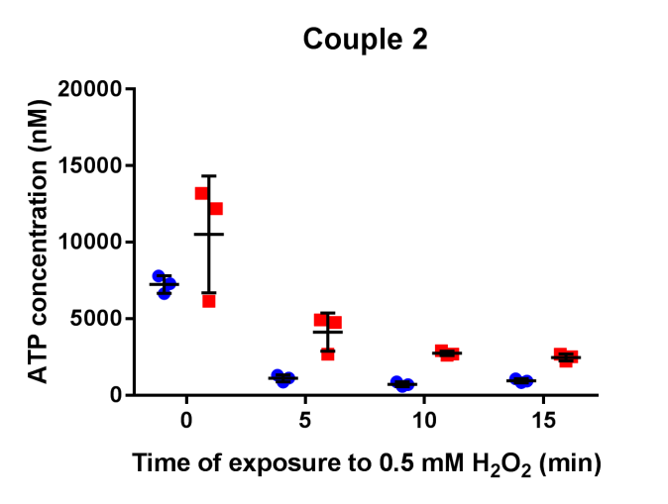
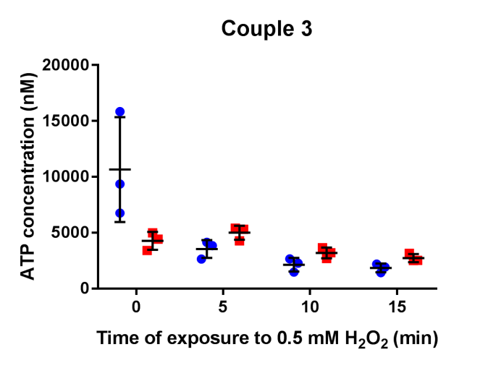
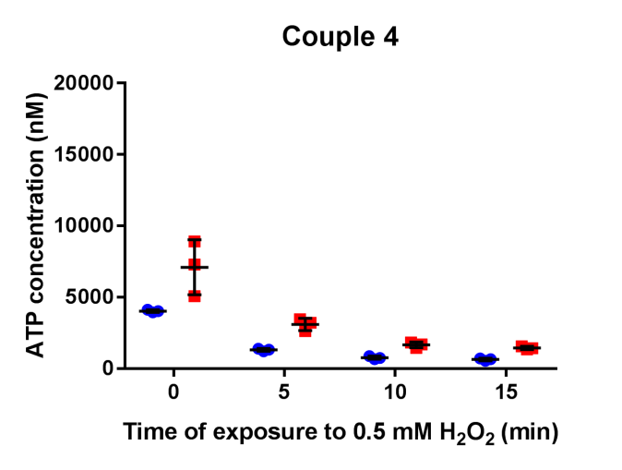
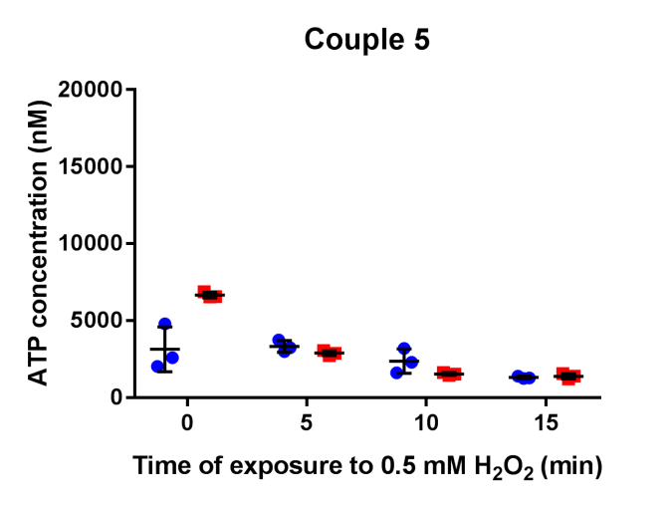
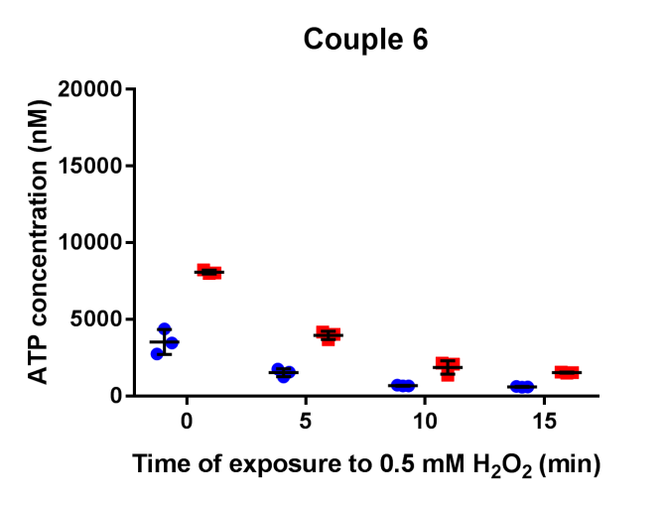
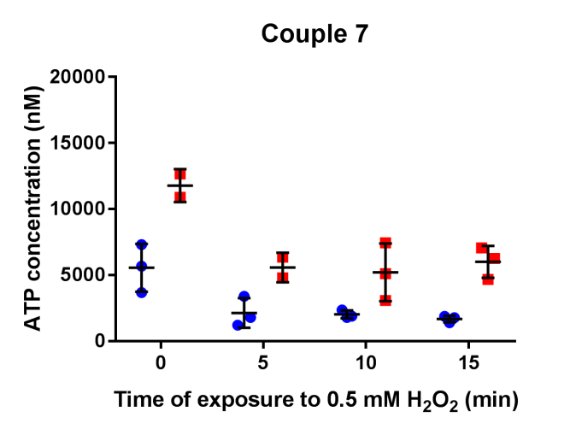
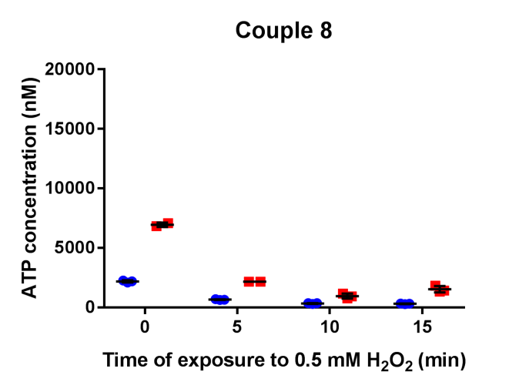
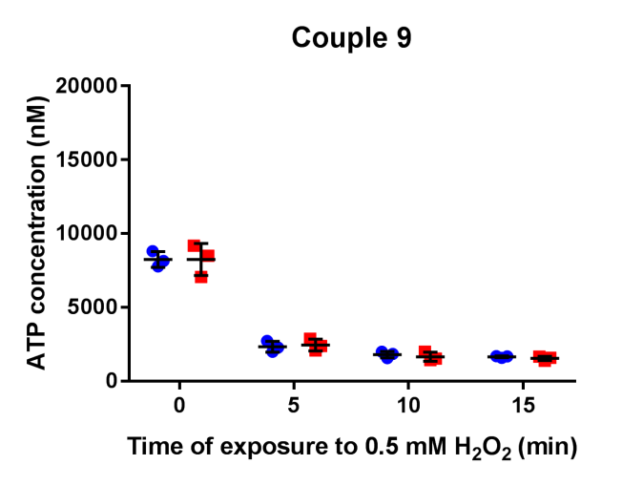
Figure e-1. The ATP concentration per couple in skin fibroblast of HD patients over time exposed to oxidative stress.
In all fibroblast cell lines, the ATP concentration decreased over time exposed to oxidative stress and in most couples, the patient with the earlier age at onset showed lower ATP levels over the time.

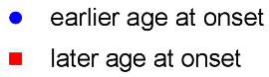
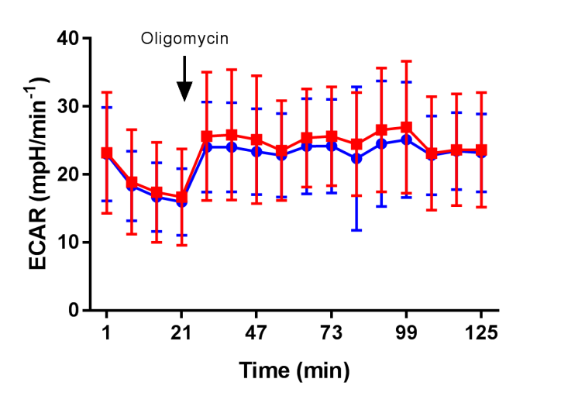
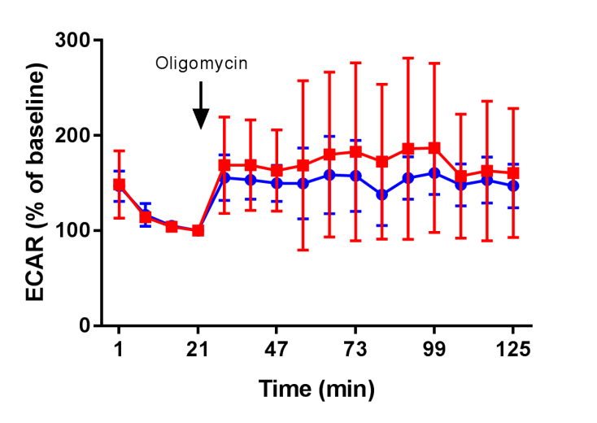
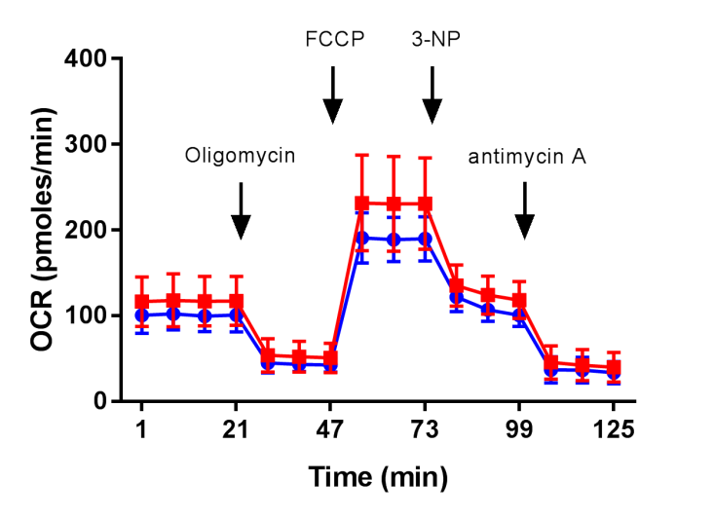
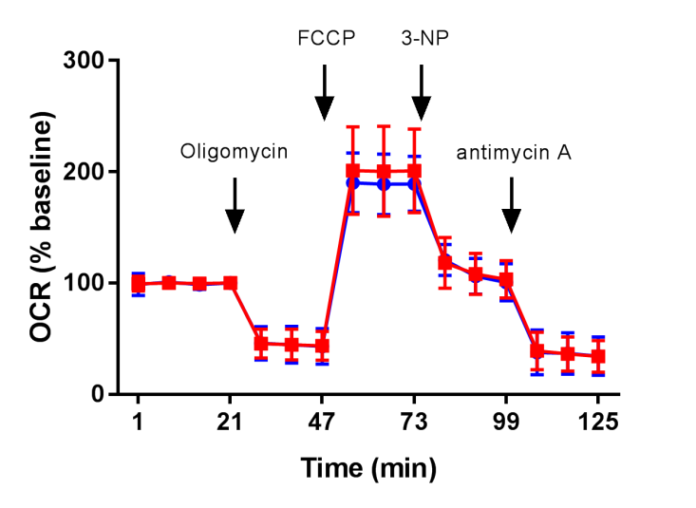
Figure e-2. Average oxygen consumption rate (OCR) and extracellular acidification rate (ECAR) during the mitochondrial stress test. A. The average OCR during the mitochondrial stress test seems lower in the group of HD patients with an earlier age at onset. B. The average OCR as a percentage of the baseline consumption does not seem to differ much between groups. C. The average ECAR during the mitochondrial stress test shows ample variation across the cell lines and the average ECAR as a percentage of the baseline displays similar results (D).
A.
C.
D.
B.

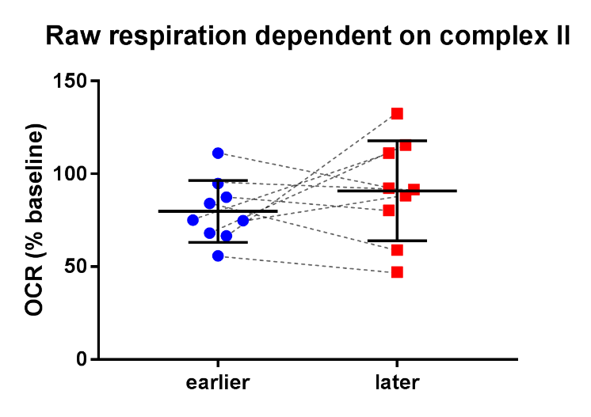
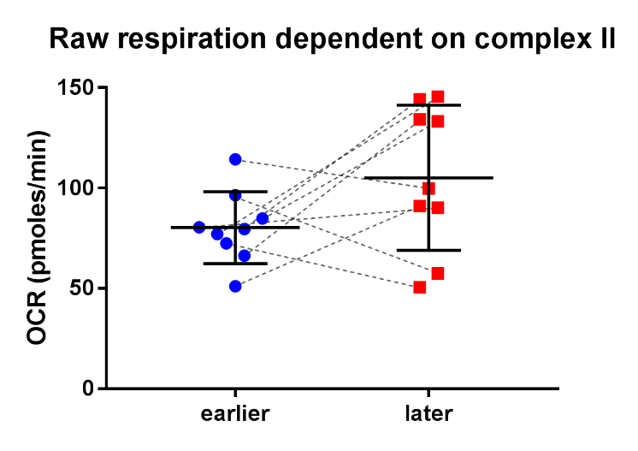
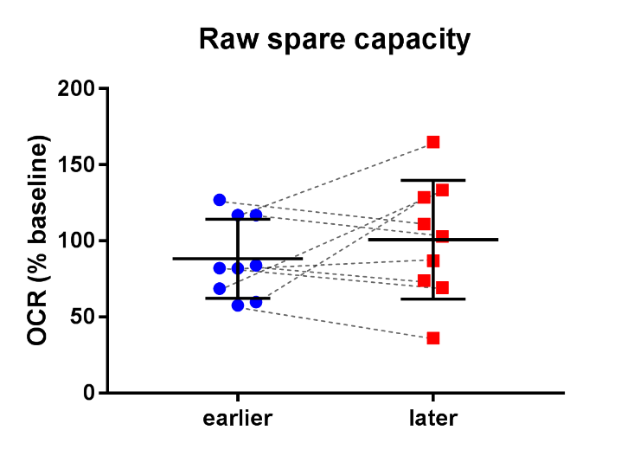
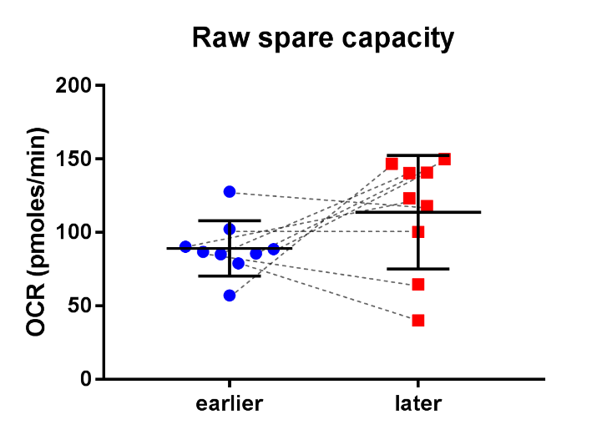
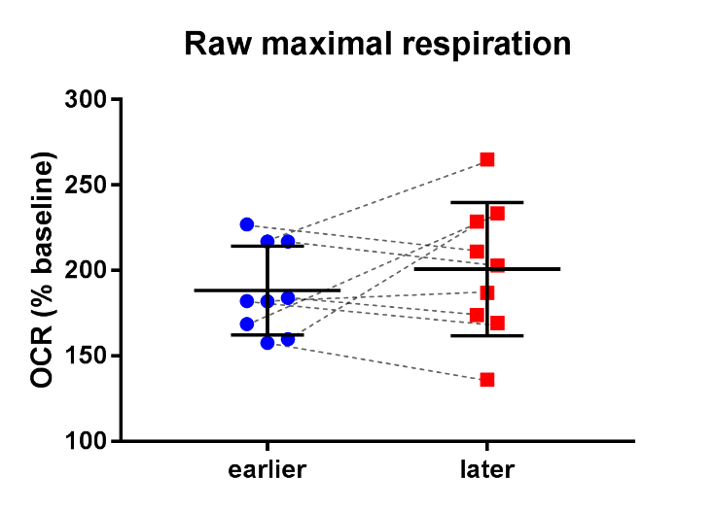
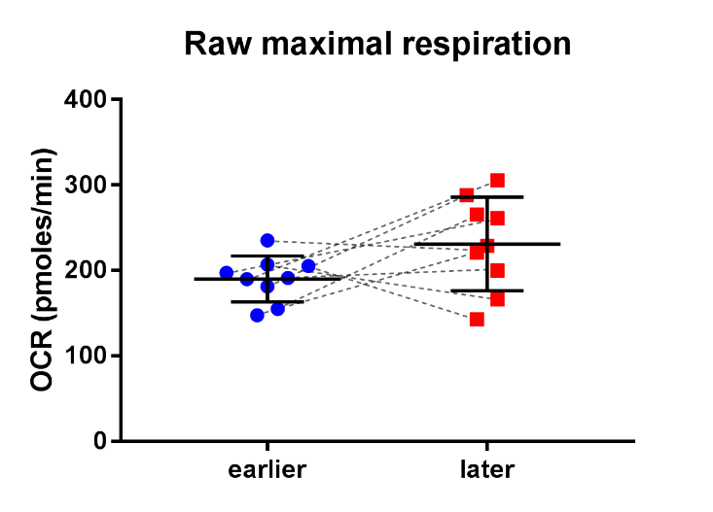
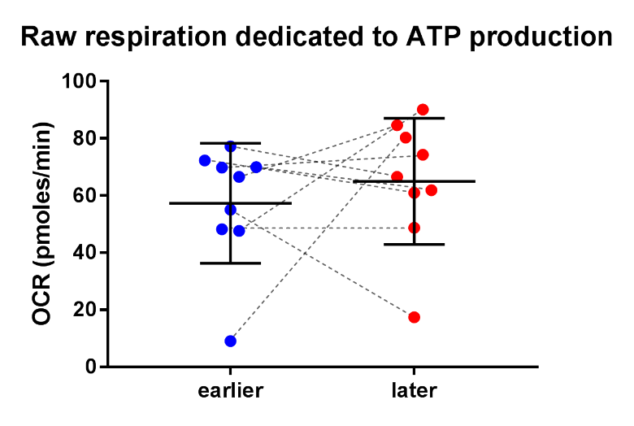
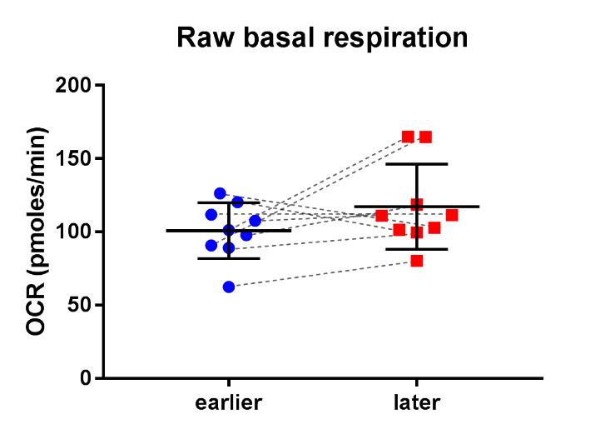
H.
F.
D.
B.
G.
E.
C.
A.
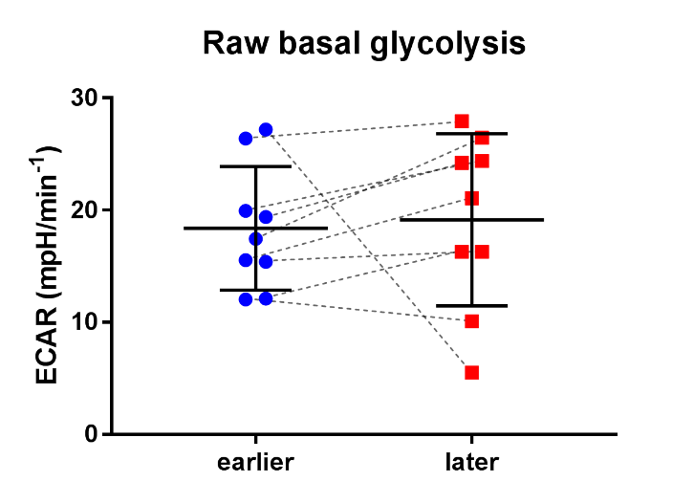

I.

Figure e-3. Raw data of the functional indices calculated from the mitochondrial stress test per age group of symptom onset in Huntington disease (HD).
When the results are not corrected for disease duration and calendar age, the differences in absolute and relative oxygen consumption rates (OCR) and extra cellular acidification rate (ECAR) are not significantly different between the group of HD patients with an earlier age at onset compared to the group of HD patients with a later age at onset. OCR = oxygen consumption rate. ECAR = extracellular acidification rate. raw data = the unadjusted values of the experiments. ● = HD patients with an earlier age at onset. ■ = HD patients with a later age at onset. - - - - - indicate matched patients. Error bars indicate ± SD.

