Lymphocyte counts and infection rates: long-term fingolimod treatment in primary progressive MS
Edward J. Fox, MD, PhD, Fred Lublin, MD, Jerry S. Wolinsky, MD, Jeffrey A. Cohen, MD, Ian M. Williams, PhD, Xiangyi Meng, PhD, Marina Ziehn, PhD, Scott Kolodny, MD, and Bruce A.C. Cree, MD, PhD, MAS

Supplemental data

Table e-1 Incidences of all infections, respiratory tract infections, and herpes infections in patients with a low white blood cell count, a low absolute neutrophil count, and both a low absolute lymphocyte count and a low white blood cell count at any visit
Table e-2 Incidences of all infections, respiratory tract infections, and herpes infections per 100 patient-years among subjects initially receiving fingolimod 1.25 mg who switched to fingolimod 0.5 mg based on nadir absolute lymphocyte count
Table e-3 Incidences of all infections, respiratory tract infections, and herpes infections per 100 patient-years among subjects initially receiving fingolimod 1.25 mg who switched to fingolimod 0.5 mg based on mean absolute lymphocyte count
Table e-4 Correlation of absolute lymphocyte count with occurrence of skin malignancies
Table e-5 Correlation of nadir absolute lymphocyte count with occurrence of skin malignancies
Figure e-1 Recovery of absolute lymphocyte count following fingolimod treatment discontinuation (overall fingolimod 0.5 mg/day group)
Figure e-2 Incidences of all infections, respiratory tract infections, and herpes infections in patients receiving fingolimod 1.25 mg/day
Figure e-3 Cumulative development of infectious complications over time (Kaplan−Meier analysis)
Table e-1 Incidences of all infections, respiratory tract infections, and herpes infections in patients with a low white blood cell count, a low absolute neutrophil count, and both a low absolute lymphocyte count and a low white blood cell count at any visit
 | WBCC ≤ 2 × 10⁹/L |  | ANC ≤ 1 × 10⁹/L |  | WBCC ≤ 2 × 10⁹/L  and ALC < 0.2 × 10⁹/L
 | Fingolimod 0.5 mg/day  (n = 11) | Fingolimod 1.25 mg/day  (n = 11) | Fingolimod 0.5 mg/day  (n = 2) | Fingolimod 1.25 mg/day  (n = 2) | Fingolimod 0.5 mg/day  (n = 4) | Fingolimod 1.25 mg/day  (n = 4)
All infections | 11 (100.0)  [49.9; 178.9] | 7 (91.0)  [36.6; 187.5] | 2 (220.0)  [26.7; 794.8] | 2 (310.9)  [37.7; 1123.0] | 4 (178.2)  [48.6; 456.2] | 2 (51.7)  [6.3; 186.8]
Upper respiratory tract infection | 4 (14.5)  [4.0; 37.2] | 1 (10.2)  [0.3; 56.9] | 1 (22.2)  [0.6; 123.9] | 0 | 3 (62.1)  [12.8; 181.4] | 0
Viral upper respiratory tract infection | 4 (12.0)  [3.3; 30.7] | 1 (9.4)  [0.2; 52.5] | 0 | 0 | 1 (7.7)  [0.2; 42.9] | 1 (25.3)  [0.6; 141.2]
Oral herpes infection | 2 (6.2)  [0.8; 22.3] | 0 | 1 (23.1)  [0.6; 128.9] | 0 | 1 (8.8)  [0.2; 49.2] | 0
Data are reported as numbers (incidences per 100 patient-years) [95% CI].
Abbreviations: ALC = absolute lymphocyte count; ANC = absolute neutrophil count; WBCC = white blood cell count.
Table e-2 Incidences of all infections, respiratory tract infections, and herpes infections per 100 patient-years among subjects initially receiving fingolimod 1.25 mg who switched to fingolimod 0.5 mg based on nadir absolute lymphocyte count
 | Nadir absolute lymphocyte count (fingolimod 1.25 mg/0.5 mg)
 | < 0.2 ×10⁹/L  (n = 25) | 0.2–0.3 ×10⁹/L  (n = 52) | 0.3–0.4 ×10⁹/L  (n = 23) | 0.4–0.5 ×10⁹/L  (n = 15) | 0.5–0.7 ×10⁹/L  (n = 3) | > 0.7 ×10⁹/L  (n = 3)
All infections | 20 (52.7)  [32.2; 81.3] | 36 (43.7)  [30.6; 60.6] | 20 (84.2)  [51.4; 130.1] | 11 (35.3)  [17.6; 63.2] | 3 (42.9)  [8.8; 125.2] | 2 (40.9)  [5.0; 147.8]
Upper respiratory tract infection | 4 (4.9)  [1.3; 12.5] | 9 (5.7)  [2.6; 10.7] | 6 (8.4)  [3.1; 18.3] | 1 (1.7)  [0.0; 9.4] | 0 | 0
Viral upper respiratory tract infection | 11 (17.6)  [8.8; 31.5] | 13 (8.1)  [4.3; 13.8] | 9 (14.6)  [6.7; 27.8] | 1 (1.7)  [0.0;6.5] | 1 (8.4)  [0.2; 46.7] | 0
Oral herpes infection | 0 | 1 (0.5)  [0.0; 3.1] | 2 (2.3)  [0.3, 8.5 | 1 (1.7)  [0.0, 9.7] | 0 | 0
Data are reported as numbers (incidences per 100 patient-years) [95% CI].

Table e-3 Incidences of all infections, respiratory tract infections, and herpes infections per 100 patient-years among subjects initially receiving fingolimod 1.25 mg who switched to fingolimod 0.5 mg based on mean absolute lymphocyte count
 | Mean absolute lymphocyte count (fingolimod 1.25 mg/0.5 mg)
 | < 0.2 ×10⁹/L  (n = 0) | 0.2–0.3 ×10⁹/L  (n = 17) | 0.3–0.4 ×10⁹/L  (n = 33) | 0.4–0.5 ×10⁹/L  (n = 29) | 0.5–0.7 ×10⁹/L  (n = 29) | > 0.7 ×10⁹/L  (n = 13)
All infections | 0 | 15 (74.6)  [41.8; 123.11] | 20 (32.4)  [19.8; 50.1] | 25 (87.8)  [56.8; 129.6] | 23 (49.8)  [31.6; 74.8] | 9 (29.4)  [13.4; 55.8]
Upper respiratory tract infection | 0 | 1 (1.8)  [0.1; 10.0] | 5 (4.9)  [1.6; 11.3] | 10 (13.2)  [6.3; 24.3] | 4 (3.6)  [1.0; 9.4] | 0
Viral upper respiratory tract infection | 0 | 7 (18.3)  [7.4;37.8] | 9 (9.8)  [45; 18.6] | 9 (10.3)  [4.7; 19.6] | 9 (9.0)  [4.1; 17.2] | 1 (2.0)  [0.1; 11.1]
Oral herpes infection | 0 | 0 | 1 (0.9)  [0.0, 5.1] | 2 (1.9)  [0.2, 6.9] | 1 (0.8)  0.0, 4.7] | 0
Data are reported as numbers (incidences per 100 patient-years) [95% CI].
Table e-4 Correlation of mean absolute lymphocyte count with occurrence of skin malignancies
 | Mean lymphocyte count (fingolimod 0.5 mg) |  |  |  |  |  | All fingolimod 0.5 mg | Placebo
 | < 0.2 ×10⁹/L  (n = 2) | 0.2–0.3 ×10⁹/L  (n = 44) | 0.3–0.4 ×10⁹/L  (n = 79) | 0.4–0.5 ×10⁹/L  (n = 58) | 0.5–0.7 ×10⁹/L  (n = 89) | > 0.7 ×10⁹/L  (n = 64) | (n = 336) | (n = 487)
Basal cell carcinoma | 0 | 1 (2.3) | 3 (3.8) | 3 (5.2) | 3 (3.4) | 4 (6.3) | 14 (4.2) | 9 (1.8)
Malignant melanoma | 0 | 0 | 0 | 0 | 1 (1.1) | 0 | 1 (0.3) | 0
Squamous cell carcinoma of the skin | 0 | 1 (2.3) | 0 | 0 | 4 (4.5) | 1 (1.6) | 6 (1.8) | 1 (0.2)
Any of the above | 0 | 2 (4.5) | 3 (3.8) | 3 (5.2) | 6 (6.7) | 4 (6.3) | 18 (5.4) | 10 (2.1)
Data are reported as numbers (%).
Table e-5 Correlation of nadir absolute lymphocyte count with occurrence of skin malignancies
 | Nadir absolute lymphocyte count (fingolimod 0.5 mg) |  |  |  |  |  | All fingolimod 0.5 mg | Placebo
 | < 0.2 ×10⁹/L  (n = 59) | 0.2–0.3 ×10⁹/L  (n = 108) | 0.3–0.4 ×10⁹/L  (n = 65) | 0.4–0.5 ×10⁹/L  (n = 55) | 0.5–0.7 ×10⁹/L  (n = 40) | > 0.7 ×10⁹/L  (n = 9) | (n = 336) | (n = 487)
Basal cell carcinoma | 1 (1.7) | 6 (5.6) | 1 (1.5) | 2 (3.6) | 4 (10.0) | 0 | 14 (4.2) | 9 (1.8)
Malignant melanoma | 0 | 0 | 0 | 1 (1.8) | 0 | 0 | 1 (0.3) | 0
Squamous cell carcinoma of the skin | 1 (1.7) | 3 (2.8) | 0 | 1 (1.8) | 1 (2.5) | 0 | 6 (1.8) | 1 (0.2)
Any of the above | 2 (3.4) | 8 (7.4) | 1 (1.5) | 3. (5.5) | 4 (10.0) | 0 | 18 (5.4) | 10 (2.1)
Data are reported as numbers (%).

Figure e-1 Recovery of absolute lymphocyte count following fingolimod treatment discontinuation (overall fingolimod 0.5 mg/day group)
Non-uniform time axis; +, mean; middle bar, median; box, Q1−Q3 interval; whisker, range.
Abbreviation: ALC = absolute lymphocyte count.

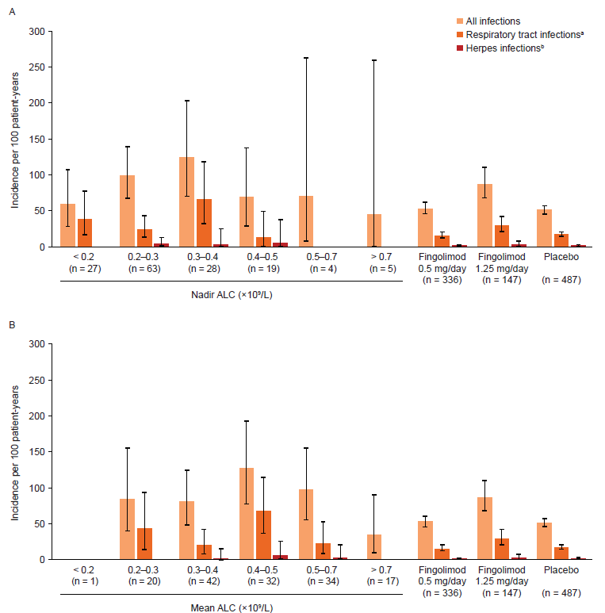
Figure e-2 Incidences of all infections, respiratory tract infections, and herpes infections in patients receiving fingolimod 1.25 mg/day

Incidences of all infections, respiratory tract infections, and herpes infections in patients receiving fingolimod 1.25 mg/day stratified by (A) nadir ALC and (B) mean ALC (left-hand side). Right-hand side shows the overall incidences in patients receiving fingolimod 1.25 mg/day, fingolimod 0.5 mg/day or placebo.
ªIncludes viral and other upper and/or lower respiratory tract infections. ^{b}Includes oral herpes, herpes simplex, herpes zoster, herpes zoster meningomyelitis, genital herpes, neurological herpes, ophthalmic herpes simplex, and ophthalmic herpes zoster.
Error bars represent 95% CI.
Abbreviation: ALC = absolute lymphocyte count.
Figure e-3 Cumulative development of infectious complications over time (Kaplan−Meier analysis)
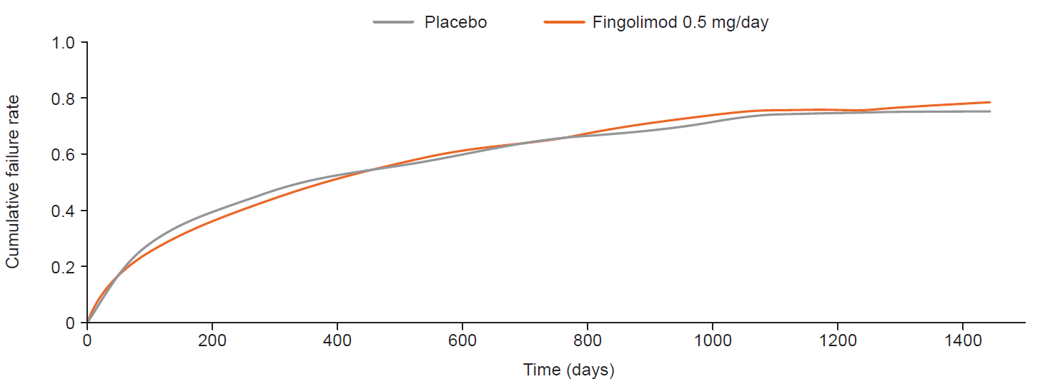
Data are shown as cumulative failure rate for number cumulative events/number of patients at risk in the fingolimod 0.5 mg and placebo groups

