Supplementary material

 | serum-IgG |  |  |  | serum-IgM |  |  |  | serum-IgA
months | 0 | 12 |  | 24 | 0 | 12 |  | 24 | 0 | 12 |  | 24
median (g/l) | 9.135 | 8.905 |  | 8.220 | 1.210 | 1.050 |  | 0.9600 | 1.995 | 1.765 |  | 1.660
comparison between | 0 and 12 |  | 0 and 24 |  | 0 and 12 |  | 0 and 24 |  | 0 and 12 |  | 0 and 24
P-value | 0.0095 |  | 0.0003 |  | < 0.0001 |  | 0.0002 |  | < 0.0001 |  | < 0.0001
Table e-1

 | CSF-IgG |  |  |  | CSF-IgM |  |  |  | CSF-IgA
months | 0 | 12 |  | 24 | 0 | 12 |  | 24 | 0 | 12 |  | 24
median (mg/l) | 36.75 | 29.55 |  | 25.75 | 0.5200 | 0.4705 |  | 0.2570 | 3.215 | 3.125 |  | 2.825
comparison between | 0 and 12 |  | 0 and 24 |  | 0 and 12 |  | 0 and 24 |  | 0 and 12 |  | 0 and 24
P-value | 0.0002 |  | 0.0001 |  | 0.0016 |  | 0.0002 |  | 0.0033 |  | <0.0001
Table e-2

 | third course | control | naïve | p
Patients, no. | 8 | 9 | 9 | -
Age, yr., median (range) | 30 (21-44) | 35 (19-58) | 33 (20-40) | 0.7814*
Male sex, no. (%) | 3 (37.5) | 3 (33.3) | 3 (33.3) | 0.6667#
MS duration, yr., median (range)  - since manifestation  - since diagnosis | 2.5 (0-10)  1 (0-9) | 5 (0-12)  2 (0-12) | 3 (0-8)  0 (0-1) | 0.5484*  0.4109*
Previous DMTs, no., median (range) | 1 (0-3) | 1 (0-6) | 0 | 0.7271*
Baseline EDSS, median (range) | 2.0 (1-4) | 2.5 (0-4) | 2 (0-4) | 0.6110*
Relapses within past 2 years, median (range) | 3 (0-6) | 3 (1-5) | 2 (1-2) | 0.6968*

Table e-3

*: statistical significance was calculated using Kruskal-Wallis test with Dunn’s post-test (Kruskal-Wallis statistics are shown; no significant differences were observed between columns with Dunn’s post-test); #: statistical significance calculated using Fisher’s exact test.
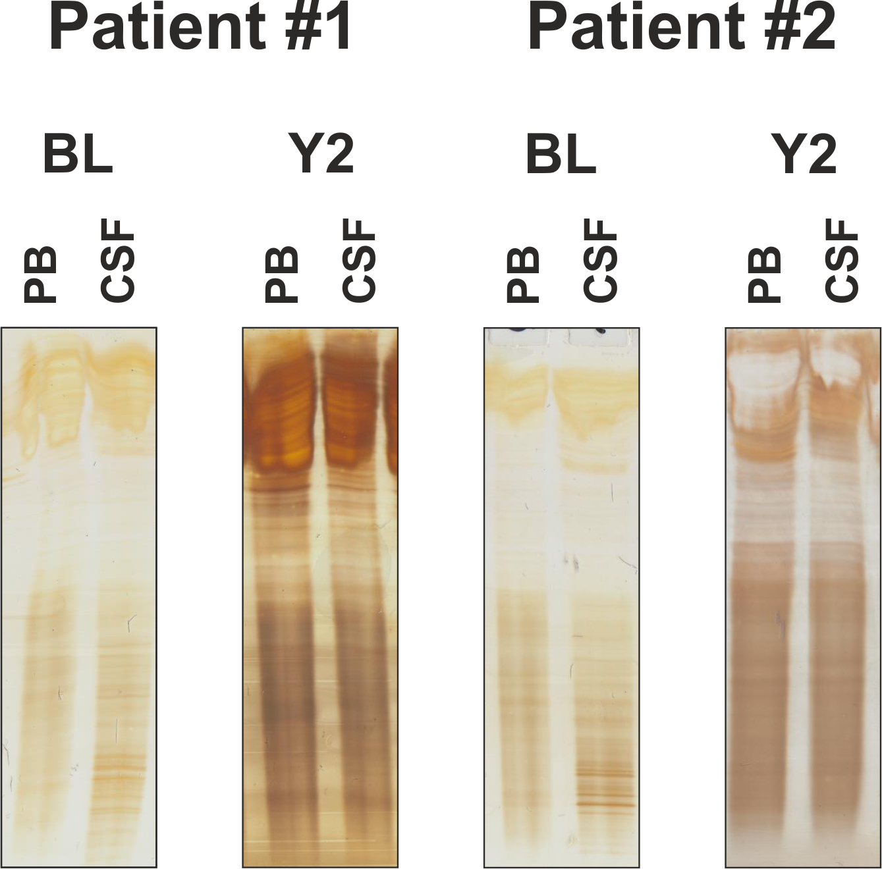

 | Patient #1 |  | Patient #2
 | BL | Y2 | BL | Y2
IgG Serum | 9,85 | 8,81 | 8,33 | 6,06
IgG CSF | 27,5 | 19,2 | 20,7 | 14
IgA Serum | 2,33 | 2,14 | 8,33 | 4,06
IgA CSF | 3,27 | 2,86 | 3 | 2,88
IgM Serum | 0,64 | 0,49 | 1,26 | 0,64
IgM CSF | 0,557 | 0,26 | 0,392 | 0,254
Albumin Serum | 39,6 | 38,3 | 48,3 | 48
Albumin CSF | 244 | 238 | 193 | 258
Protein CSF | 474 | 508 | 382 | 521
CSF cells | 2 | 0 | 1 | 1

Figure e-1: Alemtuzumab treatment results in disappearance of previously detectable oligoclonal bands in two patients
A: Determination of CSF and serum oligoclonal bands by isoelectric focusing in polyacrylamide gels with consecutive silver staining in two exemplary alemtuzumab treated patients. B: CSF cells, CSF protein concentration as well as IgG-, IgA-, IgM-, and albumin-levels in serum and CSF of the two patients mentioned in A. BL: baseline; CSF: cerebrospinal fluid; PB: peripheral blood; Y2: year 2

