**Supplementary Files**

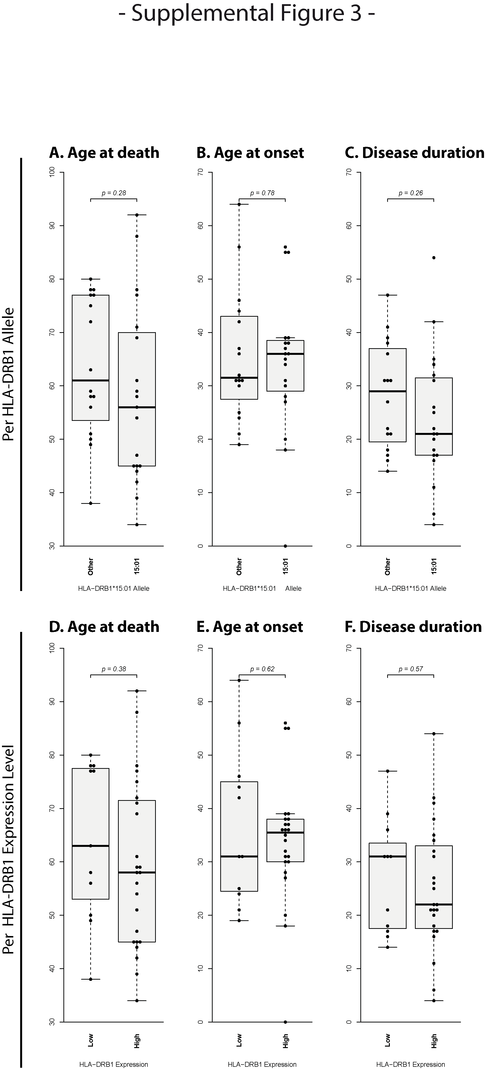

**Figure e-1: Sample population differences of *HLA-DRB1*15:01* versus other alleles**

Comparison of age, age at onset and disease duration between carriers of the *HLA-DRB1*15:01* and carriers of any other alleles. No statistically significant difference in the mean was detected when comparing *15:01* versus other allele carriers for age at death (p=0.28, df=32.8, mean (*HLA-DRB1*15:01*)=58.1, mean(other)=63.9), age at onset (p=0.78, df=32.7, mean (*HLA-DRB1*15:01*)=34.3, mean(other)=35.6) or disease duration (p=0.26, df=33, mean (*HLA-DRB1*15:01*)=23.8, mean(other)=28.1) or when comparing high versus low expressers for age at death (p=0.38, df=20.6, mean (high)=59.1, mean(low)=64.0), age at onset (p=0.62, df=16.1, mean (high)=34.1, mean(low)=36.6) or disease duration (p=0.57, df=21.0, mean (high)=25.0, mean(low)=27.4). *p*-Values are derived from a welch two-sided t-test.

**Table e-1**

Table e-1 shows the patient characterization as well as the use of the patient samples in the different experiments. Carriers of the *HLA-DRB1*15:01* allele are highlighted in bold. High, respective low, expressers which were characterized using the gene expression data from the grey matter lesion microarray are marked with an asterisk. Abbreviations: p.m. time: post-mortem time (hours); IHC: immunohistochemical characterization; HLA-DRB1 IHC: HLA-DRB1 immunohistochemistry; NAGM: normal appearing grey matter.

**Table e-2**



**B.**

**A.**



**Table e-2**

Table shows antibodies (A) used for the immunohistochemical and immunofluoresecence stainings and protocols (B) used for the immunohistochemical stainings. Abbreviations: FF: fresh frozen; NDS: normal donkey serum; PE: Paraffin-embedded; RT: Room temperature.

**Table e-3**



Table e-3 shows the HLA genotypes of all patients used in this study. Marked in bold is the *HLA-DRB1*15:01* allele, marked in bold are other MS associated alleles described previously, namely *HLA-DRB1*03:01, *04:01, *04:04* and \**13:03* [1] and \**08:01* [2]. Alleles bearing suffix 'G' in A locus has identical sequences in exon 2 and exon 3 antigen recognition sites. Alleles bearing suffix 'G' in DRB locus has identical sequences in exon 2 antigen recognition sites. Allele Database Version used in the report is 3.17.0, July 2014 [3,4]. Abbreviations: NA: not available, id est genotyping failed.

**Supplementary References**

1. Patsopoulos, N.A.; Barcellos, L.F.; Hintzen, R.Q.; Schaefer, C.; van Duijn, C.M.; Noble, J.A.; Raj, T.; Gourraud, P.A.; Stranger, B.E.; Oksenberg, J., et al. Fine-mapping the genetic association of the major histocompatibility complex in multiple sclerosis: HLA and non-HLA effects. *PLoS genetics* **2013**, *9*, e1003926, doi:10.1371/journal.pgen.1003926.

2. Moutsianas, L.; Jostins, L.; Beecham, A.H.; Dilthey, A.T.; Xifara, D.K.; Ban, M.; Shah, T.S.; Patsopoulos, N.A.; Alfredsson, L.; Anderson, C.A., et al. Class II HLA interactions modulate genetic risk for multiple sclerosis. *Nature genetics* **2015**, *47*, 1107-1113, doi:10.1038/ng.3395.

3. Robinson, J.; Halliwell, J.A.; Hayhurst, J.D.; Flicek, P.; Parham, P.; Marsh, S.G. The IPD and IMGT/HLA database: allele variant databases. *Nucleic acids research* **2015**, *43*, D423-431, doi:10.1093/nar/gku1161.

4. Robinson, J.; Malik, A.; Parham, P.; Bodmer, J.G.; Marsh, S.G. IMGT/HLA database--a sequence database for the human major histocompatibility complex. *Tissue antigens* **2000**, *55*, 280-287, doi:10.1034/j.1399-0039.2000.550314.x.