Supplementary Material

Table e-1: Antibody panel
Metal isotope tag | Target | Clone | Company
141Pr | CD49d | 9F10 | Fluidigm
142Nd | CD19 | HIB19 | Fluidigm
143Nd | HLA-DR | L243 | Fluidigm
144Nd | CD146 | P1H12 | Biolegend
145Nd | CD4 | RPA-T4 | Fluidigm
146Nd | CD8a | RPA-T8 | Fluidigm
147Sm | CD20 | 2H7 | Fluidigm
148Nd | CD34 | 581 | Fluidigm
149Sm | CD25 (IL-2R) | 2A3 | Fluidigm
150Nd | CD61 | VI-PL2 | Fluidigm
151Eu | CD278/ICOS | C398.4A | Biolegend
152Sm | CD66b | 80H3 | Fluidigm
153Eu | CD194 (CCR4) | 205410 | Fluidigm
154Sm | CD3 | UCHT1 | Fluidigm
155Gd | CD161 | HP-3G10 | Biolegend
156Gd | CD184 (CXCR4) | 12G5 | Fluidigm
158Gd | CD27 | L128 | Fluidigm
159Tb | CD45RO | UCHL1 | Biolegend
160Gd | CD14 | M5E2 | Fluidigm
161Dy | CD183 (CXCR3) | G025H7 | Biolegend
162Dy | CD11c | Bu15 | Fluidigm
163Dy | CD33 | WM53 | Fluidigm
164Dy | CD15 | W6D3 | Fluidigm
165Ho | CD127 (IL7-Ra) | A019D5 | Fluidigm
166Er | CD123 (IL-3R) | AO19D5 | Biolegend
167Er | CD162 | KPL-1 | Fluidigm
168Er | CD185 (CXCR5) | 51505 | R&D Systems
169Tm | Human IgG4 | HP6025 | Abcam
170Er | CD45RA | HI100 | Fluidigm
172Yb | CD38 | HIT2 | Fluidigm
173Yb | CD196/CCR6 | G034E3 | Biolegend
174Yb | CD279 (PD-1) | EH12.2H7 | Fluidigm
175Lu | CD235ab (Glycophorin) | HIR2 | Fluidigm
176Yb | CD56 | NCAM16.2 | Fluidigm
209Bi | CD16 | 3G8 | Fluidigm
89Y | CD45 | HI30 | Fluidigm

Figure e-1. Data analysis of peripheral blood leukocyte (PBL) samples. A) Clean-up gating into single PBLs. RBC = red blood cells. B) Manual workflow: gating of 11 PBL subtypes, QSC bead standardization, and RO calculation. ABC = antibody binding capacity. C) Unsupervised workflow: dimensionality reduction for visualization with ViSNE, automated clustering and significance testing with SAM analysis in CITRUS, and visualization of clusters with significantly different median ROs in the three patient groups on the ViSNE map.

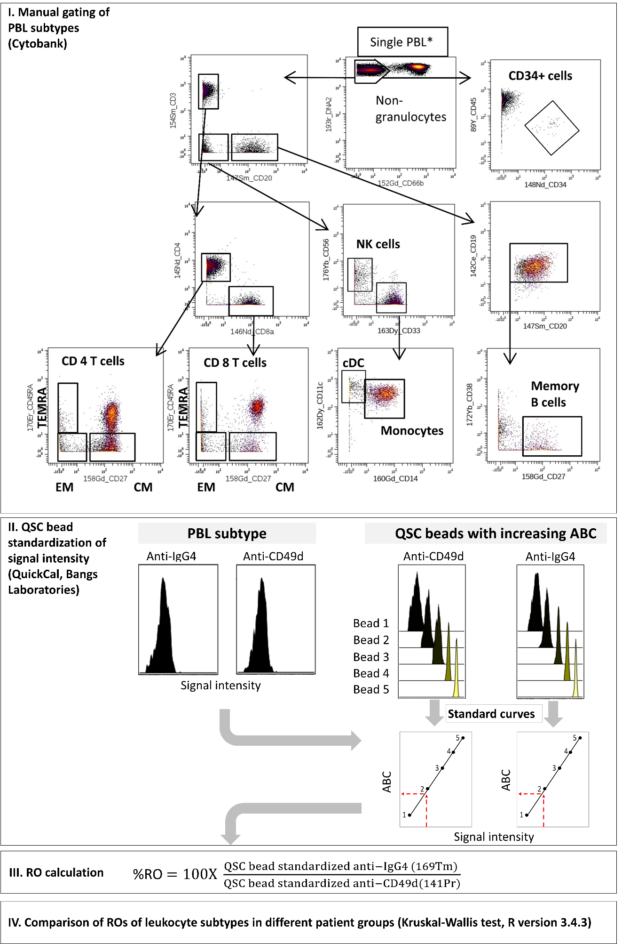
C.

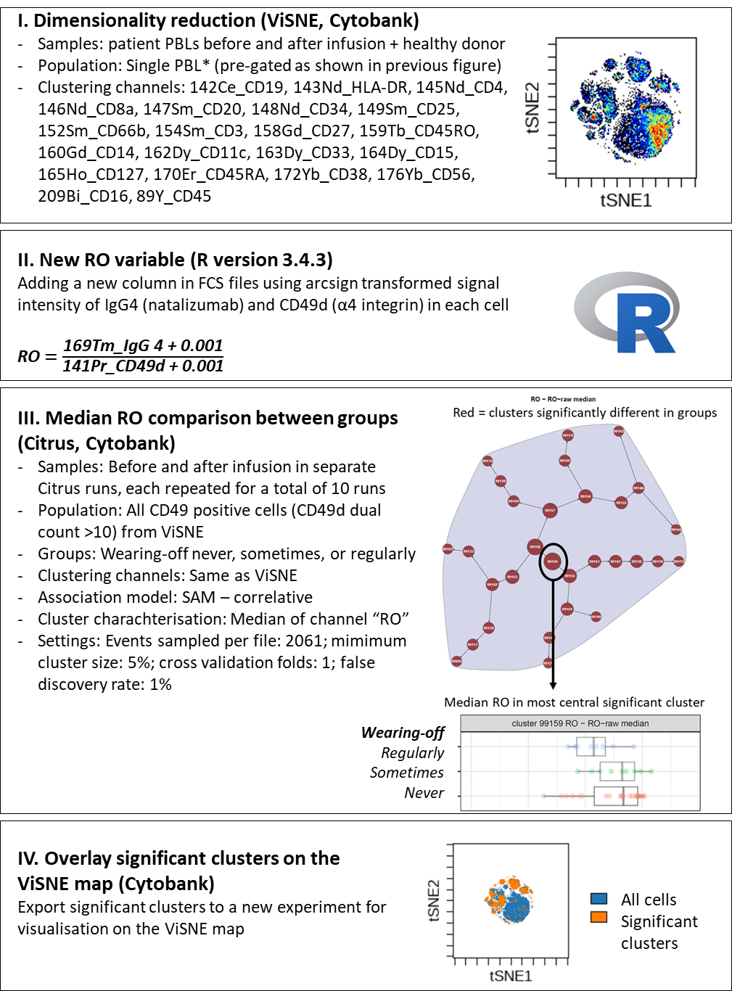

Figure e-2. Natalizumab RO in CD8⁺ and CD4⁺ T cells not stratified further into subtypes before (green) and after (orange) natalizumab infusion. P (based on Kruskal-Wallis test) comparing RO in patients reporting wearing-off symptoms never, sometimes, and regularly.