Table e-1. Comparison of the demographic, clinical and MRI-derived measures between the study cohort and the replication cohort.

Comparison of the characteristics between the study and replication cohort | p-value
Age | 0.341 ^{a)}
Sex | 0.730 ^{b)}
Disease duration | <0.001 ^{a)}
EDSS change | 0.431 ^{c)}
Follow-up | 0.287 ^{a)}
GM volume change | 0.527 ^{a)}
WM volume change | 0.469 ^{a)}
T2 Lesion volume change | 0.158 ^{c)}

- P-values derived from t-test
- P-value derived from Pearson’s chi-square test
- P-values derived from Mann-Whitney test
EDSS = Expanded Disability Status Scale; MRI = magnetic resonance imaging; WM = white matter; GM = grey matter.

Table e-2. Anatomical locations of different cortical atrophy rates within the bihemispheric, left-lateralized and cerebellar lesion pattern.

Cluster No | P-max | Size (mm²) |  | Tal X | Tal Y | Tal Z | Anatomical location
Bihemispheric lesion pattern RH
1  2 | 0.0001  0.0009 | 45.40  0.50 | 13.4  22.8 |  | -52.3  43.2 | 40.2  -10.7 | precuneus  lateral orbitofrontal
Bihemispheric lesion pattern LH
1  2 | 0.0008  0.0009 | 77.06  0.73 |  | -7.1  41.2 | 55.8  41.0 | -12.8  -7.8 | medial orbitofrontal  pars orbitalis
Left-lateralized lesion pattern RH
1  2 | 0.0003  0.0006 | 16.48  7.90 |  | 39.3  4.7 | -37.0  -71.9 | -22.5  4.8 | fusiform  lingual
Left-lateralized lesion pattern LH
1  2 | 0.0001  0.0001 | 34.35  41.72 |  | -18.1  -30.3 | 44.6  -42.0 | 34.8  51.9 | superior frontal  superior parietal
Cerebellar lesion pattern RH
1  2  3  4  5  6 | 0.0001  0.0002  0.0003  0.0007  0.0008  0.0008 | 59.02  23.95  13.03  1.29  1.02  0.98 |  | 34.3  11.0  6.6  41.1  6.7  39.8 | -73.6  -86.0  23.9  -76.4  -68.0  -36.5 | 21.9  36.6  -23.2  -13.9  33.7  -22.2 | inferior parietal  superior parietal  medial orbitofrontal  lateral occipital  precuneus  fusiform
Cerebellar lesion pattern LH
1  2  3  4  5  6  7 | 0.0001  0.0001  0.0001  0.0002  0.0002  0.0004  0.0007 | 48.84  38.65  81.64  18.01  30.07  16.20  5.48 |  | -44.7  -47.3  -53.3  -7.8  -64.0  -19.0  -41.0 | -0.2  -27.0  -35.2  -89.1  -20.6  -72.8  45.9 | 12.4  32.6  1.2  30.0  1.5  26.2  -7.3 | precentral  supramarginal  bankssts  superior parietal  superior temporal  precuneus  pars orbitalis

RH = right hemisphere; LH = left hemisphere; bankssts = banks of superior temporal sulcus.
For each cluster p-values (p-max), surface area (mm²) and Talairach (Tal X, Y, Z) coordinates are presented.

 | WM lesion distribution pattern
 | Cerebellar pattern (study cohort) | Cerebellar pattern (replication cohort) | Left- lateralized (study cohort) | Left- lateralized (replication cohort) | Bihemispheric (study cohort)
Specificity  Sensitivity  Accuracy  Confidence Interval  AUC | 57%  59%  64%  0.52 - 0.76 0.648 | 54%  56%  62%  0.50 - 0.74  0.629 | 52%  51%  56%  0.44 - 0.68  0.564 | 53%  51%  54%  0.42 - 0.66  0.543 | 56%  58%  64%  0.52 - 0.76  0.643
 | Cortical atrophy pattern
 | Cerebellar pattern (study cohort) | Cerebellar pattern (replication cohort) | Left- lateralized (study cohort) | Left- lateralized (replication cohort) | Bihemispheric (study cohort)
Specificity  Sensitivity  Accuracy  Confidence Interval  AUC | 54%  53%  56%  0.44 - 0.68  0.568 | 51%  54%  54%  0.43 - 0.66  0.549 | 48%  49%  51%  0.40 - 0.63  0.514 | 49%  52%  52%  0.41 - 0.62  0.523 | 51%  49%  52%  0.40 - 0.64  0.523
 | Co-varying patterns of WM lesions and cortical atrophy
 | Cerebellar pattern (study cohort) | Cerebellar pattern (replication cohort) | Left- lateralized (study cohort) | Left- lateralized (replication cohort) | Bihemispheric (study cohort)
Specificity  Sensitivity  Accuracy  Confidence Interval  AUC | 79%  81%  82%  0.73 - 0.91  0.824 | 83%  88%  86%  0.76 - 0.94  0.863 | 63%  59%  64%  0.52 - 0.75  0.643 | 61%  63%  66%  0.55 - 0.77  0.662 | 62%  59%  66%  0.54 - 0.77  0.665
Table e-3. ROC analysis: Specificity, sensitivity and accuracy of the WM lesion pattern and cortical atrophy pattern separately, and after integrating them as co-varying patterns.

ROC = receiver operating characteristic; WM = white matter; AUC = area under the curve

Table e-4. SVM analyses: Prediction of disability by the identified co-varying patterns of WM lesions and regional cortical atrophy.
 | Co-varying patterns of WM lesions and cortical atrophy
 | Cerebellar pattern (study cohort) | Cerebellar pattern (replication cohort) | Left- lateralized (study cohort) | Left- lateralized (replication cohort) | Bihemispheric (study cohort)
Specificity  Sensitivity  Accuracy  Explained variance | 80%  92%  88%  82% | 81%  92%  89%  84% | 60%  66%  64%  60% | 63%  59%  66%  62% | 71%  80%  75%  72%

AUC = area under the curve; SVM = support vector machine
Figure e-1. Two significant co-varying patterns of cortical atrophy and white matter lesion volume in the replication cohort. (A) “Cerebellar” lesion pattern and (B) “left-lateralized” lesion pattern.

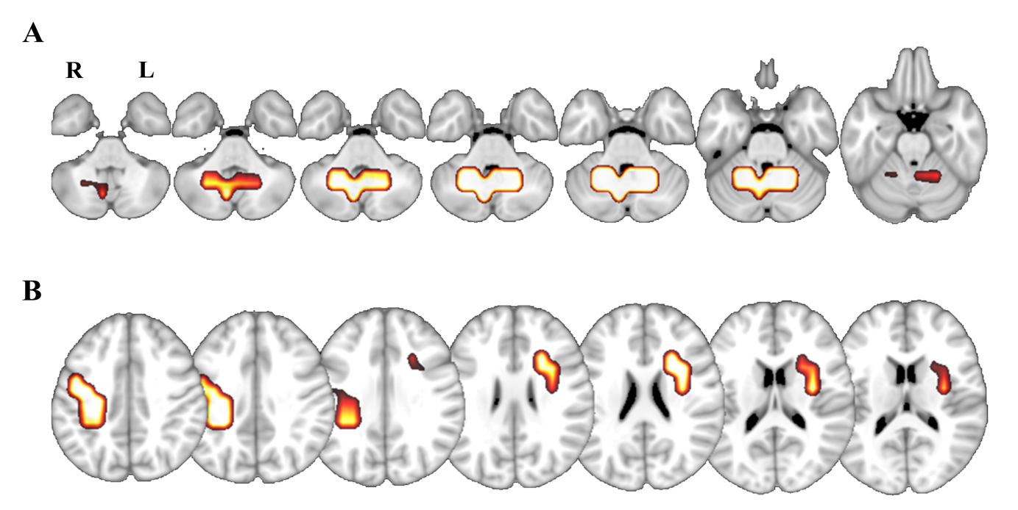
Figure e-2. Regional cortical atrophy distribution for each pattern (A) “cerebellar”, (B) “bihemispheric” and (C) “left-lateralized”. Results show lateral and medial views of the right (RH) and left hemispheres (LH). Significance level after false discovery rate correction (p < 0.05). The color bar represents the statistical significance.

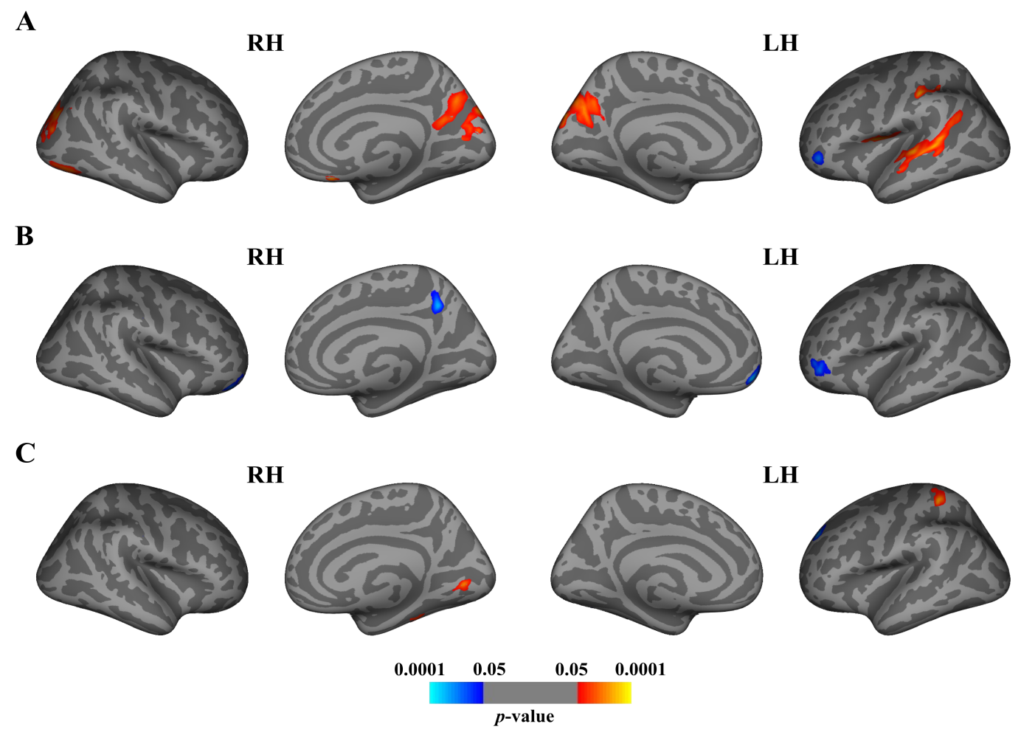
Figure e-3. Receiver operating characteristic (ROC) analysis showing the accuracy of lesion patterns in predicting disability progression in the replication cohort. The shaded areas represent 95% confidence intervals. In the legend, the area under the ROC curve (AUC) and the 95% confidence intervals are presented. The “cerebellar” pattern shows the best accuracy in predicting disability progression over time in comparison to the left-lateralized pattern (* p < 0.05).

