Suppl. figure 1: Pre-gating and gating strategy for B cell subsets and surface molecule expression. (A) Within all recorded events, singlets and cells were found using size exclusion. Living cells were thereafter defined as Zombie⁻. (B) Within the living cells, the B cell gate was defined as CD19⁺. Surface marker were evaluated as mean fluorescence intensity. B cell subpopulations are defined as follows: memory B cells (CD27^{var} CD38⁻), plasmablasts (CD20⁻ CD27⁺ CD38⁺), mature B cells (CD24^{var} CD38^{low}) and transitional B cells (CD24^{high} CD38^{high}).

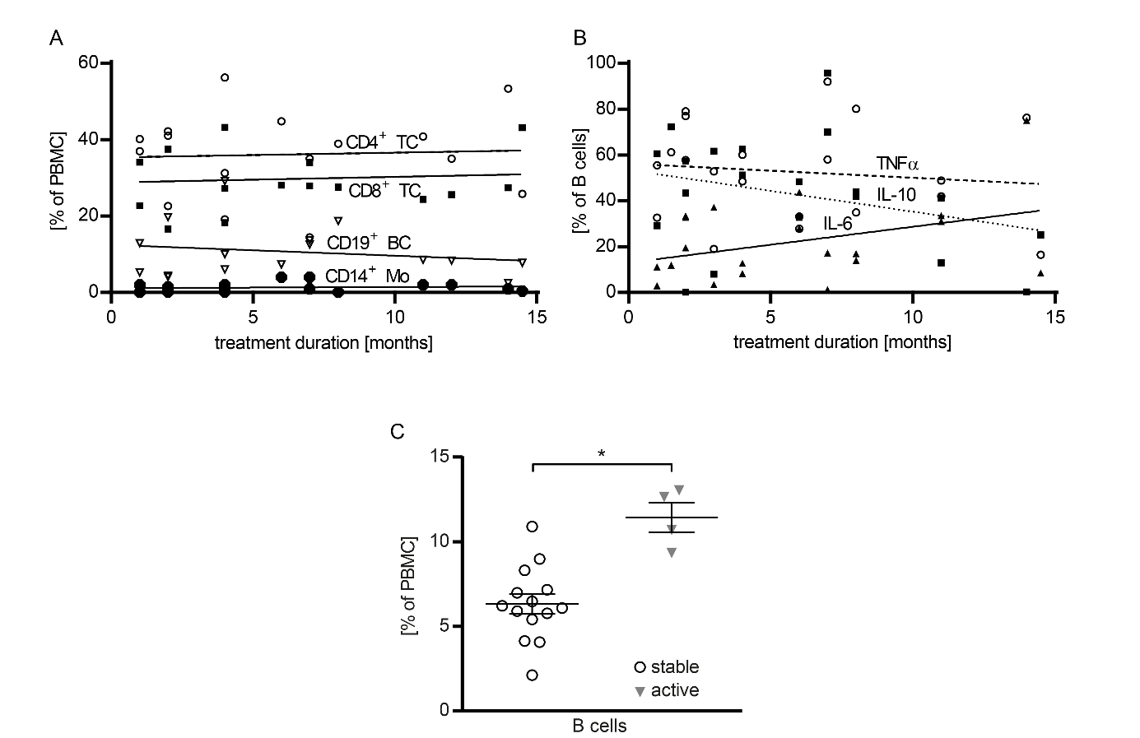
Suppl. figure 2: High BC frequency upon GA treatment correlates to an active disease course. Human peripheral blood mononuclear cells (PBMC) were isolated from glatiramer acetate (n = 20) treated multiple sclerosis (MS) patients. (A) The individual patients’ frequencies of CD4⁺, CD8⁺ TC, CD14⁺ Mo and BC were correlated with the duration of GA treatment (ns; linear regression). (B) The individual patients’ frequencies of tumor necrosis factor (TNF), interleukin (IL)-6 and IL-10 positive cells were correlated with the duration of GA treatment (ns; linear regression). (C) Peripheral blood mononuclear cells (PBMC) were isolated from glatiramer acetate (GA; n = 18) treated patients. In follow-up investigations two years after the phlebotomy the disease course was documented. The fraction of stable and active (including relapses, progression (rise in EDSS score by at least +0.5) and/or magnetic resonance imaging (MR) activity) disease courses is shown. Initial total B cell (BC) frequencies are compared between the stable and active patient cohort (* = p < 0.05; unpaired t-test).

Suppl. figure 3: GA modulates B cells in vitro. Naïve B cells purified from wild type mice were incubated with 50 μg/ml GA or vehicle at 37°C for 3h. After washing B cells were analyzed (A) for expression of activation markers, co-stimulatory molecules and the antigen-presenting molecule MHC class II as well as (B) for secretion of cytokines. Data are shown as median; n = 5.

