ON
NON
GCL
GCL
IPL
IPL

Figure e-1. Relative ganglion cell inner plexiform layer (GCIPL) thinning analysis was not applicable in this study. The ganglion cell layer (GCL) and the inner plexiform layer (IPL) are typically combined together for analysis due to the fact that the border between these two layers is not consistently identifiable in OCT segmentation. Since loss of RGC is mainly affecting the GCL leaving the IPL relatively preserved¹⁵, if the percentagewise annual GCL loss is a%, thinning of the entire GCIPL would be:
a’% = a% · T_{GCL}/(T_{GCL} + T_{IPL})
= a% · (1 – T_{IPL}/ (T_{GCL} + T_{IPL})) (1)
T_{GCL} and T_{IPL} are the thicknesses of GCL and IPL respectively.
Based on the fact that in optic neuritis (ON) eyes the baseline GCL is already significantly thinner, (1) would lead to a paradoxically smaller a’% value [increased T_{IPL}/ (T_{GCL} + T_{IPL}) component] compared to non-ON (NON) eyes if the same relative amount of RGC loss is present in both eyes. This is very different to the analysis of RNFL, where the entire nerve fibre layer is expected to be affected in the disease.
The schematic graph above represents a hypothetical example, where for illustration purposes we assume the GCL thickness to be equal to the IPL thickness in the NON eye (T_{GCL} = T_{IPL} = 1) and 50% of the IPL thickness in the ON eye (T_{GCL} = 0.5T_{IPL} = 0.5). Based on (1), 10% thinning in the GCL in NON eyes would lead to 5% thinning of the entire GCIPL (1x10%/(1+1)); By contrast, 10% thinning in the GCL in ON eyes would result in only 3.3% thinning of the entire GCIPL (0.5x10%/(0.5+1)), a paradoxically smaller value.
In the current study, GCIPL thickness measures were obtained by using the macular radial pattern (star-like) scan (6 scans, 6.00 mm long, separated by 30° from each other).¹⁶ We found that GCIPL change (in µm) over time was also faster in MS eyes (for NON: -0.23 µm per year, 95% CI: -0.38~-0.20; for ON eyes: -0.15 µm per year, 95% CI: -0.30~-0.01) compared to normal eyes (-0.01 µm per year, 95% CI: -0.14~0.11). However, there was no difference between ON and NON eyes in GCIPL thinning (p = 0.31).

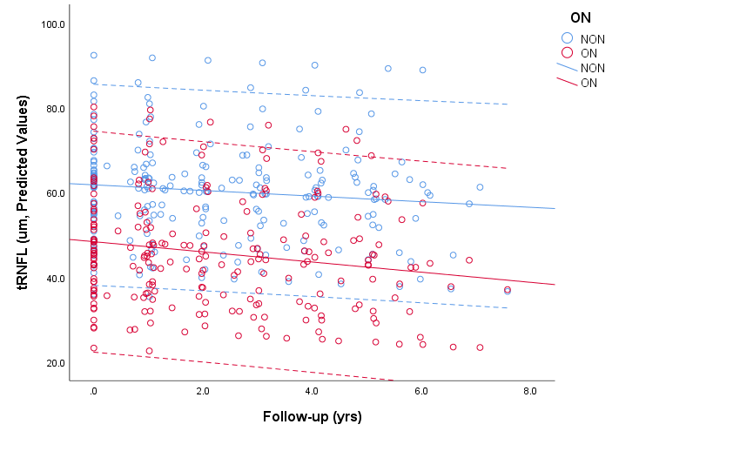
Figure e-2. Longitudinal measures of temporal retinal nerve fibre layer (tRNFL) thickness in optic neuritis (ON) and non-ON (NON) fellow eyes in MS patients. The y-axis represents predicted tRNFL values generated by the linear mixed effects model. Annualize tRNFL change rates are -0.68 μm per year (95% CI: -0.87~-0.49) for ON eyes and -0.58 μm per year (95% CI: -0.77~-0.40) for NON eyes (p = 0.73).

