Brain amyloid in virally suppressed HIV-associated neurocognitive disorder

– Supplementary Material –

Gemma C. HOWDLE, BA Sc. ¹, Yann QUIDÉ, PhD ^{1,2}, Mustafa S. KASSEM PhD ^{1,3}, Kate JOHNSON MD^{4,5}, Caroline D. RAE PhD ^{1,3}, Bruce J. BREW, MD DSc FRACP FAAN ^{3,4,5}, Lucette A. CYSIQUE PhD ^{1,3,4,}

1. Neuroscience Research Australia, Randwick, NSW, Australia
2. School of Psychiatry, UNSW Sydney, Sydney, NSW Australia
3. School of Medical Sciences, UNSW Medicine, UNSW Sydney, Sydney, NSW Australia
4. Peter Duncan Neuroscience Research Unit, St. Vincent’s Centre for Applied Medical Research, Darlinghurst, NSW, Australia
5. Departments of Neurology and Immunology, St. Vincent’s Hospital, Darlinghurst, NSW, Australia

Corresponding Author: Dr. Lucette Cysique, NeuroHIV and Quantitative Neuropsychology Research Group, Neuroscience Research Australia, PO Box 1165, Randwick NSW 2031, Australia. lcysique@unsw.edu.au

Table e-1: Case 1 profile and case statistics
 | HIV+
Age (years) | 62
Education (years) | 10
HIV duration (years) | 15.6
Current cART duration (months) | 6
Nadir CD4 cells/mL | 300
Current CD4 cells/mL | 528
Current CD8 cells/mL | 1224
Predicted WAIS-III VIQ | 98.7
GDS | 1.3
Historical AIDS | Yes
CSF Aβ-42 | 168.2
CSF t-tau | 132.2
CSF p-tau | 36.2
CSF AD-like profile | No
APOE | ε4/ε4
Hippocampal SUVRc vs NL | 0.057 (1.61) [1.15 to 2.11]*
Hippocampal SUVRc vs MCI | 0.45 (0.12) [-0.62 to 0.86]
Hippocampal SUVRc vs AD | 0.11 (1.27) [0.49 to 2.14]
Case statistics reported as One-tailed p-value (t-value) [Confidence Interval]
GDS: Global Deficit Score; SUVR: Cerebellum standardized uptake value ratio; NL: Cognitive Normal, MCI: Mild Cognitive Impairment; AD: Alzheimer’s disease
* (trend at p<.06)

Table e-2: Case 3 profile and case statistics
 | HIV+
Age (years) | 52
Education (years) | 15
HIV duration (years) | 24.8
Current cART duration (months) | 6
Nadir CD4 cells/mL | 170
Current CD4 cells/mL | 400
Current CD8 cells/mL | 700
Predicted WAIS-III VIQ | 109.9
GDS | 4.73
Historical AIDS | Yes
CSF Aβ-42 | Missing
CSF t-tau | Missing
CSF p-tau | Missing
CSF AD-like profile | Missing
APOE | Missing
Cingulum SUVRc vs NL | 0.07 (-1.47) [-1.94 to -1.02]
Cingulum SUVRc vs MCI | 0.02 (-2.55) [-4.39 to -1.04] *
Cingulum SUVRc vs AD | <0.0001 (-5.83) [-8.77 to -3.39] *
Caudate SUVRc vs NL | 0.006 (-2.64) [-3.34 to -1.99] *
Caudate SUVRc vs MCI | 0.01 (-2.97) [-5.06 to -1.26] *
Caudate SUVRc vs AD | 0.005 (-3.16) [-4.83 to -1.75] *
Putamen SUVRc vs NL | 0.07 (-1.48) [-1.95 to -1.03]
Putamen SUVRc vs MCI | 0.006 (-3.58) [-6.05 to -1.59] *
Putamen SUVRc vs AD | 0.002 (-3.56) [-5.41 to -2.00] *
Pallidum SUVRc vs NL | <0.04 (-1.80) [-2.34 to -1.31] *
Pallidum SUVRc vs MCI | 0.002 (-4.43) [-7.44 to -2.03] *
Pallidum SUVRc vs AD | 0.007 (-2.98) [-4.57 to -1.63] *
Thalamus SUVRc vs NL | 0.0006 (-3.48) [-4.36 to -2.67] *
Thalamus SUVRc vs MCI | 0.006 (-3.42) [-5.95 to -1.56] *
Thalamus SUVRc vs AD | 0.005 (-3.17) [-4.84 to -1.75] *
Case statistics reported as One-tailed p-value (t-value) [Confidence Interval]
GDS: Global Deficit Score; SUVR: Cerebellum standardized uptake value ratio; NL: Cognitive Normal, MCI: Mild Cognitive Impairment; AD: Alzheimer’s disease
p<.05 indicated by *
Table e-3: Case 5 profile and case statistics
 | HIV+
Age (years) | 54
Education (years) | 12
HIV duration (years) | 25.8
Current cART duration (months) | 16
Nadir CD4 cells/mL | 266
Current CD4 cells/mL | 528
Current CD8 cells/mL | 1150
Predicted WAIS-III VIQ | 104
GDS | 4.55
Historical AIDS | Yes
CSF Aβ-42 | 553.4
CSF t-tau | 538.5
CSF p-tau | 115.9
CSF AD-like profile | Yes
APOE | Missing
Cingulum SUVRc vs NL | 0.15 (-1.04) [-1.44 to -0.65]
Cingulum SUVRc vs MCI | 0.03 (-2.20) [-3.83 to -0.84] *
Cingulum SUVRc vs AD | 0.0002 (-5.10) [-7.70 to -2.95] *
Caudate SUVRc vs NL | <0.03 (-1.97) [-2.54 to -1.45] *
Caudate SUVRc vs MCI | 0.02 (-2.54) [-4.37 to -1.03] *
Caudate SUVRc vs AD | 0.01 (-2.65) [-4.08 to -1.42] *
Putamen SUVRc vs NL | 0.14 (-1.08) [-1.48 to -0.69]
Putamen SUVRc vs MCI | 0.01 (-3.12) [-5.31 to -1.35] *
Putamen SUVRc vs AD | <0.005 (-3.19) [-4.88 to -1.77] *
Pallidum SUVRc vs NL | 0.003 (-2.90) [-3.67 to -2.21] *
Pallidum SUVRc vs MCI | 0.0007 (-5.61) [-9.38 to -2.62] *
Pallidum SUVRc vs AD | 0.001 (-3.83) [-5.81 to -2.17] *
Thalamus SUVRc vs NL | 0.01 (-2.32) [-2.95 to -1.73] *
Thalamus SUVRc vs MCI | <0.02 (-2.68) [-4.59 to -1.11] *
Thalamus SUVRc vs AD | <0.03 (-2.28) [-3.55 to -1.18] *
Case statistics reported as One-tailed p-value (t-value) [Confidence Interval]
GDS: Global Deficit Score; SUVR: standardized uptake value ratio; NL: Cognitive Normal, MCI: Mild Cognitive Impairment; AD: Alzheimer’s disease
p<.05 indicated by *
Table e-4: Long-term clinical outcomes of the HIV+ cases

 | Deceased | Clinical evidence of progressing neurocognitive impairment | Clinical evidence of neuropsychiatric symptoms & worsening | New (old) Diagnosis of dementia (HIV, other) | Comorbid conditions | Stable and virally suppressed HIV (yes/no) | Functional impairment/dependence
Case 1  Abnormal trend for amyloid in hippocampi | No | Yes (2008, 2011) | Yes (depressive symptoms) | (ANI) MND (MSK1) + PSP-like illness | Suspicion of Progressive Supranuclear Palsy like-illness, with worsening gait ataxia and falls. A brain MRI also reveals micro-infarcts and hyperintensities to the white matter consistent with vascular injury | Yes | Partially independent with carers’ assistance
Case 2  AD-like amyloid | Yes (2019) | Yes (2018) | Yes (aggressive at times) | (Clinically moderate HAD, MSK2) AD | Aortic valve replacement, chronic obstructive pulmonary disease, ischaemic heart disease, type 2 diabetes, hypercholesterolaemia, peripheral neuropathy progressive | Yes | Fully dependent on carers’ assistance
Case 3  Decreased basal ganglia amyloid | Yes (2018) | Yes (already severe in 1995) | Yes (agitation) | (Clinically severe HAD, MSK3) | Bicuspid aortic valve with mod-severely dilated aortic root, hypercholesterolaemia, chronic obstructive pulmonary disease late in life recurrent aspiration pneumonia and urosepsis lead to hospitalisation & death | Yes (viral failure 2004) | Was in institution since initial HAD diagnosis
Case 4  Decreased basal ganglia amyloid | Yes (2016) | Yes (already moderate to severe 1998) | No | (Clinically severe HAD, MSK2) | Peripheral neuropathy, Hep C left untreated long-term, T1N3 anal squamous cell carcinoma (2015) leading to death | Yes | Was partially independent with carers/family assistance
Case 5  Decreased basal ganglia amyloid | Yes (2014) | Yes (2008) (already severe in 1997) | Yes | (Clinically severe HAD, MSK3) | Polyneuropathy, hypercholesterolaemia, hypertension, chronic kidney disease, Burkitt lymphoma (2014) ultinately leading to death | Yes | Was in institution since initial HAD diagnosis
Case 6  Normal amyloid | No | No | No | (MND, MSK1) Stable | Duodenal adenocarcinoma requiring whipples procedure & chemo complicated by pancreatic insufficiency, hyperlipidemia, hypertension, sigmoid colectomy for colon cancer (2013) partial penectomy for penile cancer (2016). Groin lymph node (2017) treated with right groin dissection & chemo-radiotherapy | Yes | Mostly independent
Case 7  Normal amyloid | No | No | No | (Clinically mild HAD, MSK1) | Painful neuropathy, functional neurological disorder, Intermittent medication compliance, type 2 diabetes intermittent control complicated by cellulitis, epilepsy, depression, hypercholesterolaemia, concussion, migraine, anal epithelial neoplasia | No (intermittent viral suppression due to ARV stopped due to other medical issues) | Partially independent with carers’ assistance
Case 8  No amyloid uptake | No | Yes (2011, self-report 2013) | Yes (comorbid diagnosis of possible bipolar disorder) | (ANI) (MND with psychiatric features, MSK 1) | Hyperlipidemia, Type 2 diabetes, hypertension, possible bipolar disorder, ART-related myalgias, lipodystrophy | Yes | Independent
Case 9  Normal amyloid | No | No | No | (ANI) Stable | Gastrooesophageal reflux disease, hypercholesterolaemia, peripheral neuropathy | Yes | Independent
Case 10  No amyloid uptake | No | Yes (2019) mild neurocognitive impairment as noted by GP | No | (ANI) MND (MSK1) | Anal dysplasia, hypercholesterolaemia, ischaemic heart disease, peripheral neuropathy, mouth, pharynx and lung cancer (2018) | Yes | Independent

Color coding: Red: amyloid increase; black: amyloid within the normal age-range; green: amyloid decrease: blue: no amyloid uptake
Table e-5: 22 ROIs

Regions of Interest from AAL | Aggregated regions-of-interest
Precentral_L | Central Region
Precentral_R
Rolandic_Oper_L
Rolandic_Oper_R
Postcentral_L
Postcentral_R
Frontal_Sup_L | Lateral Frontal
Frontal_Sup_R
Frontal_Mid_L
Frontal_Mid_R
Frontal_Inf_Oper_L
Frontal_Inf_Oper_R
Frontal_Inf_Tri_L
Frontal_Inf_Tri_R
Frontal_Sup_Medial_L | Medial Frontal
Frontal_Sup_Medial_R
Supp_Motor_Area_L
Supp_Motor_Area_R
Paracentral_Lobule_L
Paracentral_Lobule_R
Frontal_Sup_Orb_L | Orbito Frontal  Orbito Frontal
Frontal_Sup_Orb_R
Frontal_Mid_Orb_L
Frontal_Mid_Orb_R
Frontal_Med_Orb_L
Frontal_Med_Orb_R
Frontal_Inf_Orb_L
Frontal_Inf_Orb_R
Olfactory_L
Olfactory_R
Rectus_L
Rectus_R
Heschl_L | Superior Temporal
Heschl_R
Temporal_Sup_L
Temporal_Sup_R
Temporal_Mid_L | Middle Temporal
Temporal_Mid_R
Temporal_Inf_L | Inferior Temporal
Temporal_Inf_R
Parietal_Sup_L | Superior Parietal
Parietal_Sup_R
Parietal_Inf_L | Inferior Parietal
Parietal_Inf_R
SupraMarginal_L
SupraMarginal_R
Angular_L
Angular_R
Precuneus_L | Precuneus
Precuneus_R
Occipital_Sup_L | Lateral Occipital
Occipital_Sup_R
Occipital_Mid_L
Occipital_Mid_R
Occipital_Inf_L
Occipital_Inf_R
Fusiform_L | Medial Inferior Occipital
Fusiform_R
Calcarine_L
Calcarine_R
Cuneus_L
Cuneus_R
Lingual_L
Lingual_R
Temporal_Pole_Sup_L | Temporal Pole
Temporal_Pole_Sup_R
Temporal_Pole_Mid_L
Temporal_Pole_Mid_R
Cingulum_Ant_L | Cingulum  Cingulum
Cingulum_Ant_R
Cingulum_Mid_L
Cingulum_Mid_R
Cingulum_Post_L
Cingulum_Post_R
Hippocampus_L | Hippocampus
Hippocampus_R
ParaHippocampal_L | Parahippocampus
ParaHippocampal_R
Insula_L | Insula
Insula_R
Amygdala_L | Amygdala
Amygdala_R
Caudate_L | Caudate
Caudate_R
Putamen_L | Putamen
Putamen_R
Pallidum_L | Pallidum
Pallidum_R
Thalamus_L | Thalamus
Thalamus_R
L: Left; R: Right
The AALs were collapsed into 22 ROIs based on anatomical organisation and function. Unfortunately, there is no consensus of a standard by which all regions of the brain are compared or used. Herein, we collapse the AALs, according to the neuroanatomical groups in the most cited atlas of the human brain (Mai et al., 2015), as well as Prices work on neuroanatomy organisation by function (Price and Drevets, 2010, Price, 2007). Hierarchically, this is first done by physical organisation, i.e. gyri and lobes, then by function, i.e. emotional, then juxtaposed together to create broad regions representative of both, i.e. central region, orbitofrontal. In some places, i.e. Thalamus, instead of dividing into left and right, these were simplified into thalamus. These regions are not unfamiliar, the orbitofrontal ROI, for example, is commonplace within the literature. The AALs regions are presented in white, with the ROI they collapse into highlighted in blue. i.e. the first six regions collapse into the Central Region.
References:
Mai JK, Majtanik M, Paxinos G. Atlas of the human brain, 4th Ed.: Academic Press, 2015.
Price JL. Definition of the orbital cortex in relation to specific connections with limbic and visceral structures and other cortical regions. Ann N Y Acad Sci 2007;1121:54-71.
Price JL, Drevets WC. Neurocircuitry of mood disorders. Neuropsychopharmacology 2010;35:192-216.

Figure e-1: SUVRc in the aged AIBL controls selecting case with lowest, average and highest deposition
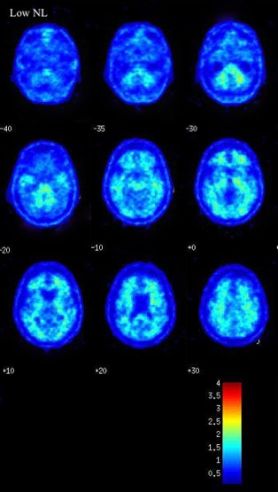
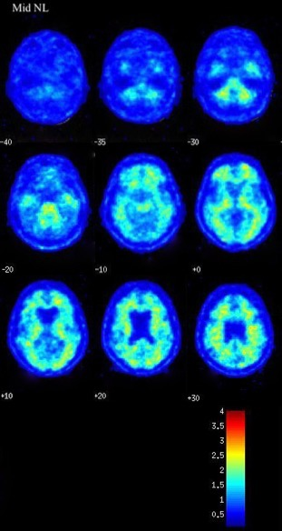

Figure e-2: SUVR_{c} in the aged AIBL MCI sample selecting cases with lowest, average and highest deposition
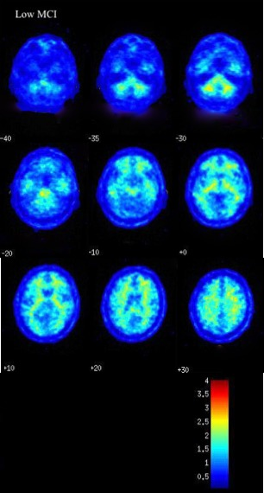
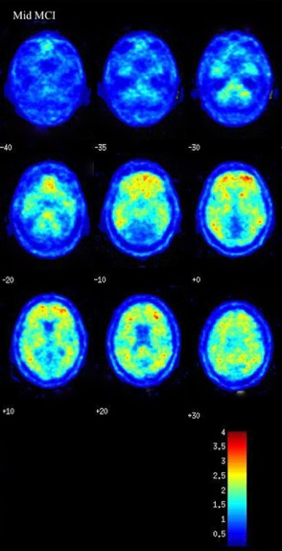
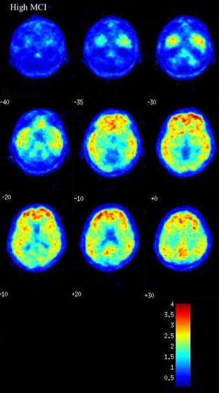

Figure e-3: SUVRc in the aged AIBL AD sample selecting case with lowest, average and highest deposition
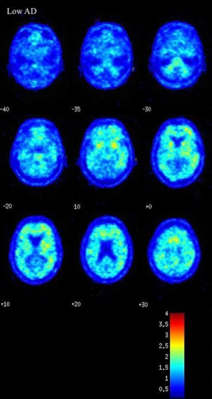
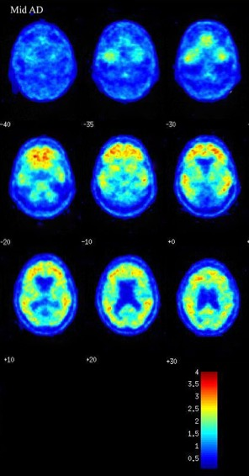
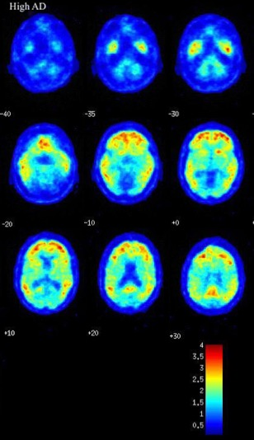

Figure e-4: HAND cases 8 and 10 with abnormal PIB PET update (raw data)

