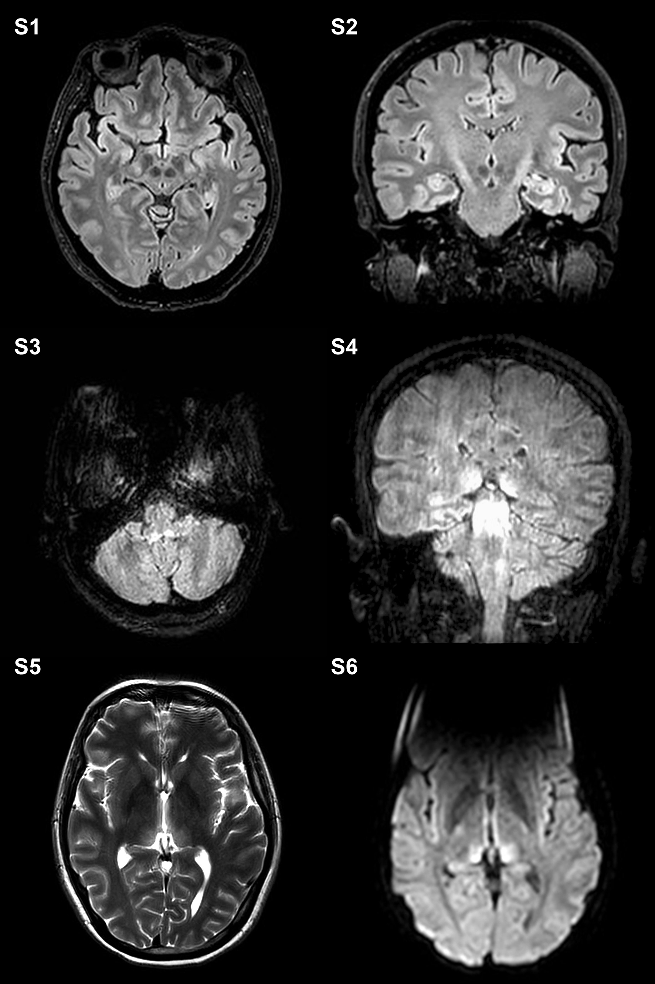

Supplementary Figure:
Figure e-1. Additional findings on Magnetic resonance imaging (MRI). In case 1, S1-S2 MRI additionally showed mild FLAIR-hyperintensity (HI) in the cortico-spinal tracts-internal capsule and cerebral peduncles-. In case 2, S3 Axial FLAIR demonstrated symmetric HI in the vestibular nuclei in the medulla. S4 Coronal FLAIR showed HI in the medial and posterior thalami, posterior midbrain and superior cerebellar peduncles. S5-S6 Symmetric T2- and DWI-HI in the medial and posterior thalami.

